AccessionIndex: TCD-SCSS-U.20121208.042
Accession Date: 8-Dec-2012
Accession By: Prof.J.G.Byrne
Object name: Unidentified Sliderules
Vintage: c.19xx
Synopsis: Sliderules.

Description:
The manufacturer of these sliderules is as yet unidentified.

Photographs courtesy Prof.J.G.Byrne and Dr.Arthur Hughes.

The homepage for this catalog is at: https://www.scss.tcd.ie/SCSSTreasuresCatalog/
Click 'Accession Index' (1st column listed) for related folder, or 'About' for further guidance.

Accession Index | Location | Vintage | Object and Identification
TCD-SCSS-U.20121208.042.01 |  | c.19xx | <Mfgr?> <model?> sliderule.  S/N: <???>
TCD-SCSS-U.20121208.042.02 |  | c.19xx
TCD-SCSS-U.20121208.042.03 |  | c.198x
TCD-SCSS-U.20121208.042.04 |  | c.198x
TCD-SCSS-U.20121208.042.05 |  | c.19xx
TCD-SCSS-U.20121208.042.06 |  | c.198x

The following instruction manuals are properly part of the literature category of this catalog, but are listed here too for convenience.

Accession Index | Object with Identification
TCD-SCSS-V.20121208.???

References:

1. Authors, Title, Publication, Publisher, Date.

2. Authors, Title, Publication, Publisher, Date.

3. Authors, Title, Publication, Publisher, Date.

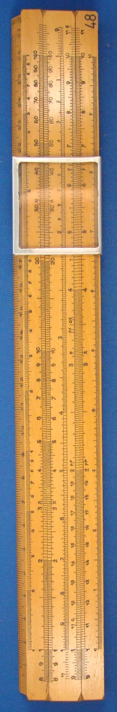
Figure 1: TCD-SCSS-U.20121208.042-fig01

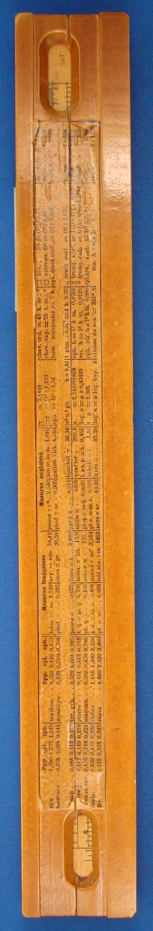
Figure 2: TCD-SCSS-U.20121208.042-fig02

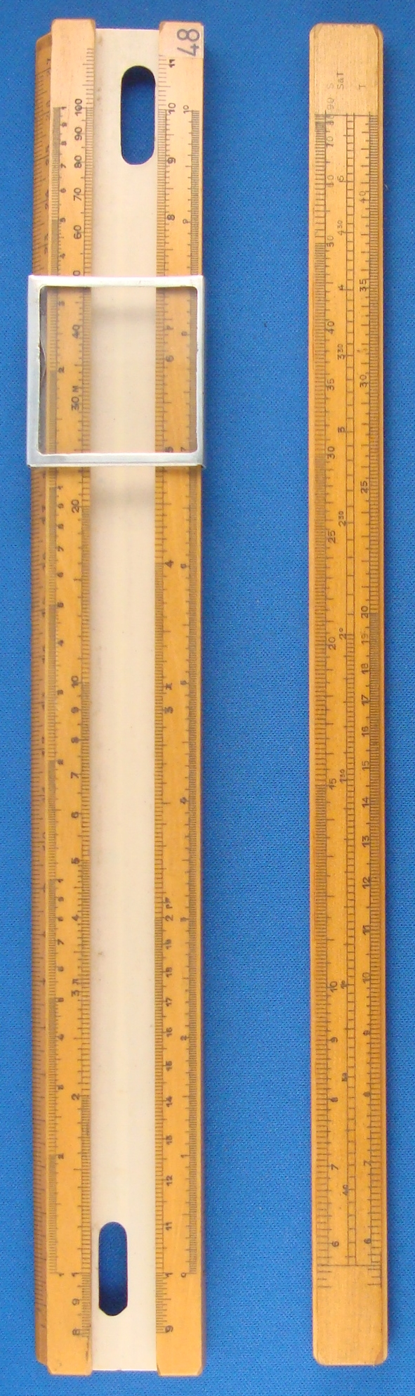
Figure 3: TCD-SCSS-U.20121208.042-fig03

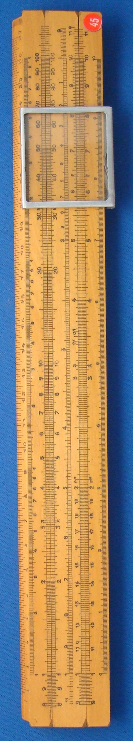
Figure 4: TCD-SCSS-U.20121208.042-fig04

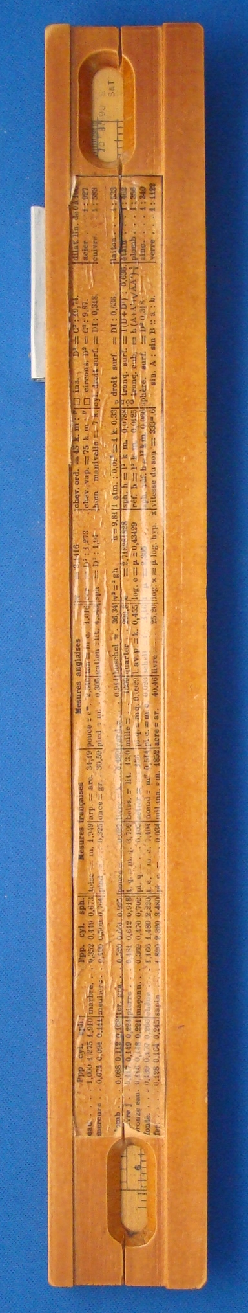
Figure 5: TCD-SCSS-U.20121208.042-fig05

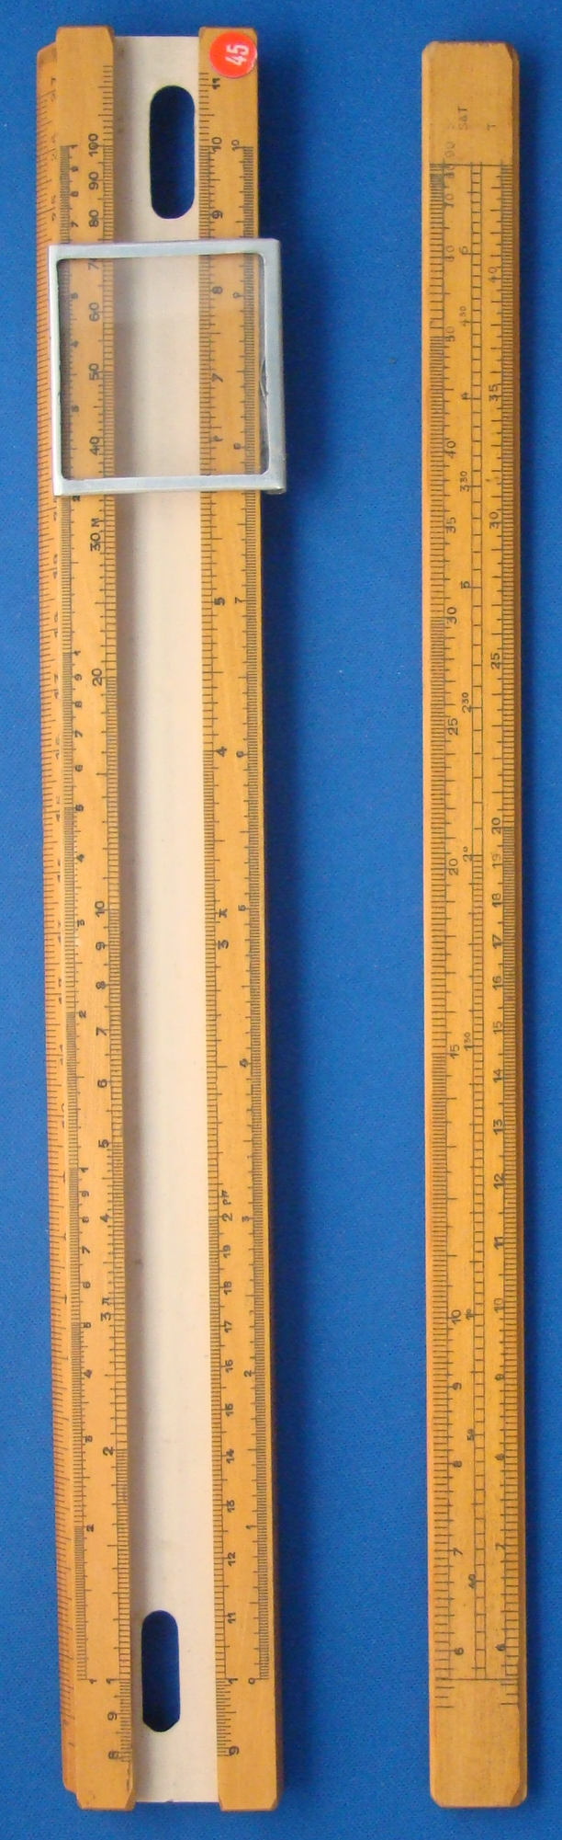
Figure 6: TCD-SCSS-U.20121208.042-fig06

