AccessionIndex: TCD-SCSS-U.20121208.038
Accession Date: 8-Dec-2012
Accession By: Prof.J.G.Byrne
Object name: L'Auto-Calcul Roulois
Vintage: c.1924
Synopsis: Fan-like multiplication aid.

Description:
The L'Auto Calcul Roulois is a Napier-bones-derived multiplication aid manufactured by Roulois, 14 Rue du Lunain, Paris, France, in c.1924. It has strips made out of pliable material, each about 22.5cm long, which can be spread like a fan. At the top of every strip is an index number in the range of ‘01’ to ‘99’ placed in order from the ‘01’ strip at the front to the ‘99’ strip at the rear. Fig.1 shows that the ‘60’ strip has red numbers from ‘01’ to ‘99’ on the left, with associated black numbers on the left that must be added to perform the multiplication (the French term these ’bars’, on which the bars of Napier are grouped together).

Photographs courtesy Prof.J.G.Byrne and Dr.Arthur Hughes.

The homepage for this catalog is at: https://www.scss.tcd.ie/SCSSTreasuresCatalog/
Click 'Accession Index' (1st column listed) for related folder, or 'About' for further guidance. Some of the items below may be more properly part of other categories of this catalog, but are listed here for convenience.

Accession Index | Object with Identification
TCD-SCSS-U.20121208.038 | L'Auto-Calcul Roulois, Fan-like multiplication aid, c.1924.

References:

1. Stephan Weiss, Rechenverfahren und Varianten historischer Multipliziergeräte, see:
http://www.mechrech.info/publikat/VarMultGer.pdf
Last browsed to on 8-Jun-2017.

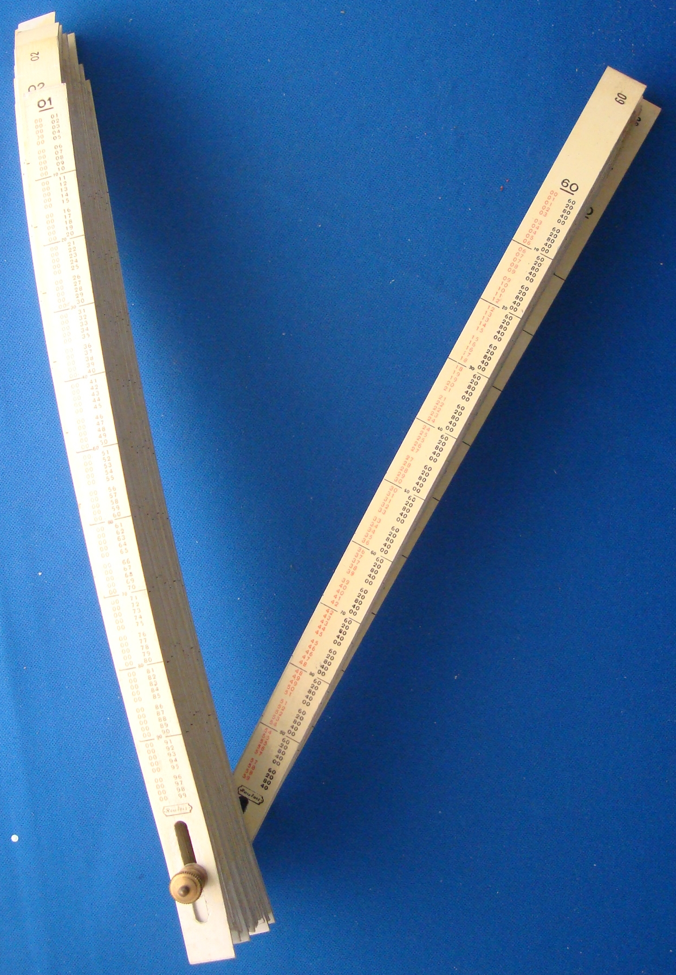
Figure 1: TCD-SCSS-U.20121208.038-fig01

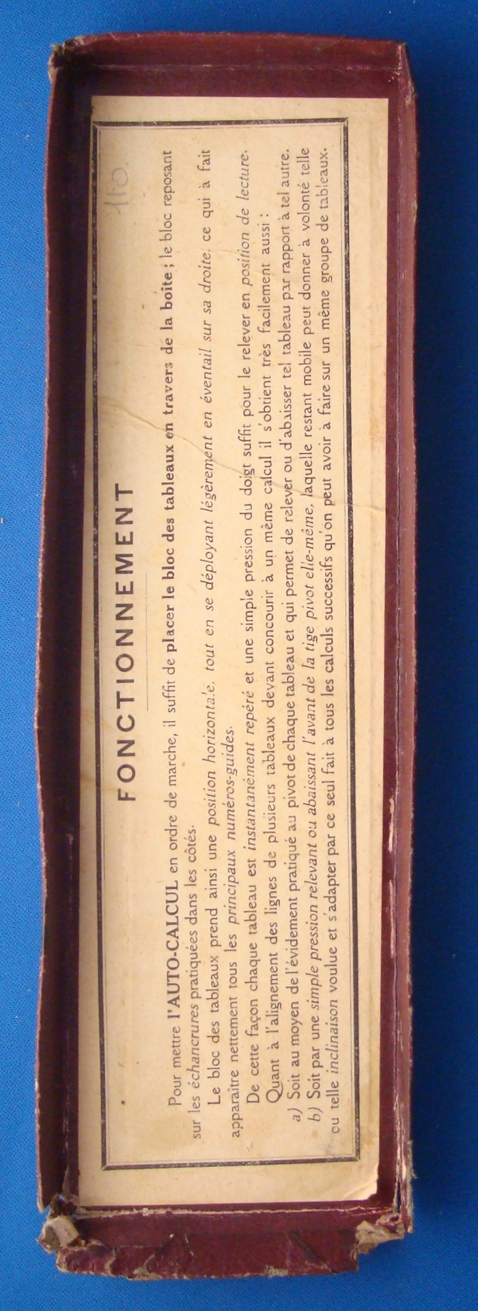
Figure 2: TCD-SCSS-U.20121208.038-fig02

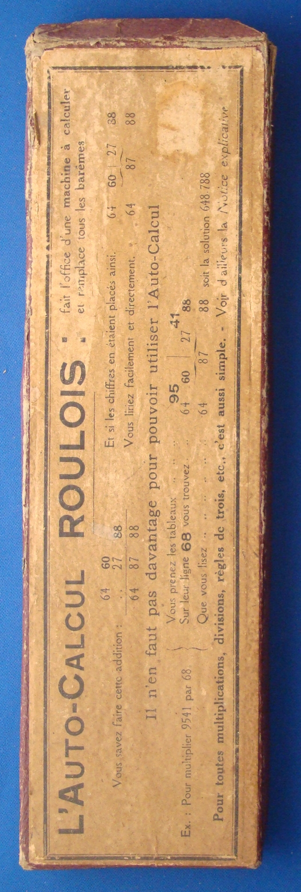
Figure 3: TCD-SCSS-U.20121208.038-fig03

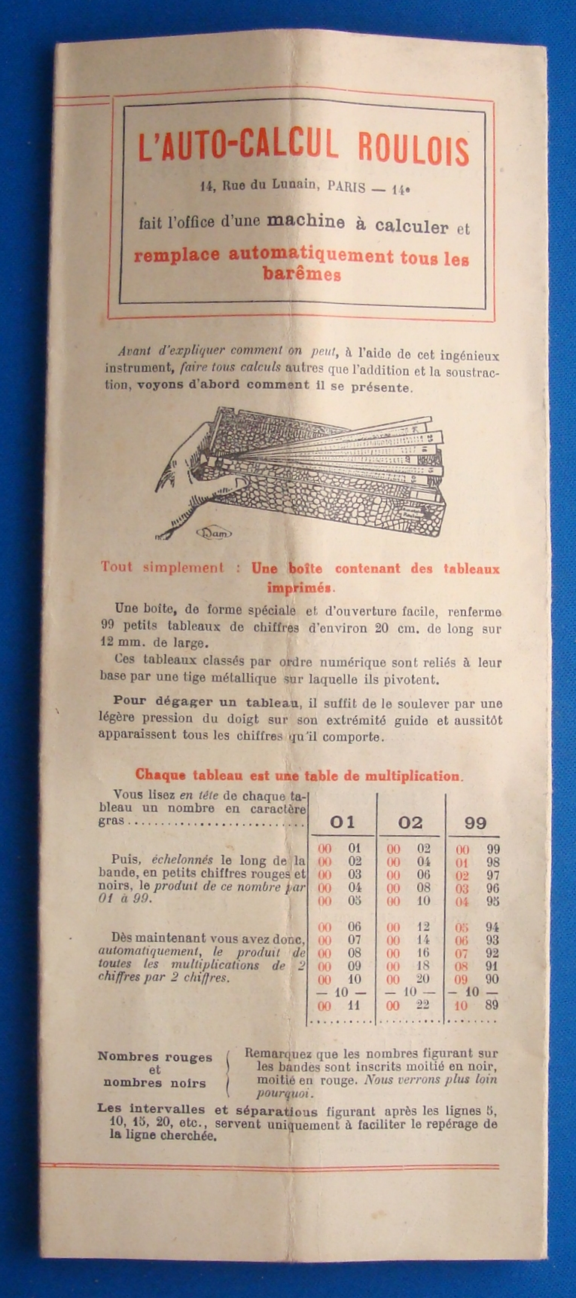
Figure 4: TCD-SCSS-U.20121208.038-fig04

