AccessionIndex: TCD-SCSS-U.20121208.037
Accession Date: 8-Dec-2012
Accession By: Prof.J.G.Byrne
Object name: R.B.Bate's Ready Reckoner
Vintage: c.1824
Synopsis: Very rare sliderule, printed paper on mahogany.

Description:
This vintage sliderule has a label on the reverse side saying:

Very rare sliderule,
printed paper on
mahogany. Published
in 1824 by Robert
Brettell Bate (1782
-1846)
£425-”

On the front the labelling says “Published 1st June 1824 by R.B.Bate, Mathematical Instrument Maker to His Majesty’s Honble Board of Excise, No.17, Poultry, London.”

This sliderule has paper scales on wood, two slides, one on each face. Paper slide rules became popular in the early 19th century.

Robert Brettell Bate was born on February 27, 1782, in Stourbridge, Worcestershire, the third of four children (all boys) of Overs and Susanna Bate. Overs was a banker and mercer (fabric merchant). By 1803 Robert had moved to London to work with his uncle, Robert Brettell, who had a haberdashery at 21 Foster Lane. In 1804 Robert married Anna Maria Sykes, daughter of Robert’s maternal aunt Mary, and they then had five children. R.B.Bate inherited the business and royalties for Sykes Hydrometer from Anna’s deceased father Bartholomew Sikes, 1731-1803 (who invented the hydrometer for measuring alcohol concentration; it was adopted as the standard measure by the Revenue Department for taxation of alcoholic drinks).

Bate then developed a very high quality optical and scientific business during the first half of the nineteenth century. His Troy pound standard weight became legal standard for American coinage at the time and his instruments were also known to have been used by The East India Company, The Royal Navy, The Board of Ordnance, The Hydrographic Office and The Bank of England. For a time he strayed into selling time-keeping instruments, leading to a dispute with the Clockmakers’ guild between 1813 and 1817. His business address was ‘17 Poultry, London’, between 1807 and 1824, then ‘21 Poultry, London’ between 1824 and 1847 (see Fig.3), although this item is labelled as having been made at ‘17 Poultry, London’.

He also strayed into publishing, writing and publishing numerous handbooks on the apparatus that he sold, publishing other’s works on navigation, and co-published the Nautical Magazine. In 1830, he was appointed sole agent for Admiralty charts. In 1833 he served as Master of the Spectaclemakers’ Guild. He was also an official Optician in Ordinary to the royal households of King George IV and Queen Victoria.

Photographs courtesy Prof.J.G.Byrne and Dr.Arthur Hughes.
The homepage for this catalog is at: https://www.scss.tcd.ie/SCSSTreasuresCatalog/
Click 'Accession Index' (1st column listed) for related folder, or 'About' for further guidance. Some of the items below may be more properly part of other categories of this catalog, but are listed here for convenience.

Accession Index | Object with Identification
TCD-SCSS-U.20121208.037 | R.B.Bate’s Ready Reckoner, Very rare sliderule, printed paper on mahogany, c.1824.

References:

1. Brian Stevenson, Robert Brettell Bate, 1782 – 1847, see:
http://microscopist.net/BateRB.html
Last browsed to on 26-Oct-2021.

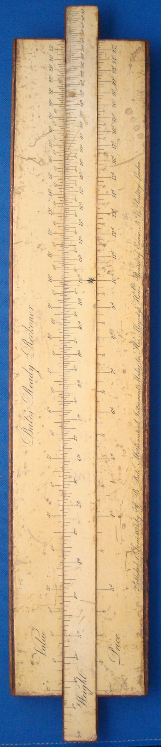
Figure 1: TCD-SCSS-U.20121208.037-fig01

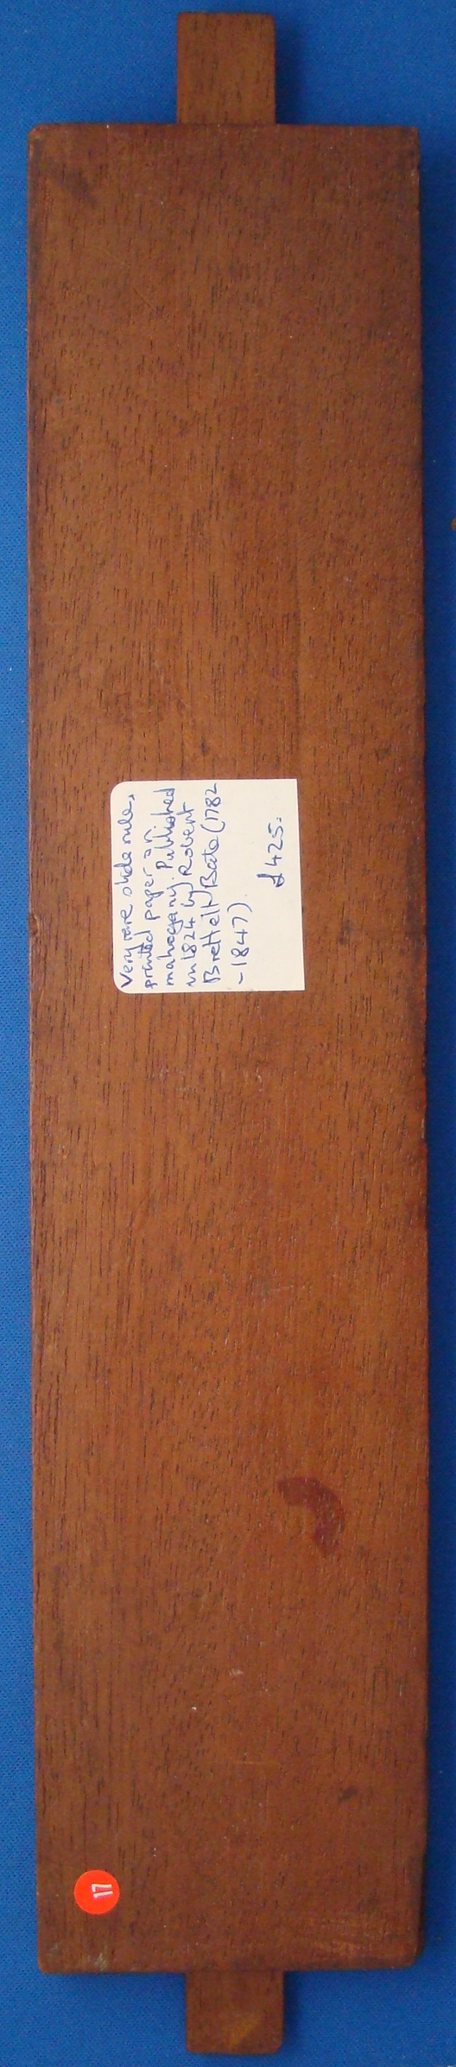
Figure 2: TCD-SCSS-U.20121208.037-fig02

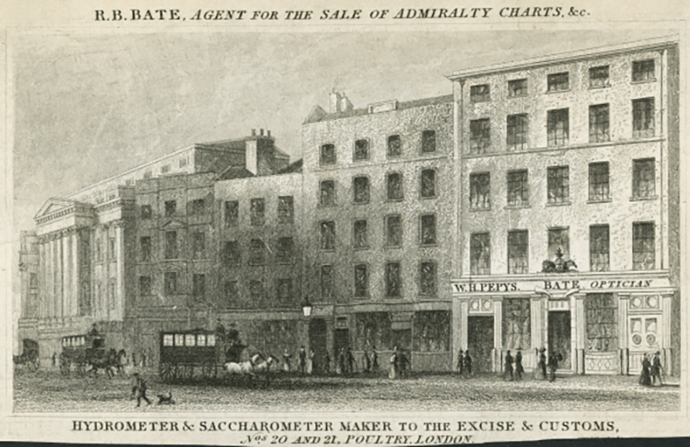
Figure 3: 20-21 Poultry, London, from ‘London Street Views 1838 to 1840’, byt John Tallis

