AccessionIndex: TCD-SCSS-U.20121208.036
Accession Date: 8-Dec-2012
Accession By: Prof.J.G.Byrne
Object name: Post
Vintage: c.19xx
Synopsis: Sliderules.

Description:
Frederick Post Co., Chicago, founded 1890, was a distributor of American branded slide rules, and other engineering supplies, which were typically relabeled standard products from well-known manufacturers from around the world [1] [2]. Post was acquired by Teledyne in December, 1967.

Photographs courtesy Prof.J.G.Byrne and Dr.Arthur Hughes.

The homepage for this catalog is at: https://www.scss.tcd.ie/SCSSTreasuresCatalog/
Click 'Accession Index' (1st column listed) for related folder, or 'About' for further guidance. Some of the items below may be more properly part of other categories of this catalog, but are listed here for convenience.

Accession Index | Object with Identification
TCD-SCSS-U.20121208.036 | Post, Sliderules, S/N: 417885, c.19xx.

References:

1. Bob Otnes, Notes on Frederick Post Slide Rules, Vol.7, No.1, Journal of the Oughtred Society, Spring, 1998.

2. Paul Ross and Ted Hume, Sliderules of the Frederick Post Company, Vol.9, No.2, Journal of the Oughtred Society, Fall, 2000.

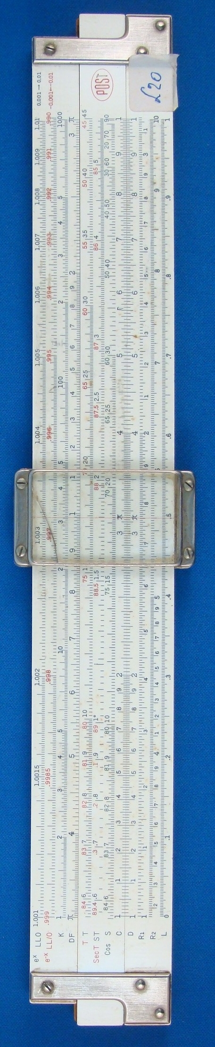
Figure 1: TCD-SCSS-U.20121208.036-fig01

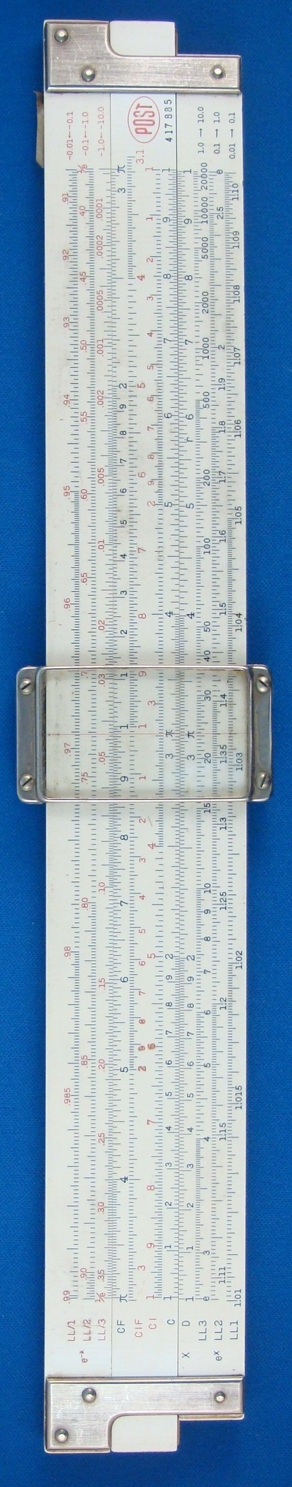
Figure 2: TCD-SCSS-U.20121208.036-fig02

