AccessionIndex: TCD-SCSS-U.20121208.029
Accession Date: 8-Dec-2012
Accession By: Prof.J.G.Byrne
Object name: Marc
Vintage: c.19xx
Synopsis: Sliderules.

Description:
Text …

Photographs courtesy Prof.J.G.Byrne and Dr.Arthur Hughes.

Accession Index | Location | Vintage | Object and Identification
TCD-SCSS-U.20121208.029.01 |  | c.19xx | <Mfgr?> <model?> sliderule.  S/N: <???>
TCD-SCSS-U.20121208.029.02 |  | c.19xx
TCD-SCSS-U.20121208.029.03 |  | c.198x
TCD-SCSS-U.20121208.029.04 |  | c.198x
TCD-SCSS-U.20121208.029.05 |  | c.19xx
TCD-SCSS-U.20121208.029.06 |  | c.198x
TCD-SCSS-U.20121208.029.07 |  | c.198x

The following instruction manuals are properly part of the literature category of this catalog, but are listed here too for convenience.

Accession Index | Object with Identification
TCD-SCSS-V.20121208.???

References:

1. Authors, Title, Publication, Publisher, Date.

2. Authors, Title, Publication, Publisher, Date.

3. Authors, Title, Publication, Publisher, Date.

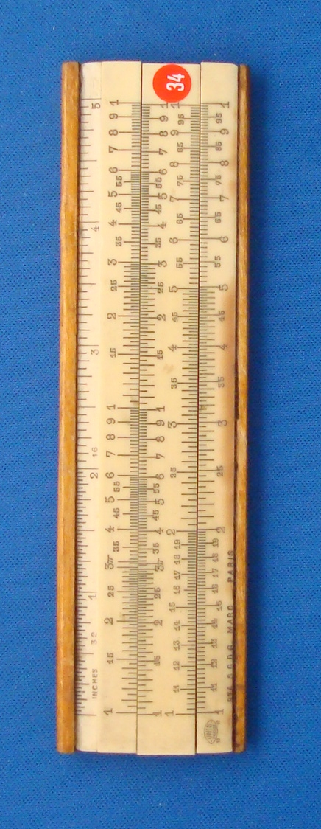
Figure 1: TCD-SCSS-U.20121208.029-fig01

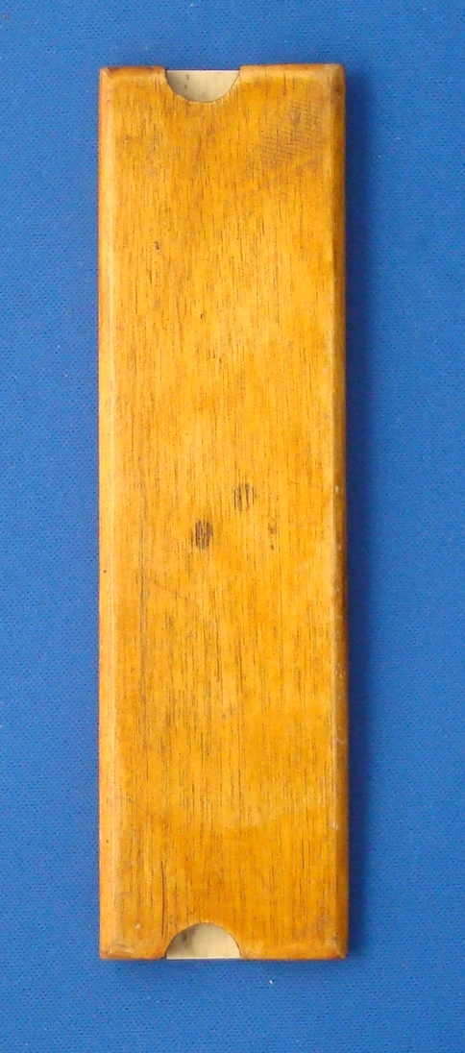
Figure 2: TCD-SCSS-U.20121208.029-fig02

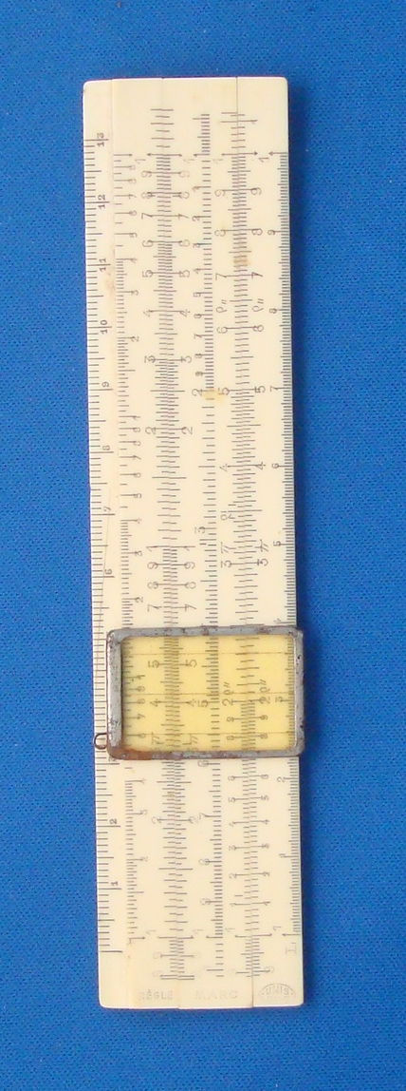
Figure 3: TCD-SCSS-U.20121208.029-fig03

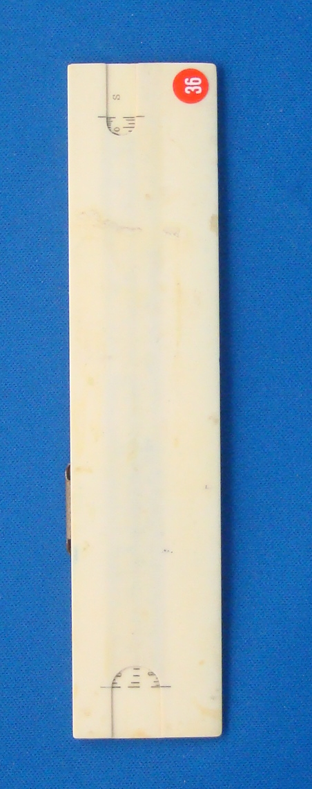
Figure 4: TCD-SCSS-U.20121208.029-fig04

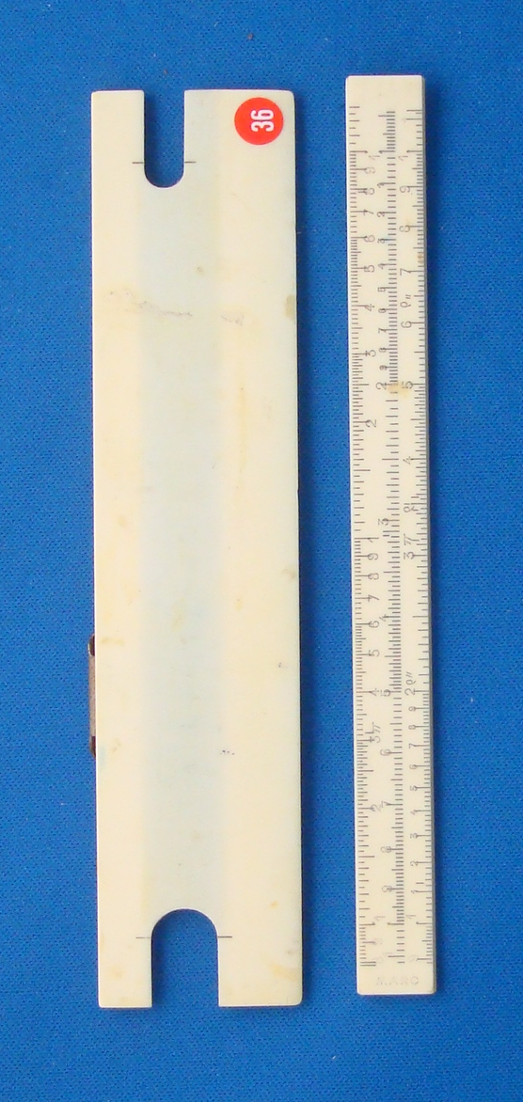
Figure 5: TCD-SCSS-U.20121208.029-fig05

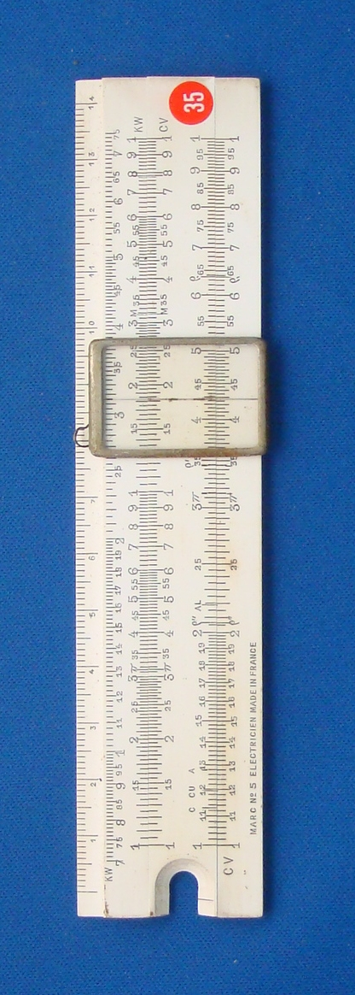
Figure 6: TCD-SCSS-U.20121208.029-fig06

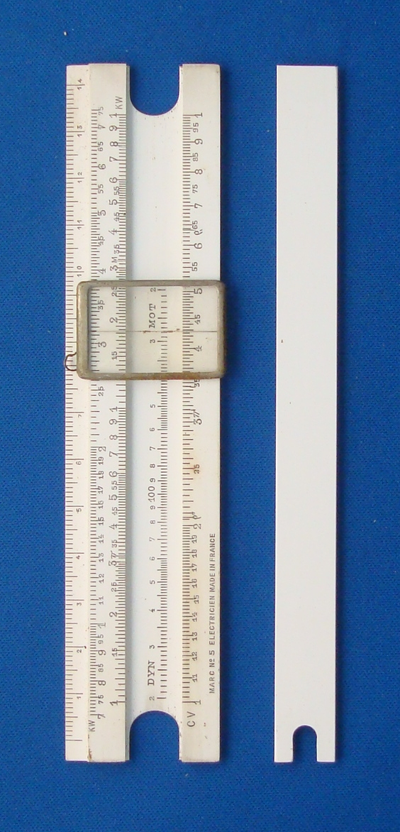
Figure 7: TCD-SCSS-U.20121208.029-fig07

