AccessionIndex: TCD-SCSS-U.20121208.022
Accession Date: 8-Dec-2012
Accession By: Prof.J.G.Byrne
Object name: Jakar
Vintage: c.19xx
Synopsis: Sliderules.

Description:
Text …

Photographs courtesy Prof.J.G.Byrne and Dr.Arthur Hughes.

Accession Index | Location | Vintage | Object and Identification
TCD-SCSS-U.20121208.022.01 |  | c.19xx | <Mfgr?> <model?> sliderule.  S/N: <???>
TCD-SCSS-U.20121208.022.02 |  | c.19xx
TCD-SCSS-U.20121208.022.03 |  | c.198x
TCD-SCSS-U.20121208.022.04 |  | c.198x
TCD-SCSS-U.20121208.022.05 |  | c.19xx
TCD-SCSS-U.20121208.022.06 |  | c.198x
TCD-SCSS-U.20121208.022.07 |  | c.198x
TCD-SCSS-U.20121208.022.08 |  | c.19xx
TCD-SCSS-U.20121208.022.09 |  | c.198x
TCD-SCSS-U.20121208.022.10 |  | c.198x
TCD-SCSS-U.20121208.022.11 |  | c.19xx
TCD-SCSS-U.20121208.022.12 |  | c.198x
TCD-SCSS-U.20121208.022.13 |  | c.198x
TCD-SCSS-U.20121208.022.14 |  | c.198x
TCD-SCSS-U.20121208.022.15 |  | c.19xx
TCD-SCSS-U.20121208.022.16 |  | c.198x
TCD-SCSS-U.20121208.022.17 |  | c.198x
TCD-SCSS-U.20121208.022.18 |  | c.19xx
TCD-SCSS-U.20121208.022.19 |  | c.198x
TCD-SCSS-U.20121208.022.20 |  | c.198x
TCD-SCSS-U.20121208.022.21 |  | c.19xx
TCD-SCSS-U.20121208.022.22 |  | c.198x
TCD-SCSS-U.20121208.022.23 |  | c.198x
TCD-SCSS-U.20121208.022.24 |  | c.198x
TCD-SCSS-U.20121208.022.25 |  | c.19xx
TCD-SCSS-U.20121208.022.26 |  | c.198x
TCD-SCSS-U.20121208.022.27 |  | c.198x
TCD-SCSS-U.20121208.022.28 |  | c.19xx
TCD-SCSS-U.20121208.022.29 |  | c.198x
TCD-SCSS-U.20121208.022.30 |  | c.198x

The following instruction manuals are properly part of the literature category of this catalog, but are listed here too for convenience.

Accession Index | Object with Identification
TCD-SCSS-V.20121208.???

References:

1. Authors, Title, Publication, Publisher, Date.

2. Authors, Title, Publication, Publisher, Date.

3. Authors, Title, Publication, Publisher, Date.

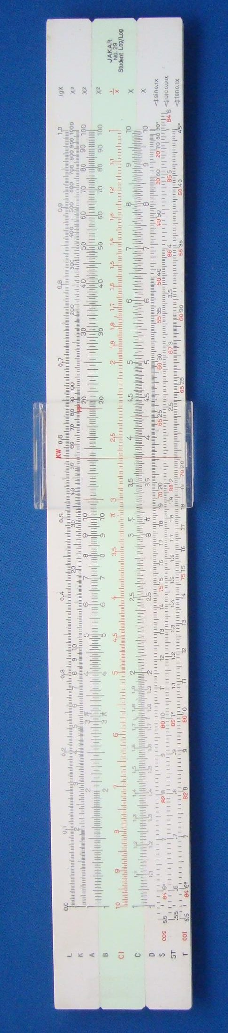
Figure 1: TCD-SCSS-U.20121208.022-fig01

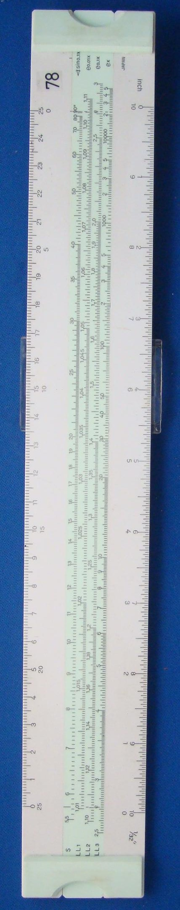
Figure 2: TCD-SCSS-U.20121208.022-fig02

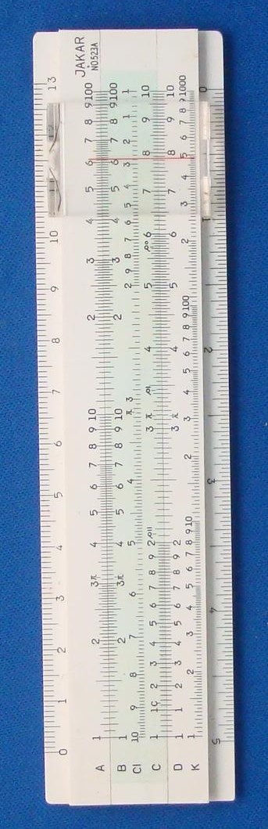
Figure 3: TCD-SCSS-U.20121208.022-fig03

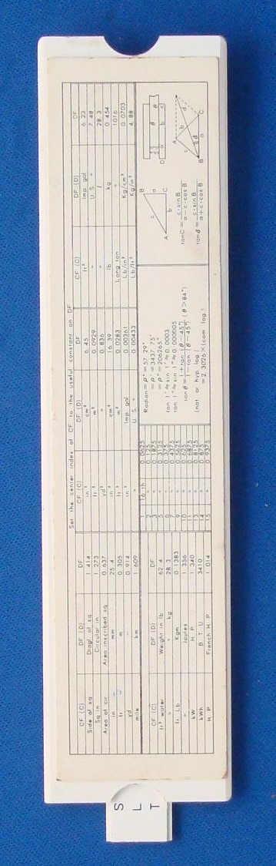
Figure 4: TCD-SCSS-U.20121208.022-fig04

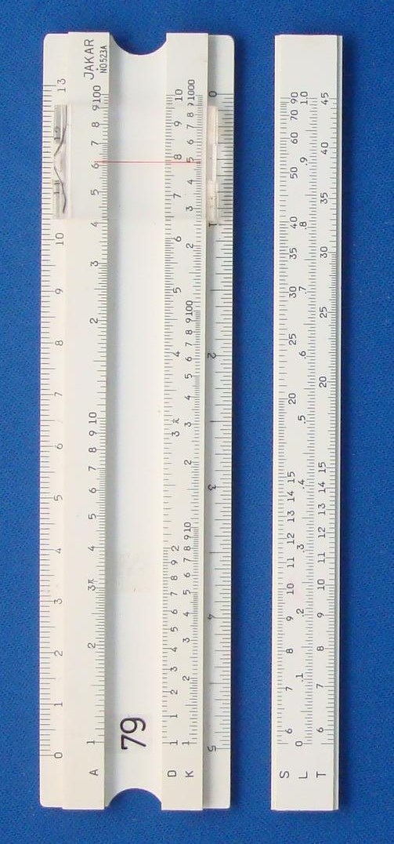
Figure 5: TCD-SCSS-U.20121208.022-fig05

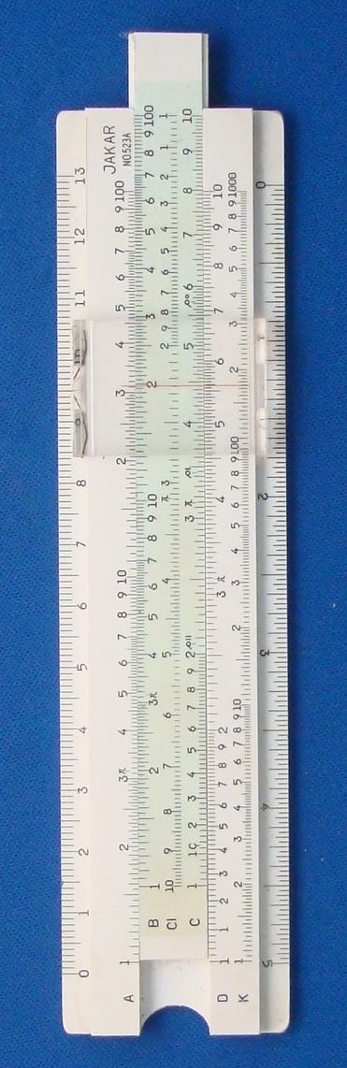
Figure 6: TCD-SCSS-U.20121208.022-fig06

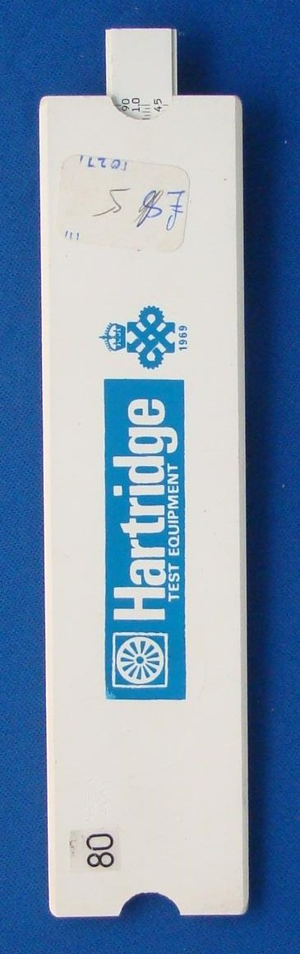
Figure 7: TCD-SCSS-U.20121208.022-fig07

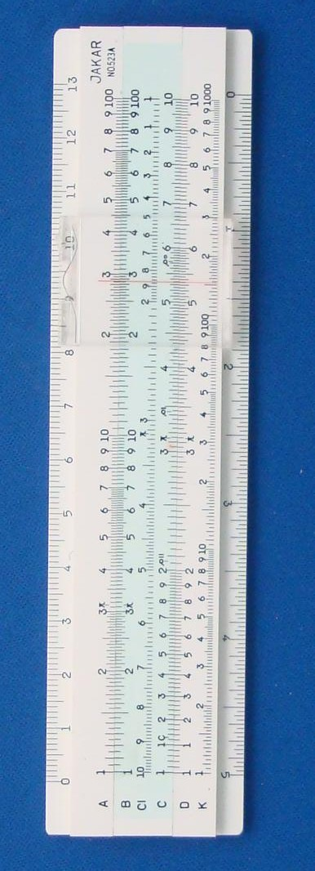
Figure 8: TCD-SCSS-U.20121208.022-fig08

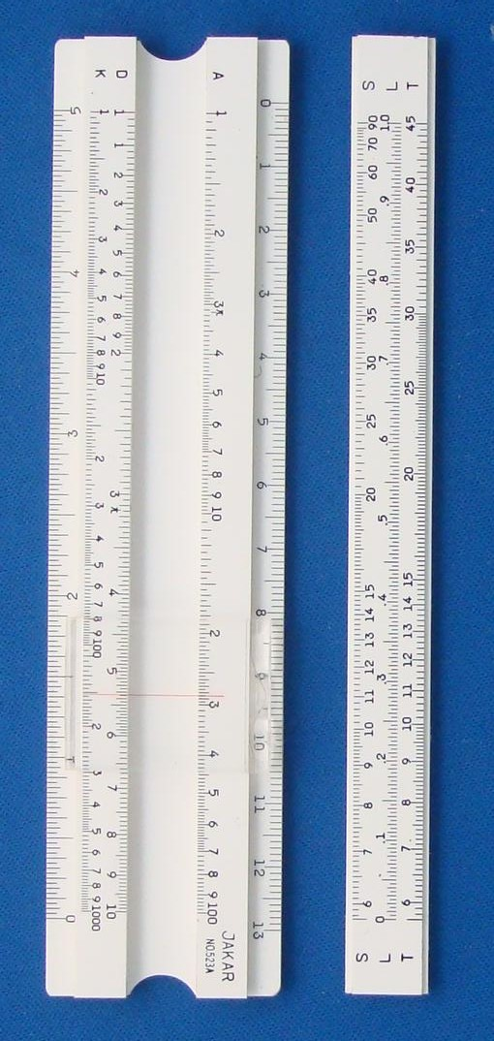
Figure 9: TCD-SCSS-U.20121208.022-fig09

