AccessionIndex: TCD-SCSS-U.20121208.010
Accession Date: 8-Dec-2012
Accession By: Prof.J.G.Byrne
Object name: Byrnegraph
Vintage: c.19xx
Synopsis: Instruments.

Description:
Text …

Accession Index | Location | Vintage | Object and Identification
TCD-SCSS-U.20121208.010.01 |  | c.19xx | <Mfgr?> <model?> sliderule.  S/N: <???>
TCD-SCSS-U.20121208.010.02 |  | c.19xx
TCD-SCSS-U.20121208.010.03 |  | c.198x
TCD-SCSS-U.20121208.010.04 |  | c.198x

References:

1. Authors, Title, Publication, Publisher, Date.

2. Authors, Title, Publication, Publisher, Date.

3. Authors, Title, Publication, Publisher, Date.

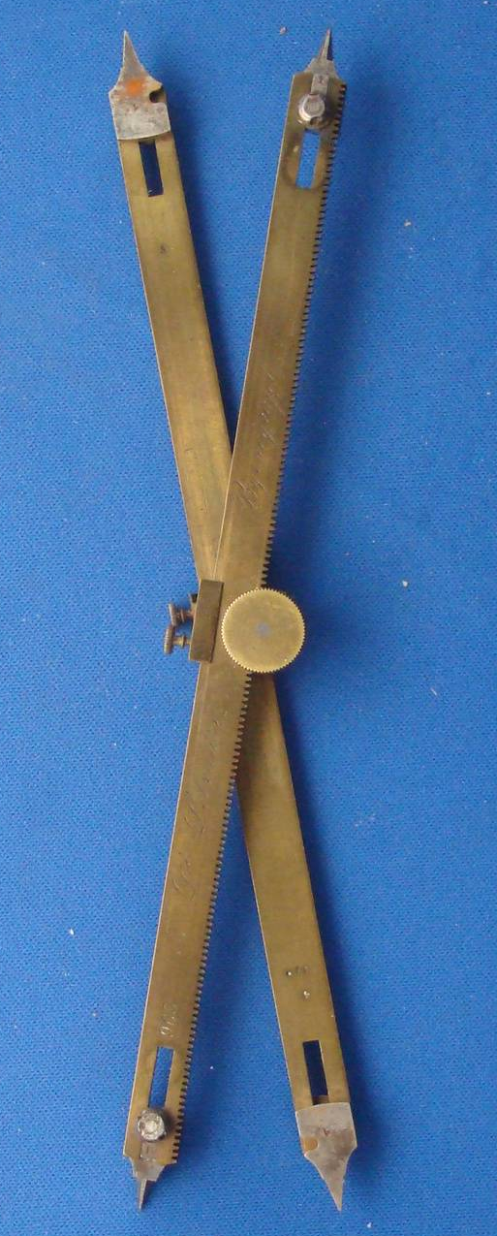
Figure 1: TCD-SCSS-U.20121208.010-fig01

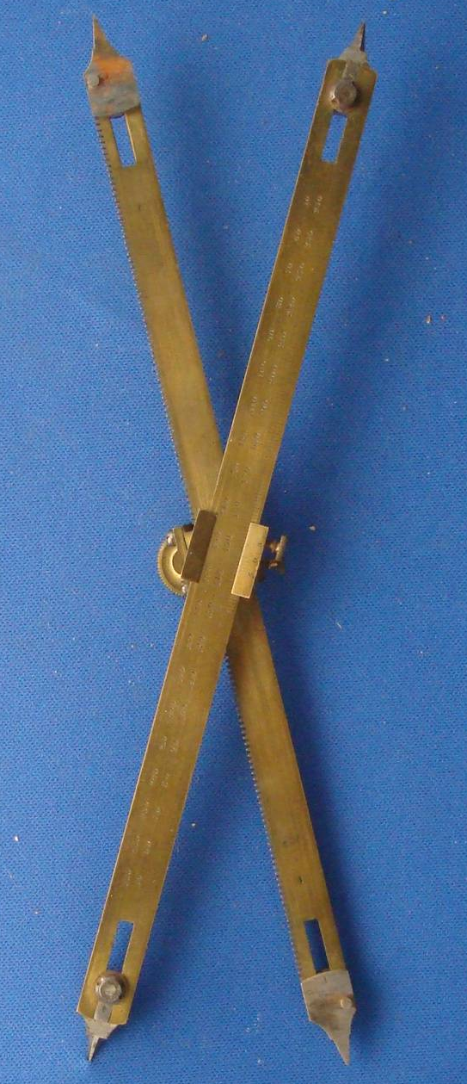
Figure 2: TCD-SCSS-U.20121208.010-fig02

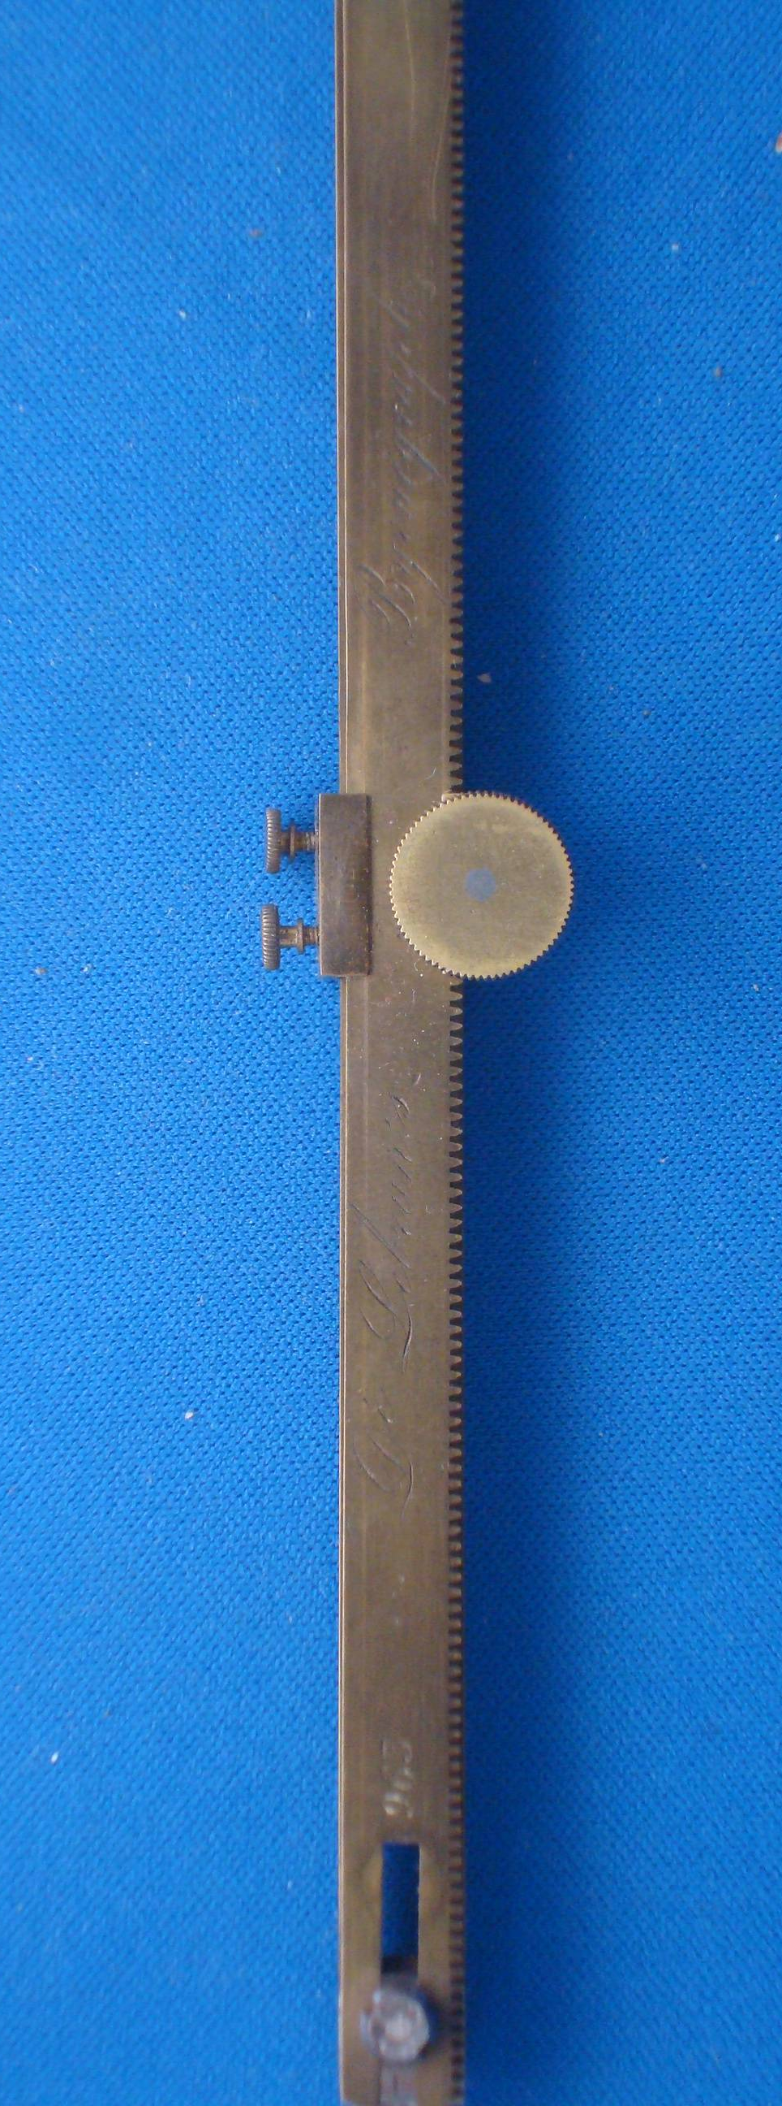
Figure 3: TCD-SCSS-U.20121208.010-fig03

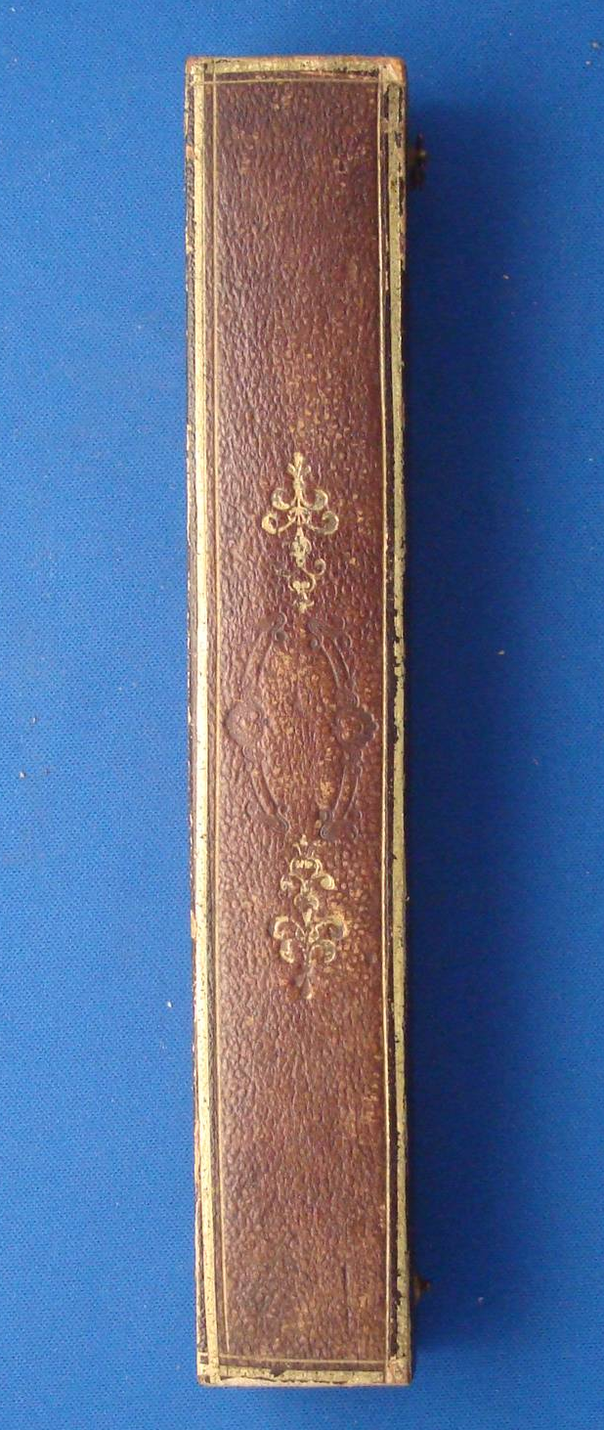
Figure 4: TCD-SCSS-U.20121208.010-fig04

