AccessionIndex: TCD-SCSS-U.20121208.008
Accession Date: 8-Dec-2012
Accession By: Prof.J.G.Byrne
Object name: British Thornton
Vintage: c.19xx
Synopsis: Sliderules.

Description:
Text …

Accession Index | Location | Vintage | Object and Identification
TCD-SCSS-U.20121208.008.01 |  | c.19xx | <Mfgr?> <model?> sliderule.  S/N: <???>
TCD-SCSS-U.20121208.008.02 |  | c.19xx
TCD-SCSS-U.20121208.008.03 |  | c.198x
TCD-SCSS-U.20121208.008.04 |  | c.198x
TCD-SCSS-U.20121208.008.05 |  | c.198x
TCD-SCSS-U.20121208.008.06 |  | c.19xx
TCD-SCSS-U.20121208.008.07 |  | c.198x
TCD-SCSS-U.20121208.008.08 |  | c.198x
TCD-SCSS-U.20121208.008.09 |  | c.198x
TCD-SCSS-U.20121208.008.10 |  | c.19xx
TCD-SCSS-U.20121208.008.11 |  | c.198x
TCD-SCSS-U.20121208.008.12 |  | c.198x
TCD-SCSS-U.20121208.008.13 |  | c.198x
TCD-SCSS-U.20121208.008.14 |  | c.19xx
TCD-SCSS-U.20121208.008.15 |  | c.198x
TCD-SCSS-U.20121208.008.16 |  | c.198x
TCD-SCSS-U.20121208.008.17 |  | c.198x
TCD-SCSS-U.20121208.008.18 |  | c.19xx
TCD-SCSS-U.20121208.008.19 |  | c.198x
TCD-SCSS-U.20121208.008.20 |  | c.198x
TCD-SCSS-U.20121208.008.21 |  | c.198x
TCD-SCSS-U.20121208.008.22 |  | c.19xx
TCD-SCSS-U.20121208.008.23 |  | c.198x
TCD-SCSS-U.20121208.008.24 |  | c.198x
TCD-SCSS-U.20121208.008.25 |  | c.198x
TCD-SCSS-U.20121208.008.26 |  | c.19xx
TCD-SCSS-U.20121208.008.27 |  | c.198x
TCD-SCSS-U.20121208.008.28 |  | c.198x
TCD-SCSS-U.20121208.008.29 |  | c.198x
TCD-SCSS-U.20121208.008.30 |  | c.198x
TCD-SCSS-U.20121208.008.31 |  | c.198x
TCD-SCSS-U.20121208.008.32 |  | c.19xx
TCD-SCSS-U.20121208.008.33 |  | c.198x
TCD-SCSS-U.20121208.008.34 |  | c.198x
TCD-SCSS-U.20121208.008.35 |  | c.198x
TCD-SCSS-U.20121208.008.36 |  | c.19xx
TCD-SCSS-U.20121208.008.37 |  | c.198x

References:

1. Authors, Title, Publication, Publisher, Date.

2. Authors, Title, Publication, Publisher, Date.

3. Authors, Title, Publication, Publisher, Date.

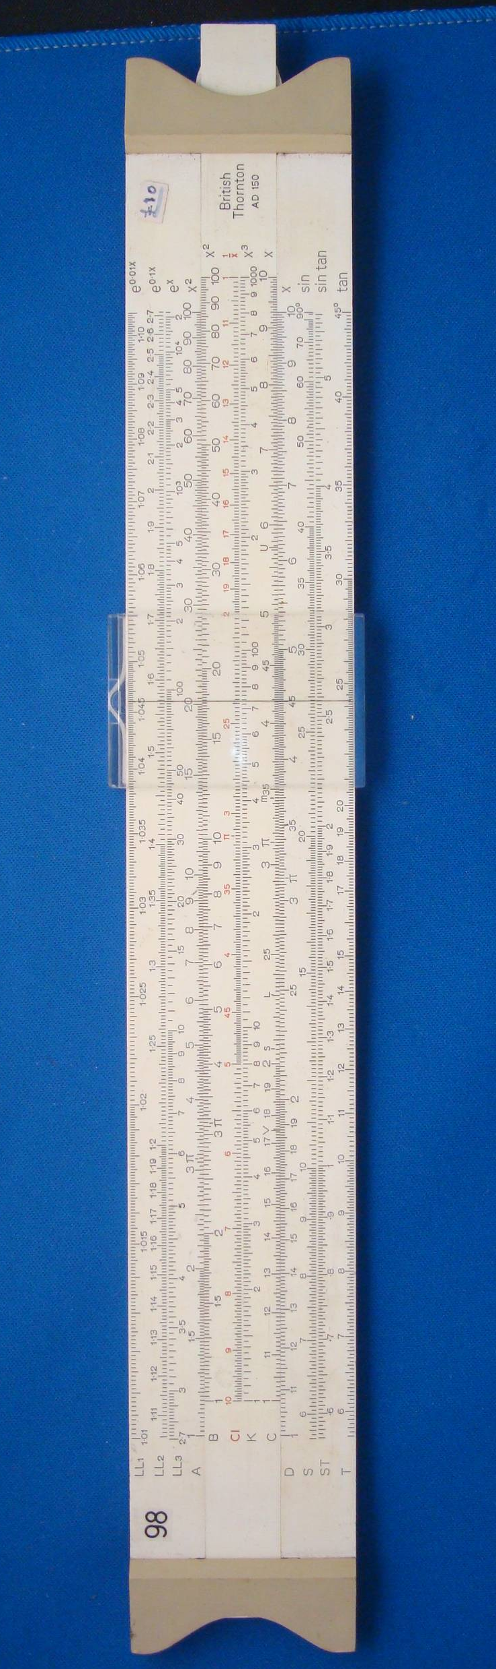
Figure 1: TCD-SCSS-U.20121208.008-fig01

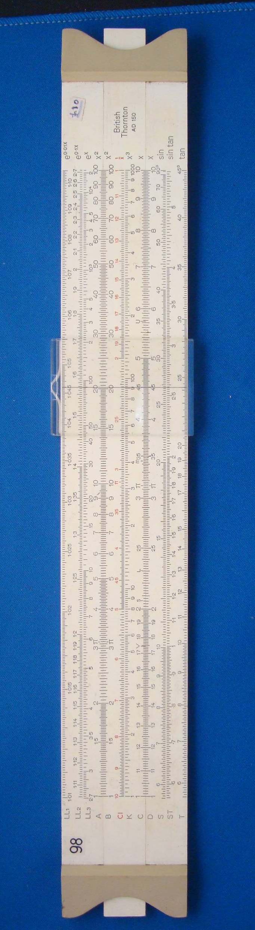
Figure 2: TCD-SCSS-U.20121208.008-fig02

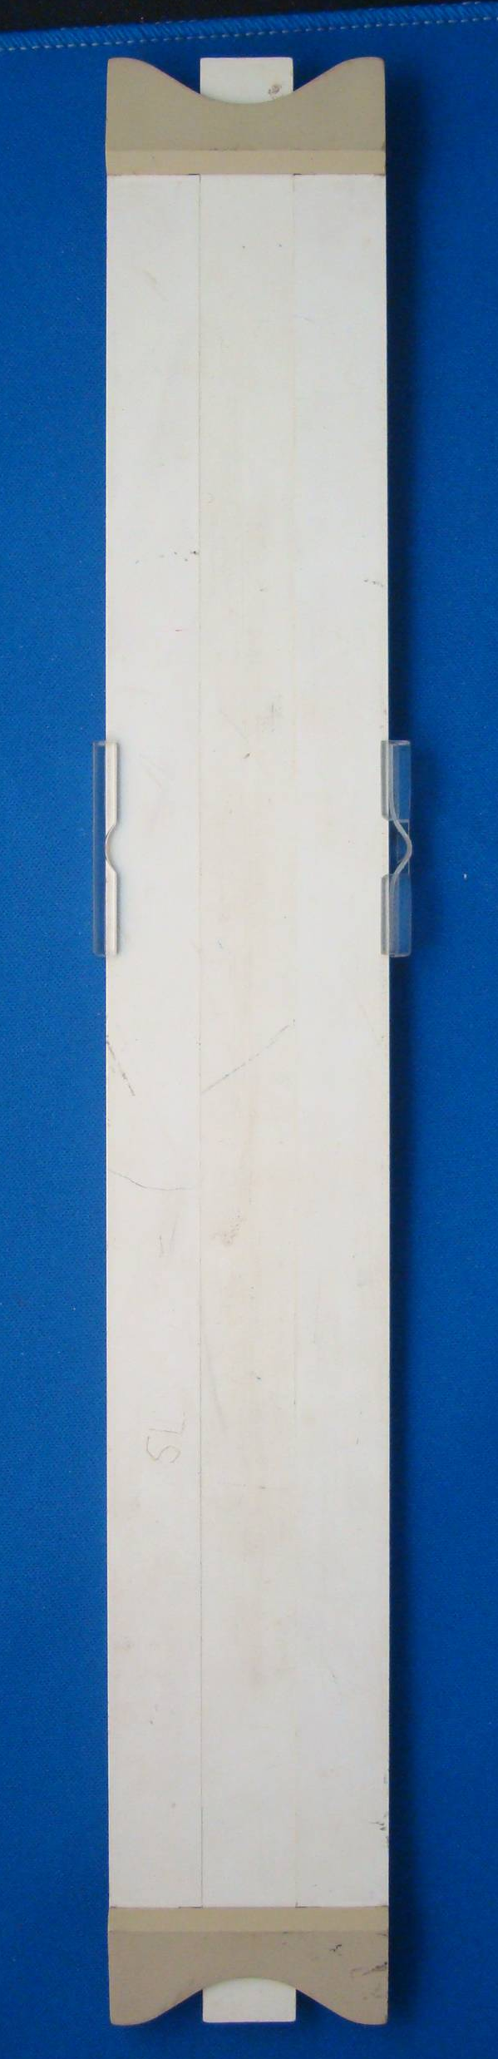
Figure 3: TCD-SCSS-U.20121208.008-fig03

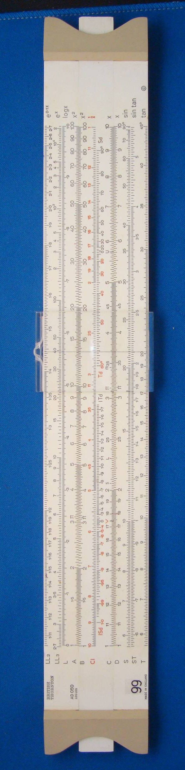
Figure 4: TCD-SCSS-U.20121208.008-fig04

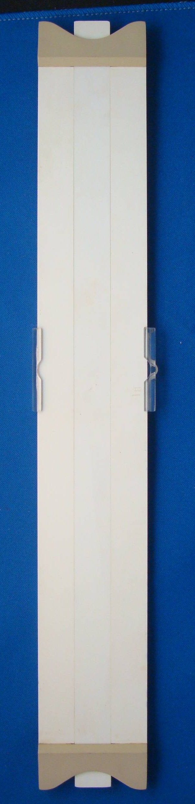
Figure 5: TCD-SCSS-U.20121208.008-fig05

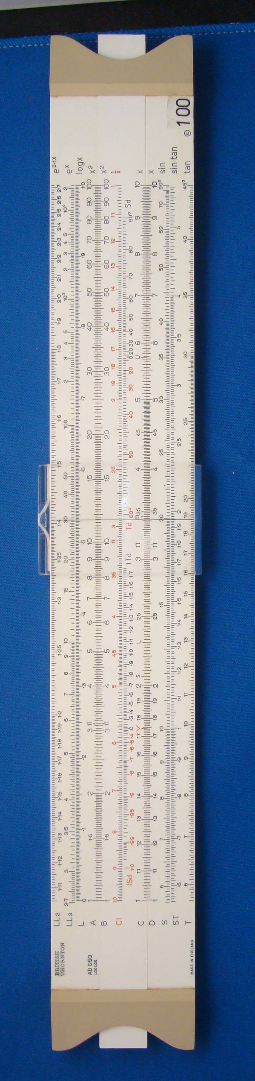
Figure 6: TCD-SCSS-U.20121208.008-fig06

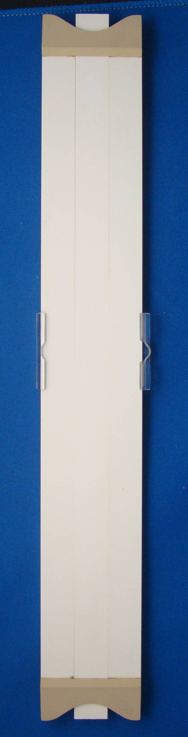
Figure 7: TCD-SCSS-U.20121208.008-fig07

