AccessionIndex: TCD-SCSS-U.20121208.006
Accession Date: 8-Dec-2012
Accession By: Prof.J.G.Byrne
Object name: Barbotheu
Vintage: c.19xx
Synopsis: Sliderules.

Description:
Text …

Photographs courtesy Prof.J.G.Byrne and Dr.Arthur Hughes.

Accession Index | Location | Vintage | Object and Identification
TCD-SCSS-U.20121208.006.01 |  | c.19xx | <Mfgr?> <model?> sliderule.  S/N: <???>
TCD-SCSS-U.20121208.006.02 |  | c.19xx
TCD-SCSS-U.20121208.006.03 |  | c.198x

The following instruction manuals are properly part of the literature category of this catalog, but are listed here too for convenience.

Accession Index | Object with Identification
TCD-SCSS-V.20121208.???

References:

1. Authors, Title, Publication, Publisher, Date.

2. Authors, Title, Publication, Publisher, Date.

3. Authors, Title, Publication, Publisher, Date.

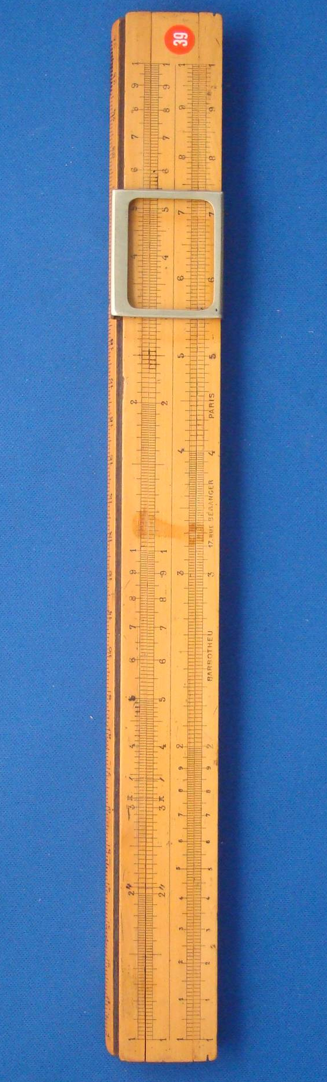
Figure 1: TCD-SCSS-U.20121208.006-fig01

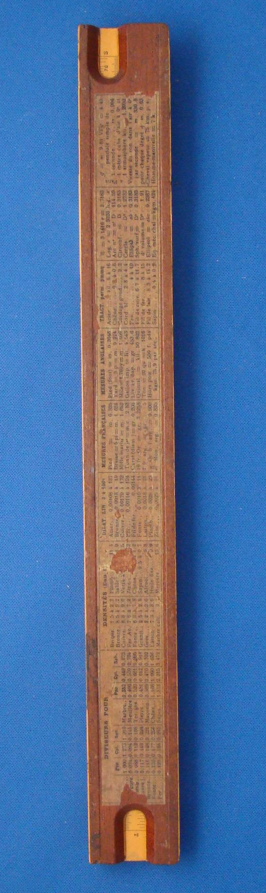
Figure 2: TCD-SCSS-U.20121208.006-fig02

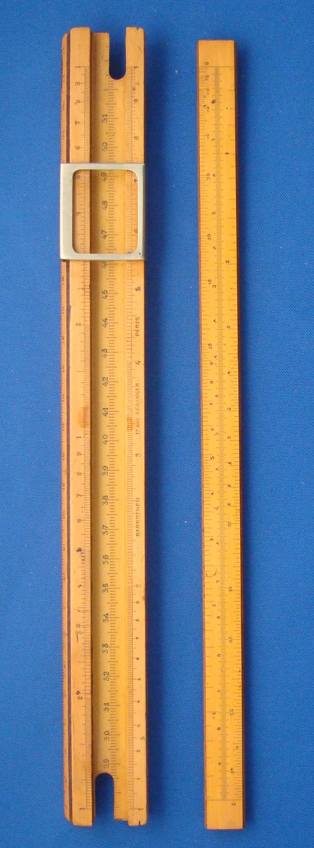
Figure 3: TCD-SCSS-U.20121208.006-fig03

