AccessionIndex: TCD-SCSS-U.20121208.001
Accession Date: 8-Dec-2012
Accession By: Prof.J.G.Byrne
Object name: Abacus Calculations
Vintage: c.1xxx
Synopsis: Descriptions of calculations on the abacus (invented by the Chinese).

Description:
Text excerpt from a chapter on abacus calculations in a book titled Reckoning in the Middle Ages.

Photographs courtesy Prof.J.G.Byrne and Dr.Arthur Hughes.

The homepage for this catalog is at: https://www.scss.tcd.ie/SCSSTreasuresCatalog/
Click 'Accession Index' (1st column listed) for related folder, or 'About' for further guidance. Some of the items below may be more properly part of other categories of this catalog, but are listed here for convenience.

Accession Index | Object with Identification
TCD-SCSS-U.20121208.001 | Abacus Calculations, Descriptions of calculations on the abacus (invented by the Chinese), c.1xxx.

References:

1. Maxwell, R.P., How to use the Chinese abacus, Trowbridge, 1979, see catalog Literature entry: TCD-SCSS-V.20121208.328
.
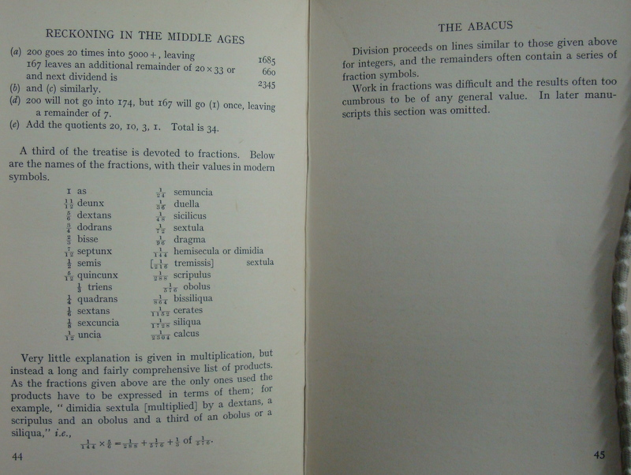
Figure 1: TCD-SCSS-U.20121208.001-fig01

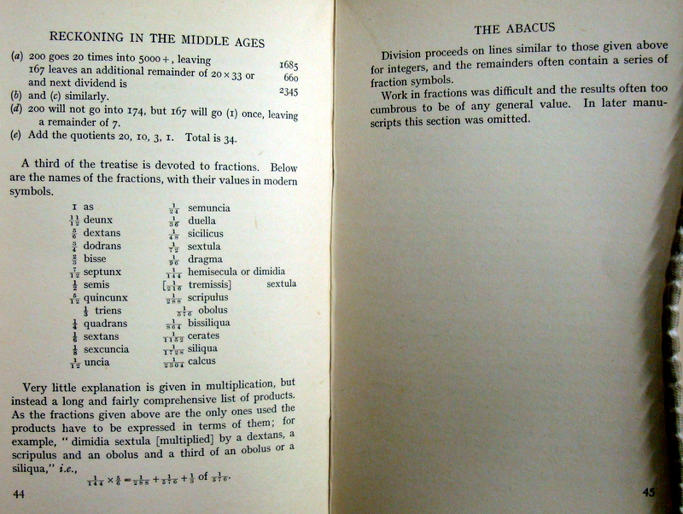
Figure 2: TCD-SCSS-U.20121208.001-fig02

