AccessionIndex: TCD-SCSS-X.20121208.005
Accession Date: 8-Dec-2012
Accession By: Dr.Brian Coghlan, John Moriarty, Mike Nowlan, Michael Doherty, Ken Gordon
Object name: History of the Computer Laboratory, Trinity College Dublin
Vintage: c.1968
Synopsis: The evolution of Trinity College Dublin computing services as reflected in the long line of machines used by the Computer Lab since its inception.

Description:
The Computer Lab was established in 1968, coincident with the installation of a new IBM 360/44, as described below by John Moriarty, the first Director of the Computer Laboratory [1]:
I joined Trinity in March 1968 as a lecturer in systems engineering but was immediately charged with setting up the “Computer Laboratory” – a new central service department to run the IBM System/360 Model 44 which was due for delivery later that year. This became my main job with the title of director although I continued to do some teaching for several years to come.

Recruitment of programming and operations staff and the organising of accommodation for the new department’s staff and equipment continued through the spring and summer of 1968 so that everything was ready for the arrival of the machine before the year-end.

A prefabricated “Terrapin” building was constructed in the Fellows Garden between the old library and Nassau Street. Part of the standard Terrapin [the Computer Room] was modified with the installation of air-conditioning, a raised floor to accommodate cabling, and an automatic fire protection system. In addition to the Computer Laboratory this building also provided staff accommodation for the departments of Computer Science and Statistics and a second Terrapin was located nearby for use as a lecture theatre by these departments. The accommodation was ready and the core staff appointed when the machine was delivered in November 1968 and the Laboratory was officially opened by the then Minister for Education, Brian Lenihan, senior, on 9th January 1969.

Contact was established with other organisations with similar interests and problems. The Laboratory became an active member of the Share European Association (SEAS), an association of scientific users of IBM systems, and I attended their meetings in Schevingen and Grenoble in 1968 and 1969. Trinity also participated in the “Forty Forum”, a group of UK universities which also used 360 Model 44 machines and met in Glasgow and Trinity during 1969.

The Computer Laboratory (now IT Services) was a new central College service department, independent of academic and administrative structures, established to provide a service to all sectors of College, as recalled by John Moriarty [2]:
The 360/44 went straight into the Computer Laboratory which had just been set up as a central service department, rather like the Library but not as prestigious a unit, of course! I believe that the Computer Science Department was set up at the same time. Trinity was organised into Schools up to that time and was just setting up a faculty structure, possibly as a result of the "merger" proposals which were current then. I had been a part-time Lecturer in Computer Science in the Engineering School since 1963 and in 1967/8 applied for a full-time Lectureship in Electrical Engineering arising from the resignation of the late Percy McCormack. On joining College full-time on 1st March, 1968, I was "rebadged" either Lecturer in Computer Science or Lecturer in Systems Engineering, I do not recall which, and was immediately relieved of most teaching work and charged with preparing, on a full-time basis, for the arrival of the 360 which had been ordered earlier. This involved recruiting staff, organising accommodation, etc. I do not recall exactly when the Dept.Computer Science and Computer Laboratory were formally set up but the Lab was certainly in existence as an independent unit when the 360/44 arrived in late 1968. The Engineering School had replaced the original 1620 by an IBM 1130 in September 1967. The 360/44 remained in the Terrapin in the Fellows Garden until the imminent building of the Arts block forced it's evacuation to Pearse Street in September 1972.

Trivia: March 2018 may mark the 50th anniversary of the founding of the Computer Laboratory, the Dept.Computer Science (and perhaps the Dept.Statistics too)

The IBM 360/44 was the first time-sharing system in Ireland, with eight local IBM 2260 Display Stations user terminals directly connected via multicore or coax cables to an IBM 2848 Display Control. These terminals were housed in the Terrapin huts in the Fellows Garden, then later when moved into 200 Pearse Street they were in a single row of eight against a wall. For details see elsewhere in the Hardware category of this catalog.

From the 1971/72 Annual Report of the Computer Lab:
APPENDIX
EQUIPMENT
The specifications of the equipment currently installed are as follows:
1 x IBM 2044 Model H Central Processing Unit with 262,144 bytes (256K) of core storage and with: One Multiplexor Channel
One high speed multiplexor channel
Single disk storage drive in CPU
Store and Fetch protection
Floating point arithmetic
Console printer keyborad
Interval timer
Commercial Feature (full 360 instruction set
1 x IBM 2841 Model l Storage Control with File Scan and Record Overflow
2 x IBM 2415 Model 4, Magnetic Tape Unit and Control (2 drives) with 9-track compatibility,
i.e., 800 b.p.i. tape at 15000 b.p.s. or 1600 b.p.i. tape or 30000 b.p.s.
1 x IBM 2821 Model 2 Control Unit (for 1403 printer)
1 x IBM 1403 Model 2 Printer with:
Universal Character Set feature and Interchangeable Chain Cartridge adapter
Print Positions: 132
Maximum Rated Speed: 600 lines/minute
Available chains: QN2
TN Modified for Library

1 x IBM 2501 Model B2 Card Reader with Card Image Feature
1 x IBM 1442 Model N2 Card Punch with Card Image Feature
Speed: 91 to 256 cards/minute depending on number of columns punched.
8 x IBM 2260 Display Stations Model 1 with alphanumeric keyboards
1 x IBM 1053 Model 4 Printer with pin-feed platen and accelerated carriage return
4 x IBM 2311 Model 1 Direct Access Storage Units
1 x IBM 2702 Transmission Control Unit
1 x IBM 1050 Terminal in a remote User Location
6 x IBM 2741 Terminals in the Laboratory and User Locations

++++++++++++++++
DEC-2060 ???
++++++++++++++++

A PDP 11/34 was installed in the academic year 1979/80 for Library circulation control. As recalled by Michael Doherty [3]:
It was funded as part of the setting up of the Lecky Library in the Arts block. The funds were not made available until some years after the Lecky was opened. In December the day before the College was closing for the Christmas break, word come through that if the computer could be delivered by the 31st of December funds were available. I came in on during the Christmas break and opened the Lab and a truck rolled up and we unloaded a DEC computer.

This system was first mentioned in the 1979/80 Computer Laboratory annual report (but not in the 1978/79 report). The configuration is shown as:
1 x CPU with l28K memory
8 x asynchronous lines
3 x RL0l Disc drives
1 x LA 36 Console

The 11/34 chassis, one RL01 and the LA36 are preserved in this collection, see elsewhere in the Hardware category of this catalog. It was the TCD Library’s first dedicated computer system. The Library had already intensively used the TCD computing systems, including those of the Dept.Computer Science, since the early days of computing in TCD (e.g. they were significant users of the IBM 360/44), but this was their first dedicated computer system, operated by the Computer Lab. It had a rackmounted CPU with octal keypad. Disk cardtridges and some documentation have also survived. It was saved by Paul Harrington (who acquired it from Michael Doherty) and is held in store by him until space in SCSS becomes available.

++++++++++++++++
ICL-Fujitsu machine ???
++++++++++++++++

Many thanks to John Moriarty, first Director of the Computer Laboratory at Trinity
College Dublin, Mike Nowlan, second Director, and Michael Doherty and Ken Gordon, long-serving core staff members of the Computer Lab.
The homepage for this catalog is at: https://www.scss.tcd.ie/SCSSTreasuresCatalog/
Click 'Accession Index' (1st column listed) for related folder, or 'About' for further guidance.
Some of the items below may be more properly part of other categories of this catalog, but are listed here for convenience.

Accession Index | Object with Identification
TCD-SCSS-X.20121208.005 | History of the Computer Laboratory, Trinity College Dublin. The evolution of Trinity College Dublin computing services as reflected in the long line of machines used by the Computer Lab since its inception, c.1968.
TCD-SCSS-T.20121208.018 | IBM 360/44 console and subsystems, hardware: Control panel, CPU logic, core memory from IBM 360/44 installed in Trinity College Dublin to provide a service to all sectors of College, including the Dept.Computer Science, c.1969.
TCD-SCSS-T.20121208.xxx | DEC-20:  c.19??
TCD-SCSS-T.20150615.001 | DEC PDP 11/34: The first dedicated TCD Library computer system, rackmounted CPU with octal keypad, RL02 and RL05 disk drives, RL02/05 disks (RSX11 and BSD 2.x, IIRC) and some documentation. Held in store by Paul Harrington until space in SCSS becomes available, c.1975.
TCD-SCSS-T.20121208.xxx | ICL-Fujitsu:  c.19??
TCD-SCSS-T.20121208.017 | IBM Card Punch Model 29C: Classic IBM punched card punch, c.1969.
TCD-SCSS-T.20161127.001 | Acoustic delay line unit from IBM 2848: Acoustic delay line unit from the IBM 2848 Display Control for the IBM 2260 Display Stations used with TCD's IBM 360/44, c.1964.
TCD-SCSS-T.20121208.014 | IBM 870 Patch Panels: 2 x Patch panels from IBM 870 punched-card-to-tape converter, c.1964.

References:

- John Moriarty, John Moriarty: IBM Ireland customer engineer / systems engineer 1957-68, TechArchives, 2016, see:
http://techarchives.irish/irelands-first-computers-1956-69/john-moriarty/
Last browsed to on 17-Nov-2016.

- John Moriarty, email communications, Nov-2016.

- Michael Doherty, email communications, Jun-2017.

See the extensive set of Computer Lab Annual Reports in the related folder in this catalog.

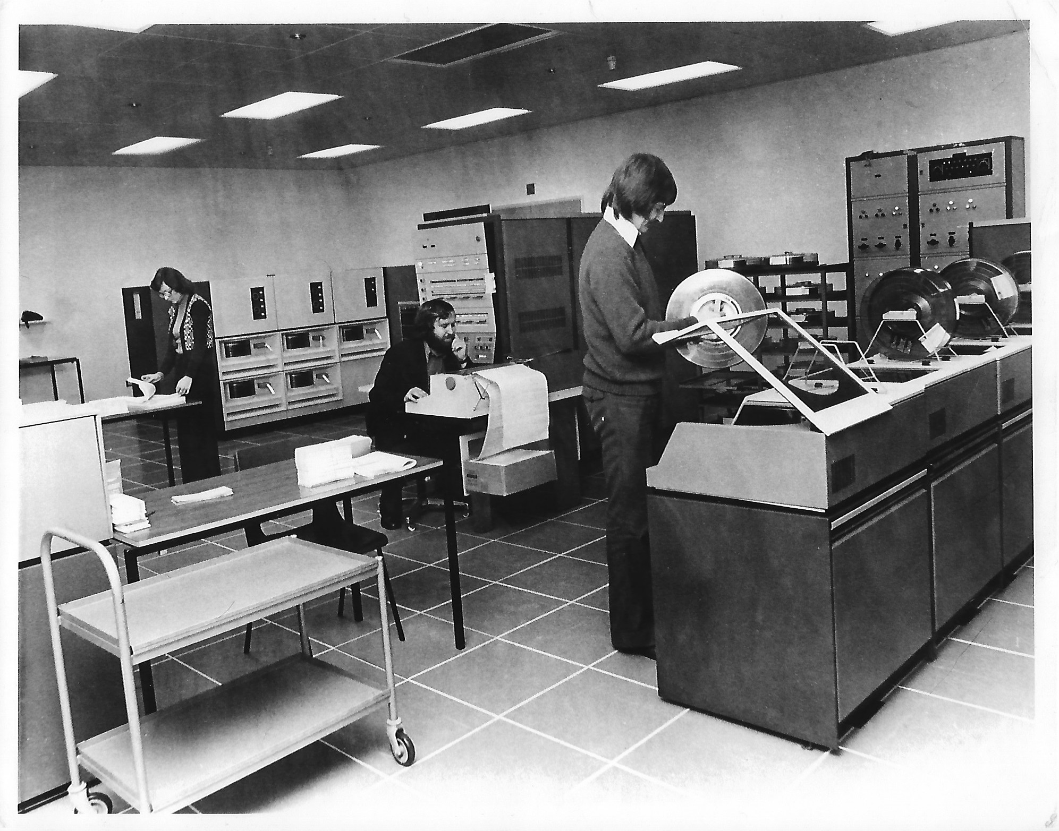
Figure 1: BM 360/44 in action c.1974, image courtesy Prof.J.G.Byrne
The verso carries the printed inscription 'IBM 360/44 Computer Laboratory, Trinity College Dublin
(L to R) Majella Ryan, Jack Grace, Tony Flynn September 1974'

