Ludgate podcast created by AI

Our 2023 IEEE paper , reported on the fabrication-ridden answers (“2086 words of which 1007 words [48%] were fake”) generated by ChatGPT in response to a set of queries about Percy Ludgate. The evidence implies that as the known information reduces the “hallucinations” sharply increase, perhaps exponentially.

Clearly more experiments, using various Large Language Models (LLMs), might help gain a clearer impression of the likely trustworthiness of LLMs when used, for example as historians’ assistants, let alone more critical (for example safety-related), applications of computers, and of some of the factors likely to influence this trustworthiness. But careful fully independent checking of any and all results which are going to be relied upon would still seem to be an absolute requirement. This is despite (and indeed partly because of) the plausibility provided by current LLM’s impressive linguistic and grammatical achievements.

These views are highlighted by a further experiment we have conducted by providing notebooklm.google.com with the following documents:

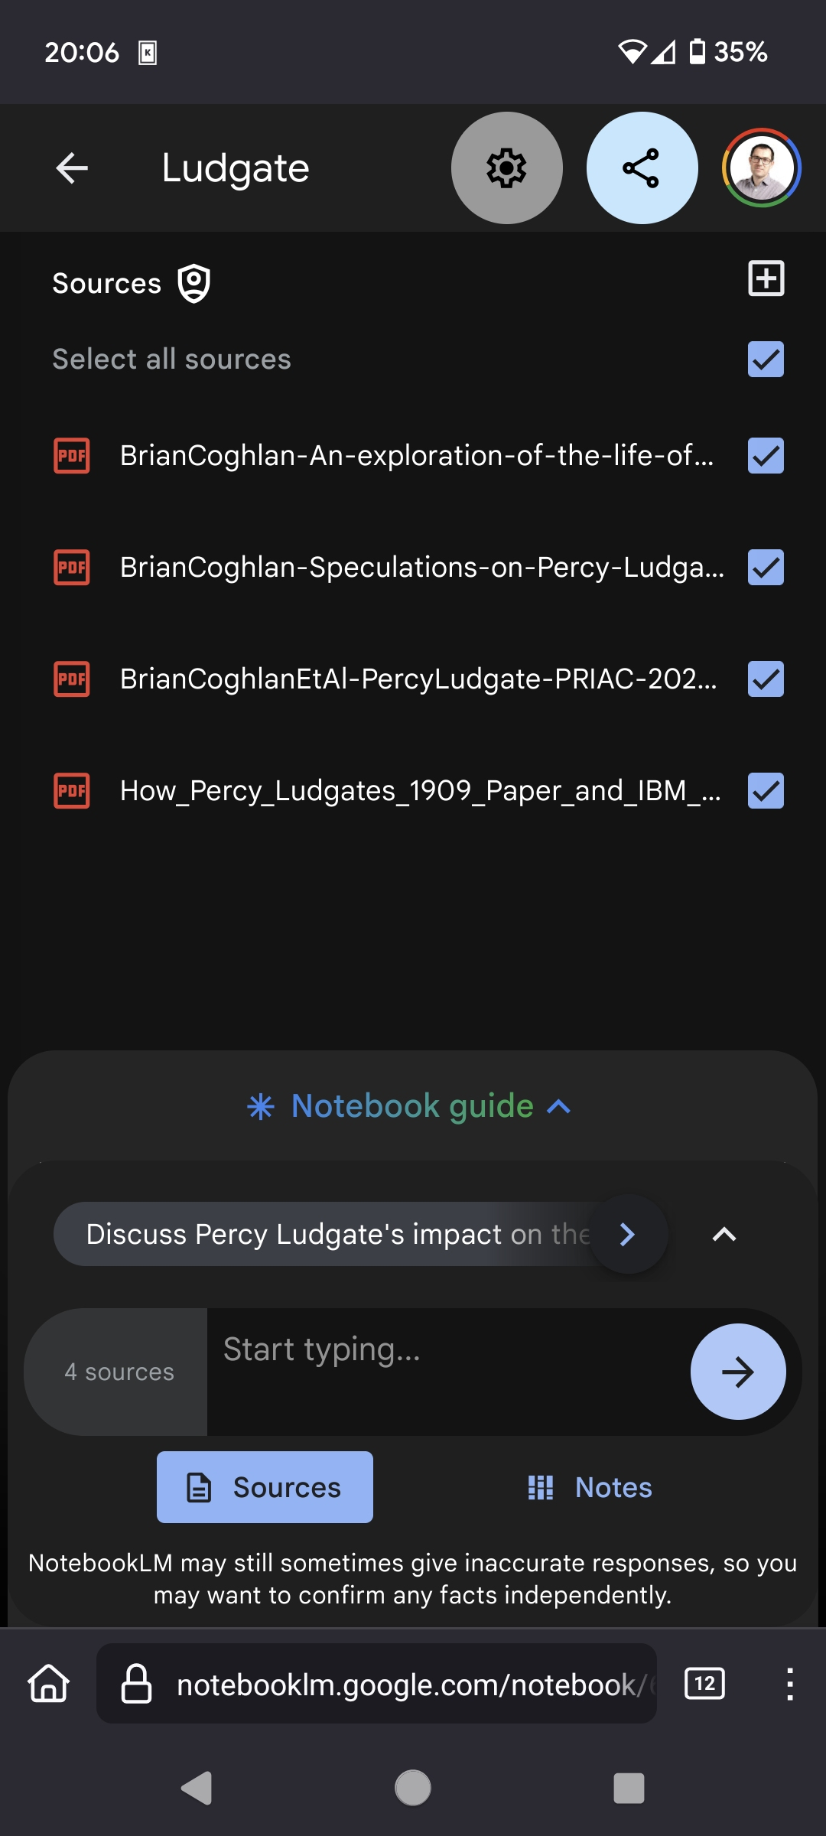
An exploration of the life of Percy Ludgate.

Speculations on Percy Ludgate's Difference Engine.

Percy Ludgate (1883–1922), Ireland’s first computer designer.

How Percy Ludgate’s 1909 paper (and IBM) helped thwart Konrad Zuse’s Computer Patent in 1960.
These give incomplete information per se, since the latter two in particular make extensive use of traditional references.

Then “Generate” in the "Audio Overview" section of NotebookLM was simply clicked, i.e. no guidance or instruction was given.

The resulting Ludgate podcast created by AI is both highly appealing to listeners and very accurate. It is worth noting that the podcast still contained some inaccuracies, for example the understandable but probably erroneous inference that Ludgate’s ideas just “emerged fully formed”. More importantly, this very simple experiment reinforces the worrying evidence for our thesis that where LLMs have access to very complete information they propagate that accuracy, but where the known information is scarce the deviations from that corpus are especially egregious.
Brian Randell
Brian Arthur Coghlan
Noel O’Boyle

2nd November, 2024

Brian Randell and Brian Coghlan, ChatGPT's Astonishing Fabrications About Percy Ludgate, IEEE Annals of the History of Computing, pp.71-72, Vol.45, No.2, April-June 2023.
Brian Randell, Brian Coghlan, Noel O’Boyle, ChatGPT’s Astonishing Fabrications about Percy Ludgate, detailed analysis, The John Gabriel Byrne Computer Science Collection, 24th April 2023.
E.g. the SCSS Ludgate Webpage provides online the complete body of current knowledge on Ludgate and his machine. But it is not known if the LLM (Gemini 1.5) could indirectly ingest from references to such sources.
Subsequently a new feature has been added to allow the user to provide some guidance to the AI in the "Customize" section, asking it to focus on particular topics, sources, or targeting a specific audience.
But for context see pp.12-16 of the work-in-progress Ludgate biography and genealogy.

