Civil Service February 1903 Examinations Merit List
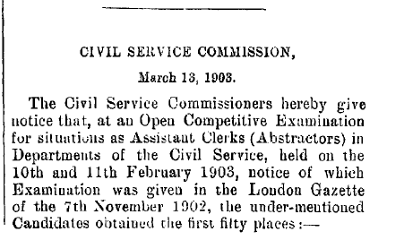
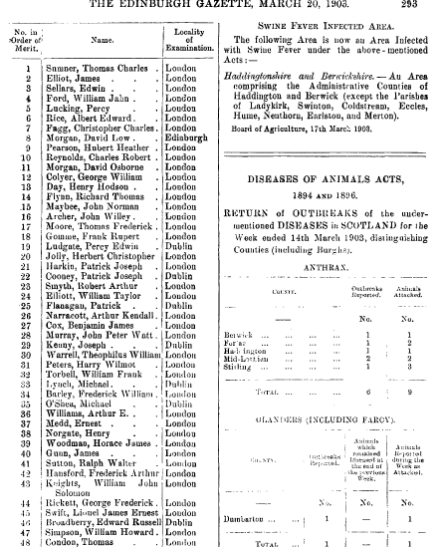
Ranked 022: Patrick Joseph Cooney
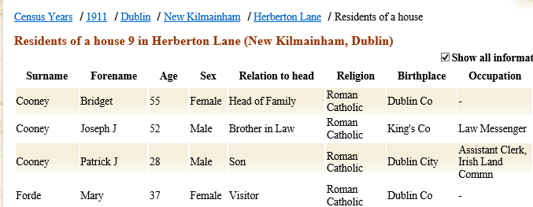
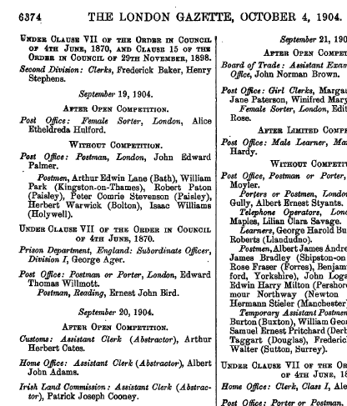
Ranked 025: Patrick Flanagan
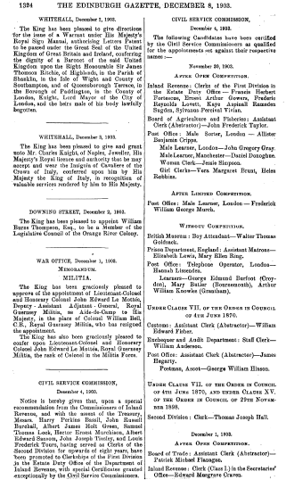
Ranked 029: Joseph Kenny
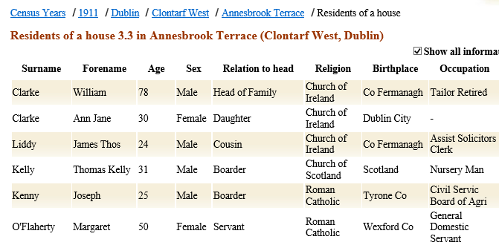
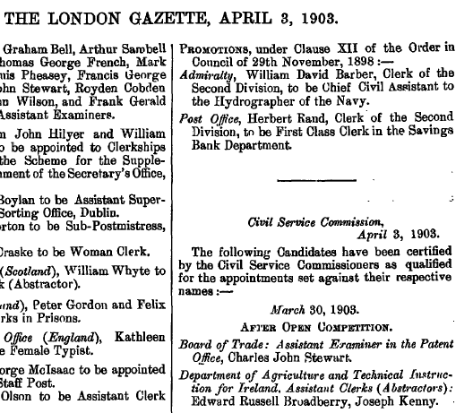

Ranked 033: Michael Lynch
The evidence is not absolutely conclusive in this case as the name Michael Lynch is common, but for the candidate appointed below the fact that the appointment is to the Irish Land Commission, that the person identified in the 1911 Census below was a barrister at land, and that in the 1901 and 1911 Census his father was Assistant Land Commissioner and a barrister, is quite compelling evidence of a match. In addition, of over 140 persons of the right age bracket and named Michael Lynch in the 1911 Census, only two others could concievably have been Civil Service staff, one a postmaster and the other a surgeon, neither matching an appointmnt to the Irish Land Commission.
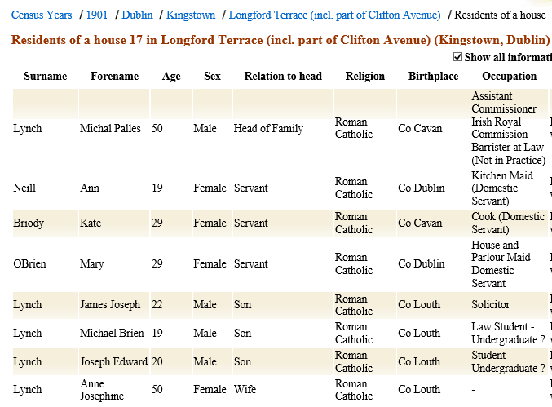
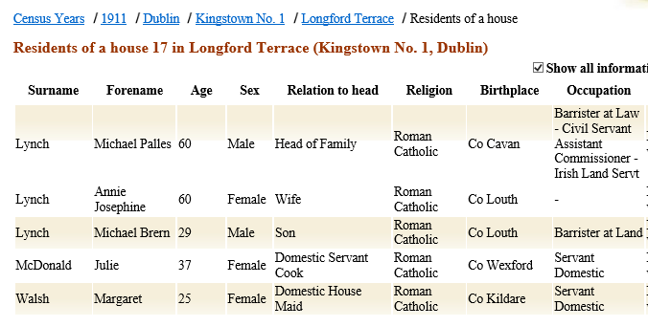
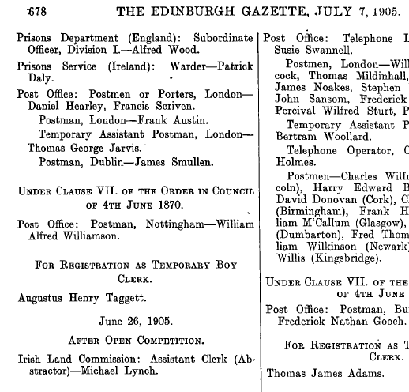
Ranked 035: Michael O’Shea
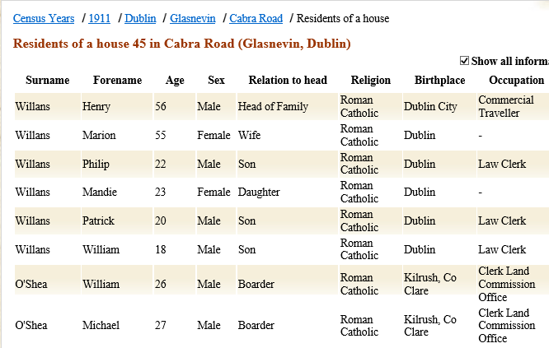
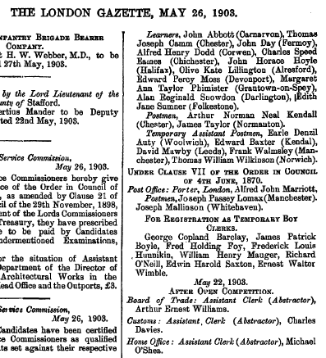
Ranked 046: Edward Russell Broadberry
