Introduction
The spreadsheet of the gradual development and renumbering of Foster Terrace (last page) suggests a convincing identification of Percy Ludgate's original 1892 home.
Thom's 1886 details 37 dwellings numbered No.1 to No.36 plus No.19 1/2. The 37 plots are clearly outlined on the 1890s OSI map and are the only properties in Foster Terrace listed in the 1901 Census. External features recorded by the enumerators in the 1901 and 1911 Census returns enables visual identification of each of these 37 houses. By 1911 two small terraces are part developed/planned as numbers 1 to 4 O'Connell Villas and 1 to 8 Ardilaun Villas, on opposite sides of the road. O'Connell Villas eventually form a terrace of six dwellings but Ardilaun Villas are truncated at four. These terraces have separate entries in Thom's until they are fully incorporated into the Foster Terrace renumbering in 1933/34. The transition of the numbering can be confirmed by pinpointing individual residents before and after renumbering.
Thom's 1971 states numbers "25 to 28 Building Site" having previously being designated as "Building Space" since c.1940. They are no longer recorded in subsequent Thom's Directories. No.39 (previously numbered 4 Ardilaun Villas) abuts the perimeter wall of the stadium estate boundary. It would appear that the planned homes numbered 8, 7, 6 and 5 Ardilaun Villas would have been allocated the reserved numbers 25, 26, 27 and 28 respectively but have since been subsumed by Croke Park car park.
The terrace of six houses numbered 39 to 49 St.James Avenue built in 1934 appear to have been built on an infill site and were never part of Foster Terrace (see Thom's 1933/34/35). A modern extension 49A St.James Ave corners with Foster Terrace.
It is hoped the City Burghers will eventually be able to supply definitive evidence of the number reallocation, including the appropriate Maps.
1890s OSI Map
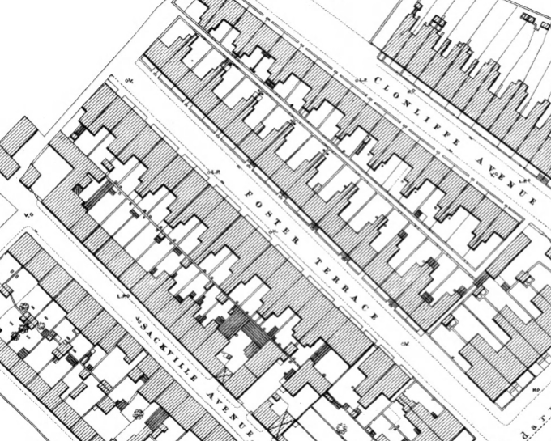
1911 Census - O'Connell Villas and Ardilaun Villas located in Foster Terrace
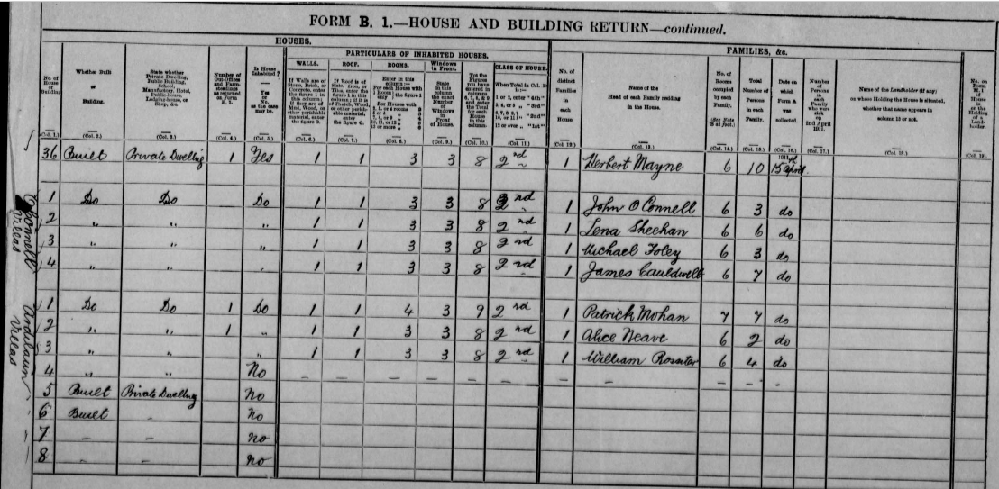

Thom’s Directories 1887, 1932, 1934 for Foster Terrace
Thom's 1887 | Thom's 1932 |  | Thom's 1934
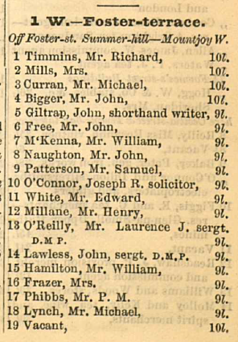  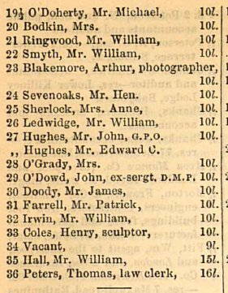 |  | 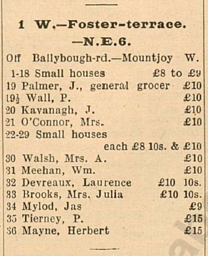  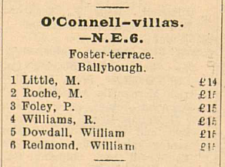  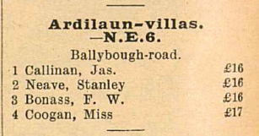 |  | 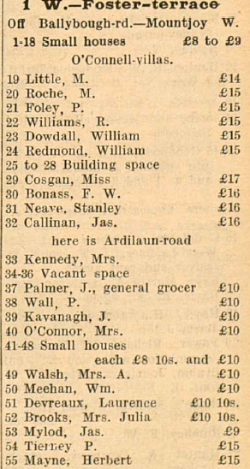

Thom’s Directories 1940, 1971, 1972 for Foster Terrace
Thom's 1940 | Thom's 1971 | Thom's 1972
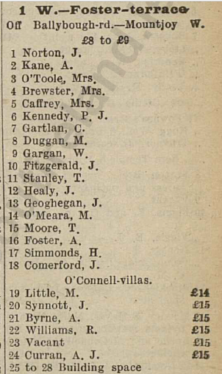 | 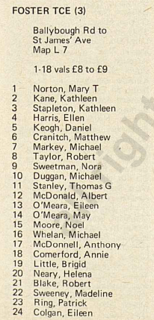 | 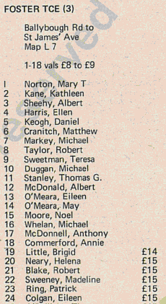
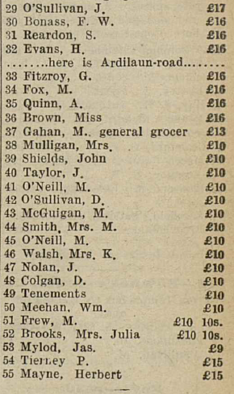 | 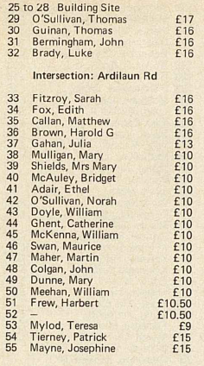 | 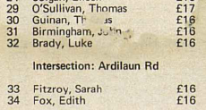  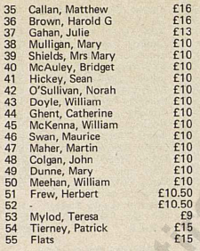

Google Satellite View of terrace numbered 29, 30 31 and 32
These properties were previously numbered 4, 3, 2 and 1 Ardilaun Villas.
No.29 abuts Croke Park estate perimeter.
Plots for Nos. 8, 7, 6 and 5 Ardilaun Villas (reserved numbers 25, 26, 27 and 28 respectively) appear to have been subsumed by Croak Park car park.
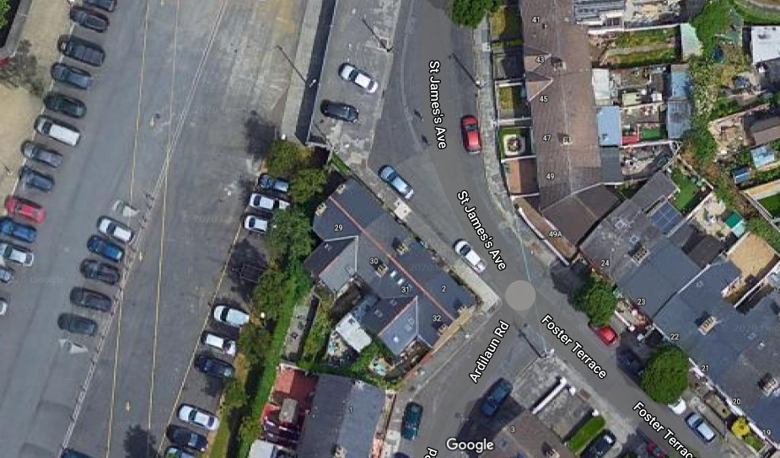

Thom's Directories 1934, 1935, 1936 for St.James's Ave, Ballybough
These Thom's Directories clearly show the odd numbered properties numbers 39 to 49 that were added to St.James's Ave in 1935.
Thom's 1934 | Thom's 1935 | Thom's 1936
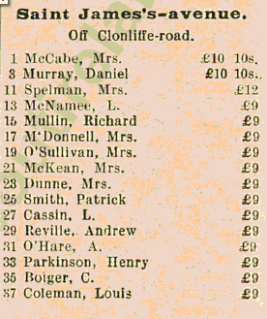 | 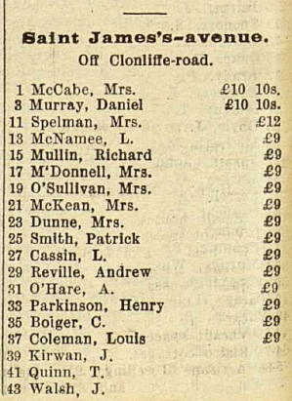 | 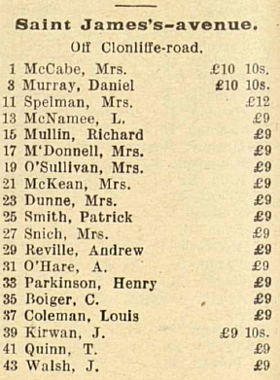
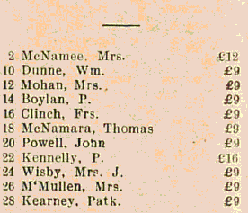 | 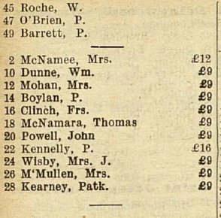 | 