Note on Foster Terrace, Ballybough, Dublin

The following statement relating to Foster Terrace caught my attention on https://cottageology.com/

*" In case you are doing any archival research, be aware that the house numbers changed some time in the mid-twentieth century."* .... and so it seems.....

The original phase(s) of Foster Terrace development consisted of 34 cottages and 2 two storied houses with eighteen homes on either side of the road as outlined on the OSI 25" plot map of 1897 (see below). They were numbered sequentially 1 to 36. Subsequently, a single plot was developed as cottage No. "19 1/2" \* According to the 1901 Census the 34 cottages and No. "19 1/2" were four roomed 3rd class homes with one window to front.\*\* The exceptions were house Nos. 35 & 36, these being two storied 2nd class homes with three windows to front. Between Nos. 34 and 35 was an undesignated plot (later developed as cottage No. 53). Nos. 17 and 18 were demolished at some point and replaced with two bungalow style houses. All other post 1901 buildings are two storied houses. Buildings from the Ludgates' period of occupation in the 1890s are identifiable from the 1901 House and Building Census Returns (see below) in conjunction with cross referencing the OSI plot map.

Further development of remaining plots necessitated some renumbering. Four of the 55 newly designated numbers (25 to 28) are not in use and have no postcode assigned. If these houses were ever built, they have since been demolished during an earlier expansion of the Croke Park access apron. Cottages 1 to 18 have retained their original numbers and 19 to 34 have been renumbered 37 to 52. House Nos. 35 and 36 have been renumbered 54 and 55.

I calculate that the Ludgate family home at "28 Foster Terrace" has since been renumbered 46. It was here that Percy would have spent most of his school years in the 1890s.

\* If cottage No. "19 1/2" was adjacent to No. 19 it has since been replaced by an individually designed two storied house and renumbered 36.

\*\* Cottage design differs on opposite sides of the street, in particular, porticos, fan lights, roof elevations and chimney locations which suggests staggered phased development.

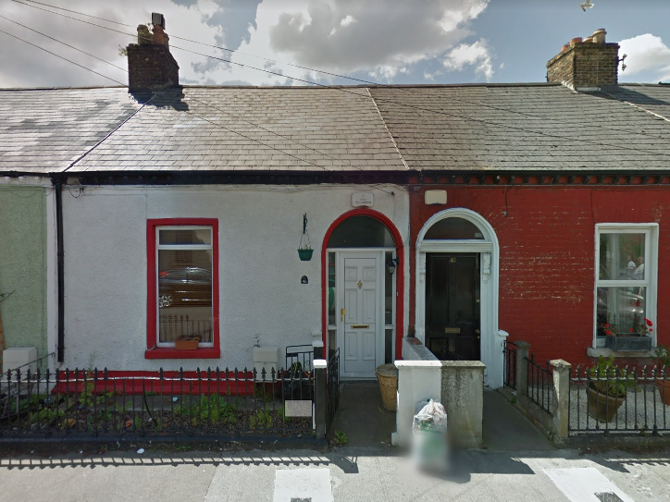

No. 46 Foster Terrace, Dublin (originally No. 28) - 2014 Street View

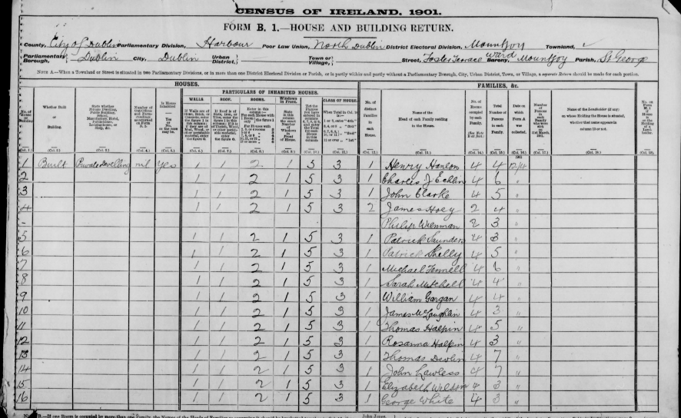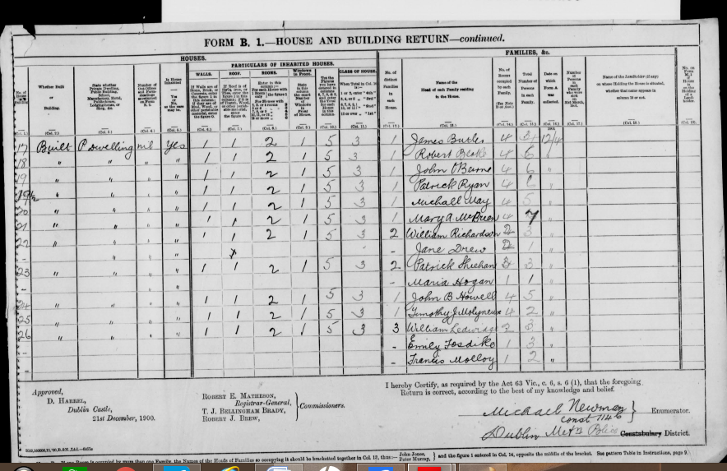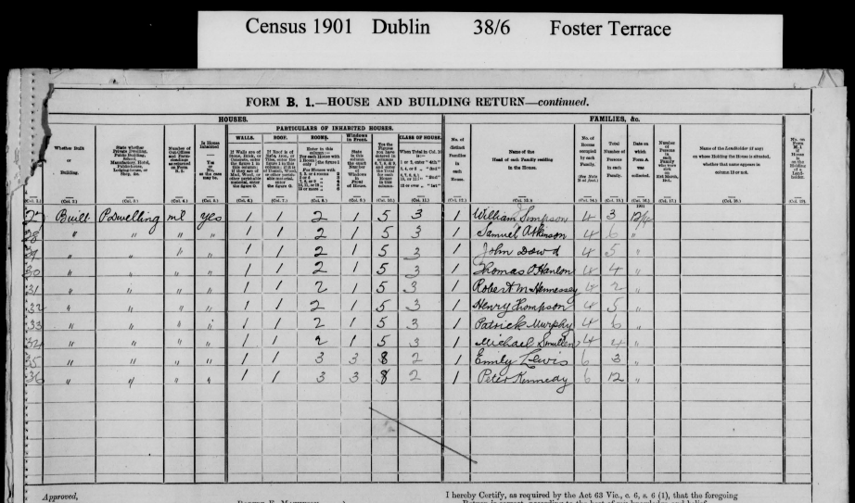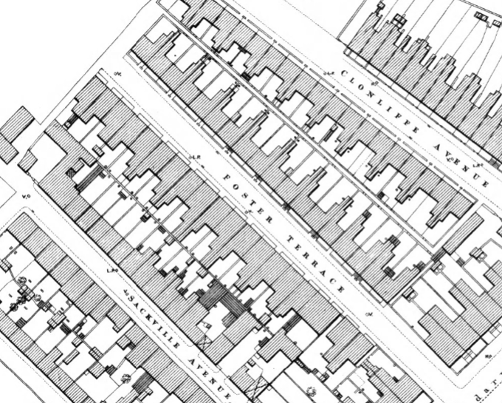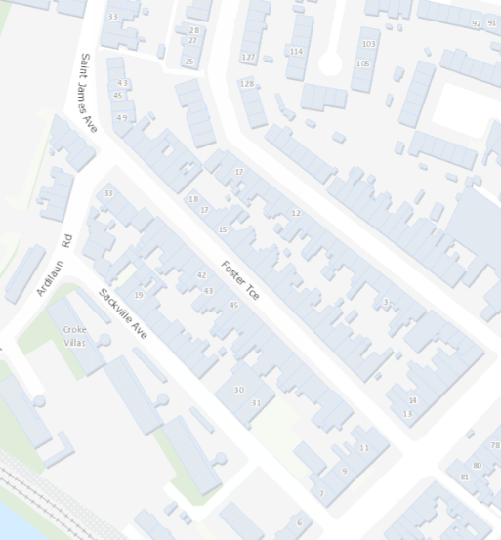

Above - OSI's 25" Historical Plot Map (1897) and Online Townlands Map (2019) of Foster Terrace, Ballybough

Extract from https://cottageology.com

Foster Terrace

"Foster Terrace is a long terrace of single story cottage style dwellings. The roofs are flush with the eaves which have slight ornamentation. The original door cases are quite grand in stature for the size of the cottages with full semi-circular fanlights over. Again there are relatively few exteriors in their original state, with most having been rendered or pebble dashed over. Also many windows have been enlarged which alters the proportions of the dwellings irrevocably.

At the top of the street numbers 17 and 18 were demolished at some point and replaced with standard bungalow style houses that bear absolutely no resemblance to the original terrace so they are not being included in this survey. The level of alterations to this street is unfortunate as it has the potential to be one of the prettier original streets in the area.

A huge thanks to Alex Klemm – a resident of Fosters Terrace for the following information which was provided March 2013:

They were originally built in the mid/late 19th century (our deeds go back to 1872), and early occupants included DMP members, clerks, artisans. In case you are doing any archival research, be aware that the house numbers changed some time in the mid-twentieth century.

They are split-level – single story in the front, two story to the back. Although most houses now have attic conversions, originally there would have been a large sitting room to the front, another large room to the back, and then stairs down to the kitchen. Above the kitchen is what would have been the sole dedicated bedroom, although given the number of occupants in each house the other rooms must have doubled as sleeping accommodation.

In one sense, they were ‘cottages masquerading as big houses’ – the fireplaces in the two main downstairs rooms were very ornate, the hallway had coving and an elaborate internal archway just in front of the two sets of stairs (up to the bedroom and down to the kitchen).

Also, our house at least was built on the foundations of an earlier house, as we discovered when the dining room (back room) floor was dug up to conduct damp-proofing works."