AccessionIndex: TCD-SCSS-V.20221015.003
Accession Date: 15-Oct-2022
Accession By: Dr.Brian Coghlan
Object name: Percy Ludgate (1883-1922): Ireland's First Computer Designer
Vintage: 2022
Synopsis: Brian Coghlan and Brian Randell (edd), The John Gabriel Byrne Computer Science Collection, ISBN 9781911566298, 246 pp, first print.

Description:
This item is the signed first published print of the first book on Percy Edwin Ludgate, see elsewhere in this catalog for the proof print. This book collects together much of the original material, plus extensive new information on the family, life and work of Percy Ludgate, including two very significant discoveries.

Percy Ludgate published the world’s second design of a programmable digital computer over a hundred years ago, and died in Dublin a hundred years ago this year. is published papers lay un-noticed for another sixty years until unearthed and highlighted by Professor Brian Randell. Both Ludgate and his machine then remained shrouded in mystery for a further fifty years. This book lifts the veil, provides an eminently readable historical review for the general reader in the first sixty pages, and establishes an important reference book for future scholars.

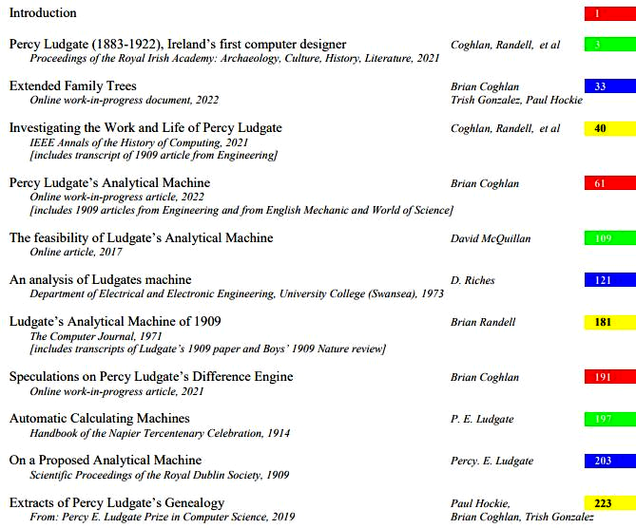
Figure 1: Table of Contents of ‘Percy Ludgate (1883-1922): Ireland's First Computer Designer’
The homepage for this catalog is at: https://www.scss.tcd.ie/SCSSTreasuresCatalog/
Click 'Accession Index' (1st column listed) for related folder, or 'About' for further guidance.
Some of the items below may be more properly part of other categories of this catalog, but are listed here for convenience.

Accession Index | Object with Identification
TCD-SCSS-V.20221015.003 | Percy Ludgate (1883-1922): Ireland's First Computer Designer. Brian Coghlan and Brian Randell (edd), The John Gabriel Byrne Computer Science Collection, ISBN 9781911566298, 246 pp, first print, 2022.
TCD-SCSS-V.20221015.002 | Percy Ludgate (1883-1922): Ireland's First Computer Designer. Brian Coghlan and Brian Randell (edd), The John Gabriel Byrne Computer Science Collection, 246 pp, proof print, 2022.
TCD-SCSS-V.20221015.001 | Unveiling of a Science Plaque to Percy Edwin Ludgate. Videos and photographs of the unveiling of the Ludgate Plaque. 2022.
TCD-SCSS-X.20121208.002 | Percy E. Ludgate Prize in Computer Science. Prize in memory of Percy Ludgate's novel 1909 design for an Analytical Engine, the next after Babbage's. c.1909.
TCD-SCSS-V.20170124.001 | Nature volume that includes article on Percy Ludgate's analytical engine. Nature, Vol.81, including: C.V.Boys, 'A new analytical engine', pp.14-15, Jul-1909.
TCD-SCSS-V.20121208.873 | On a Proposed Analytical Machine Percy E.Ludgate, offprint of article in Scientific Proceedings of the Royal Dublin Society. Apr-1909.
TCD-SCSS-V.20170221.001 | Napier Tercentenary Celebration Handbook that includes article by Percy Ludgate. Handbook of the Napier tercentenary celebration or modern instruments and methods of calculation, Ed: E.M.Horsburgh, including: Percy E.Ludgate, 'Automatic Calculating Machines'. 1914.
TCD-SCSS-V.20170217.001 | Reprint of 1909 RDS Proceedings that includes article on Percy Ludgate's analytical engine. Scientific Proceedings of the Royal Dublin Society, 12 (9), including: Percy E.Ludgate, 'On a Proposed Analytical Machine', pp.77-91, 28-Apr-1909, reprinted 2016.
TCD-SCSS-V.20190903.002 | 'An exploration of the life of Percy Ludgate'. Video and audio recordings of a presentation at the West Cork History Festival. 2019.
TCD-SCSS-V.20190903.001 | Podcast on Percy Ludgate. Audio recording of an interview at the West Cork History Festival. 2019.
TCD-SCSS-V.20200520.001 | Archives of The English Mechanic and World of Science. The full archive set in which was first discovered a diagram of Percy Ludgate's Analytical Machine. 2020.
TCD-SCSS-V.20210520.001 | 20-May-2021 edition of the Irish Times. A printed issue that contains an article on Percy Ludgate by Dr.Chris Horn. 2021.
TCD-SCSS-V.20210507.001 | Investigating the Work and Life of Percy Ludgate. Technical paper by Coghlan, Randell, Hockie, Gonzalez, McQuillan, O'Regan, in the IEEE Annals of the History of Computing, plus a printed copy of the issue that contains the paper, both courtesy of Institute of Electrical and Electronics Engineers (IEEE). 2021.
TCD-SCSS-V.20210916.001 | Investigating the Work and Life of Percy Ludgate (1883-1922). Brian Randell, video of and slides for Zoom presentation about Percy Ludgate to The Computer Conservation Society (CCS), U.K. 2021.
TCD-SCSS-V.20210428.001 | Percy Ludgate (1883 -1922) - Charles Babbage's First Successor. Brian Randell, video of and slides for Zoom presentation about Percy Ludgate to The National Museum of Computing (TNMOC), Bletchley Park, U.K. 2021.
TCD-SCSS-V.20210921.001 | Percy Ludgate (1883-1922), Ireland's first computer designer. Historical paper by Coghlan, Randell, Hockie, Gonzalez, McQuillan, O'Regan, in the Proceedings of the Royal Irish Academy: Archaeology, Culture, History, Literature, plus a printed copy of the issue that contains the paper, both courtesy of RIA. 2021.

References:

- Wikipedia, Percy Ludgate, see:
https://en.wikipedia.org/wiki/Percy_Ludgate
Last browsed to on 24-Oct-2022.

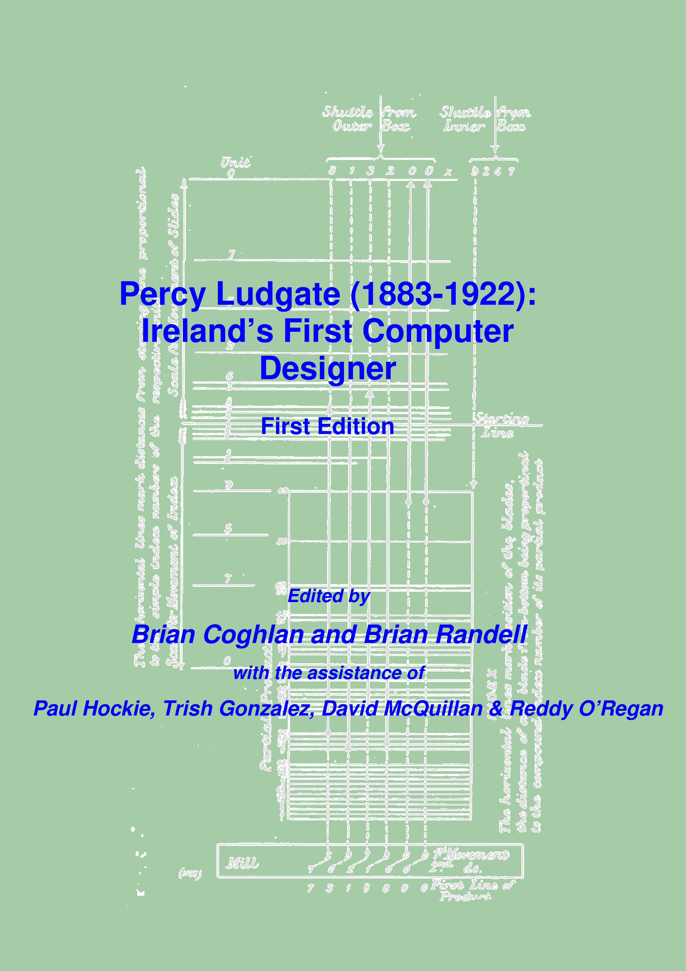
Figure 2: ‘Percy Ludgate (1883-1922): Ireland's First Computer Designer’, front cover

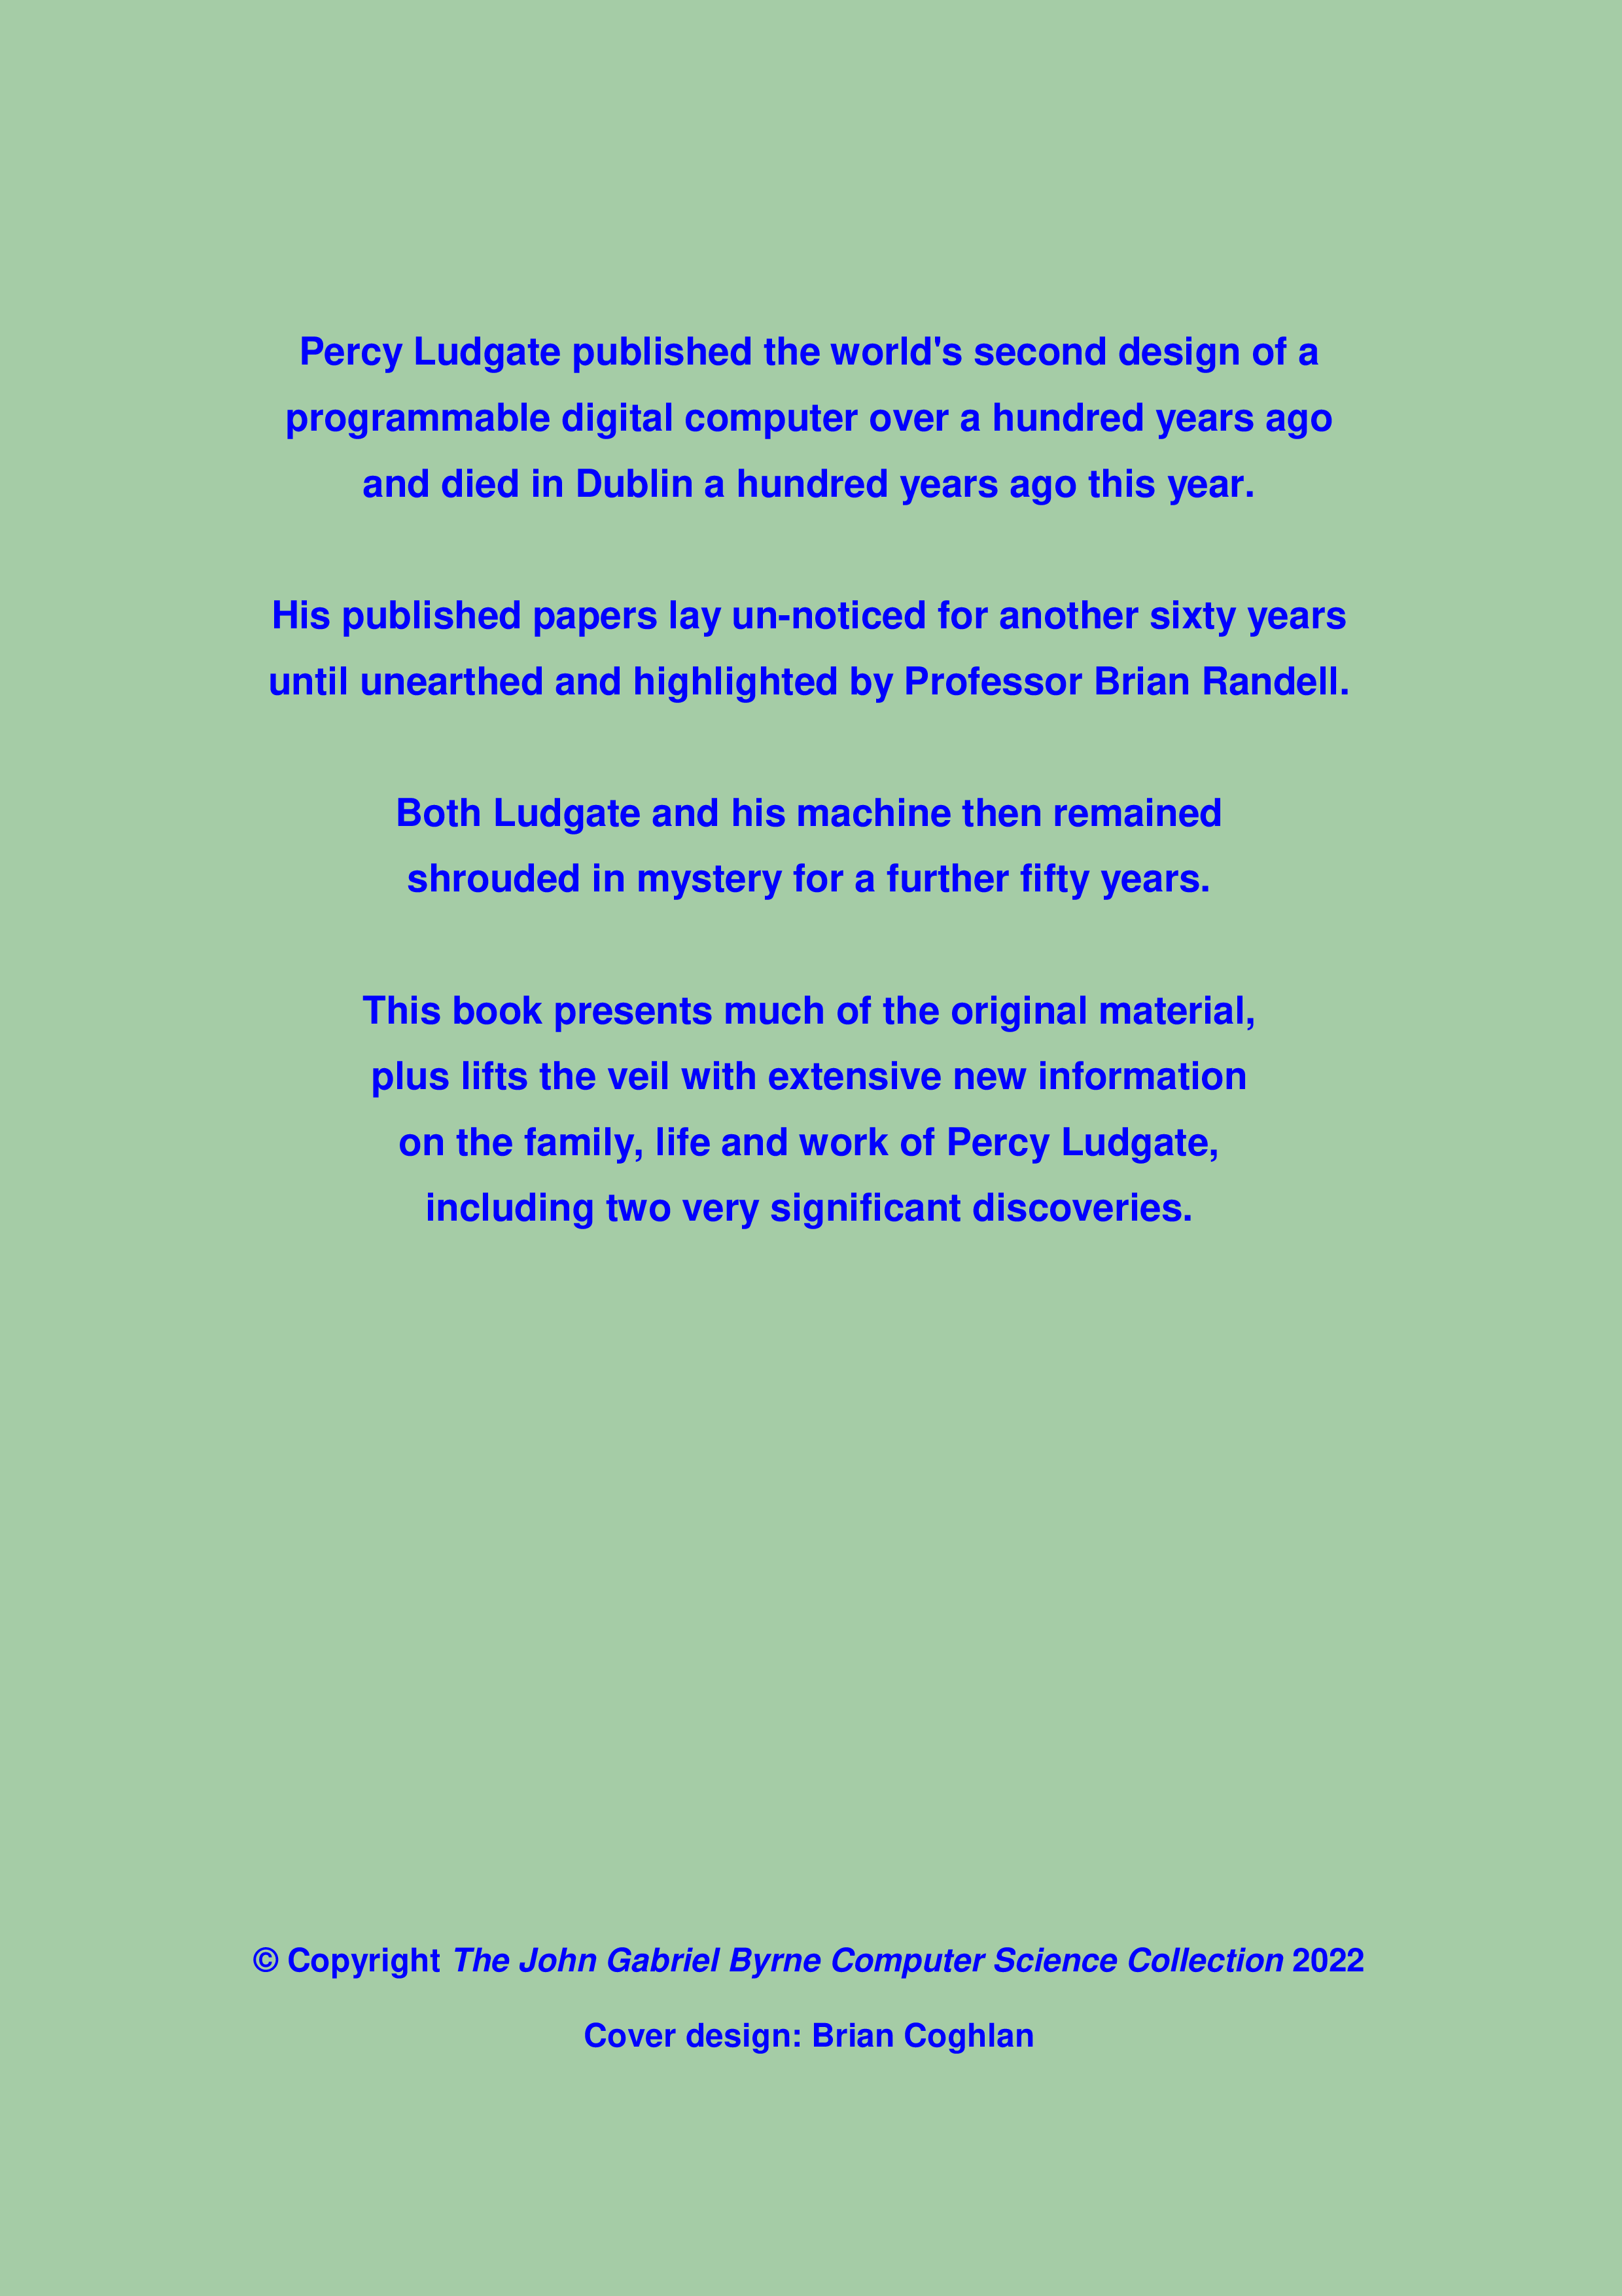
Figure 3: ‘Percy Ludgate (1883-1922): Ireland's First Computer Designer’, rear cover

