AccessionIndex: TCD-SCSS-V.20220825.007
Accession Date: 25-Aug-2022
Accession By: Dr.Brian Coghlan
Object name: Nokia 8210 User Manual
Vintage: c.2000
Synopsis: Nokia, manual for 8210 mobile phone.

Description:
The Nokia 8210 was a highly successful text-oriented mobile phone released in Oct-1999. Especially notable was the very popular pink ladies mobile phone that began Nokia's rise to dominance of the early post-millenium mobile market.

This document is still under construction.

Many thanks to Brian Coghlan for donating this item.

The homepage for this catalog is at: https://www.scss.tcd.ie/SCSSTreasuresCatalog/
Click 'Accession Index' (1st column listed) for related folder, or 'About' for further guidance.
Some of the items below may be more properly part of other categories of this catalog, but are listed here for convenience.

Accession Index | Object with Identification
TCD-SCSS-V.20220825.007 | Nokia 8210 User Manual. Nokia, manual for 8210 mobile phone. c.2000.
TCD-SCSS-T.20150608.002 | Nokia 8210 Mobile Phone. Pink ladies mobile phone that began Nokia's rise to dominance of the early post-millenium mobile market. 1999.

References:

- Wikipedia, Nokia, see:
https://en.wikipedia.org/wiki/Nokia
Last browsed to on 25-Aug-2022.

- gsmarena.com, Nokia 8210, see:
https://www.gsmarena.com/nokia_8210-19.php
Last browsed to on 25-Aug-2022.

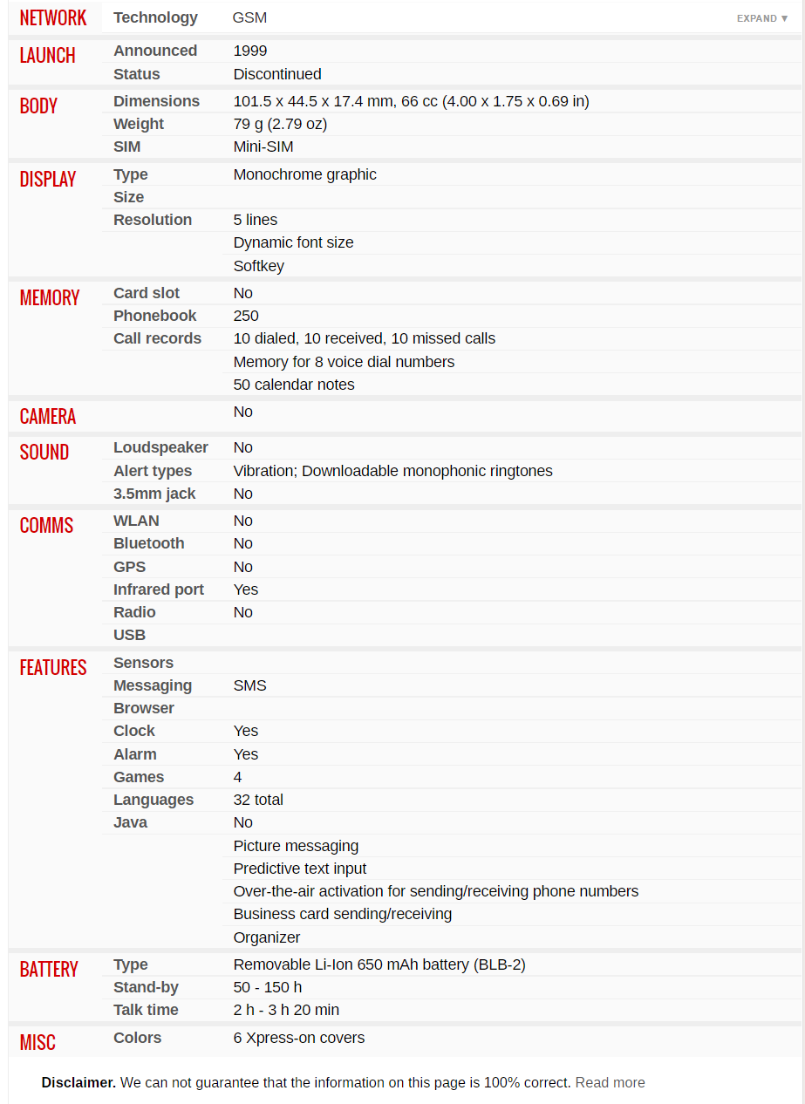
Figure 1: Nokia 8210 specifications from gsmarena.com

Figure 2: Nokia 8210

++++++++++++++++++++++++++++
+++ Please see images in related folder +++
++++++++++++++++++++++++++++

