AccessionIndex: TCD-SCSS-V.20220825.006
Accession Date: 25-Aug-2022
Accession By: Dr.Brian Coghlan
Object name: Motorola V3690 User Manual
Vintage: c.2000
Synopsis: Motorola, manual for V3690 dual-band clamshell mobile phone.

Description:
The V3690 was a very popular clamshell text-oriented dual-band mobile phone, one of very few early mobiles allowing firmware updates. See Figure 1 for the V3690 specification [1][2].

This document is still under construction.

Many thanks to Brian Coghlan for donating this item.

The homepage for this catalog is at: https://www.scss.tcd.ie/SCSSTreasuresCatalog/
Click 'Accession Index' (1st column listed) for related folder, or 'About' for further guidance.
Some of the items below may be more properly part of other categories of this catalog, but are listed here for convenience.

Accession Index | Object with Identification
TCD-SCSS-V.20220825.006 | Motorola V3690 User Manual. Motorola, manual for V3690 dual-band clamshell mobile phone. c.2000.
TCD-SCSS-T.20150608.001 | Motorola V3690 Mobile Phone. Dual-band clam-case mobile phone, one of very few early mobiles allowing firmware updates. c.2000.

References:

- Wikipedia, List of Motorola V series phones, see:
https://en.wikipedia.org/wiki/List_of_Motorola_V_series_phones
Last browsed to on 25-Aug-2022.

- gsmarena.com, Motorola V3690, see:
https://www.gsmarena.com/motorola_v3690-213.php
Last browsed to on 25-Aug-2022.

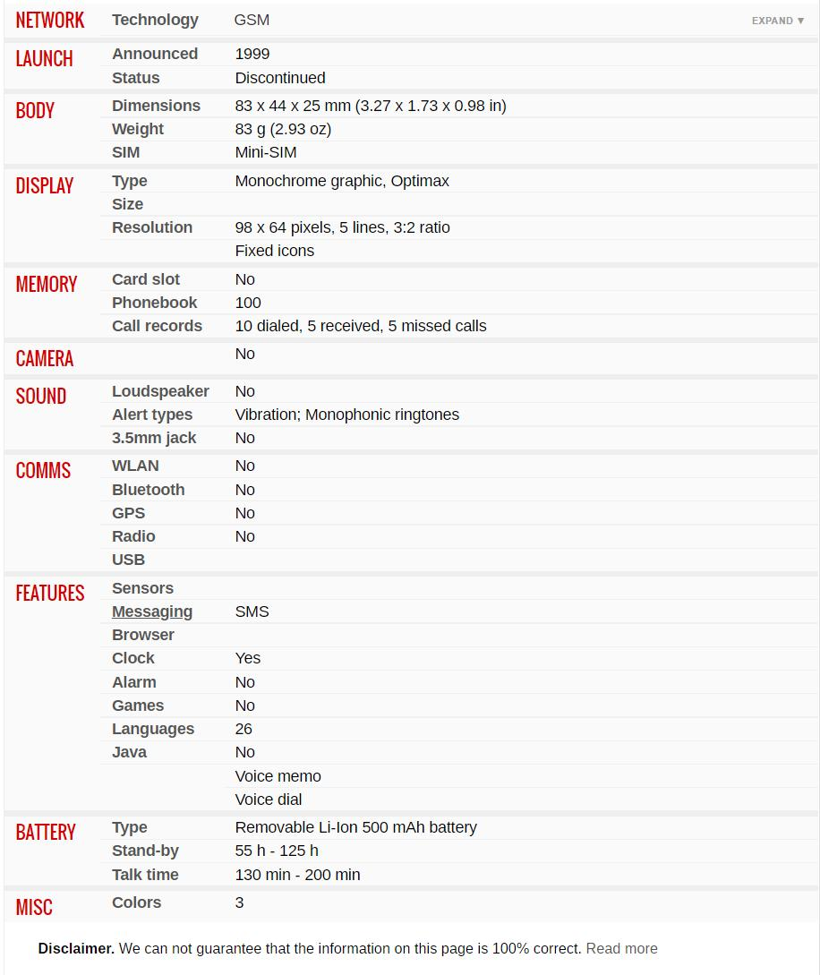
Figure 1: Motorola V3690 specifications from gsmarena.com

Figure 2: Motorola V3690

++++++++++++++++++++++++++++
+++ Please see images in related folder +++
++++++++++++++++++++++++++++

