AccessionIndex: TCD-SCSS-V.20210921.001
Accession Date: 21-Sep-2021
Accession By: Royal Irish Academy
Object name: Percy Ludgate (1883-1922), Ireland's first computer designer
Vintage: 2021
Synopsis: Historical paper by Coghlan, Randell, Hockie, Gonzalez, McQuillan, O'Regan, in the Proceedings of the Royal Irish Academy: Archaeology, Culture, History, Literature, plus a printed copy of the issue that contains the paper, both courtesy of RIA.

Description:
This historical paper [1], and its companion technical paper [2], report the first substantive discoveries in fifty years about the work and life of Percy Ludgate. The paper’s Abstract is shown on the first page of this paper in Fig.1. The front page of the enclosing issue is shown in Fig.2. For further detailed background on Ludgate, see [3]. This ongoing pro bono investigation was begun in 2016 by Brian Coghlan under the aegis of this Collection, and then Brian Randell, Paul Hockie, Trish Gonzalez, David McQuillan and Reddy O’Regan agreed to join with their specialist knowledge and skills. It has been further aided by joint outreach activities with the Ludgate Hub.

Percy Ludgate was the second person to publish a design for a computer (his Analytical Machine) [4], the first after Babbage’s Analytical Engine. Ludgate’s life was and remains full of mysteries. He died young and single, and by 1987 there were no known descendants of his parents, so family and personal details were scarce. His ancestors, close family members and extended family, any surviving descendants of those, his domestic situation, his own life, schooling and career progression, any tax and legal issues, his motivations and inspirations, the submission process for his 1909 paper, likewise for his 1914 paper, his World War I activities, his health and death, and even his final resting place, all presented many unknowns. This historical paper concentrated on the new details and understandings of Ludgate’s life that had been discovered.

Our grateful thanks to the RIA for arranging to publish this paper on open access under the terms of the Creative Commons attribution license, and for donating a printed copy of the issue that contains the paper to The John Gabriel Byrne Computer Science Collection.

The homepage for this catalog is at: https://www.scss.tcd.ie/SCSSTreasuresCatalog/
Click 'Accession Index' (1st column listed) for related folder, or 'About' for further guidance. Some of the items below may be more properly part of other categories of this catalog, but are listed here for convenience.

Accession Index | Object with Identification
TCD-SCSS-V.20210921.001 | Historical paper by Coghlan, Randell, Hockie, Gonzalez, McQuillan, O'Regan, 'Percy Ludgate (1883-1922), Ireland's first computer designer', in the Proceedings of the Royal Irish Academy: Archaeology, Culture, History, Literature, plus a printed copy of the issue that contains the paper, both courtesy of RIA, 2021.
TCD-SCSS-V.20210921.001.01 | Historical paper by Coghlan, Randell, Hockie, Gonzalez, McQuillan, O'Regan, 'Percy Ludgate (1883-1922), Ireland's first computer designer', in the Proceedings of the Royal Irish Academy: Archaeology, Culture, History, Literature, Vol. 121C, pp. 1-30, 2021, DOI: 10.3318/PRIAC.2021.121.09, preserved as electronic file: https://www.scss.tcd.ie/SCSSTreasuresCatalog/literature/TCD-SCSS-V.20210921.001/BrianCoghlanEtAl-PercyLudgate-PRIAC-2021-121-09.pdf, courtesy of RIA.
TCD-SCSS-V.20210921.001.02 | Printed copy of the Proceedings of the Royal Irish Academy: Archaeology, Culture, History, Literature, Vol. 121C, 2021, courtesy of RIA.
TCD-SCSS-V.20210507.001 | Technical paper by Coghlan, Randell, Hockie, Gonzalez, McQuillan, O'Regan, 'Investigating the Work and Life of Percy Ludgate', in the IEEE Annals of the History of Computing, plus a printed copy of the issue that contains the paper, both courtesy of IEEE, 2021.
TCD-SCSS-X.20121208.002 | Percy E. Ludgate Prize in Computer Science. Prize in memory of Percy Ludgate's novel 1909 design for an Analytical Engine, the next after Babbage's, c.1909.

References:
- Coghlan, Randell, Hockie, Gonzalez, McQuillan, O'Regan, ‘Percy Ludgate (1883-1922), Ireland’s First Computer Designer’, Proceedings of the Royal Irish Academy: Archaeology, Culture, History, Literature, Vol. 121C, pp. 1-30, DOI: 10.3318/PRIAC.2021.121.09, 2021.

- Coghlan, Randell, Hockie, Gonzalez, McQuillan, O'Regan, ‘Investigating the Work and Life of Percy Ludgate’, IEEE Annals of the History of Computing, Vol. 43, No.1, pp. 19-37, DOI: 10.1109/MAHC.2020.3038431, January-March, 2021.

- Trinity College Dublin, Percy E. Ludgate folder, see: https://www.scss.tcd.ie/SCSSTreasuresCatalog/miscellany/TCD-SCSS-X.20121208.002/
For a more mobile-friendly interface to selected Ludgate folder contents, see:
https://www.scss.tcd.ie/SCSSTreasuresCatalog/ludgate/
Also Percy E. Ludgate Prize in Computer Science. Available at:
https://www.scss.tcd.ie/SCSSTreasuresCatalog/miscellany/TCD-SCSS-X.20121208.002/TCD-SCSS-X.20121208.002.pdf
Last viewed 21-Sep-2021.

- Percy E. Ludgate, ‘On a proposed analytical machine’, Scientific Proceedings of the Royal Dublin Society, Vol. 12, No. 9, pp. 77–91, April, 1909. Available at: https://www.scss.tcd.ie/SCSSTreasuresCatalog/literature/TCD-SCSS-V.20121208.873/TCD-SCSS-V.20121208.873.pdf
Last viewed 21-Sep-2021.

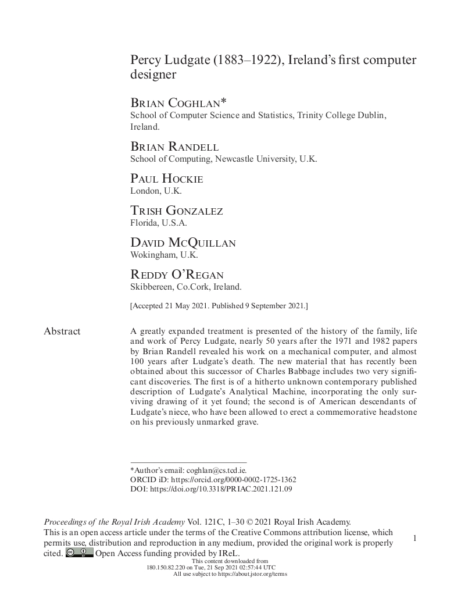
Figure 1: ‘Percy Ludgate (1883-1922), Ireland's first computer designer‘, first page.
Courtesy of RIA.

<< PHOTO TBD >>
Figure 2: Proceedings of the Royal Irish Academy: Archaeology, Culture, History, Literature,
Vol. 121C, 2021, front page.
Courtesy of RIA.

An electronic copy of this historical paper from the Proceedings of the Royal Irish Academy: Archaeology, Culture, History, Literature is available at: https://www.scss.tcd.ie/SCSSTreasuresCatalog/literature/TCD-SCSS-V.20210921.001/BrianCoghlanEtAl-PercyLudgate-PRIAC-2021-121-09.pdf
An electronic copy of the companion technical paper from the IEEE Annals of the History of Computing is available at: https://www.scss.tcd.ie/SCSSTreasuresCatalog/literature/TCD-SCSS-V.20210507.001/IEEE-Annals-FINAL-asPublished-Ludgate-20210307-0849.pdf
? An e-commerce hub opened in 2016 in Ludgate’s birthplace Skibbereen.

