AccessionIndex: TCD-SCSS-V.20210520.001
Accession Date: 20-May-2021
Accession By: Dr.John Walsh
Object name: 20-May-2021 edition of the Irish Times
Vintage: 2021
Synopsis: A printed issue that contains an article on Percy Ludgate by Dr.Chris Horn.

Description:
Dr.Chris Horn has been a regular writer of articles to the Irish Times on technology, especially in the realm of software technologies and the related industry. This article was instead about Ireland’s first computer designer, Percy Ludgate (1883-1922), the second person (the first was Charles Babbage) to publish a design for an analytical machine.

Ludgate was born in Skibbereen in 1883. His family moved to Dublin c.1890, where he spent the rest of his life. By the 1901 Census he held a junior post in the Irish Civil Service, while by the 1911 Census he was a clerk to a corn merchant, and by 1916 he was a qualified accountant. He published his paper on what he called his Analytical Machine in the Scientific Proceedings of the Royal Dublin Society (RDS) in 1909, while he was still just a clerk, an amazing achievement. It was reviewed in Nature shortly afterwards. His machine design was very novel, creating several new concepts. Like Babbage’s Analytical Engine, it was never built. Unlike Babbage’s legacy of hundreds of design drawings, Ludgate’s drawings have not yet been found.

A (less than perfect) photograph of this article, see Fig.1, is available online at: https://www.scss.tcd.ie/SCSSTreasuresCatalog/literature/TCD-SCSS-V.20210520.001/TCD-SCSS-V.20210520.001-Fig01.jpg
A printout of the text of the article is available online at: https://www.scss.tcd.ie/SCSSTreasuresCatalog/literature/TCD-SCSS-V.20210520.001/Remembering-PercyLudgate-Irelands-first-computer-scientist-IrishTimes-transcript-20210520.pdf

Further detail on the life and contributions of Percy Ludgate can be seen via a mobile-friendly Ludgate page of this Collection, see:
https://www.scss.tcd.ie/SCSSTreasuresCatalog/ludgate/

Dr.Chris Horn did his Ph.D. in the Department of Computer Science, Trinity College Dublin, became a staff member, and then was a founder of Iona Ltd.

Many thanks to John Walsh for donating this item.

The homepage for this catalog is at: https://www.scss.tcd.ie/SCSSTreasuresCatalog/
Click 'Accession Index' (1st column listed) for related folder, or 'About' for further guidance. Some of the items below may be more properly part of other categories of this catalog, but are listed here for convenience.

Accession Index | Object with Identification
TCD-SCSS-V.20210520.001 | 20-May-2021 edition of the Irish Times, A printed issue that contains an article on Percy Ludgate by Dr.Chris Horn, 2021.
TCD-SCSS-V.20121208.873 | On a Proposed Analytical Machine, Percy E.Ludgate, offprint of article in Scientific Proceedings of the Royal Dublin Society, 1909.
TCD-SCSS-V.20170124.001 | Nature volume that includes review of article on Percy Ludgate's analytical engine, Nature, Vol.81, including: C.V.Boys, 'A new analytical engine', pp.14-15, Jul-1909.
TCD-SCSS-X.20121208.002 | Percy E. Ludgate Prize in Computer Science. Prize in memory of Percy Ludgate's novel  1909 design for an Analytical Engine, the next after Babbage's.
TCD-SCSS-V.20210507.001 | Technical paper by Coghlan, Randell, Hockie, Gonzalez, McQuillan, O'Regan, 'Investigating the Work and Life of Percy Ludgate', in the IEEE Annals of the History of Computing, plus a printed copy of the issue that contains the paper, both courtesy of IEEE, 2021.
TCD-SCSS-V.20210921.001 | Historical paper by Coghlan, Randell, Hockie, Gonzalez, McQuillan, O'Regan, 'Percy Ludgate (1883-1922), Ireland's first computer designer', in the Proceedings of the Royal Irish Academy: Archaeology, Culture, History, Literature, plus a printed copy of the issue that contains the paper, both courtesy of RIA, 2021.
TCD-SCSS-X.20121208.001 | Charles Babbage's Engines, Irish interactions with Charles Babbage regarding his Difference Engines and Analytical Engine, c.1843.
TCD-SCSS-V.20121208.870 | Ada Lovelace's famous translation with an 'Addition', Prof.J.G.Byrne's offprint of Ada Lovelace's translation of L.Menabrea's 'Sketch' of the Analytical Engine, incorporating an offprint of Charles Babbage's 'Addition', c.1843.
TCD-SCSS-V.20171231.001 | Ed: Chris Horn, Professor John Byrne: Reminiscences: Father of Computing in Ireland, ISBN-10: 1520696841, ISBN-13: 978 1520696843, 2017.

References:

- Chris Horn, Remembering Percy Ludgate, Ireland’s first computer scientist, p.16, Irish Times, 20th May, 2021.

- Ed. Chris Horn, Professor John Byrne: Reminiscences: Father of Computing in Ireland, ISBN-10: 1520696841, ISBN-13: 978-1520696843, 2017, see elsewhere in this catalog.

- Coghlan, Randell, Hockie, Gonzalez, McQuillan, O'Regan, ‘Investigating the Work and Life of Percy Ludgate’, IEEE Annals of the History of Computing, Vol. 43, No.1, pp. 19-37, DOI: 10.1109/MAHC.2020.3038431, January-March, 2021.

- Coghlan, Randell, Hockie, Gonzalez, McQuillan, O'Regan, ‘Percy Ludgate (1883-1922), Ireland’s First Computer Designer’, Proceedings of the Royal Irish Academy: Archaeology, Culture, History, Literature, Vol. 121C, pp. 1-30, DOI: 10.3318/PRIAC.2021.121.09, 2021.

- Percy E. Ludgate, ‘On a proposed analytical machine’, Scientific Proceedings of the Royal Dublin Society, Vol. 12, No. 9, pp. 77–91, April, 1909. Available at: https://www.scss.tcd.ie/SCSSTreasuresCatalog/literature/TCD-SCSS-V.20121208.873/TCD-SCSS-V.20121208.873.pdf
Last viewed 20-May-2021.
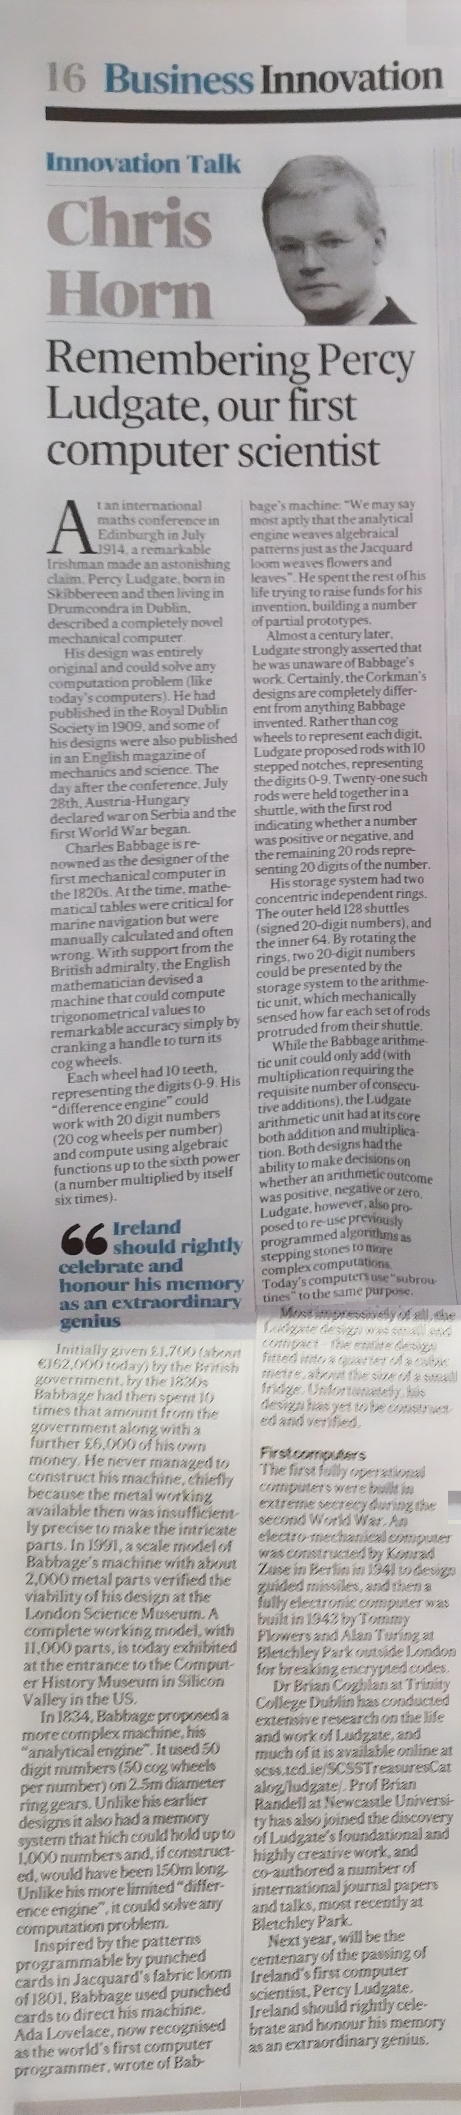
Figure 1: “Remembering Percy Ludgate, Ireland’s first computer scientist”,
by Chris Horn, page 16, Irish Times, 20th May, 2021.

