AccessionIndex: TCD-SCSS-V.20210507.001
Accession Date: 7-May-2021
Accession By: Institute of Electrical and Electronics Engineers (IEEE)
Object name: Investigating the Work and Life of Percy Ludgate
Vintage: 2021
Synopsis: Technical paper by Coghlan, Randell, Hockie, Gonzalez, McQuillan, O'Regan, in the IEEE Annals of the History of Computing, plus a printed copy of the issue that contains the paper, both courtesy of IEEE.

Description:
This technical paper [1], and its companion historical paper [2], reported the first substantive discoveries in fifty years about the work and life of Percy Ludgate. The paper’s Abstract is shown on the first page of this paper in Fig.1. The front page of the enclosing issue is shown in Fig.2. For further detailed background on Ludgate, see [3]. This ongoing pro bono investigation was begun in 2016 by Brian Coghlan under the aegis of this Collection, and then Brian Randell, Paul Hockie, Trish Gonzalez, David McQuillan and Reddy O’Regan agreed to join with their specialist knowledge and skills. It has been further aided by joint outreach activities with the Ludgate Hub.

Percy Ludgate was the second person to publish a design for a computer (his Analytical Machine) [4], the first after Babbage’s Analytical Engine. His design was very novel, utilising discrete logarithmic indexes (Irish logarithms) that he invented to do multiplication. Its arithmetic unit was designed to perform the now common multiply-accumulate (MAC) operation, the first computer arithmetic unit to do so. It also was designed to perform division by convergent series seeded with an estimate from a mechanical table of initial values (again a first), and could be stepped through a sequence of operations either manually or under automatic control, the latter using perforated paper. His sequencer had two-operand instructions, subroutines and pre-emption, so was closer to that of modern computers than Babbage’s. His storage system was based around two concentric cylinders that held numbers as the displacements of rods in shuttles, another novel invention. But, while Ludgate’s 1909 paper explained key principles of his machine, it was not very forthcoming otherwise, and none of his drawings of the machine had been found. This technical paper concentrated on the new details and understandings of the machine that had been discovered and also deduced.

Our grateful thanks to the IEEE for generously granting permission to preserve and republish the electronic copy of this paper, and for donating a printed copy of the issue that contains the paper to The John Gabriel Byrne Computer Science Collection.

The homepage for this catalog is at: https://www.scss.tcd.ie/SCSSTreasuresCatalog/
Click 'Accession Index' (1st column listed) for related folder, or 'About' for further guidance. Some of the items below may be more properly part of other categories of this catalog, but are listed here for convenience.

Accession Index | Object with Identification
TCD-SCSS-V.20210507.001 | Technical paper by Coghlan, Randell, Hockie, Gonzalez, McQuillan, O'Regan, 'Investigating the Work and Life of Percy Ludgate', in the IEEE Annals of the History of Computing, plus a printed copy of the issue that contains the paper, both courtesy of IEEE, 2021.
TCD-SCSS-V.20210507.001.01 | Technical paper by Coghlan, Randell, Hockie, Gonzalez, McQuillan, O'Regan, 'Investigating the Work and Life of Percy Ludgate', in the IEEE Annals of the History of Computing, Vol. 43, No. 1, pp. 19-37, January-March, 2021, DOI: 10.1109/MAHC.2020.3038431, preserved as electronic file: https://www.scss.tcd.ie/SCSSTreasuresCatalog/literature/TCD-SCSS-V.20210507.001/IEEE-Annals-FINAL-asPublished-Ludgate-20210307-0849.pdf, Electronic ISSN: 1934-1547, courtesy of IEEE.
TCD-SCSS-V.20210507.001.02 | Printed copy of the issue of the IEEE Annals of the History of Computing titled 'Early Computers: Imagined and Built', Vol. 43, No. 1, January-March, 2021, Print ISSN: 1058-6180, courtesy of IEEE.
TCD-SCSS-V.20210921.001 | Historical paper by Coghlan, Randell, Hockie, Gonzalez, McQuillan, O'Regan, 'Percy Ludgate (1883-1922), Ireland's first computer designer', in the Proceedings of the Royal Irish Academy: Archaeology, Culture, History, Literature, plus a printed copy of the issue that contains the paper, both courtesy of RIA, 2021.
TCD-SCSS-X.20121208.002 | Percy E. Ludgate Prize in Computer Science. Prize in memory of Percy Ludgate's novel 1909 design for an Analytical Engine, the next after Babbage's, c.1909.

References:
- Coghlan, Randell, Hockie, Gonzalez, McQuillan, O'Regan, ‘Investigating the Work and Life of Percy Ludgate’, IEEE Annals of the History of Computing, Vol. 43, No.1, pp. 19-37, DOI: 10.1109/MAHC.2020.3038431, January-March, 2021.

- Coghlan, Randell, Hockie, Gonzalez, McQuillan, O'Regan, ‘Percy Ludgate (1883-1922), Ireland’s First Computer Designer’, Proceedings of the Royal Irish Academy: Archaeology, Culture, History, Literature, Vol. 121C, pp. 1-30, DOI: 10.3318/PRIAC.2021.121.09, 2021.

- Trinity College Dublin, Percy E. Ludgate folder, see: https://www.scss.tcd.ie/SCSSTreasuresCatalog/miscellany/TCD-SCSS-X.20121208.002/
For a more mobile-friendly interface to selected Ludgate folder contents, see:
https://www.scss.tcd.ie/SCSSTreasuresCatalog/ludgate/
Also Percy E. Ludgate Prize in Computer Science. Available at:
https://www.scss.tcd.ie/SCSSTreasuresCatalog/miscellany/TCD-SCSS-X.20121208.002/TCD-SCSS-X.20121208.002.pdf
Last viewed 7-May-2021.

- Percy E. Ludgate, ‘On a proposed analytical machine’, Scientific Proceedings of the Royal Dublin Society, Vol. 12, No. 9, pp. 77–91, April, 1909. Available at: https://www.scss.tcd.ie/SCSSTreasuresCatalog/literature/TCD-SCSS-V.20121208.873/TCD-SCSS-V.20121208.873.pdf
Last viewed 7-May-2021.

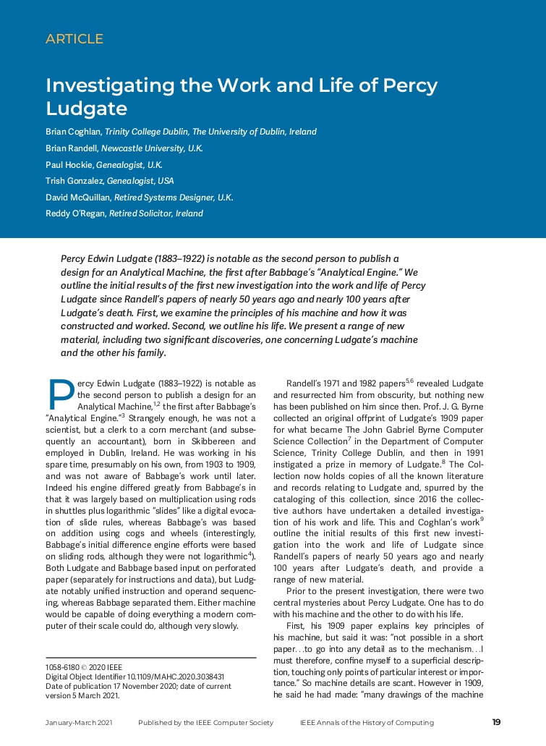
Figure 1: ‘Investigating the Work and Life of Percy Ludgate', first page.
Courtesy of IEEE.

<< PHOTO TBD >>
Figure 2: 'Early Computers: Imagined and Built', IEEE Annals of the History of Computing,
Vol. 43, No.1, January-March 2021, front page.
Courtesy of IEEE.

An electronic copy of this technical paper from the IEEE Annals of the History of Computing is available at: https://www.scss.tcd.ie/SCSSTreasuresCatalog/literature/TCD-SCSS-V.20210507.001/IEEE-Annals-FINAL-asPublished-Ludgate-20210307-0849.pdf
An electronic copy of the companion historical paper from the Proceedings of the Royal Irish Academy: Archaeology, Culture, History, Literature is available at: https://www.scss.tcd.ie/SCSSTreasuresCatalog/literature/TCD-SCSS-V.20210921.001/BrianCoghlanEtAl-PercyLudgate-PRIAC-2021-121-09.pdf
? An e-commerce hub opened in 2016 in Ludgate’s birthplace Skibbereen.

