AccessionIndex: TCD-SCSS-V.20210505.001
Accession Date: 5-May-2021
Accession By: Dr.Brian Coghlan
Object name: History of the Inductive Sciences, from the earliest to the present time
Vintage: 1837
Synopsis: Rev. William Whewell, M.A., 3-volume set with East India College crest on its covers, Publ. John W. Parker, London, 1-Jan-1837.

Description:
William Whewell (born 24-May-1794, died 6-Mar-1866), was the very influential Master of Trinity College, Cambridge. To quote from [2]:

The eighteenth and nineteenth centuries … were two very different scientific eras in the UK. The eighteenth century was the last in which science was primarily conducted by financially independent individuals, and when the more deductive scientific method of ‘natural philosophy’ held sway, whereby derived facts were logically deduced from existing ‘knowledge’. From the early nineteenth century a more inductive and disciplined scientific method based on precepts outlined by Francis Bacon progressively dominated, whereby collected evidence could by induction engender falsifiable theories and thereby ‘new knowledge’ until proven otherwise.

… this change … was passionately promoted in the first half of the nineteenth century by [Charles] Babbage, William Whewell, John Herschel and Richard Jones (members of the so-called ‘Philosophical Breakfast Club’). … In 1831, William Harcourt, David Brewster, Babbage, Whewell and others founded the British Association for the Advancement of Science (Whewell coined the term ‘scientist’ at its 1833 meeting). … In 1834, Babbage, Jones, Whewell and others founded the Royal Statistical Society. … Herschel and Whewell were reportedly the more influential scientists of their generation. …

His best-known works are two books that attempt to systematize the development of the sciences. The first book traced how each branch of the sciences had evolved since early times. This item is a copy of that first book, and is notable for having the East India College crest on its covers.

Thanks to Brian Coghlan for donating this item.
The homepage for this catalog is at: https://www.scss.tcd.ie/SCSSTreasuresCatalog/
Click 'Accession Index' (1st column listed) for related folder, or 'About' for further guidance. Some of the items below may be more properly part of other categories of this catalog, but are listed here for convenience.

Accession Index | Object with Identification
TCD-SCSS-V.20210505.001 | Rev. William Whewell, M.A., History of the Inductive Sciences, from the earliest to the present time, 3-volume set with East India College crest on its covers, Publ. John W. Parker, London, 1-Jan-1837.
TCD-SCSS-V.20210505.001.01 | Rev. William Whewell, M.A., History of the Inductive Sciences, from the earliest to the present time, Volume 1, with East India College crest on its covers, Publ. John W. Parker, London, 1-Jan-1837.
TCD-SCSS-V.20210505.001.02 | Rev. William Whewell, M.A., History of the Inductive Sciences, from the earliest to the present time, Volume 2, with East India College crest on its covers, Publ. John W. Parker, London, 1-Jan-1837.
TCD-SCSS-V.20210505.001.03 | Rev. William Whewell, M.A., History of the Inductive Sciences, from the earliest to the present time, Volume 3, with East India College crest on its covers, Publ. John W. Parker, London, 1-Jan-1837.

References:

- Rev. William Whewell, M.A., History of the Inductive Sciences, from the earliest to the present time, 3-volume set, Publ. John W. Parker, London, 1-Jan-1837.

2. Ed: Coghlan, Randell, Hockie, Gonzalez, McQuillan, O'Regan, ‘Percy Ludgate (1883-1922), Ireland’s First Computer Designer’, Proceedings of the Royal Irish Academy: Archaeology, Culture, History, Literature, Vol. 121C, pp. 1-30, DOI: 10.3318/PRIAC.2021.121.09, 2021.

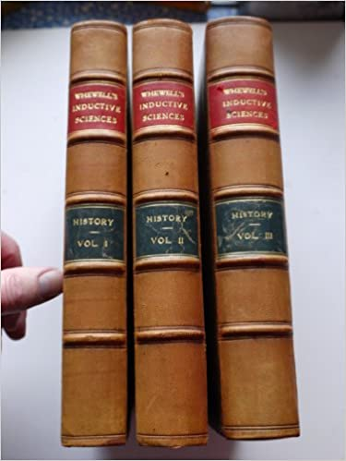
Figure 1: William Whewell’s History Of The Inductive Sciences, bindings.

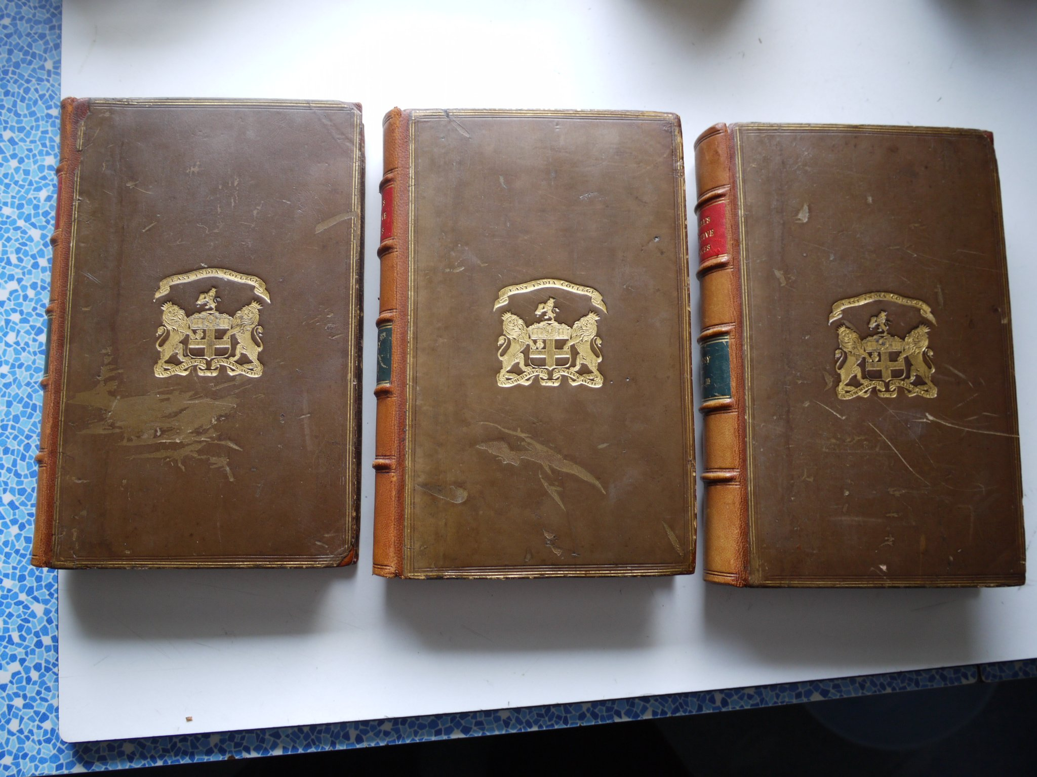
Figure 2: William Whewell’s History Of The Inductive Sciences, front covers.

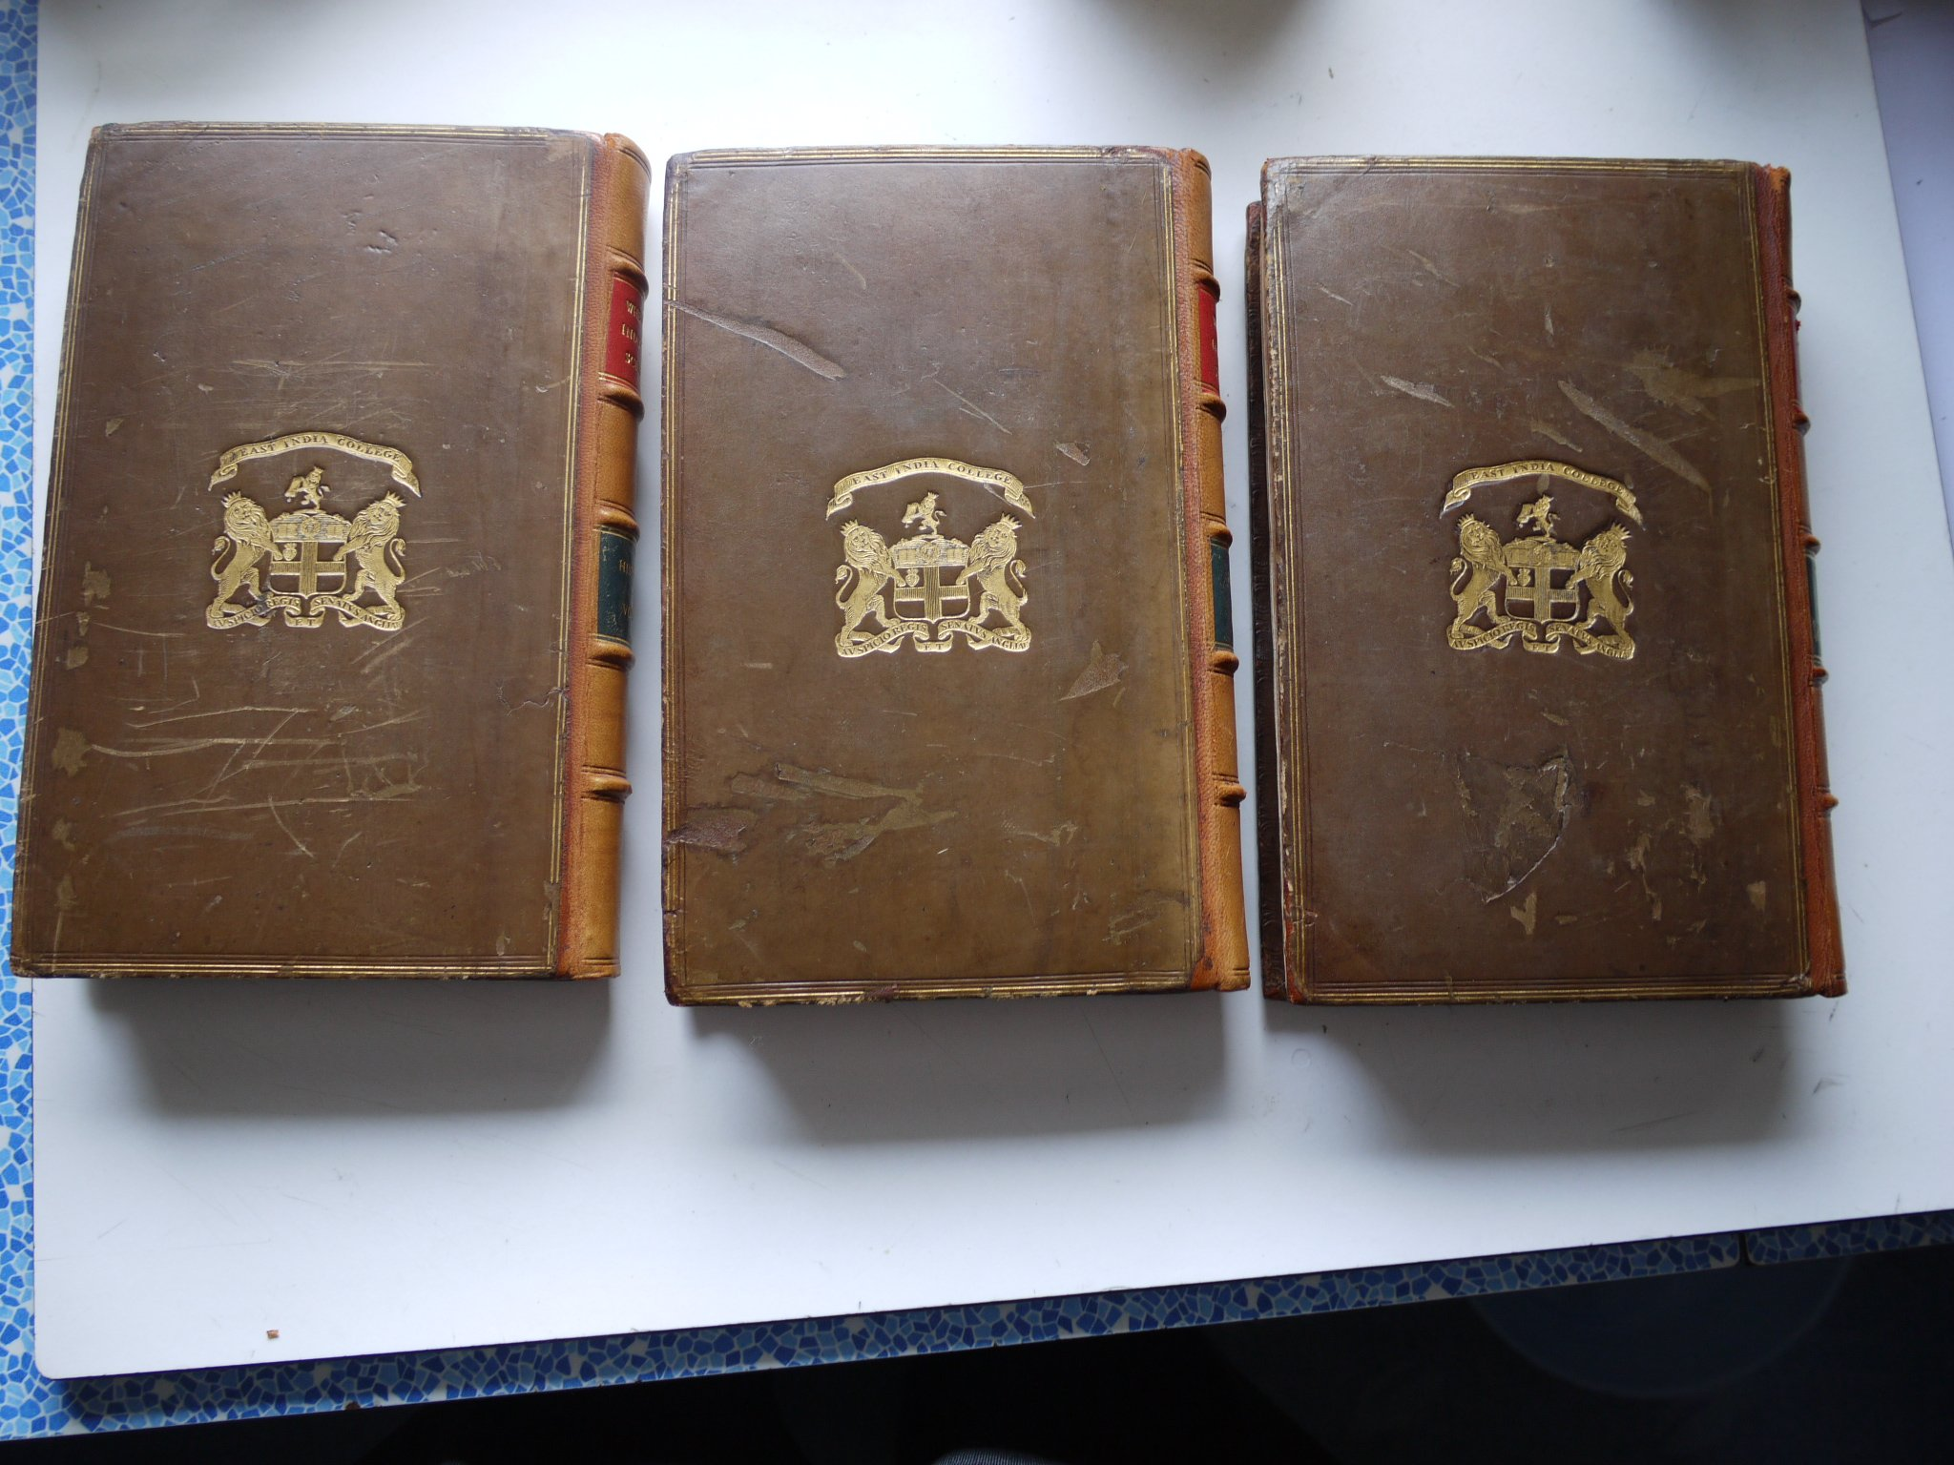
Figure 3: William Whewell’s History Of The Inductive Sciences, rear covers.

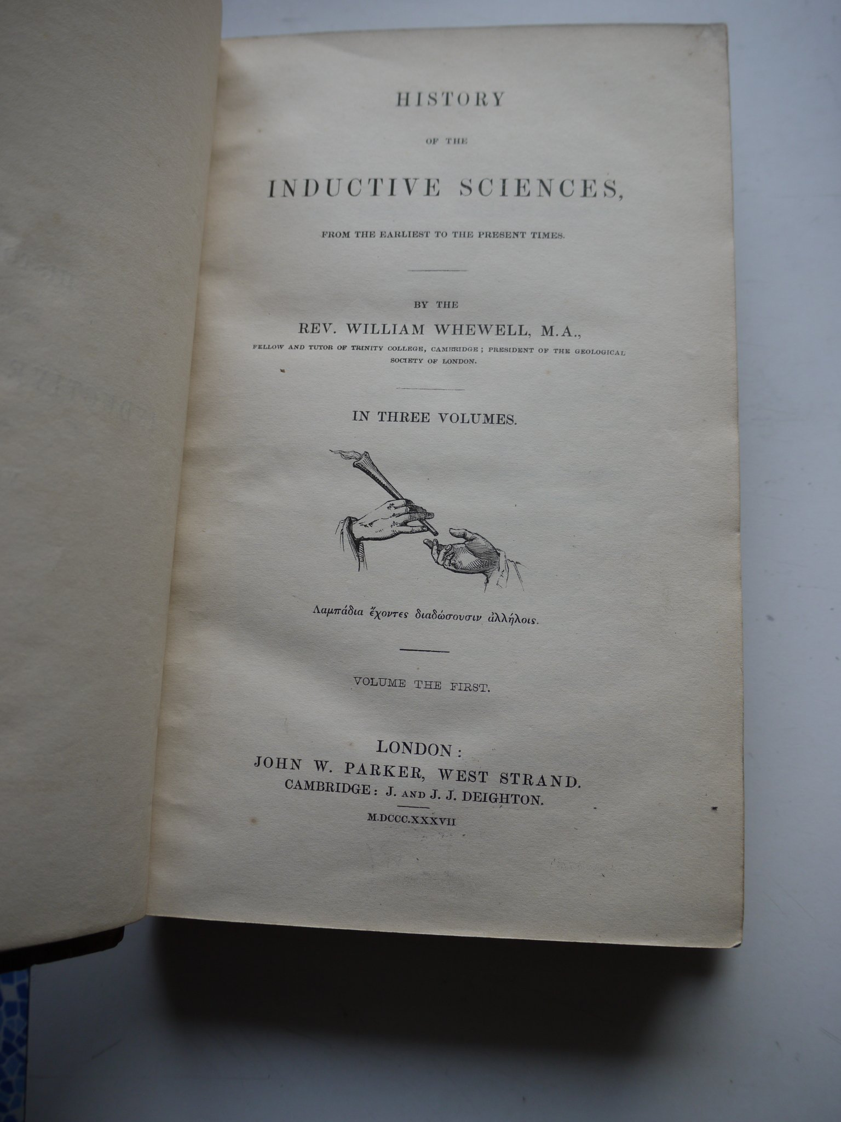
Figure 4: William Whewell’s History Of The Inductive Sciences, title page.

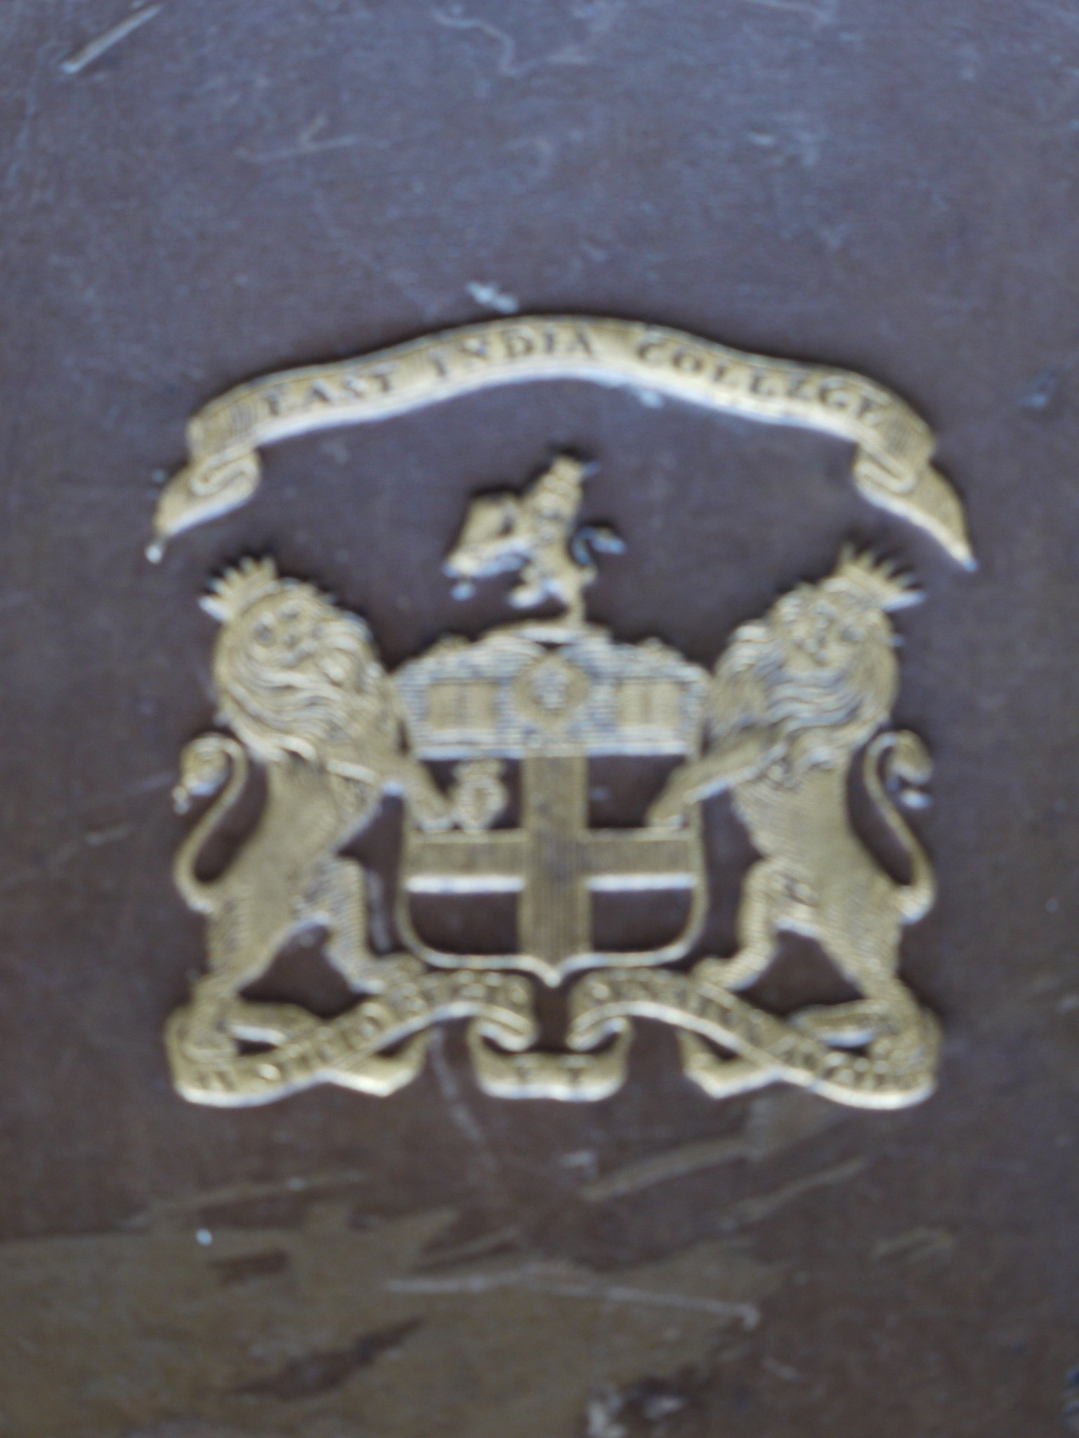
Figure 5: William Whewell’s History Of The Inductive Sciences, East India College Crest.

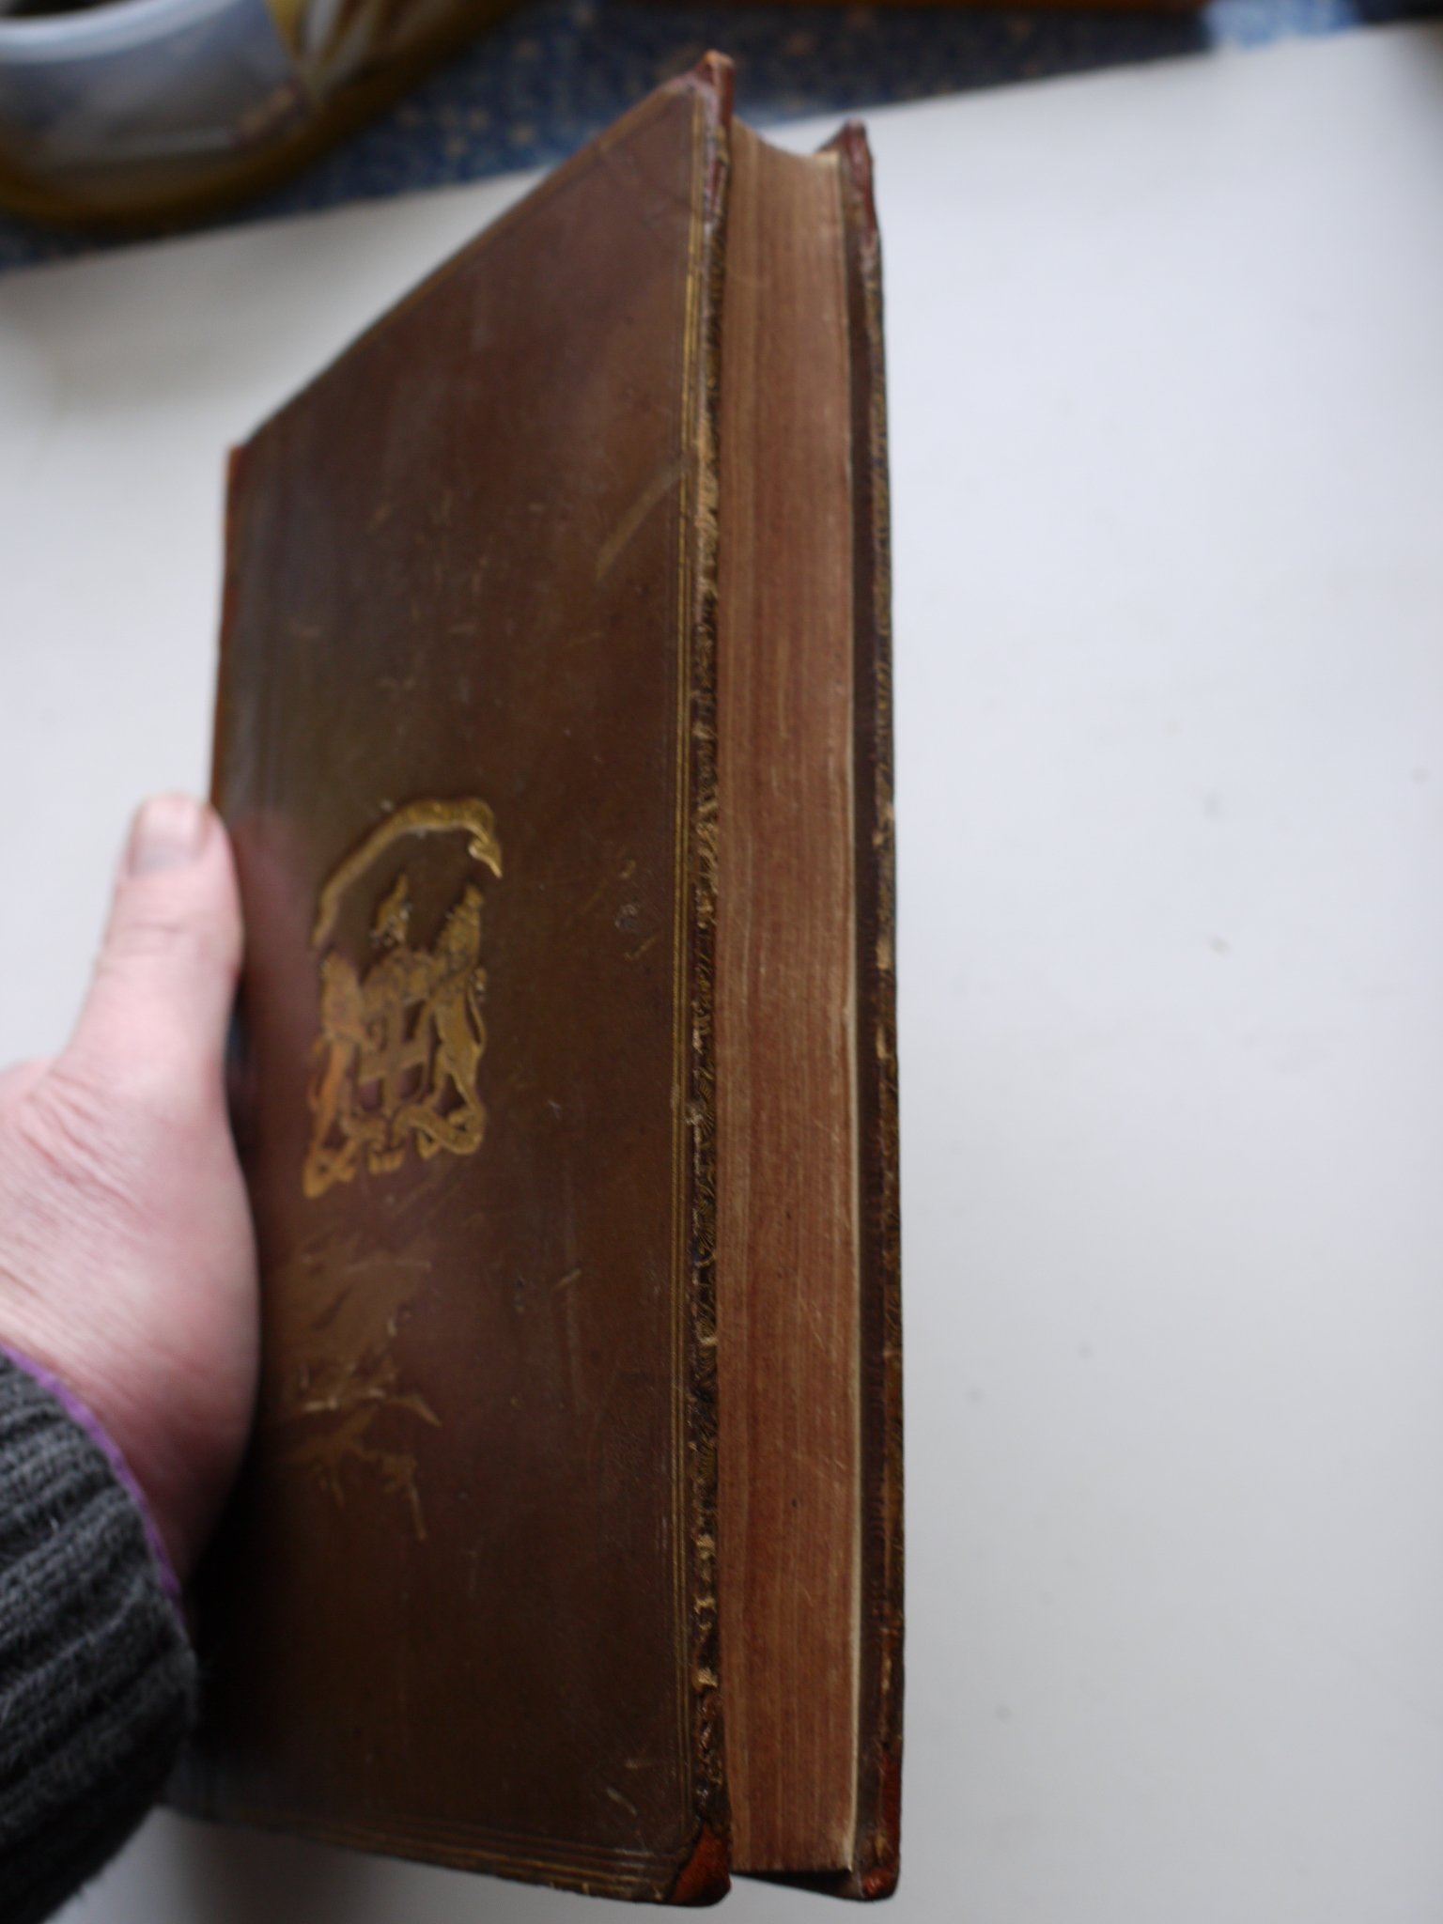
Figure 6: William Whewell’s History Of The Inductive Sciences, page-edges

