AccessionIndex: TCD-SCSS-V.20210409.001
Accession Date: 9-Apr-2021
Accession By: Dr.Dan McCarthy
Object name: Milestones in Analog and Digital Computing, Vols 1-2
Vintage: 2020
Synopsis: Herbert Bruderer, 3rd Edition, the 1st English-language edition of Meilensteine der Rechentechnik: Zur Geschichte der Mathematik Und der Informatik, on analog and digital computing devices, historical automatons and selected scientific instruments, 2000 pages, 700 colour illustrations, 150 tables, ISBN: 978-3-030-40973-9, DOI: 10.1007/978-3-030-40974-6, Springer, Berlin.

Description:
This Third Edition is the first English-language edition of Herbert Bruderer’s award-winning Meilensteine der Rechentechnik, illustrated in full color throughout two volumes. The Third Edition is devoted to both analog and digital computing devices, as well as the world's most magnificient historical automatons and select scientific instruments (employed in astronomy, surveying, time measurement, etc.). It also features detailed instructions for analog and digital mechanical calculating machines and instruments, and is said to be the only such historical book with comprehensive technical glossaries of terms not found in print or in online dictionaries. The book also includes a very extensive bibliography based on the literature of numerous countries around the world.

The content is covered over 25 chapters in sections titled: Introduction, Basic Principles, The Coming of Age of Arithmetic, Classification of Calculating Aids and Related Instruments, and Chronology. This item in the Collection is the hardcopy version, but there is an eBook version available (eBook ISBN: 978-3-030-40974-6).

Thanks to Dan McCarthy for undertaking the arrangements for the purchase of this substantial and important work, which acquisition was funded from Prof.J.G.Byrne’s bequest to The John Gabriel Byrne Computer Science Collection.
The homepage for this catalog is at: https://www.scss.tcd.ie/SCSSTreasuresCatalog/
Click 'Accession Index' (1st column listed) for related folder, or 'About' for further guidance. Some of the items below may be more properly part of other categories of this catalog, but are listed here for convenience.

Accession Index | Object with Identification
TCD-SCSS-V.20210409.001 | Milestones in Analog and Digital Computing, Vols 1-2. Herbert Bruderer, 3rd Edition, the 1st English-language edition of Meilensteine der Rechentechnik: Zur Geschichte der Mathematik Und der Informatik, on analog and digital computing devices, historical automatons and selected scientific instruments, 2000 pages, 700 colour illustrations, 150 tables, ISBN: 978-3-030-40973-9, DOI: 10.1007/978-3-030-40974-6, Springer, Berlin, 2020.

References:

- Herbert Bruderer, Milestones in Analog and Digital Computing, 3rd Edition, the 1st English-language edition of Meilensteine der Rechentechnik: Zur Geschichte der Mathematik Und der Informatik, on analog and digital computing devices, historical automatons and selected scientific instruments, 2 vols, 2000 pages, 700 colour illustrations, 150 tables, 2020.

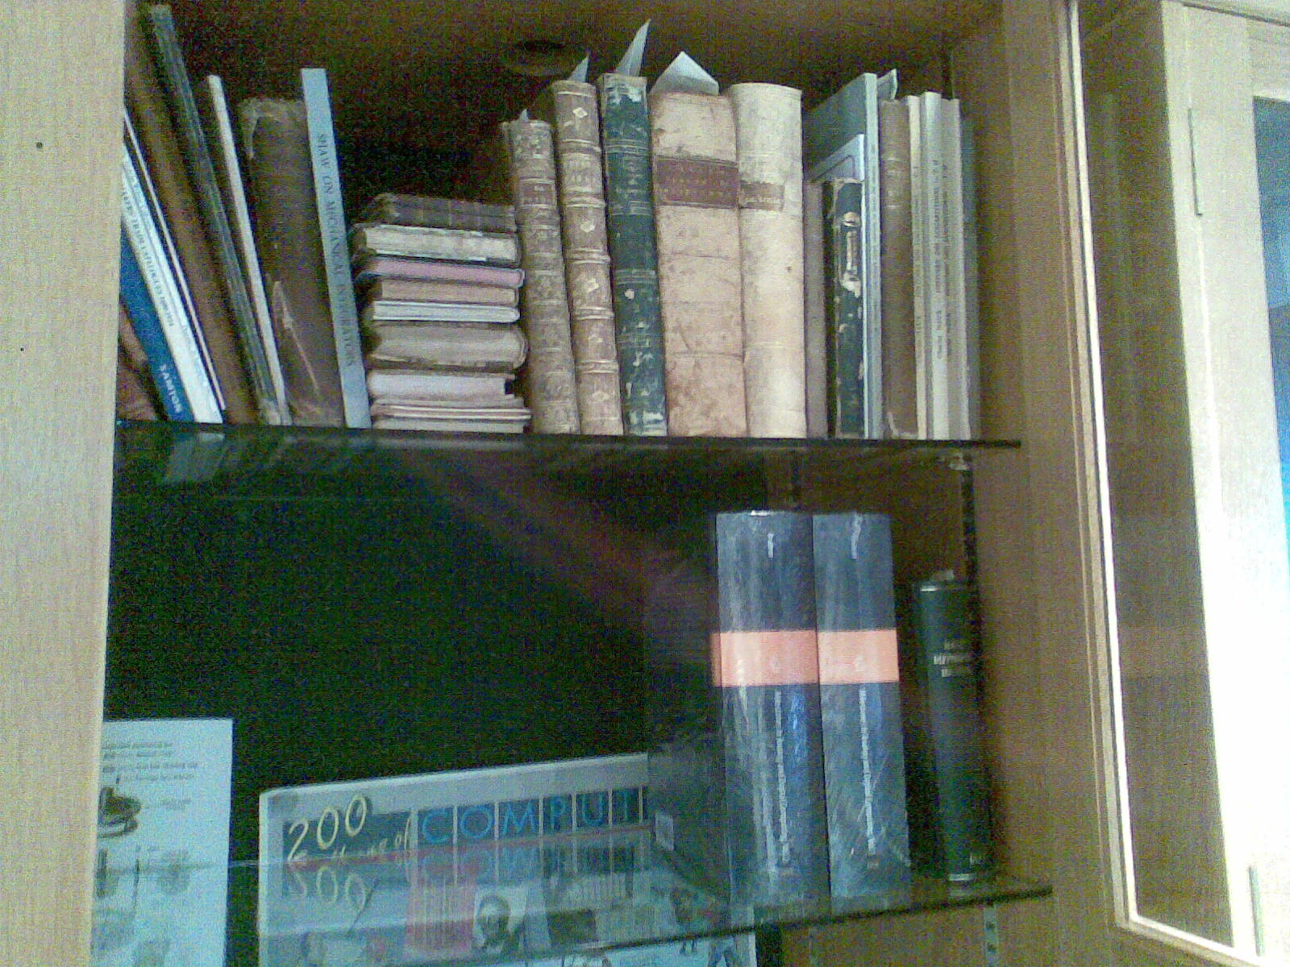
Figure 1. Herbert Bruderer, ‘Milestones in Analog and Digital Computing’,
Two volumes on the lower shelf, in the Sweeney Library,
School of Computer Science and Statistics, Trinity College Dublin.

