AccessionIndex: TCD-SCSS-V.20191011.001
Accession Date: 11-Oct-2019
Accession By: Gerry Lacey
Object name: Class Photograph, TCD Engineering School BAI Class of 1989-1990
Vintage: 1990
Synopsis: Trinity College Dublin, Class Photographs, with accompanying identification.

Description:
Many thanks to Gerry Lacey, a TCD Engineering School graduate of 1989-90, who donated this Class Photograph.

The homepage for this catalog is at: https://www.scss.tcd.ie/SCSSTreasuresCatalog/
Click 'Accession Index' (1st column listed) for related folder, or 'About' for further guidance. Some of the items below may be more properly part of other categories of this catalog, but are listed here for convenience.

Accession Index | Object with Identification
TCD-SCSS-V.20191011.001 | Class Photograph, TCD Engineering School BAI Class of 1989-1990, Trinity College Dublin, Class Photographs, with accompanying identification, 1990.

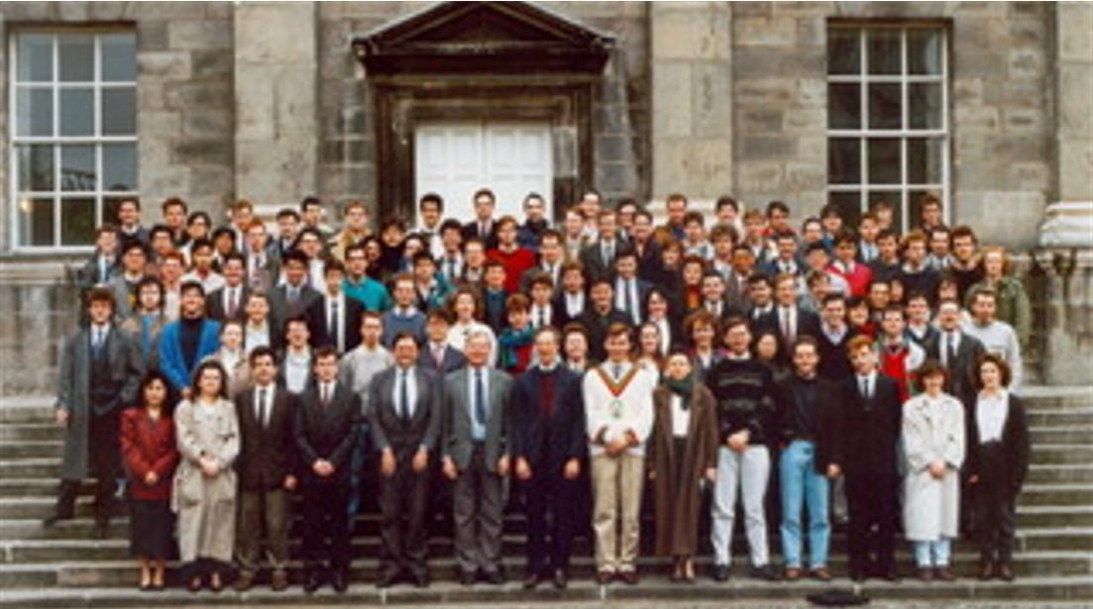
Figure 1: Photograph, TCD Engineering School BAI Class of 1989-1990
Photograph courtesy Gerry Lacey

Figure 2: Photograph, TCD Engineering School BAI Class of 1989-1990
Photograph and identification courtesy <?>

