AccessionIndex: TCD-SCSS-V.20180315.001
Accession Date: 15-Mar-2018
Accession By: Jim Dowling
Object name: Class Photograph, B.A.(Mod) Computer Science class of 1995-1996
Vintage: 1996
Synopsis: Trinity College Dublin, photograph with accompanying identification.

Description:
Many thanks to Jim Dowling, a TCD B.A.(Mod) Computer Science graduate of 1995-96, who donated this Class Photograph.

The homepage for this catalog is at: https://www.scss.tcd.ie/SCSSTreasuresCatalog/
Click 'Accession Index' (1st column listed) for related folder, or 'About' for further guidance. Some of the items below may be more properly part of other categories of this catalog, but are listed here for convenience.

Accession Index | Object with Identification
TCD-SCSS-V.20180315.001 | Class Photograph, B.A.(Mod) Computer Science class of 1995-1996, Trinity College Dublin, photograph with accompanying identification, 1996.
TCD-SCSS-V.20180315.001.001 | Class Photograph, B.A.(Mod) Computer Science class of 1995-1996, Trinity College Dublin, electronic image of photograph, 1996.

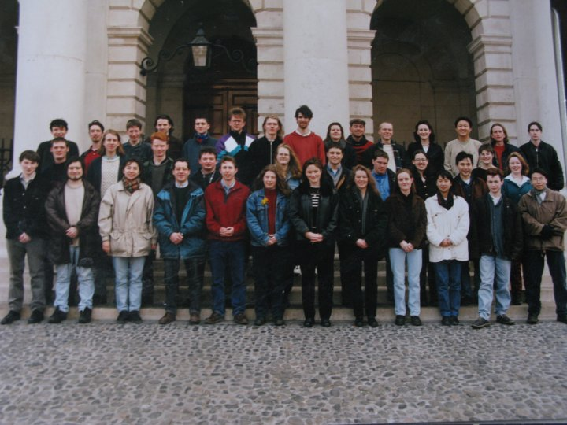
Figure 1: Class Photograph, B.A.(Mod) Computer Science class of 1995-1996
Photograph courtesy Jim Dowling

Figure 2: Class Photograph, B.A.(Mod) Computer Science class of 1995-1996
Photograph and identification courtesy <?>

