AccessionIndex: TCD-SCSS-V.20180313.001
Accession Date: 13-Mar-2018
Accession By: Kevin Ryan
Object name: Class Photograph, TCD Engineering School BAI Class of 1970-1971
Vintage: 1971
Synopsis: Trinity College Dublin, Class Photographs, with accompanying identification.

Description:
Many thanks to Kevin Ryan, a TCD Engineering School graduate of 1970-71, who donated this Class Photograph.

The homepage for this catalog is at: https://www.scss.tcd.ie/SCSSTreasuresCatalog/
Click 'Accession Index' (1st column listed) for related folder, or 'About' for further guidance. Some of the items below may be more properly part of other categories of this catalog, but are listed here for convenience.

Accession Index | Object with Identification
TCD-SCSS-V.20180313.001 | Class Photograph, TCD Engineering School BAI Class of 1970-1971, Trinity College Dublin, Class Photographs, with accompanying identification, 1971.

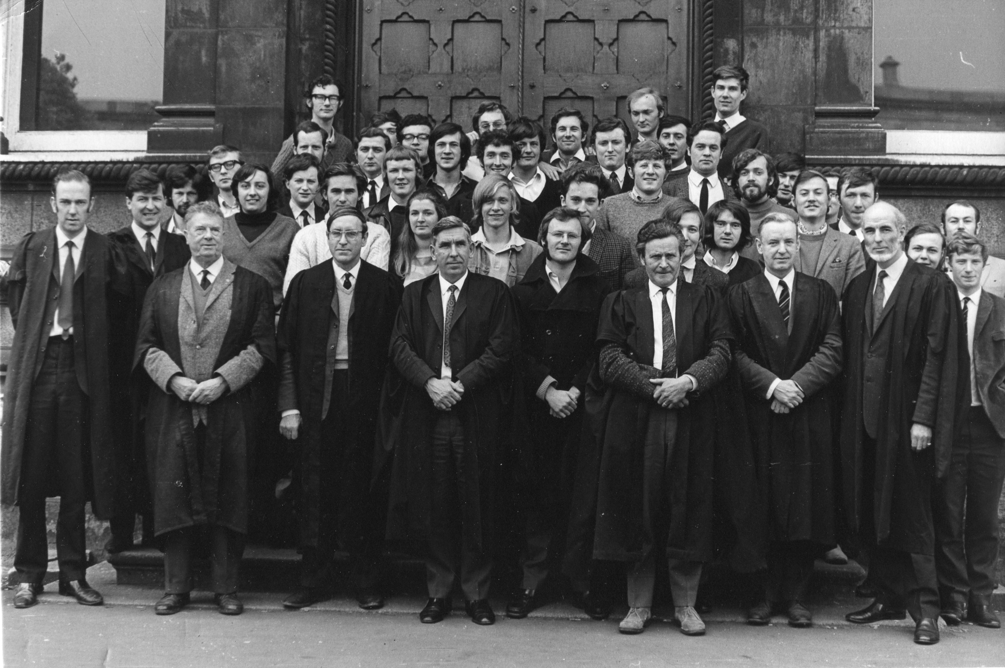
Figure 1: Photograph, TCD Engineering School BAI Class of 1970-1971
Photograph courtesy Kevin Ryan

Figure 2: Photograph, TCD Engineering School BAI Class of 1970-1971
Photograph and identification courtesy <?>

