AccessionIndex: TCD-SCSS-V.20180312.010
Accession Date: 12-Mar-2018
Accession By: TCD Engineering School
Object name: Class Photograph, TCD Engineering School BAI Class of 1984-1985
Vintage: 1985
Synopsis: Trinity College Dublin, Class Photographs, with accompanying identification.

Description:
Many thanks to the Engineering School, Trinity College Dublin, for permission to republish the official class photograph.

The homepage for this catalog is at: https://www.scss.tcd.ie/SCSSTreasuresCatalog/
Click 'Accession Index' (1st column listed) for related folder, or 'About' for further guidance. Some of the items below may be more properly part of other categories of this catalog, but are listed here for convenience.

Accession Index | Object with Identification
TCD-SCSS-V.20180312.010 | Class Photograph, TCD Engineering School BAI Class of 1984-1985, Trinity College Dublin, Class Photographs, with accompanying identification, 1985.

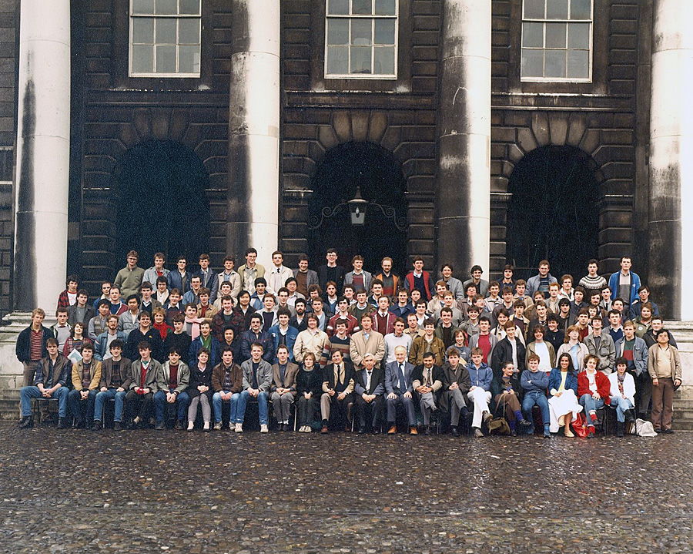
Figure 1: Photograph, TCD Engineering School BAI Class of 1984-1985
Photograph courtesy Engineering School, Trinity College Dublin

Figure 2: Photograph, TCD Engineering School BAI Class of 1984-1985
Photograph and identification courtesy <?>

