AccessionIndex: TCD-SCSS-V.20180222.003
Accession Date: 22-Feb-2018
Accession By: Bryan Alton, TCD Engineering School
Object name: Class Photograph, TCD Engineering School BAI Class of 1977-1978
Vintage: 1978
Synopsis: Trinity College Dublin, Class Photographs, with accompanying identification.

Description:
Many thanks to the Engineering School, Trinity College Dublin, for permission to republish the official class photograph.

Also many thanks to Bryan Alton for donating the class photograph identification.

The homepage for this catalog is at: https://www.scss.tcd.ie/SCSSTreasuresCatalog/
Click 'Accession Index' (1st column listed) for related folder, or 'About' for further guidance. Some of the items below may be more properly part of other categories of this catalog, but are listed here for convenience.

Accession Index | Object with Identification
TCD-SCSS-V.20180222.003 | Class Photograph, TCD Engineering School BAI Class of 1977-1978, Trinity College Dublin, Class Photographs, with accompanying identification, 1978
TCD-SCSS-V.20180222.003.001 | Class Photograph, TCD Engineering School BAI Class of 1977-1978, Trinity College Dublin, 1978
TCD-SCSS-V.20180222.003.002 | Class Photograph, TCD Engineering School BAI Class of 1977-1978, Trinity College Dublin, electronic image of photograph with accompanying identification, 1978

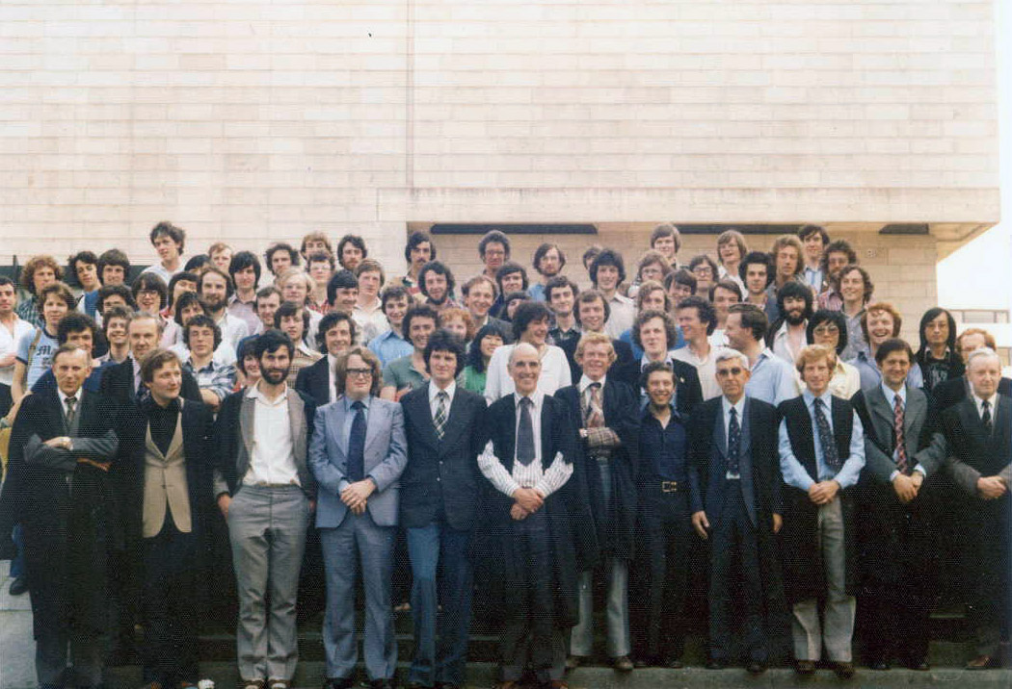
Figure 1: Photograph, TCD Engineering School BAI Class of 1977-1978
Photograph courtesy Engineering School, Trinity College Dublin

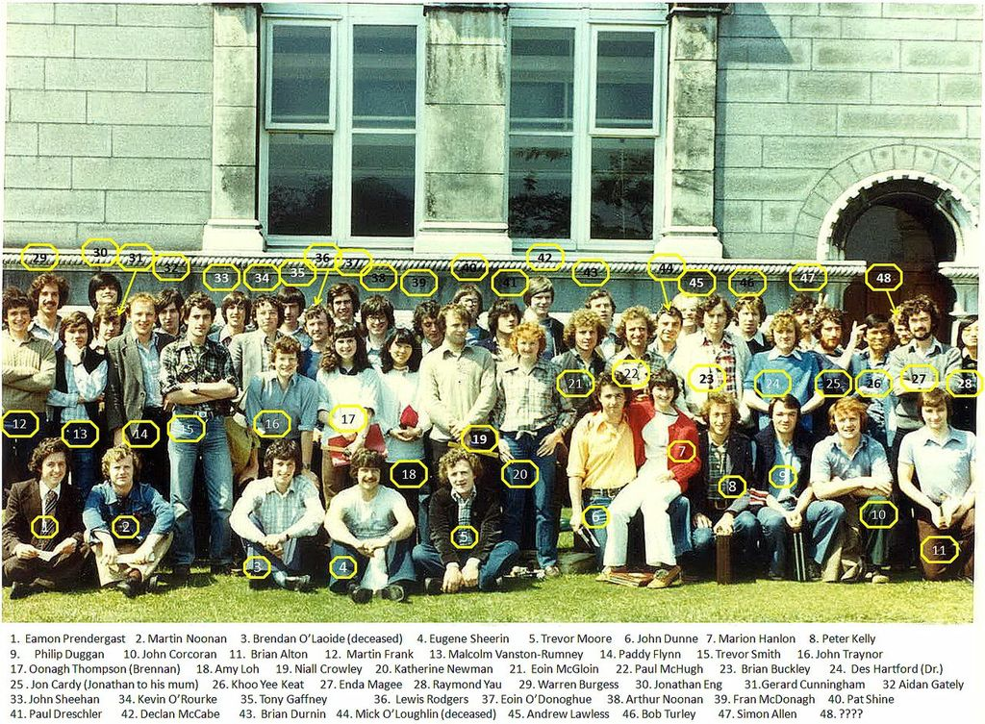
Figure 2: Photograph, TCD Engineering School BAI Class of 1977-1978
Photograph courtesy Bryan Alton

