AccessionIndex: TCD-SCSS-V.20180217.001
Accession Date: 17-Feb-2018
Accession By: Prof.Dave Vernon, TCD Engineering School
Object name: Class Photograph, TCD Engineering School BAI Class of 1978-1979
Vintage: c.1979
Synopsis: Trinity College Dublin, Class Photographs, with accompanying identification.

Description:
Many thanks to the Engineering School, Trinity College Dublin, for permission to republish the official class photograph.

Also many thanks to Dave Vernon, a TCD Engineering School graduate of 1979, and subsequently a Dept.Computer Science postgraduate then staff member, who donated the additional photographs.

Dave was in the undergraduate Engineering class of 1978-1979. The BAI degree course lasted four years, but without specialisation for the first two years.

The homepage for this catalog is at: https://www.scss.tcd.ie/SCSSTreasuresCatalog/
Click 'Accession Index' (1st column listed) for related folder, or 'About' for further guidance. Some of the items below may be more properly part of other categories of this catalog, but are listed here for convenience.

Accession Index | Object with Identification
TCD-SCSS-V.20180217.001 | Class Photograph, TCD Engineering School BAI Class of 1978-1979, Trinity College Dublin, Class Photographs, with accompanying identification, c.1979.
TCD-SCSS-V.20180217.001.001 | High-resolution Class Photograph, TCD Engineering School BAI Class of 1978-1979, Trinity College Dublin, c.1979.
TCD-SCSS-V.20180217.001.002 | Low-resolution Class Photograph, TCD Engineering School BAI Class of 1978-1979, Trinity College Dublin, c.1979.
TCD-SCSS-V.20180217.001.003 | Class Photograph, TCD Engineering School BAI Class of 1978-1979, Trinity College Dublin, photograph with identification, 1970.

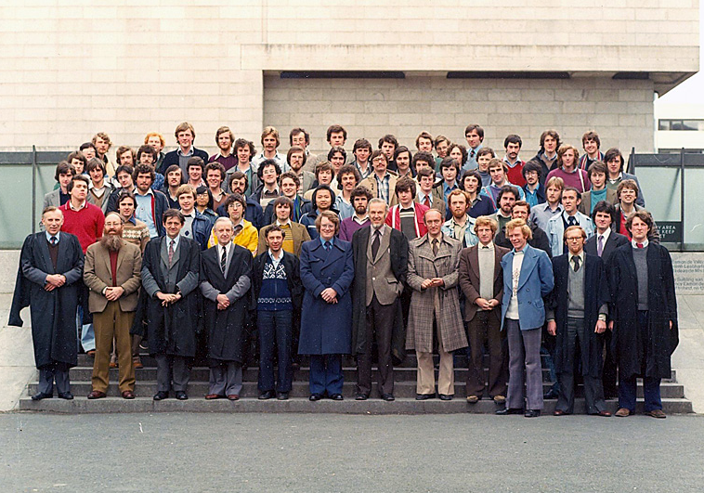
Figure 1: Class Photograph, TCD Engineering School BAI Class of 1978-1979
High-resolution photograph courtesy Engineering School, Trinity College Dublin

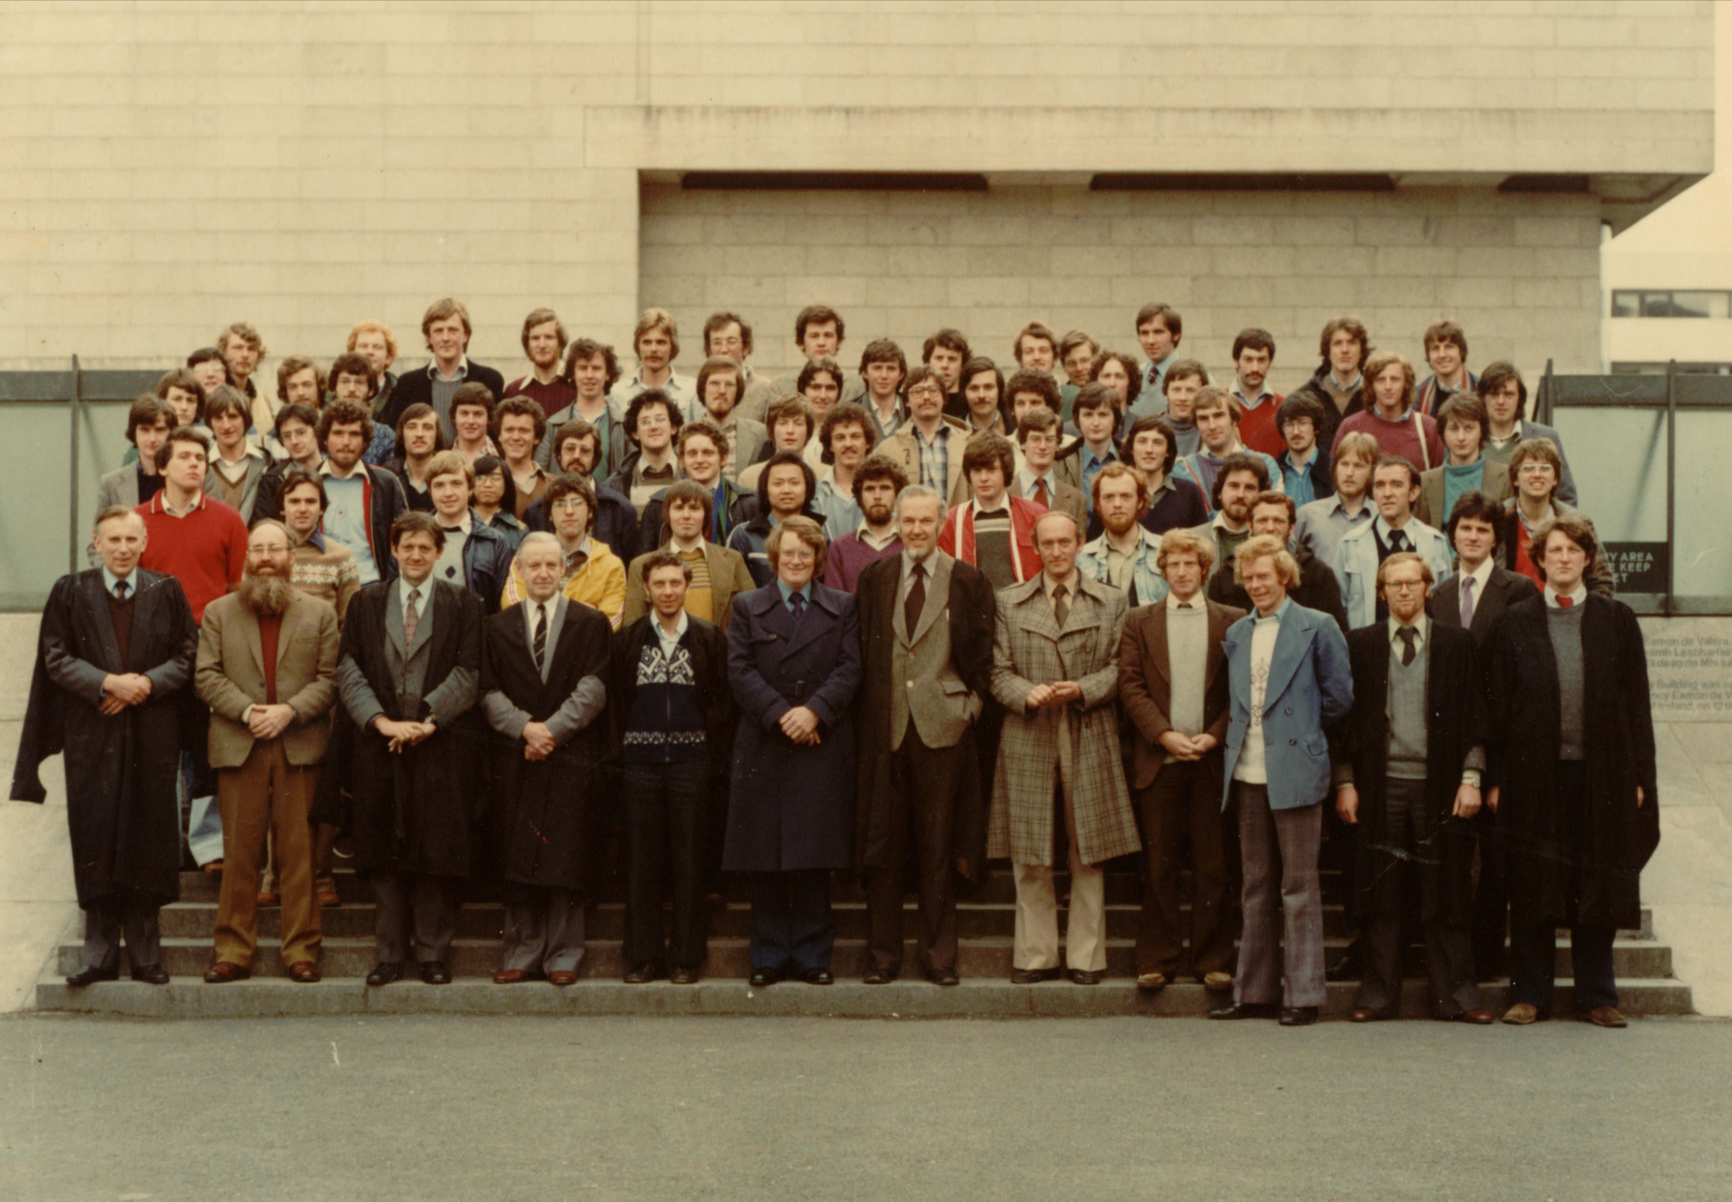
Figure 2: Class Photograph, TCD Engineering School BAI Class of 1978-1979
Low-resolution photograph courtesy Dave Vernon

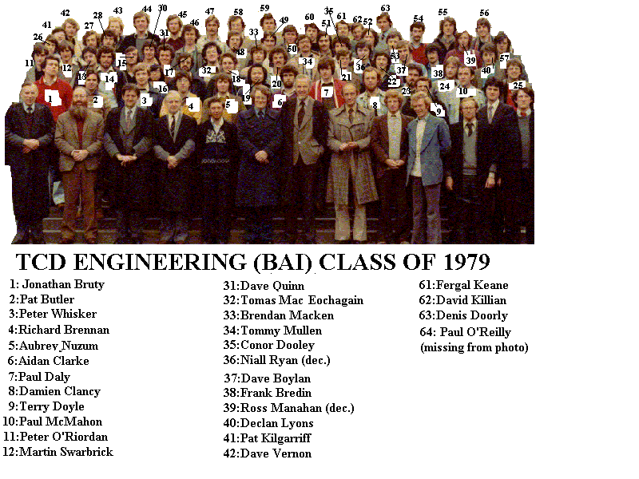
Figure 3: Class Photograph, TCD Engineering School BAI Class of 1978-1979 identification
Photograph and identification courtesy Dave Vernon

