AccessionIndex: TCD-SCSS-V.20180124.002
Accession Date: 24-Jan-2018
Accession By: Elizabeth Oldham
Object name: Class Photograph, TCD M.Sc. in Computer Practice Class of 1978-1979
Vintage: 1979
Synopsis: Trinity College Dublin, Class Photographs, with accompanying identification.

Description:
Professor J.G.Byrne of the Department of Computer Science, Trinity College Dublin, initiated the Computers in Education Diploma, a graduate diploma course first run in 1973-74. The higher-achieving students from the first four cohorts taking the diploma course were invited to proceed to a second year of study leading to the degree of Master in Computer Practice – another initiative of Professor Byrne’s. The Master’s course was run only once, starting in Autumn 1977, but it made a significant contribution, see Elizabeth Oldham’s History of Computing Education in Irish Schools elsewhere in this catalog. Figure 1 shows Professor Byrne with the graduates on the occasion of their Commencements in summer 1979.

Many thanks to Elizabeth Oldham for donating this item, and for permission to publish it in this online catalog.

The homepage for this catalog is at: https://www.scss.tcd.ie/SCSSTreasuresCatalog/
Click 'Accession Index' (1st column listed) for related folder, or 'About' for further guidance. Some of the items below may be more properly part of other categories of this catalog, but are listed here for convenience.

Accession Index | Object with Identification
TCD-SCSS-V.20180124.002 | Class Photograph, TCD M.Sc. in Computer Practice Class of 1978-1979, Trinity College Dublin, Class Photographs, with accompanying identification, 1979.
TCD-SCSS-V.20180124.001 | Elizabeth Oldham, History of Computing Education in Irish Schools. Video of presentation to Computers in Education Society of Ireland (CESI) Computer Science Symposium, September 2017.

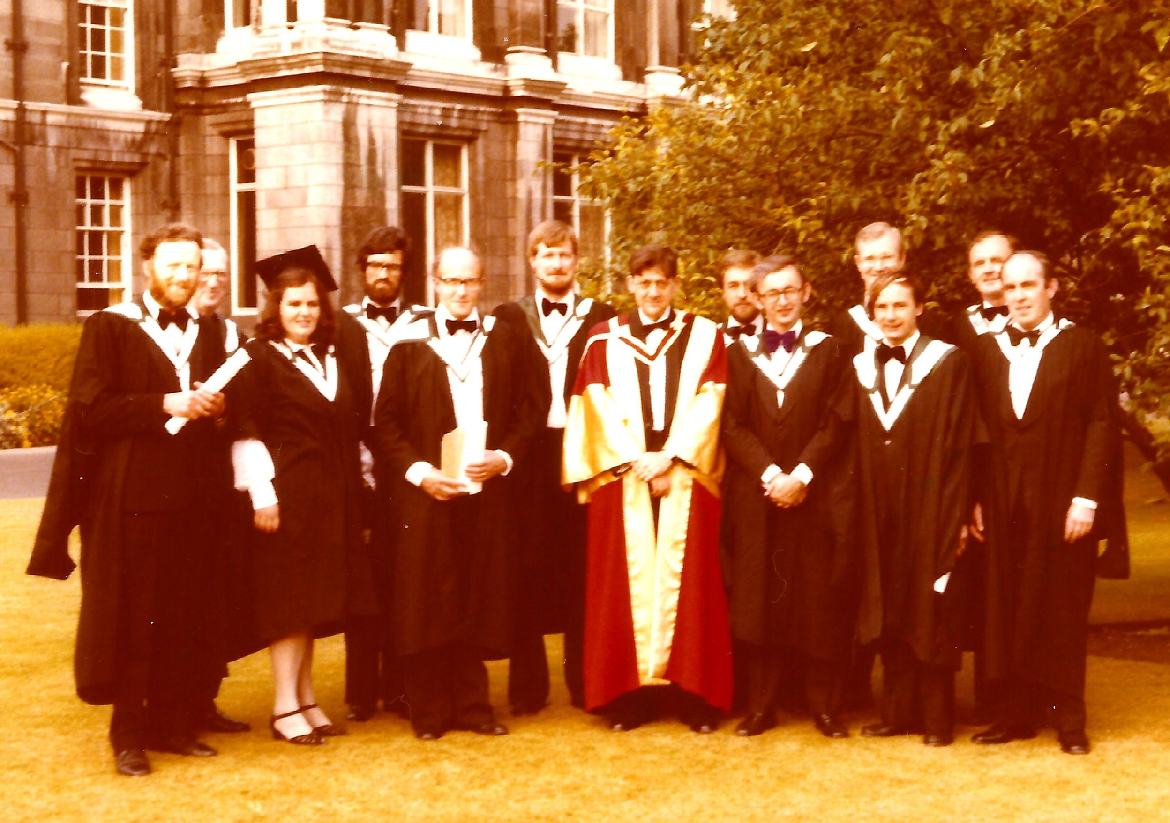
Figure 1: Graduates of the M.Sc. in Computer Practice, 1979, with Prof.J.G.Byrne
Photograph courtesy Elizabeth Oldham

Figure 2: Graduates of the M.Sc. in Computer Practice, 1979, with Prof.J.G.Byrne
Photograph and identification courtesy <?>

