AccessionIndex: TCD-SCSS-V.20180124.001
Accession Date: 24-Jan-2018
Accession By: Elizabeth Oldham
Object name: History of Computing Education in Irish Schools
Vintage: 2017
Synopsis: Video of presentation to Computers in Education Society of Ireland (CESI) Computer Science Symposium, September 2017.

Description:
This item is a video recording of a presentation on the history of computing education in Irish schools, given by Elizabeth Oldham on the 16-Sep-2017, to the Computers in Education Society of Ireland (CESI) Computer Science Symposium.

Many thanks to Elizabeth Oldham for donating this item, and also to Daniel Murray for recording [2] this event, and to CESI for permission to preserve a copy of the recording in this collection for posterity, and to publish it in this online catalog.

The extended description below, again by Elizabeth Oldham (currently Adjunct Assistant Professor, School of Mathematics, and previously Lecturer and then Senior Lecturer in the School of Education) brings the history up to date, including the contributions made by the School of Education at Trinity College Dublin.

Setting the Scene
Additional notes on the part played by Trinity with regard to computing in schools
Elizabeth Oldham

My short presentation “Setting the scene” at the Computers in Education Society of Ireland (CESI) Computer Science Symposium (16th September 2017) focused on the system-level developments with regard to computing in Irish schools from around 1970, and on the role of CESI as advocates for such developments and as providers of in-career support – especially one-week “summer courses” – for teachers. The talk did not address the role of third-level institutions. That omission is remedied somewhat here, at least with respect to the contribution of Trinity College. Two main phases are distinguished: the early years (from around 1970 to about 1990), and the more recent years (from the late 1990s to the present time).

In the early period Professor Byrne, Professor of Computer Science, gave crucial support to the thrust for “computers in education” in at least two ways. First, he supervised the M.Sc. done by Fr. Cyril Byrne, CSSp, a second-level teacher, in devising a pseudo-assembly language – Computer Science Student Programming language, or CSSP – suitable for simple programming in schools. The language was named in the “Computer Studies option” introduced into the Leaving Certificate Mathematics course in 1980. Secondly, he initiated the Computers in Education Diploma, a graduate diploma course first run in 1973-74. Directed at teachers, not only did this provide thorough in-career development for many participants – some of whom went on to be leaders in the field of “computers in education” – but also its first cohort formed the Dublin Branch of CESI. From about 20 entrants in the first year, the uptake grew to nearer 100 per annum for a while, especially when it appeared that possession of the graduate diploma might be a recognisable qualification for teaching computing courses in schools. However, that did not happen. Although a Computer Studies course was introduced into the junior cycle of post-primary education in 1985, it never became strongly embedded; attention in schools moved away from more rigorous computing to a focus on computer skills and on teaching and learning with ICT. The Diploma course faded out, partly because of – cheaper – competition elsewhere (though the competing courses were not labelled as being at graduate level), and partly because of the changed focus in schools.

It should be noted that the higher-achieving students from the first four cohorts taking the Computers in Education Diploma were invited to proceed to a second year of study leading to the degree of Master in Computer Practice – another initiative of Professor Byrne’s. The Master’s course was run only once, starting in Autumn 1977, but it made a significant contribution in providing outstanding leaders for computing as CESI and other bodies sought (albeit with only limited success) to get Computer Studies / Computer Science courses established in the school curriculum. Figure 2 shows Professor Byrne with the graduates on the occasion of their Commencements in summer 1979.

The role of the School of Education under Professor Valentine Rice in this period should also be mentioned. Professor Rice ensured that teacher education courses from at least 1969 – the year in which I took the Higher Diploma in Education – contained an element on “computers in education,” or (later) “education and the new information technologies.” For around 25 years as a member of staff in the School of Education, I taught these elements, eventually handing over to a colleague appointed specifically for the task. However, the focus was on general education about the roles that ICT could or should play in education, together with provision of an experience of what we would now call computational thinking; the courses were not geared to the production of computing specialists, though some students chose to conduct their research in the area.

The second phase of Trinity’s contribution started in the late 1990s. Under the leadership of both Professor Byrne in Computer Science and Susan Parkes in Education, the Centre for Research in IT in Education (CRITE) was formally established in 2000. Professor Byrne was particularly involved with regard to the associated Master’s programme, the M.Sc. in IT and Education (later Technology and Learning), which took in its first cohort of students the previous year (1999). CRITE has been a powerhouse for innovative research ever since. Some of its work, and the work of the allied initiative Bridge21 (Bridge to 21st Century Learning) – originally Bridge2College – has focused on aspects of computing. The recent establishment of a Postgraduate Certificate in 21C Teaching and Learning, again as a joint initiative between the Department of Computer Science (now School of Computer Science and Statistics) and the School of Education, aims to enhance the expertise of participant teachers in new models of teaching and learning with particular emphasis on STEM subjects: Science, Technology, Engineering, Mathematics and – of especial interest here – Computer Science.

Professor Byrne continued to be supportive and interested over the years. He would be delighted to know that – at last! – an exciting Leaving Certificate course in Computer Science was launched by the Minister for Education and Skills in February 2018, and will be implemented (initially in a small number of schools) in autumn 2018. The new Computer Science course specification owes much to the Bridge21 model for teaching and learning, and the Certificate course will continue to develop and help to provide the suitably qualified and knowledgeable teachers who will be required for successful implementation.

I can end on a personal note. I first met Professor Byrne in 1969 when I was asked to lecture on Logic to the Computer Science students (and later to all the engineers). His vision for the topic reflected his belief in a broad general education. Later, when I was working on my M.Ed. thesis, I wrote programs in FORTRAN to process data collected for the Curriculum Development Unit in College (no SPSS or equivalent was available to us in those days!); Professor Byrne himself helped me locate an elusive bug in one of the programs. We met also in a very different context: on many occasions I sat near him in the old West Stand at Lansdowne Road, watching Rugby matches. His interest in Rugby did not equal his passion for horse racing, but it was strong. In more recent years, when he was still able to come into College, we sometimes encountered each other in the Hamilton restaurant and chatted as we ate our lunch. It was a toss-up as to whether we talked about computer education or Rugby! I shall always cherish the happy memories.

Many thanks to Elizabeth Oldham for permission to republish the description above.

The video of this presentation is available at:
https://www.scss.tcd.ie/SCSSTreasuresCatalog/literature/TCD-SCSS-V.20180124.001/ElizabethOldham-Intro-talk-CESI-Symposium-2017.mp4
The slides for the presentation are available at:
(a) https://www.scss.tcd.ie/SCSSTreasuresCatalog/literature/TCD-SCSS-V.20180124.001/ElizabethOldham-Intro-talk-CESI-Symposium-2017.ppt
(b) https://www.scss.tcd.ie/SCSSTreasuresCatalog/literature/TCD-SCSS-V.20180124.001/ElizabethOldham-Intro-talk-CESI-Symposium-2017.pptx

The homepage for this catalog is at: https://www.scss.tcd.ie/SCSSTreasuresCatalog/
Click 'Accession Index' (1st column listed) for related folder, or 'About' for further guidance.
Some of the items below may be more properly part of the other categories of this catalog, but listed here for convenience.

Accession Index | Object with Identification
TCD-SCSS-V.20180124.001.001 | Elizabeth Oldham, History of Computing Education in Irish Schools. Video of presentation to Computers in Education Society of Ireland (CESI) Computer Science Symposium, September 2017. Electronic video file in MPEG-4 format on DVD and online (Video: AVC1, 1280 x 720, 1010kbps, 25fps, Audio: AAC, 192kbps, 44kHz).
TCD-SCSS-V.20180124.001.002 | Elizabeth Oldham, History of Computing Education in Irish Schools. Slides for presentation to Computers in Education Society of Ireland (CESI) Computer Science Symposium, September 2017. Electronic file of Powerpoint slide presentation in PPT and PPTX formats on CD and online.
TCD-SCSS-V.20180409.001 | Prof.Jane Grimson, Memorial Discourse on Prof.J.G.Byrne presented on Trinity Monday, 2018.
TCD-SCSS-T.20160323.001 | Networking and the Internet, Networking hardware and the arrival of the Internet in Ireland, c.1991.
TCD-SCSS-X.20121208.004 | History of the Department of Computer Science, Trinity College Dublin. The evolution of computer science as reflected in the long line of machines used by the department since its inception, c.1969
TCD-SCSS-X.20121208.006 | Department of Statistics, Trinity College Dublin. The evolution of the Dept.Statistics as reflected in the machines used since its inception c.1968.
TCD-SCSS-X.20121208.005 | The Computer Laboratory, Trinity College Dublin. The evolution of Trinity College Dublin computing services as reflected in the long line of machines used by the Computer Lab since its inception c.1968.

See the related documents in the associated folder in this catalog.

References:

- Computers in Education Society of Ireland, see:
http://www.cesi.ie/
Last browsed to on 24-Jan-2018.

- Elizabeth Oldham, Setting the Scene; Getting it right this time ..., CESI Symposium-2017, published by Daniel Murray on YouTube, see:
https://www.youtube.com/watch?v=8r6fSW0d1W8&feature=youtu.be
Last browsed to on 24-Jan-2018.

- Elizabeth Oldham, The First Twenty-Five Years: Recollections of a Long-Standing Member, Computers in Education Society of Ireland, see:
http://www.cesi.ie/about-cesi/first-25-years/
Last browsed to on 24-Jan-2018.

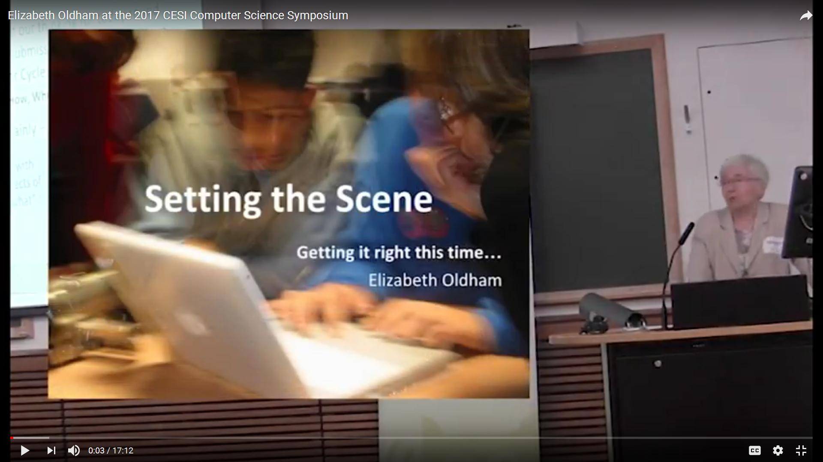
Figure 1: Presentation by Elizabeth Oldham on the history of computing education in Irish schools
to the Computers in Education Society of Ireland (CESI) Computer Science Symposium, September 2017 Screenshot from recording by Daniel Murray

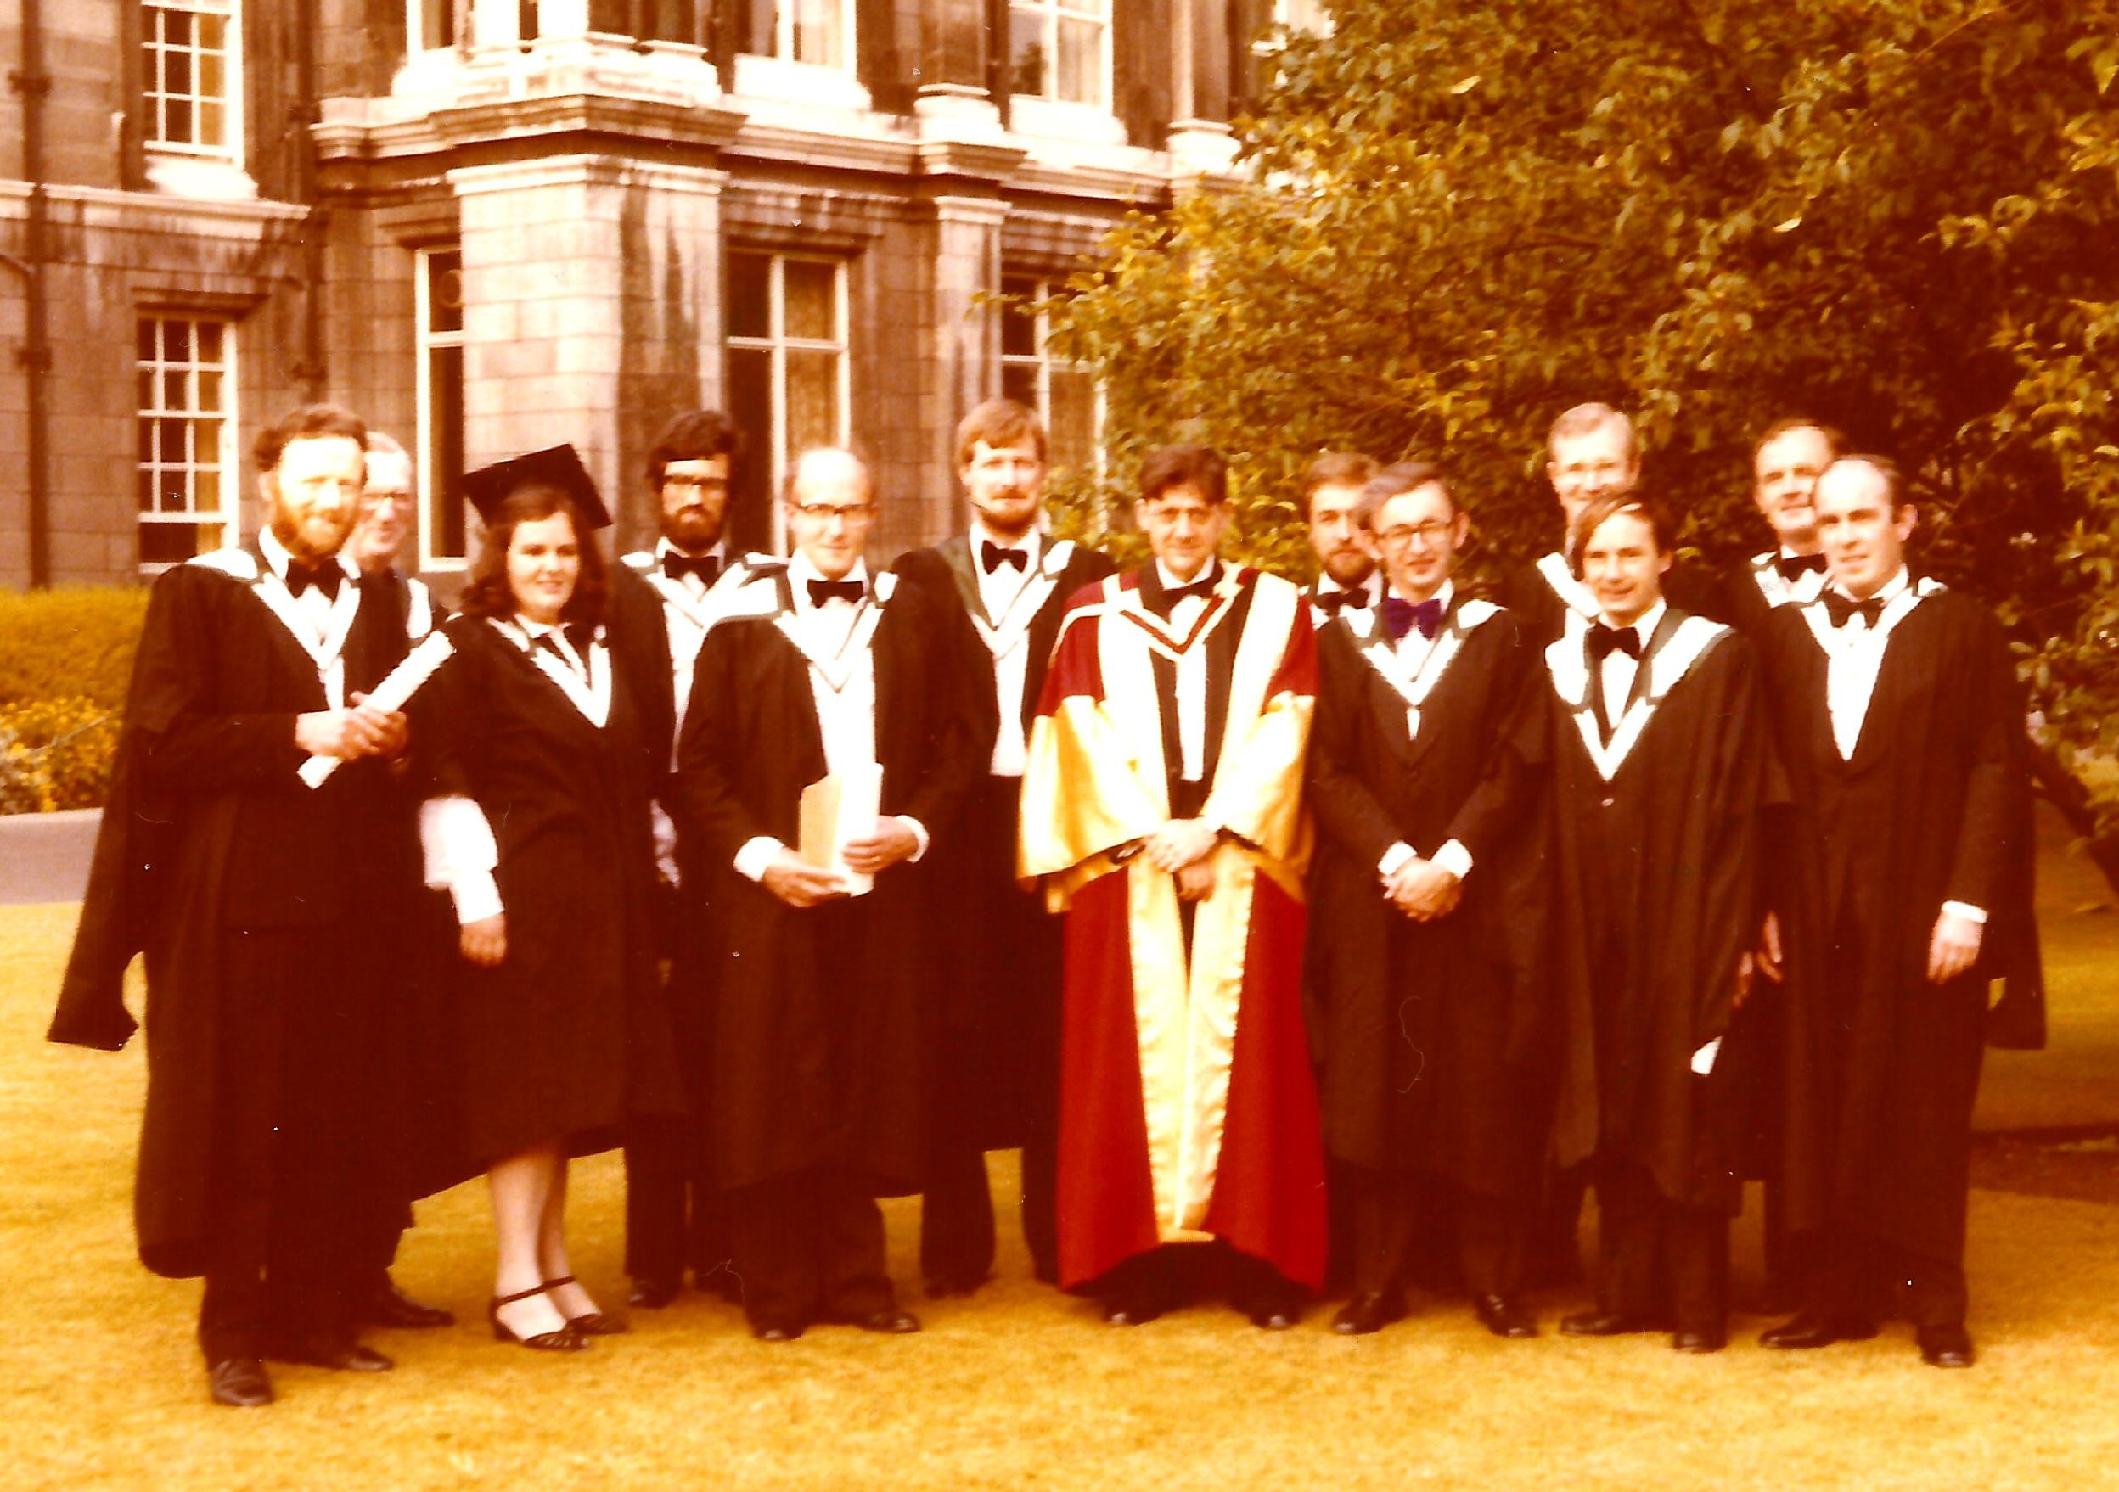
Figure 2: Graduates of the M.Sc. in Computer Practice, 1979, with Prof.J.G.Byrne
Photograph courtesy Elizabeth Oldham

