AccessionIndex: TCD-SCSS-V.20171231.001
Accession Date: 31-Dec-2017
Accession By: Dr.Chris Horn
Object name: Professor John Byrne: Reminiscences: Father of Computing in Ireland
Vintage: 2017
Synopsis: Ed: Chris Horn, ISBN-10: 1520696841, ISBN-13: 978 1520696843.

Description:
Professor John Gabriel Byrne, see Fig.1, was the founding professor and long-time head of the University’s Department of Computer Science [1], a Senior Fellow, dedicated public servant, and notably self-effacing and kindly gentleman, who is acknowledged by many as the “Father of Computing in Ireland”. This book [2] draws on an appeal for the memories of those who knew Prof.Byrne well, see Fig.2.

The book, see Fig.3, is available online, for example at: https://www.amazon.com/Professor-John-Byrne-Reminiscences-Computing/dp/1520696841

Further detail on the life and contributions of Prof.J.G.Byrne can be found in related documents in the associated folder in this catalog [3], in the nine interviews of Prof.J.G.Byrne by Maurice O'Keefe [4], and in the obituaries of Prof.J.G.Byrne [5, 6, 7]. The history of the department’s major contribution to Irish networking and the Internet is outlined in [8], while the history of the department itself can be found in [9]. Further details can be found in the history of the Department of Statistics (now united with Computer Science in the School of Computer Science and Statistics) [10], the history of the Computer Laboratory (now IT Services) [11], and the history of computing education in Irish schools by Elizabeth Oldham [12].

This book is edited by Dr.Chris Horn, who did his Ph.D. in Prof.Byrne’s department, became a staff member, and then was a founder of Iona Ltd. Many thanks to Chris for his efforts in creating this book, and for donating this item.
The homepage for this catalog is at: https://www.scss.tcd.ie/SCSSTreasuresCatalog/
Click 'Accession Index' (1st column listed) for related folder, or 'About' for further guidance. Some of the items below may be more properly part of other categories of this catalog, but are listed here for convenience.

Accession Index | Object with Identification
TCD-SCSS-V.20171231.001 | Ed: Chris Horn, Professor John Byrne: Reminiscences: Father of Computing in Ireland, ISBN-10: 1520696841, ISBN-13: 978 1520696843, 2017.
TCD-SCSS-V.20180409.001 | Prof.Jane Grimson, Memorial Discourse on Prof.J.G.Byrne presented on Trinity Monday, 2018. Official electronic audio file in MPEG-3 format on CD and online (Video: AVC1, 1280 x 720, 4869kbps, 25fps, Audio: AAC, 160kbps, 48kHz).
TCD-SCSS-V.20180312.001 | Memorium and Obituaries for Prof.J.G.Byrne, born: 25-Jul-1933, died: 16-Apr-2016, see:  https://scss.tcd.ie/SCSSTreasuresCatalog/Prof-John-Gabriel-Byrne-1933-2016.pdf
TCD-SCSS-V.20160929.001 | Nine interviews of Prof.J.G.Byrne, TCD. O'Keefe, Maurice & Jane, 'Irish Life and Lore, Trinity College Dublin, John Byrne', CD no.55, 68:50 mins, MPEG 160kbps. Vintage: c.2012.
TCD-SCSS-X.20180907.002 | Prof.J.G.Byrne, Computerisation of the TCD Library 1872 Accessions Index.
TCD-SCSS-V.20180312.002 | Portrait of Prof.John Gabriel Byrne, Trinity College Dublin, portrait by Atsushi Kaga, 2005.
TCD-SCSS-X.20121208.007 | Richardson’s Fantastic Forecast Factory. Painting of imaginary prediction factory, based on Ch.11 of Richardson’s 'Weather Prediction by Numerical Process', ink and water colour, commissioned and owned by Prof.J.G.Byrne, painted by and Copyright of Stephen Conlin, 1986.
TCD-SCSS-T.20160323.001 | Networking and the Internet, Networking hardware and the arrival of the Internet in Ireland, c.1991.
TCD-SCSS-X.20121208.004 | History of the Department of Computer Science, Trinity College Dublin. The evolution of computer science as reflected in the long line of machines used by the department since its inception, c.1969
TCD-SCSS-X.20121208.006 | Department of Statistics, Trinity College Dublin. The evolution of the Dept.Statistics as reflected in the machines used since its inception c.1968.
TCD-SCSS-X.20121208.005 | The Computer Laboratory, Trinity College Dublin. The evolution of Trinity College Dublin computing services as reflected in the long line of machines used by the Computer Lab since its inception c.1968.
TCD-SCSS-V.20180124.001 | Elizabeth Oldham, History of Computing Education in Irish Schools. Video of presentation to Computers in Education Society of Ireland (CESI) Computer Science Symposium, September 2017.
TCD-SCSS-X.20121208.001 | Charles Babbage's Engines, Irish interactions with Charles Babbage regarding his Difference Engines and Analytical Engine, c.1843.
TCD-SCSS-V.20121208.870 | Ada Lovelace's famous translation with an 'Addition', Prof.J.G.Byrne's offprint of Ada Lovelace's translation of L.Menabrea's 'Sketch' of the Analytical Engine, incorporating an offprint of Charles Babbage's 'Addition', c.1843.
TCD-SCSS-X.20121208.002 | Percy E. Ludgate Prize in Computer Science. Prize in memory of Percy Ludgate's novel  1909 design for an Analytical Engine, the next after Babbage's.
TCD-SCSS-T.20121208.019 | IBM 1620. TCD's first computer, purchased in 1962. Vintage: c.1959.
TCD-SCSS-T.20121208.018 | IBM 360/44 console and subsystems. Control panel, CPU logic, core memory from IBM 360/44 installed in Trinity College Dublin to provide a service to all sectors of College, including the Dept.Computer Science, from 1969. Vintage: c.1965
References:
- Trinity College Dublin, School of Computer Science and Statistics, see:
https://www.scss.tcd.ie/
Last viewed 14-Feb-2018.

2. Ed: Chris Horn, Professor John Byrne: Reminiscences: Father of Computing in Ireland, ISBN-10: 1520696841, ISBN-13: 978-1520696843, 2017, see elsewhere in this catalog.

3. Jane Grimson, Memorial Discourse on Prof.J.G.Byrne, presented on Trinity Monday, 2018, Trinity College Dublin, see associated folder in this catalog.

4. O'Keefe, Maurice & Jane, Nine interviews of Prof.J.G.Byrne, TCD., 'Irish Life and Lore, Trinity College Dublin, John Byrne', CD no.55, 68:50 mins, MPEG 160kbps, c.2012, see elsewhere in this catalog.

5. Irish Times, The father of computing in Ireland, Saturday, 23-Apr-2016, see:
https://scss.tcd.ie/SCSSTreasuresCatalog/Prof-John-Gabriel-Byrne-1933-2016.pdf
Last browsed to on 14-Feb-2018.

6. The Library of Trinity College Dublin, Passing of Professor John Byrne, Memorium, 28-Apr-2016, see:
https://www.tcd.ie/library/news/passing-of-professor-john-byrne/
https://scss.tcd.ie/SCSSTreasuresCatalog/Prof-John-Gabriel-Byrne-1933-2016.pdf
Last browsed to on 14-Feb-2018.

7. Irish Computer Society, Obituary: ICS Distinguished Fellow - Professor John Byrne, 25-Apr-2016, see:
https://www.ics.ie/news/obituary-ics-distinguished-fellow-professor-john-byrne
https://scss.tcd.ie/SCSSTreasuresCatalog/Prof-John-Gabriel-Byrne-1933-2016.pdf
Last browsed to on 14-Feb-2018.

8. School of Computer Science and Statistics, Networking and the Internet, Networking hardware and the arrival of the Internet in Ireland, c.1991, see elsewhere in this catalog.

9. School of Computer Science and Statistics, History of the Department of Computer Science, Trinity College Dublin, The evolution of computer science as reflected in the long line of machines used by the department since its inception, c.1969, see elsewhere in this catalog

10. School of Computer Science and Statistics, Department of Statistics, Trinity College Dublin. The evolution of the Dept.Statistics as reflected in the machines used since its inception, c.1968, see elsewhere in this catalog.

11. School of Computer Science and Statistics, The Computer Laboratory, Trinity College Dublin. The evolution of Trinity College Dublin computing services as reflected in the long line of machines used by the Computer Lab since its inception, c.1968, see elsewhere in this catalog.

12. Elizabeth Oldham, History of Computing Education in Irish Schools, video of presentation to Computers in Education Society of Ireland (CESI) Computer Science Symposium, September 2017, see elsewhere in this catalog.
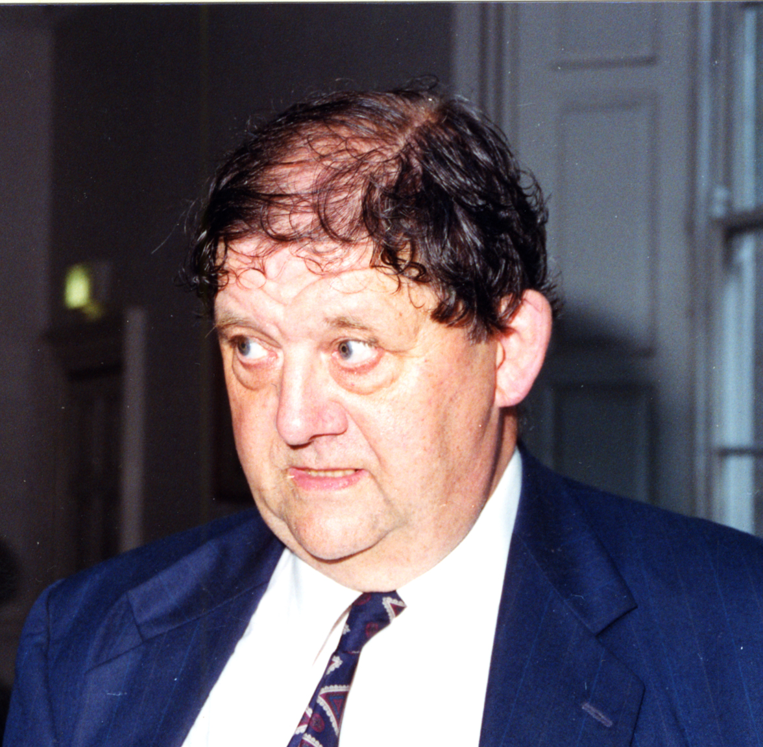
Figure 1: Professor John Gabriel Byrne,”the image of John”

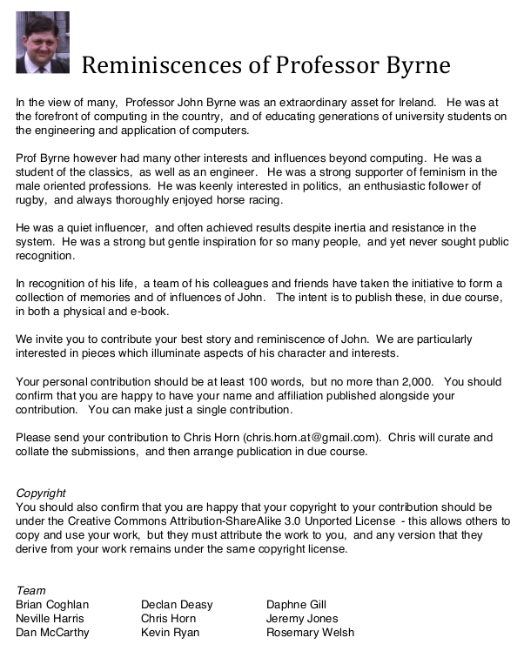
Figure 2: Appeal that led to the book on Professor John Gabriel Byrne

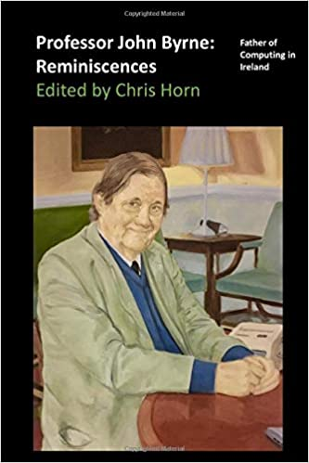
Figure 3: Professor John Byrne: Reminiscences: Father of Computing in Ireland, front cover

