AccessionIndex: TCD-SCSS-V.20170124.001
Accession Date: 24-Jan-2017
Accession By: Dr.Brian Coghlan
Object name: Nature volume that includes review of article on Percy Ludgate's analytical engine
Vintage: c.1909
Synopsis: Nature, Vol.81, including: C.V.Boys, 'A new analytical engine', pp.14-15, Jul-1909.

Description:
In 1909, working entirely on his own in his spare time, unaware of Babbage’s work, Dublin clerk to a corn merchant (and later an accountant) Percy Edwin Ludgate (1883-1922) designed an analytical engine, the next after Charles Babbage. There are only three sources on Ludgate’s machine: his Apr-1909 paper in the Scientific Proceedings of the Royal Dublin Society [1], the Jul-1909 review of Ludgate’s article by Charles Vernon Boys in this Volume 81 of Nature [2], and his 1914 article in the Napier Tercentenary Celebration handbook [3]. For more detail on Percy Ludgate’s Analytical Engine see elsewhere in the Hardware category of this catalog.

Ludgate’s 1909 paper was refereed by Prof.A.W.Conway, then by Sir Charles Vernon Boys (1855-1944), a very well-known British physicist.

This item is a complete ex-libris 1st Edition Volume 81 (Jul-1909 to Oct-1909) of 540 pages, published by Macmillan and Co., London, measuring 10.5” x 8” (263mm x 200mm). It has the usual markings on the front cover and spine, and on the spine there is an additional handwritten ’53’. It is in good condition, solidly bound in the original Nature brown/orange with planetary gilt planet and stars on both the spine and the front, black ruled and lettered, but with slight scuffing at the edges and a small closed tear at the head of the spine.

Also included in this volume is John G.McKendrick’s “Further Experiments with the Gramophone”, pp. 488-490.

For the front and rear covers, title pages, table of contents, selected content, etc, see Figure 1 onwards below.

The homepage for this catalog is at: https://www.scss.tcd.ie/SCSSTreasuresCatalog/
Click 'Accession Index' (1st column listed) for related folder, or 'About' for further guidance.
Some of the items below are more properly part of the Hardware category of this catalog, but are listed here for convenience.

Accession Index | Object with Identification
TCD-SCSS-V.20170124.001 | Nature volume that includes review of article on Percy Ludgate's analytical engine, Nature, Vol.81, including: C.V.Boys, 'A new analytical engine', pp.14-15, Jul-1909.
TCD-SCSS-V.20121208.873 | On a Proposed Analytical Machine, Percy E.Ludgate, offprint of article in Scientific Proceedings of the Royal Dublin Society, 1909.
TCD-SCSS-V.20170217.001 | Reprint of 1909 RDS Proceedings that includes article on Percy Ludgate's analytical engine, Scientific Proceedings of the Royal Dublin Society, Vol.12, No.9, including: Percy E.Ludgate, 'On a Proposed Analytical Machine', pp.77-91, 28-Apr-1909, reprinted 2016.
TCD-SCSS-V.20170221.001 | Napier Tercentenary Celebration Handbook that includes article by Percy Ludgate, Handbook of the Napier tercentenary celebration or modern instruments and methods of calculation, Ed: E.M.Horsburgh, including: Percy E.Ludgate, 'Automatic Calculating Machines', 1914.
TCD-SCSS-X.20121208.002 | Percy E. Ludgate Prize in Computer Science, Prize in memory of Percy Ludgate's novel 1909 design for an Analytical Engine, the next after Babbage's, c.1909.
TCD-SCSS-X.20121208.001 | Charles Babbage's Engines, Irish interactions with Charles Babbage regarding his Difference Engines and Analytical Engine, c.1843.

References:

- Percy E.Ludgate, On a Proposed Analytical Machine, Scientific Proceedings of the Royal Dublin Society, Vol.12, No.9, pp.77–91, 28-Apr-1909, see:
http://www.fano.co.uk/ludgate/paper.html
Last viewed 5-Jan-2017.

- C.V.Boys, A New Analytical Engine, Nature Vol.81, pp. 14-15, Jul-1909.

- Percy E.Ludgate, Automatic Calculating Machines, In “Handbook of the Napier tercentenary celebration or modern instruments and methods of calculation”, Ed: E.M.Horsburgh, 1914, see (in Trinity College Library):
http://stella.catalogue.tcd.ie/iii/encore/plus/C__SNapier%20tercentenary%20celebration__Orightresult__U?lang=eng&suite=cobalt
Last viewed 24-Jan-2017.

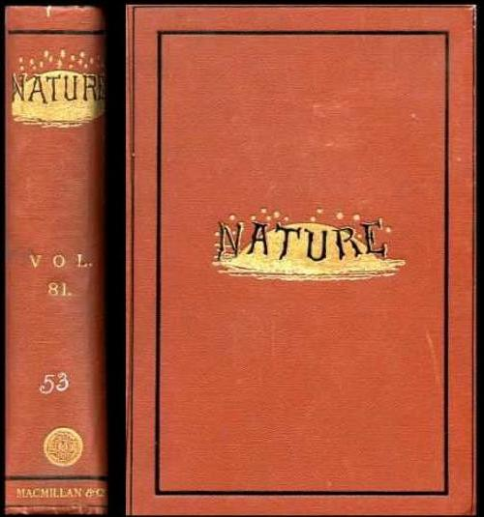
Figure 1: Nature, Vol.81, spine and front cover

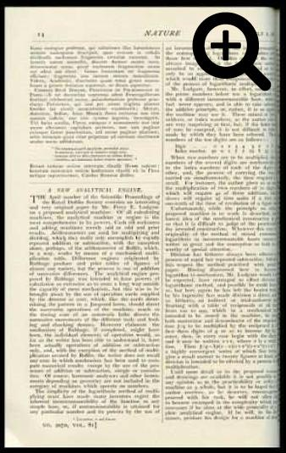
Figure 2: Nature, Vol.81, article on Ludgate’s analytical engine, page 14

