Revealing a hidden past

A few weeks ago Raymond Jordan from the conservation department contacted me to see if I could help with a particular imaging challenge. Dr. Dan McCarthy and Dr. Brian Coghlan from the School of Computer Science and Statistics had contacted him to see if he might provide some aid deciphering a very faint inscription on a historic volume purchased for the John Gabriel Byrne Computer Science Collection. This first edition of Charles Babbage’s “Table of the Logarithms of the Natural Numbers from 1 to 108000”, is believed to be a copy once owned by Lt.Col. Thomas Frederick Colby of the Irish Ordnance Survey. See:
https://www.scss.tcd.ie/SCSSTreasuresCatalog/literature/TCD-SCSS-V.20161219.001/TCD-SCSS-V.20161219.001.pdf

The faint pencil inscription on the first page of the volume is barely visible to the naked eye with many portions seemingly worn away completely. Digital photography helped reveal a bit more, but the handwriting style and the many unreadable portions made transcription a guessing game for some of the inscription and an impossibility for the rest.

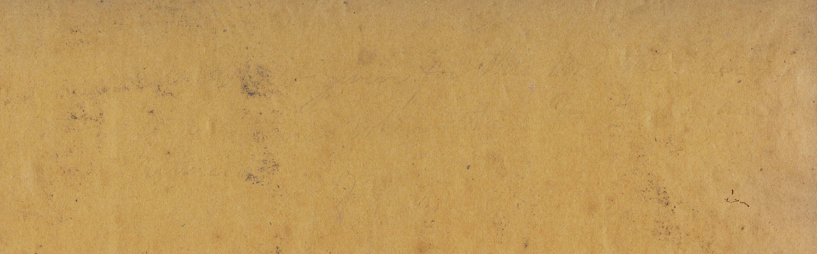
Visible Light


Visible Light (detail)


Visible Light (problem area detail)

As a first step I asked Gill Whelan to image the inscription using our highest resolution camera. This device has an effective resolution of 200 Megapixels (200 million tiny pixels or dots making up the image). While this work helped to reveal bit more information, it was still unable to render the inscription clearly visible. In this state several words were viewable but debate continued to surround the many unclear areas and large gaps in the text.

Spectral imaging
The next stage of the process was to see if specialised forms of digital imaging would be able to pick up and accentuate any faint traces of graphite in the lost areas of the inscription. By using specialised tools and techniques it was our hope that imaging in the infrared spectrum of light might reveal some more information.

Human beings are able to utilise wavelengths of light from approximately 390nm to 700nm. This light encompasses the full rainbow of colours from violet and blue at the 390nm side of the scale to the reds at the 700nm side of the scale.

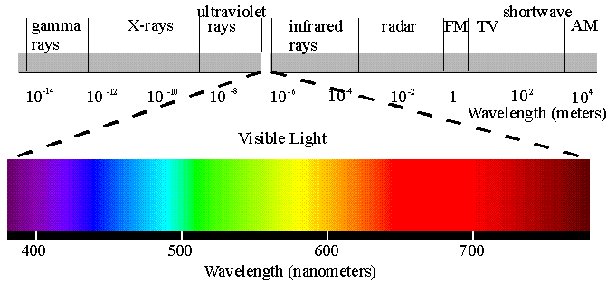

The infrared spectrum exists in wavelengths from the mid 700’s nm to approximately 1mm, past the deepest red browns our eyes can see. Many animals do have visual systems that can see into the infrared spectrum, reptiles, some birds and many insects can see into this space that is invisible to humans (it’s how mosquitoes are able to find even the tiniest area of exposed skin no matter how carefully you cover up). Because this light is invisible to us, it is perfectly adapted to the many uses where we do not want to see illumination. Security camera night vision, television remote controls, automatic door openers, and the autofocus on your digital camera or phone are a few of the many uses of infrared illumination you will likely come across every day.

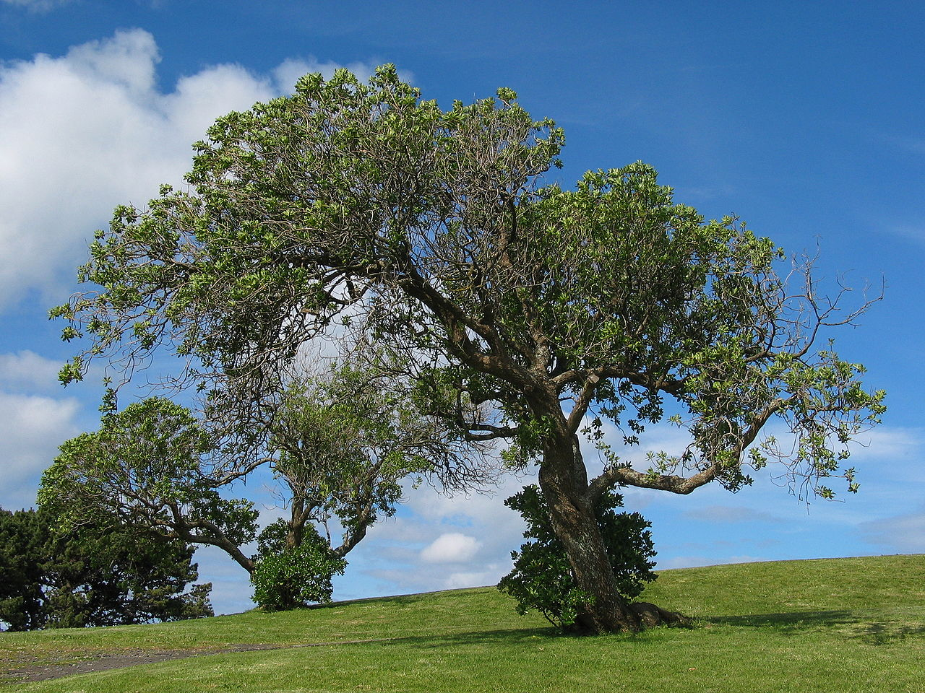
Natural Light Image (Image taken by Daniel Schwen, CC share-alike)

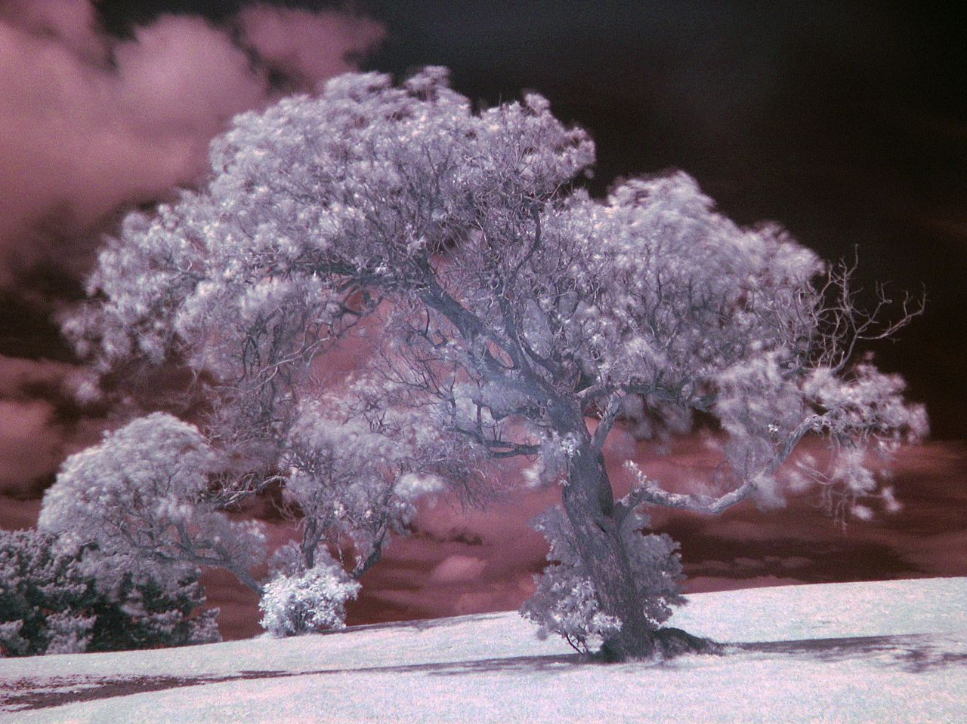
Infrared Image (Image taken by Daniel Schwen, CC share-alike)

By having the specialised IR filters removed from a camera sensor and having the camera’s focus specially tuned to the longer infrared light wavelength we were able to have one of our standard cameras adapted to capture the infrared spectrum in an area close to the wavelengths of human vision, commonly called “near infrared”. Camera manufacturers go to a lot of trouble to eliminate infrared from your images by adding filters to camera sensors and fixing focus on areas of visible light. Camera sensors are naturally able to capture infrared light, but unfortunately by doing so images become unnatural looking (at least to a human).

Because the modified camera sensor also captures visible light we needed to isolate the specific wavelengths of Infrared. By working with a variety of lens filters that isolate specific ranges of infrared wavelengths from visible light, and a standard light source that naturally produces a lot of infrared illumination, we were able to utilise the specific IR wavelengths that were reflected by the graphite that makes up the pencil inscription.

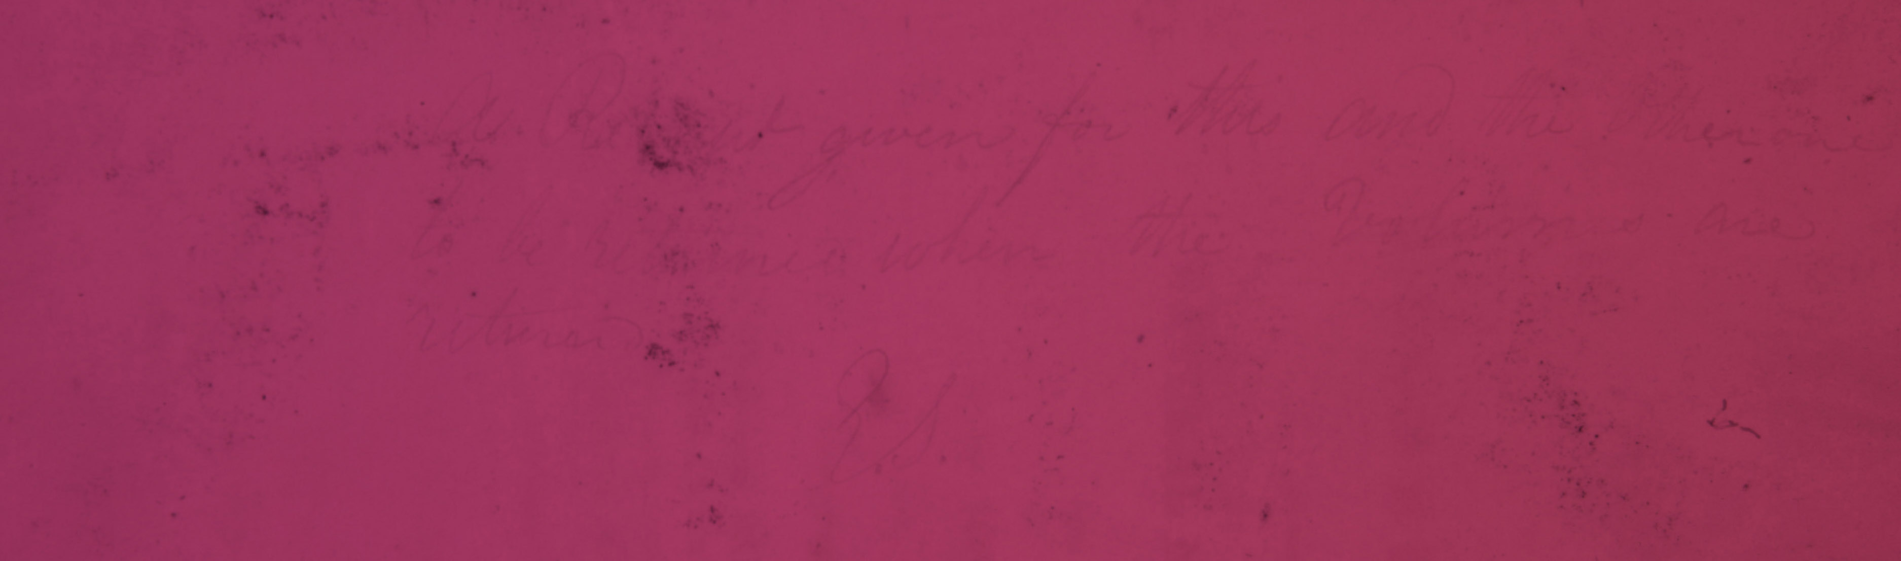
Infrared Image

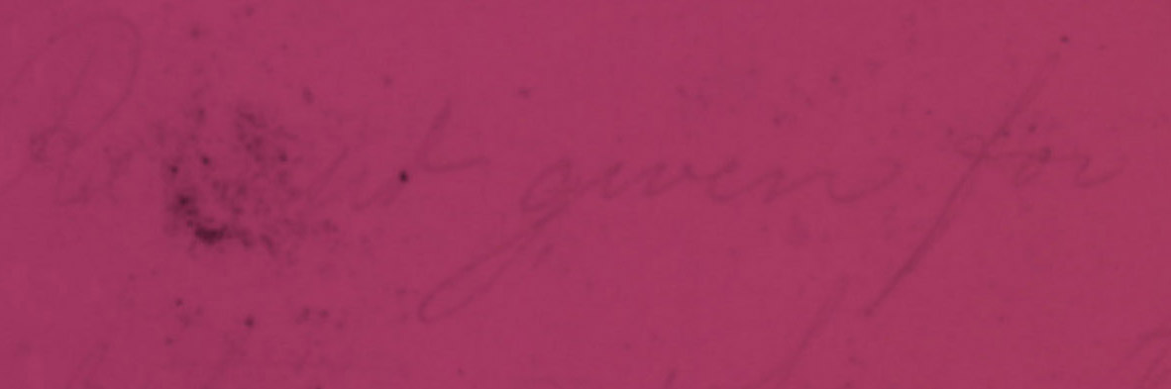
Infrared Image (detail)

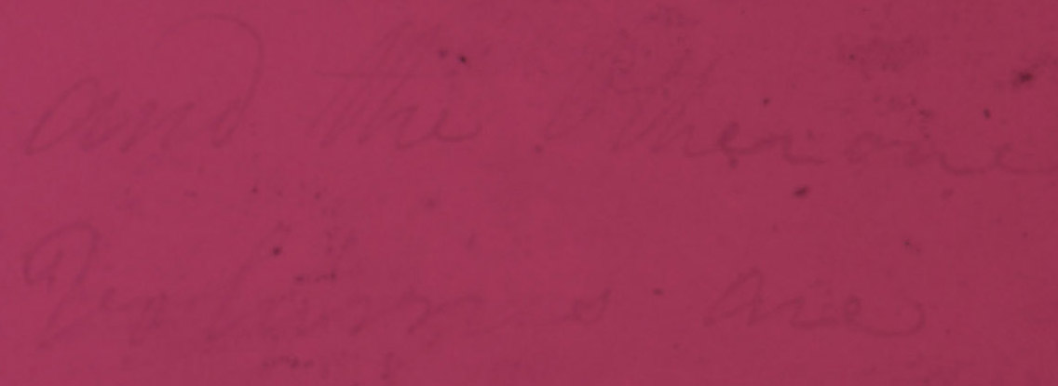
Infrared Image (problem area detail)

This first attempt was very surprising, I had little hope that the missing areas of the inscription were there at all but had just worn off the page and that there was nothing left to capture. In fact the text was revealed in its entirety even in those areas that showed no information at all under natural light. This new image clearly had all the information, however it was still faint and somewhat difficult to read making the transcription more prone to subconscious influence and error.

High Dynamic Range Photography (HDR)
In order to accentuate the text to help make transcription more accurate a post processing step was utilised. There is a new technique in photography called High Dynamic Range (HDR) imaging. Dynamic range is the ability of a sensor to capture both detailed ranges of grey in the dark areas of the image as well as detailed steps of light grey in the bright or white areas of an image simultaneously. When you are on holiday and take a photo on the beach and later realise the clouds turned into solid blobs of white with none of the detail you were able to see in person, that is a limitation of the dynamic range available to your camera.

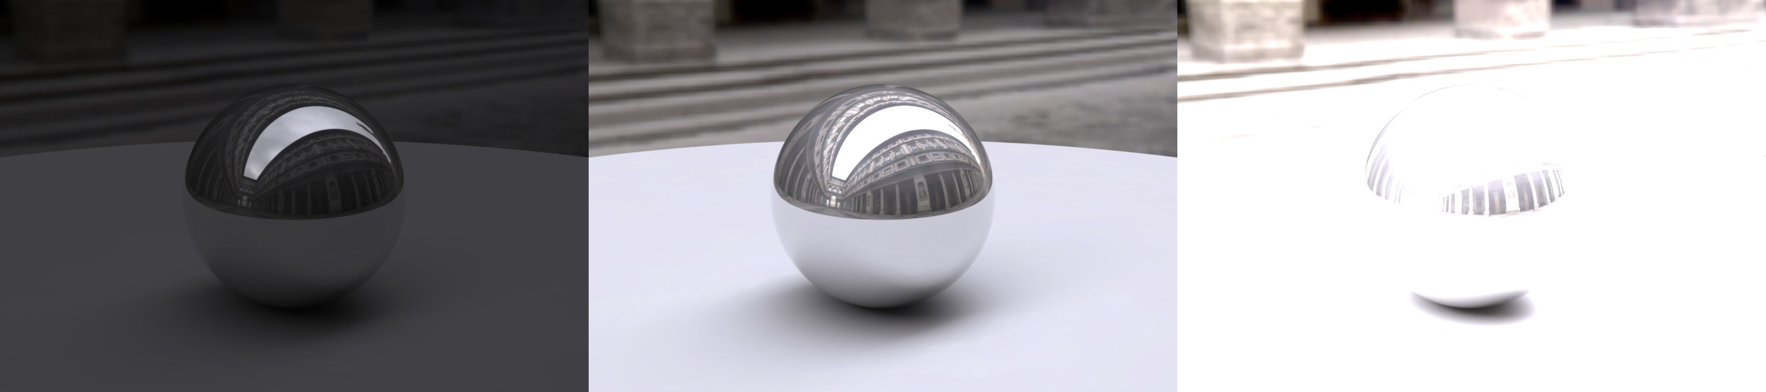 Example of Dynamic Range limitations

HDR photography addresses this limitation by assembling a single composite image from a variety of differently exposed images. By capturing a set of images that ranges from very under exposed to very over exposed, software is able to assemble a composite image that has a much greater dynamic range than any single capture from the camera. HDR images are generally recognised by highly exaggerated colours and contrast although they are also able to be generated with a natural look. It is this very exaggeration that provides the opportunity to isolate and enhance the inscription.

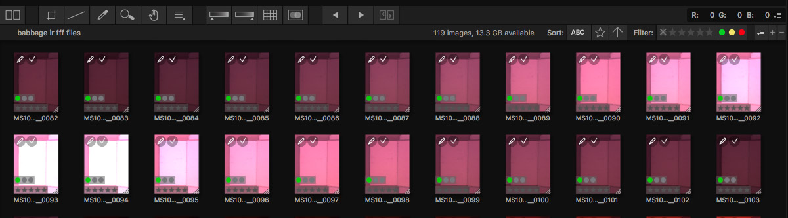Example of image sets used to create HDR composite images

In the final HDR composite image we now see a clearly readable inscription that can be transcribed without concern that readability is impacting the transcription, leaving the transcriber only required to translate personalised script of the writer. We really could not have been happier with the final outcome and learned a great deal along the way.

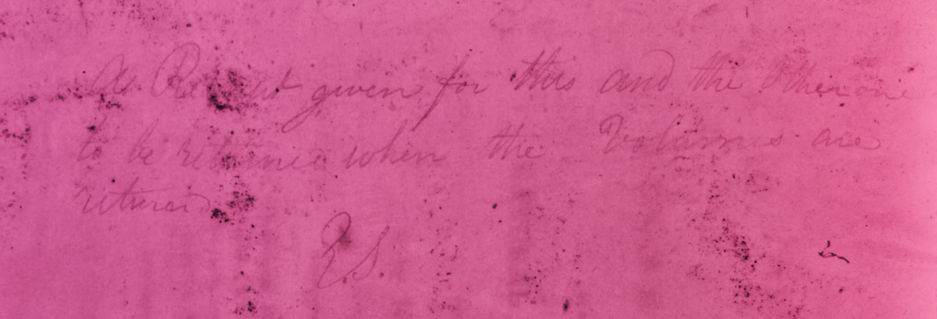
HDR Infrared Image

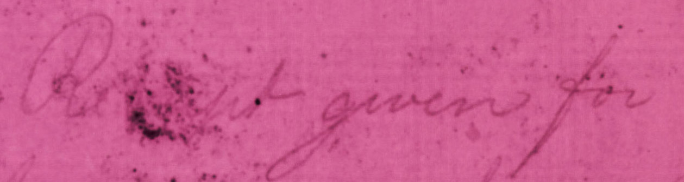
HDR Infrared (detail)

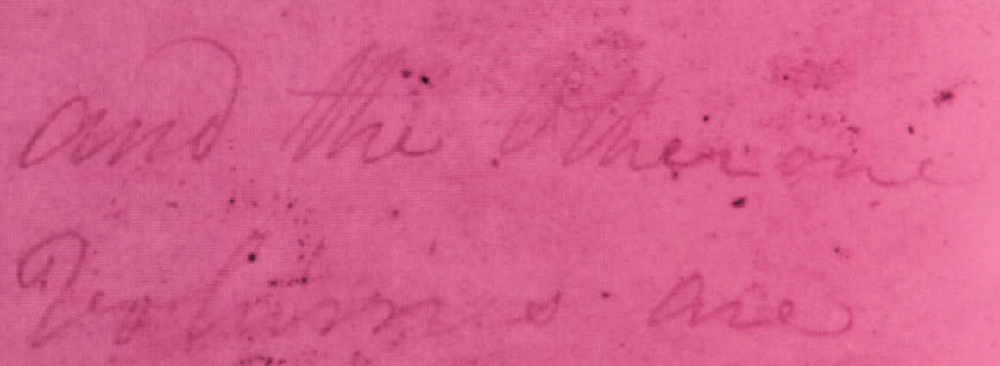
HDR Infrared (problem area detail)

Hasn’t this been done before?
Yes it has. For some time specialised spectral imaging techniques have been used to reveal a wide variety of lost or unreadable content. In most of these cases the spectral imaging was done using specialised equipment and light sources, working through individual wavelength steps searching for the perfect combination that reveals the lost or damaged content. In the majority of these cases the search is a project unto itself with specialised technical staff and significant periods of time given to determining the correct combination of illuminant and wavelength.

In the case of the DRIS imaging we have taken a different approach. Everything that this case study has done is designed to remove “the project” from the activity. Our goal is to provide specialised imaging within a production workflow utilising the same equipment as is used in our high quality imaging activities. The camera is a modified version of the cameras we use every day and the illuminant is part of our standard lighting system.

Through a simple camera swap an additional image, or set of infrared images can be taken within our standard imaging workflow. While this result may not be as robust as that of a dedicated multi spectral project, it is a remarkably effective way to add significant value to the academic and research process, without a project plan, without specialised staff, and without all the added cost and time.

Were we to fully implement this technique into our workflow (more work still needs to be done to isolate different material types and condition issues before this can occur) the burden of this specialised imaging as part of the standard book digitisation activity would add 15 to 25 minutes of additional time to the overall task, including HDR post processing and repository ingest.

My head is spinning from all this technical stuff, just tell me what it says
While the work has just begun, the first feedback I received offered this (subject to change as Dan McCarthy and Brian Coghlan continue their analysis)

Line 1: A Receipt given for this and the other one
Line 2: to be returned when the volumes are
Line 3: returned.
Line 4: C. B.

The initials, including the odd looking C and the general stylisation of the handwriting, have also been tentatively attributed to Charles Babbage, so it looks like the John Gabriel Byrne Computer Science Collection has an exciting and important new addition.

Special thanks to Ray Jordan, Gill Whelan, Dan McCarthy and Brian Coghlan for their support and participation in this work.

