AccessionIndex: TCD-SCSS-V.20160929.001
Accession Date: 29-Sep-2016
Accession By: Dr.Brian Coghlan
Object name: Nine interviews of Prof.J.G.Byrne, TCD
Vintage: c.2012
Synopsis: O'Keefe, Maurice & Jane, 'Irish Life and Lore, Trinity College Dublin, John Byrne', CD no.55, 68:50 mins, MPEG 160kbps.

Description:
In May-2016 Prof.Barbara Wright found a 1-page list of what was covered in a set of recorded interviews "Track 1-9" (see Fig.1) of Prof.J.G.Byrne (sometimes called the father of computer science in Ireland, who sadly had passed away shortly beforehand), but neither she nor others had these or knew who recorded them and why. Despite a fairly intensive search no-one was found who knew anything about these interviews.

An appeal was launched both by email and via this catalog to try to find the set of recordings, or at least to try to find someone who might know who recorded the interviews, as they would be of great value to the School of Computer Science and Statistics, TCD, where an effort was underway to compose a book about Prof.Byrne, and the interviews would be extremely helpful.

On 18-Sep-2016 these mysterious recordings were found, thanks to Prof.Byrne’s nephew Edmund Williams, Rosemary Welsh and Chris Horn. The recordings are in Maurice & Jane O’Keefe’s collection Irish Life and Lore, see [1] and [2]. They are available on a CD and/or electronic file, and copies of both have been deposited in this collection and in the associated folder in this collection.

The full set of the Irish Life and Lore interview series is also in the TCD Library [3], including the Trinity College Dublin Collection [4] of interviews of TCD staff, also see list in Fig.3. Some other Irish Life and Lore collections also include TCD staff, e.g. Roderick Kernan in the South Dublin Collection [5], Mary Boydell in the Fleischmann Collection [6], Valentine Rice in the Kerry Collections [7], and Roy Johnston in the RDS Collection [8].

The homepage for this catalog is at: https://www.scss.tcd.ie/SCSSTreasuresCatalog/
Click 'Accession Index' (1st column listed) for related folder, or 'About' for further guidance. Some of the items below may be more properly part of other categories of this catalog, but are listed here for convenience.

Accession Index | Object with Identification
TCD-SCSS-V.20160929.001 | O'Keefe, Maurice & Jane, Nine interviews of Prof.John Byrne, 'Irish Life and Lore, Trinity College Dublin, John Byrne', CD no.55, 68:50 mins, MPEG 160kbps, 2012.

References:

- O'Keefe, Maurice & Jane, 'Irish Life and Lore, Trinity College Dublin, John Byrne', see:
http://www.irishlifeandlore.com/search-result.php?PageNum=2&DbQuery_TotalRows=23&s=byrne
Last browsed to on 29-Sep-2016.

- O'Keefe, Maurice & Jane, 'Irish Life and Lore', see:
http://www.irishlifeandlore.com/
Last browsed to on 29-Sep-2016.

- O'Keefe, Maurice & Jane, 'Irish Life and Lore' interview series, Trinity College Dublin Library, see:
http://stella.catalogue.tcd.ie/iii/encore/plus/C__S%28irish%20life%20%26%20lore%29%20%28collection%29%20%28compiled%29%20f%3Ai%20l%3Aeng__Orightresult__U?lang=eng&suite=cobalt
Last browsed to on 29-Sep-2016.

- O'Keefe, Maurice & Jane, 'Irish Life and Lore, Trinity College Dublin Collection', see:
http://www.irishlifeandlore.com/search-result.php?dbc=collectionName&collectionName=Trinity%20College,%20Dublin,%20Collection
Last browsed to on 29-Sep-2016.

- O'Keefe, Maurice & Jane, 'Irish Life and Lore, South Dublin Collection‘ [Roderick Kernan], see:
http://www.irishlifeandlore.com/search-result.php?s=Roderick+Kernan
Last browsed to on 29-Sep-2016.

- O'Keefe, Maurice & Jane, 'Irish Life and Lore, Fleischmann Collection’ [Mary Boydell], see:
http://www.irishlifeandlore.com/search-result.php?s=Mary+Boydell
Last browsed to on 29-Sep-2016.

- O'Keefe, Maurice & Jane, 'Irish Life and Lore, Kerry Collections‘ [Valentine Rice], see:
http://www.irishlifeandlore.com/search-result.php?s=Valentine+Rice
Last browsed to on 29-Sep-2016.

- O'Keefe, Maurice & Jane, 'Irish Life and Lore, RDS Collection’, [Roy Johnston], see:
http://www.irishlifeandlore.com/search-result.php?s=Roy+H.+W.+Johnston
Last browsed to on 29-Sep-2016.

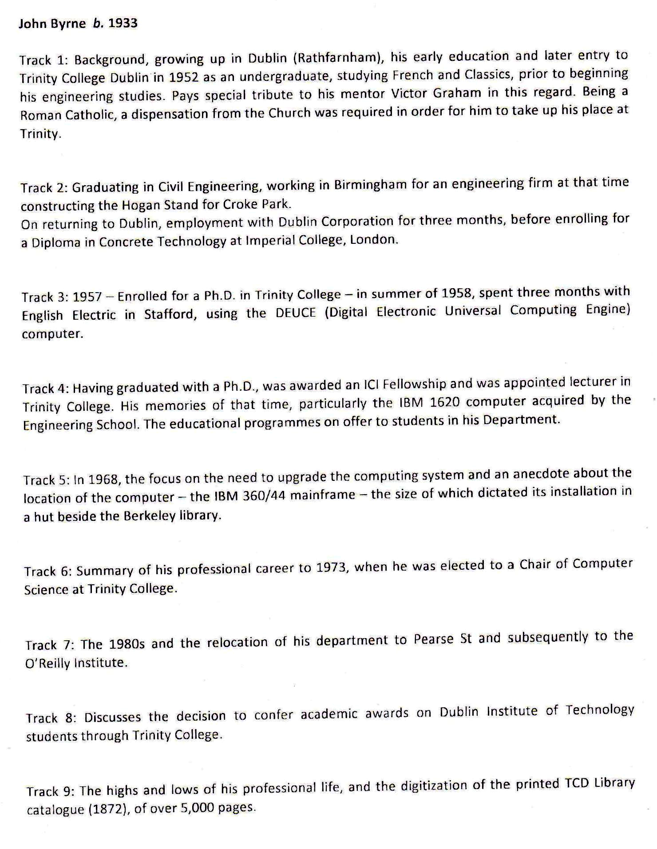
Figure 1: Interviews of Prof.John Byrne, list of what was covered in a set of recordings "Track 1-9", courtesy Prof.Barbara Wright, TCD

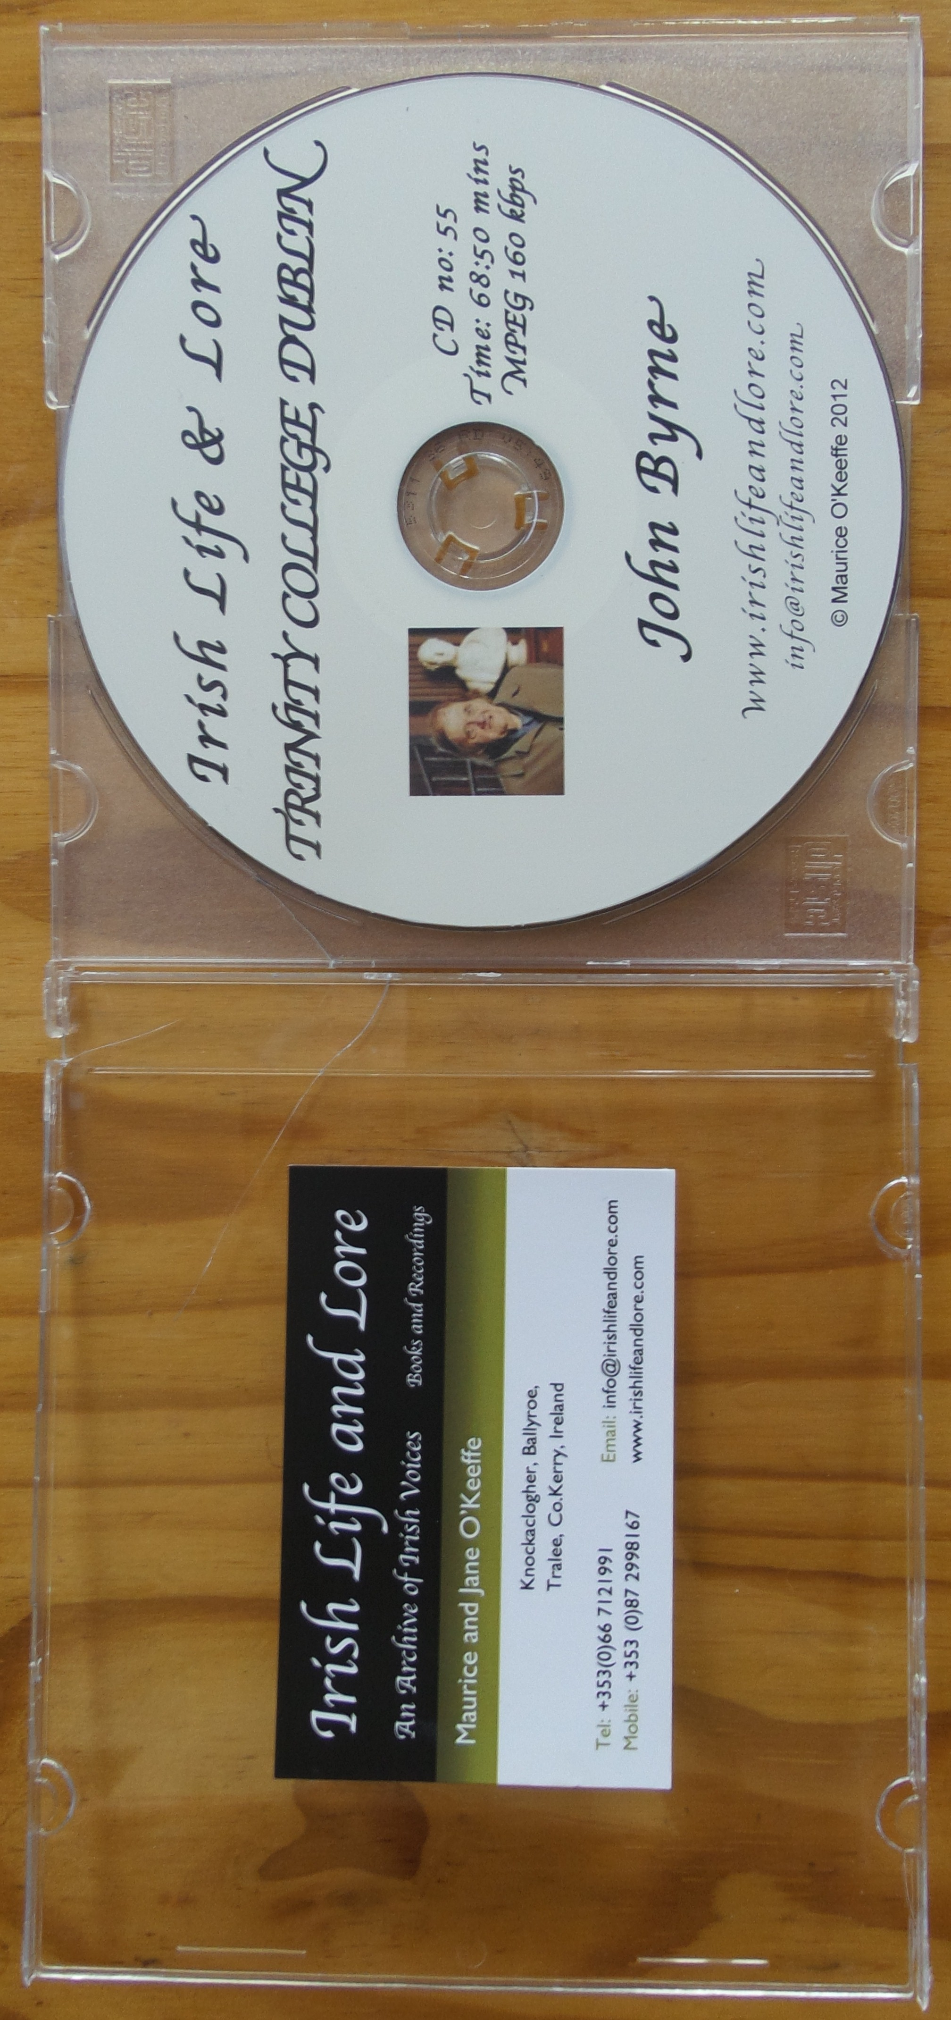
Figure 2: Interviews of Prof.John Byrne, CD no.55
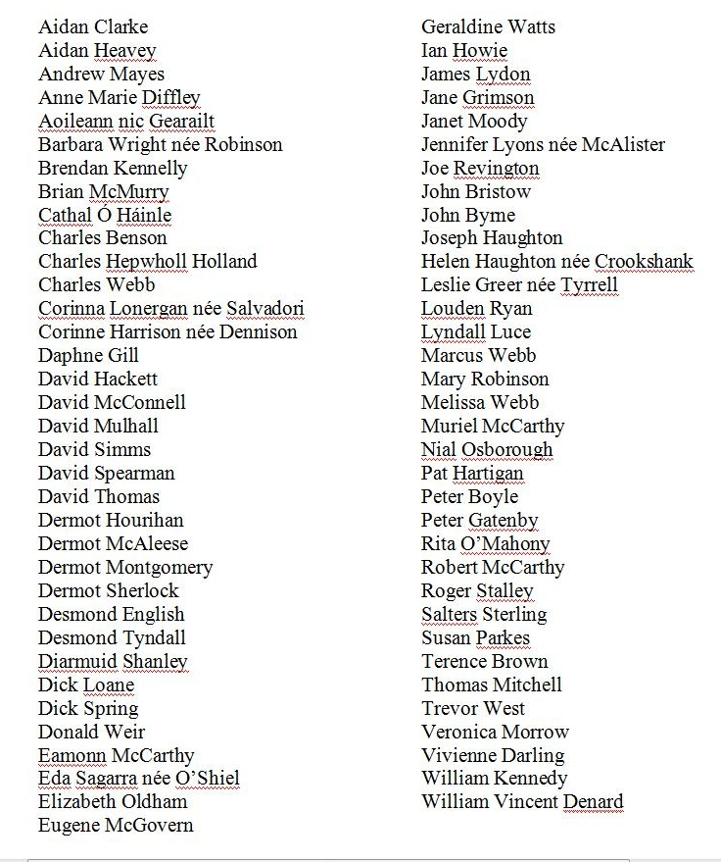
Figure 3: List of TCD staff interviewed for Irish Life and Lore, Trinity College Dublin Collection

