AccessionIndex: TCD-SCSS-V.20160425.003
Accession Date: 25-Apr-2016
Accession By: Paul O'Kane
Object name: Class Photograph, TCD Engineering School BAI Class of 1966-1970
Vintage: c.1970
Synopsis: Trinity College Dublin, photograph that includes first undergraduate TCD Computer Science class.

Description:
Many thanks to Paul O’Kane, a TCD Engineering School graduate, who donated these items, having originally taken this photograph on a Nikkormat FT using a tripod and self-timer.

Paul was in Prof.J.G.Byrne's first undergraduate Computer Science classes from 1966-1970, when that stream was part of the Engineering degree (B.A.I.), and indeed when the department was still part of the School of Engineering. This was the first undergraduate Computer Science degree course in Ireland. The BAI degree course lasted four years, but there was no specialisation in the first year 1966/67. There were only five graduates in 1970 from that pioneering 1966-1970 Computer Science class:

Bruce Buttimore
Ed Dunlop
Neil Kennedy
Paul O'Kane
Jane Wright (subsequently department staff member and Vice-Provost of TCD)

The staff in the photograph are:

John Byrne, lecturer in computer science
Ronald (Ronnie) Cox, lecturer in civil engineering
Jonathan Fisher, researcher/assistant in the electronic engineering lab, worked with Brendan Scaife
Gerald Fitzgibbon, lecturer in civil engineering
Victor Graham, lecturer in mathematics
Neville Harris, lecturer in computer science
Reginald (Reg) Kirwan, lecturer in civil engineering/soil mechanics
Francis Neelamkavil, lecturer in computer science
Michael (Mike) Peirce, lecturer in mechanical engineering
Brendan Scaife, lecturer in electrical engineering
Garrett Scaife, lecturer in mechanical engineering
William (Bill) Wright, Dean of Engineering, lecturer in civil engineering

The homepage for this catalog is at: https://www.scss.tcd.ie/SCSSTreasuresCatalog/
Click 'Accession Index' (1st column listed) for related folder, or 'About' for further guidance. Some of the items below may be more properly part of other categories of this catalog, but are listed here for convenience.

Accession Index | Object with Identification
TCD-SCSS-V.20160425.003 | Class Photograph, TCD Engineering School BAI Class of 1966-1970, Trinity College Dublin, photograph that includes first undergraduate TCD Computer Science class, c.1970.
TCD-SCSS-V.20160425.003.001 | Class Photograph, TCD Engineering School BAI Class of 1966-1970, Trinity College Dublin, negative of photograph, 1970.
TCD-SCSS-V.20160425.003.002 | Class Photograph, TCD Engineering School BAI Class of 1966-1970, Trinity College Dublin, 10x8 print of photograph, 1970.
TCD-SCSS-V.20160425.003.003 | Class Photograph, TCD Engineering School BAI Class of 1966-1970, Trinity College Dublin, electronic image of photograph, 1970.

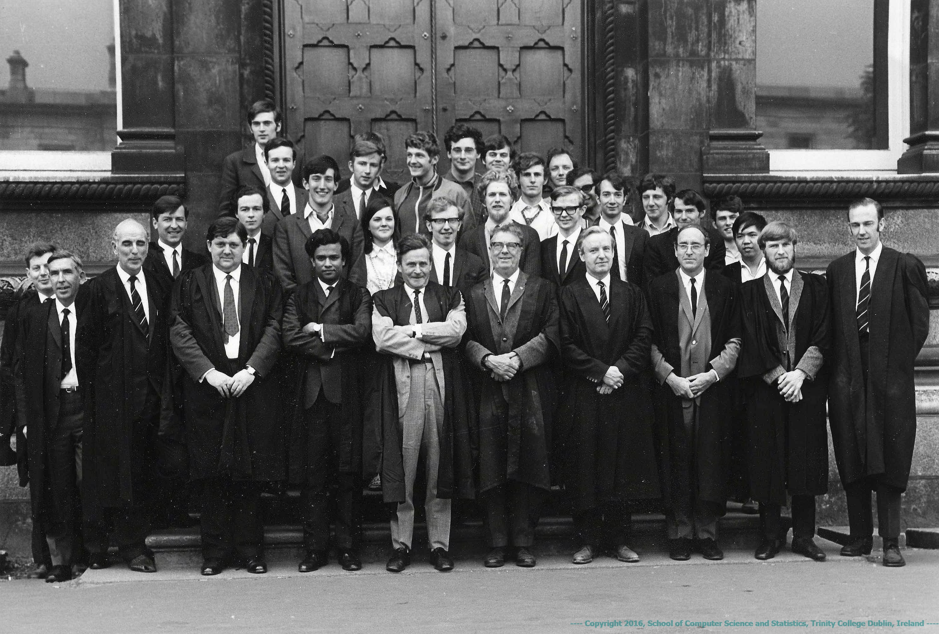
Figure 1: Class Photograph, TCD Engineering School BAI Class of 1966-1970
(includes first undergraduate TCD Computer Science class)
Photograph courtesy Paul O’Kane

 | 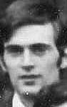  Roger  Packham | 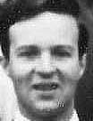  Ed  Dunlop | 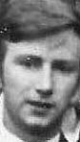  Neil  Kennedy | 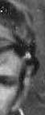  John  Reddaway | 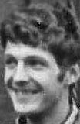  Bruce  Buttimore | 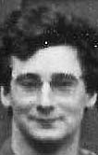  Bill  Grimson | 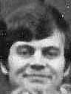  Richard  Greene | 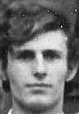  Dave  Black | 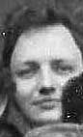  Bob  Flood | 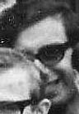  Alan  Brompton
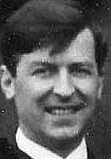  Michael  Peirce | 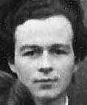  Des  Browne | 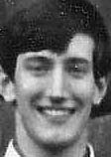  Herbie  Harper | 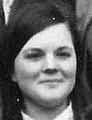  Jane  Wright | 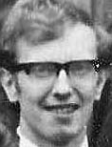  Paul  O'Kane | 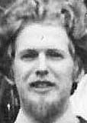  Derek  Mitchell | 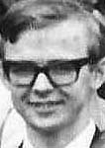  Jimmy  Frayne | 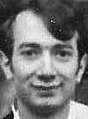  Leonard  Abrahamson | 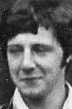  Tim  Cooper | 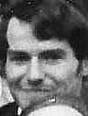  Paddy  Carlyle | 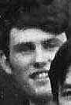  Dave  Mayne | 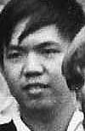  ???  ???
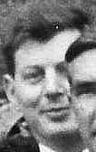  Neville  Harris | 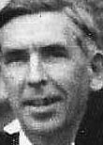  Brendan  Scaife | 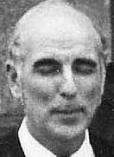  Garrett  Scaife | 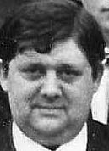  John  Byrne | 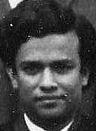  Francis  Neelamkavil | 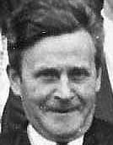  William  Wright | 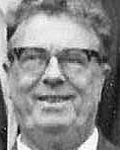  Gerald  Fitzgibbon | 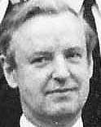  Victor  Graham | 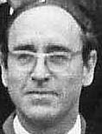  Reginald  Kirwan | 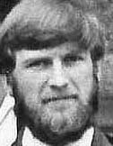  Jonathan  Fisher | 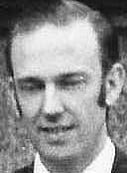  Ronald  Cox
Figure 1: Class Photograph, TCD Engineering School BAI Class of 1966-1970 identification
Thumbnails and identification courtesy Paul O’Kane and Leonard Abrahamson

