AccessionIndex: TCD-SCSS-V.20160305.001
Accession Date: 5-Mar-2016
Accession By: Dr.Brian Coghlan
Object name: Calculating Ada: The Countess of Computing
Vintage: c.2015
Synopsis: BBC FOUR, TV documentary about Ada Lovelace narrated by Dr.Hannah Fry broadcast at 9pm 17-Sep-2015.

Description:
BBC FOUR television broadcast a documentary Calculating Ada: The Countess of Computing, narrated by Dr.Hannah Fry, a mathematician from University College London (UCL), at 9pm on 17-Sep-2015. This TV program was recorded in full HD then converted to an MPEG4 file CalculatingAda.mp4 and stored on a DVD for this collection.

The program covered the early life of Lady Augusta Ada Lovelace, her introduction to Charles Babbage and his partially constructed Difference Engine (recreated in its entirety in 1991 by the London Science Museum), and in particular her astonishing 1843 monograph on the architecture of Babbage’s subsequent Analytical Engine, a paper design for an advanced and complex mechanical computer that is considered to be the nineteenth century forerunner of the electronic computers of the twentieth century. The program explicitly described how Lovelace’s monograph went beyond Babbage’s invention to propose what is now recognised as the first published description of a computer program, and to speculate on more abstruse applications.

The homepage for this catalog is at: https://www.scss.tcd.ie/SCSSTreasuresCatalog/
Click 'Accession Index' (1st column listed) for related folder, or 'About' for further guidance. Some of the items below may be more properly part of other categories of this catalog, but are listed here for convenience.

Accession Index | Object with Identification
TCD-SCSS-V.20160305.001 | Calculating Ada: The Countess of Computing, BBC FOUR, TV documentary about Ada Lovelace narrated by Dr.Hannah Fry broadcast at 9pm 17-Sep-2015. c.2015.  MPEG4 file CalculatingAda.mp4 on DVD.
TCD-SCSS-V.20121208.870 | Ada Lovelace's famous translation with an 'Addition', Prof.J.G.Byrne's offprint of Ada Lovelace's translation of L.Menabrea's 'Sketch' of the Analytical Engine, incorporating an offprint of Charles Babbage's 'Addition', c.1843.

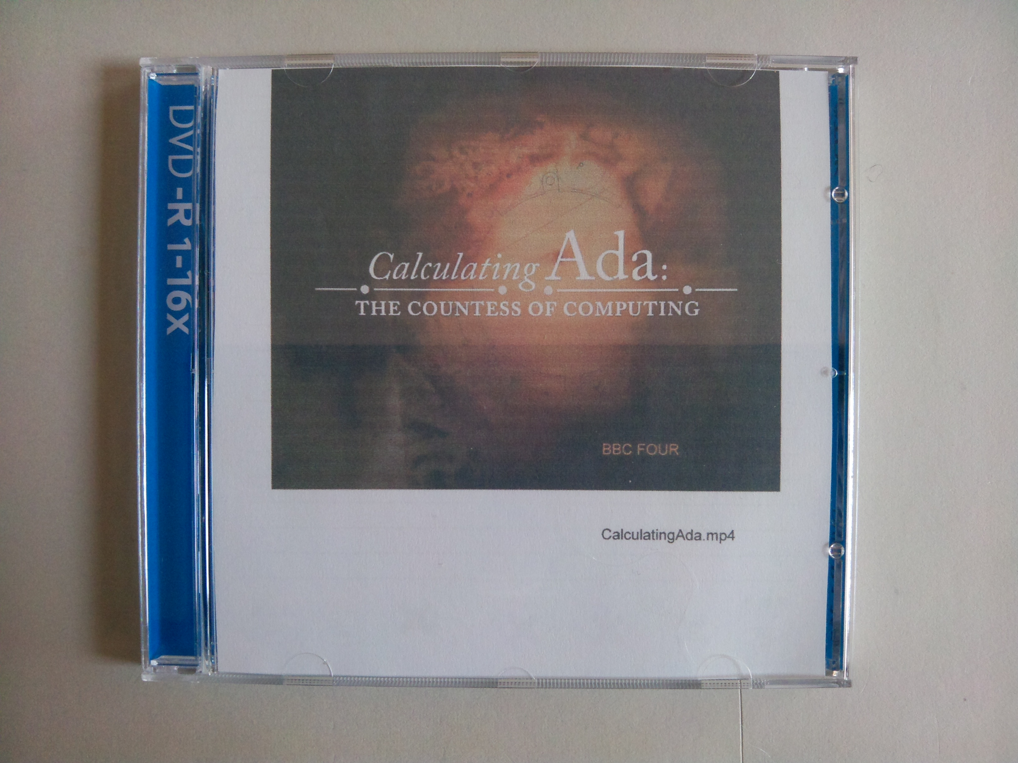
Figure 1: Calculating Ada, view of DVD cover

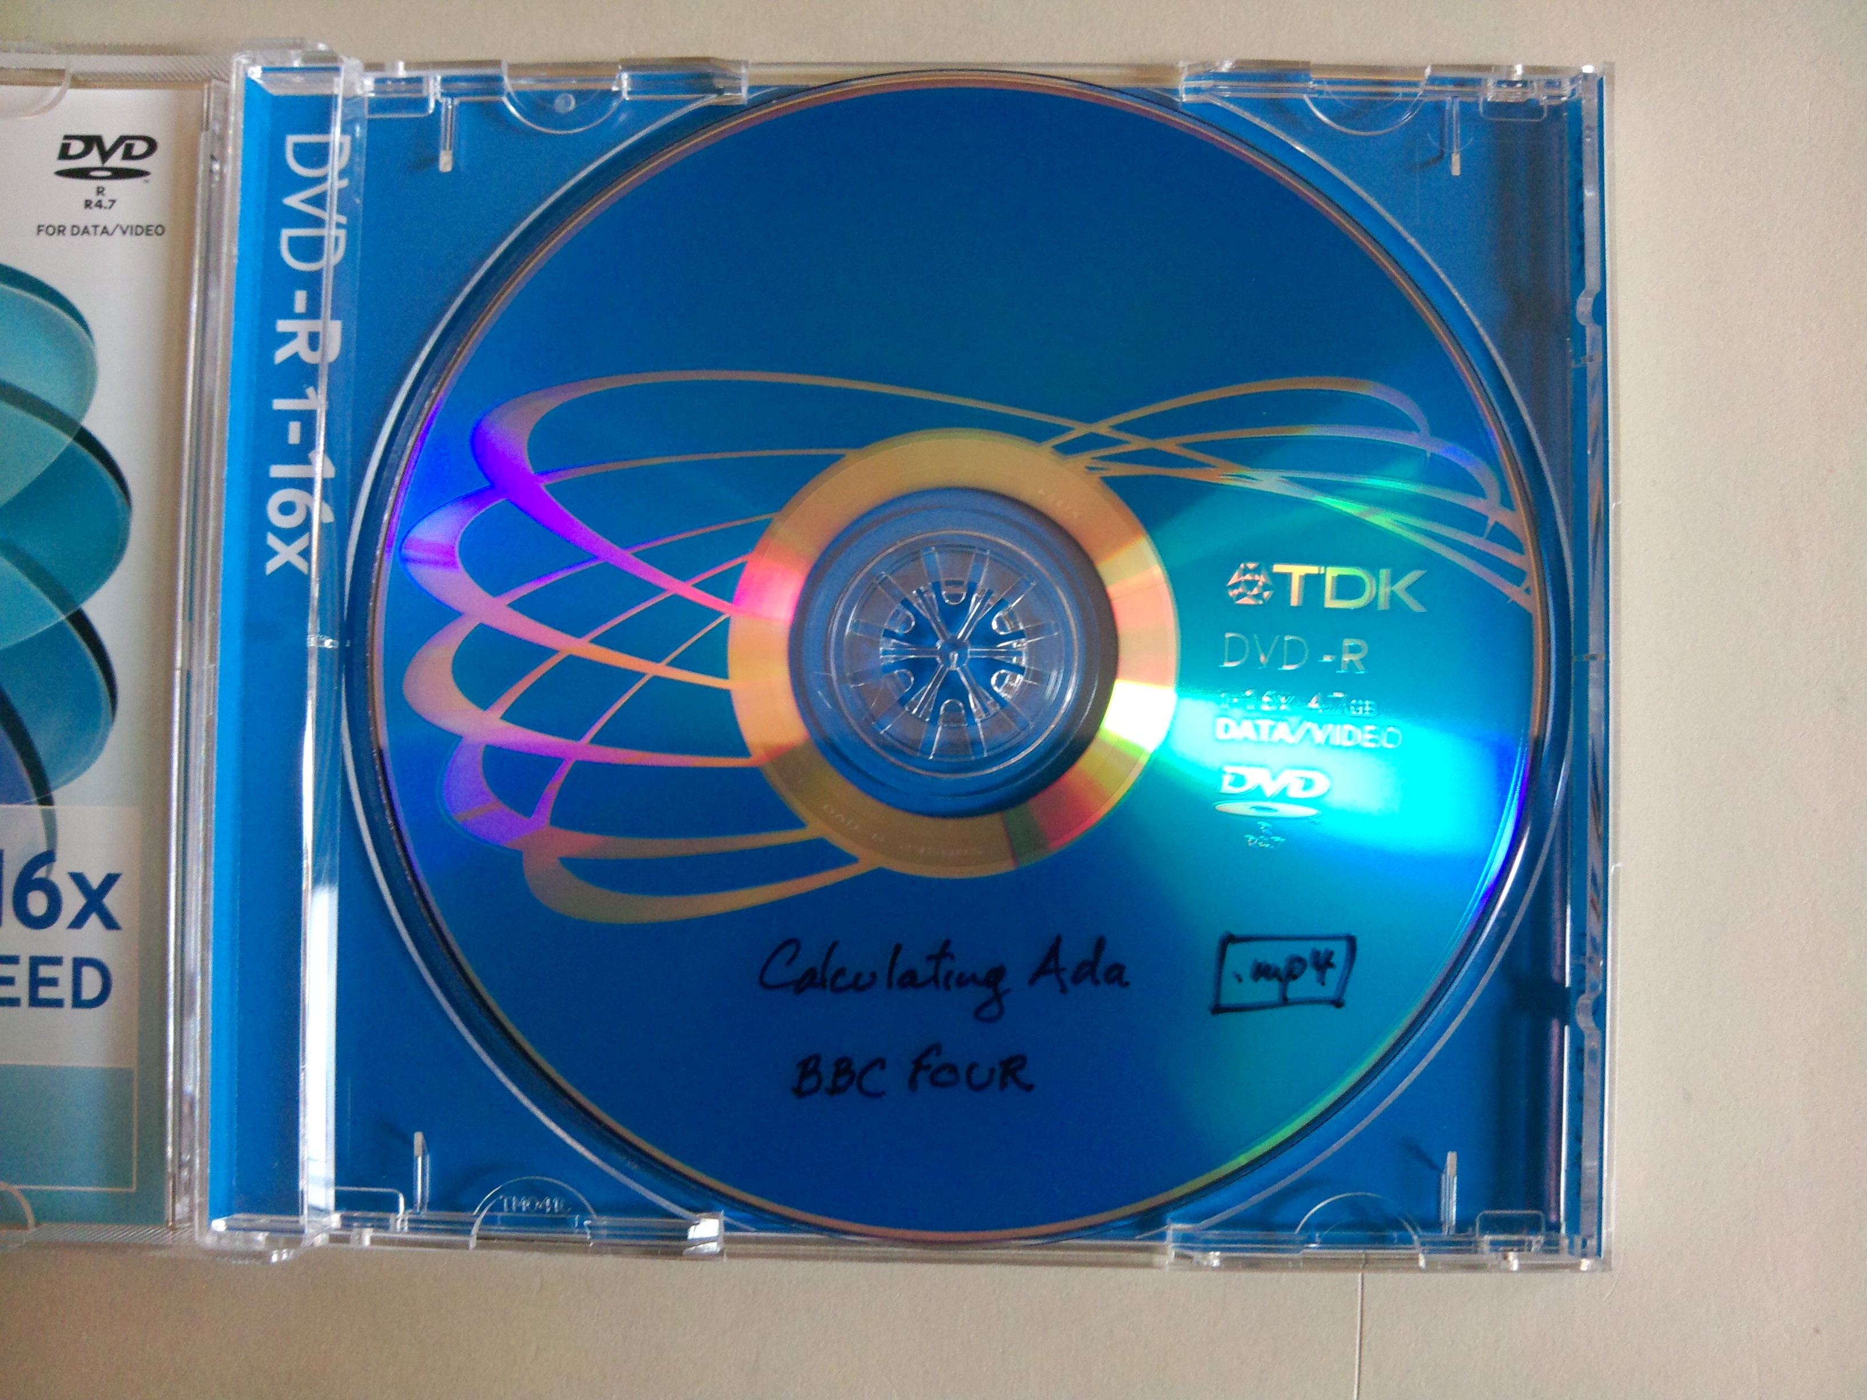
Figure 2: Calculating Ada, front view of DVD

