AccessionIndex: TCD-SCSS-V.20160121.007
Accession Date: 21-Jan-2016
Accession By: Peter Canavan
Object name: Year-2000 stickers
Vintage: c.1999
Synopsis: Two sheets 3 x 4 Year-2000 NONcompliant stickers and two sheets 3 x 4 Year-2000 Compliant stickers.

Description:
The Year-2000, or Y2K-problem, or Millennium-bug, arose where abbreviated dates were recorded in order to save space. The problem existed both within and beyond computing wherever dates were recorded in abbreviated form, but it was especially important in computing systems due to their wide usage in society, and especially in mission-critical or safety-critical systems such as aircraft or hospital systems.

Early computers were constructed of large and expensive components, so storage of a single bit both occupied significant physical space and cost a lot. Even though such computers were extremely expensive by modern standards, storage was very limited by these physical space and cost constraints. By 1970 large expensive machines rarely had more than 64kB of memory, by late 1970s rarely more than 1MB. Less expensive machines had considerably less memory. Similarly with other forms of storage.

This might seem quaint to later generations who have become used to gigabytes of space, however software had to be written more efficiently, and especially for large data sets, data had to be represented more efficiently, than is now the case. A typical “Hello World” program was often implemented in less than 1kB, whereas a typical modern Java implementation might take three or more orders of magnitude more space. For data, there was widespread abbreviation of the year to the last two digits, so there was an assumption of the twentieth century.

The problem was well acknowledged by the late 1990s. It was expected that it might cause ambiguity about dates before and after 2000, or errors in derivation of intervals between dates spanning 2000, or failure to recognise 2000 as a leap year, and worst case these effects might cause crashes or critical errors. A determined industry-wide effort was made to identify vulnerable computing systems and software and to fix these where possible. Those that were safe were labelled as compliant, and vice-versa. Two sheets in this collection have 3 x 4 arrays of Year-2000 NONcompliant stickers, and another two sheets have 3 x 4 arrays of Year-2000 Compliant stickers. The global effort was rewarded, as there were very few reported anomalies.

Many thanks to Peter Canavan, Network Manager, Broadcast Operations, Australian Broadcasting Commission (ABC), who donated these items from his personal collection.

The homepage for this catalog is at: https://www.scss.tcd.ie/SCSSTreasuresCatalog/
Click 'Accession Index' (1st column listed) for related folder, or 'About' for further guidance. Some of the items below may be more properly part of other categories of this catalog, but are listed here for convenience.

Accession Index | Object with Identification
TCD-SCSS-V.20160121.007 | Year-2000 stickers, Two sheets 3 x 4 Year-2000 NONcompliant stickers and two sheets 3 x 4 Year-2000 Compliant stickers, 1999.
TCD-SCSS-V.20160121.007.01 | Year-2000 NONcompliant stickers, two sheets.
TCD-SCSS-V.20160121.007.02 | Year-2000 Compliant stickers, two sheets.

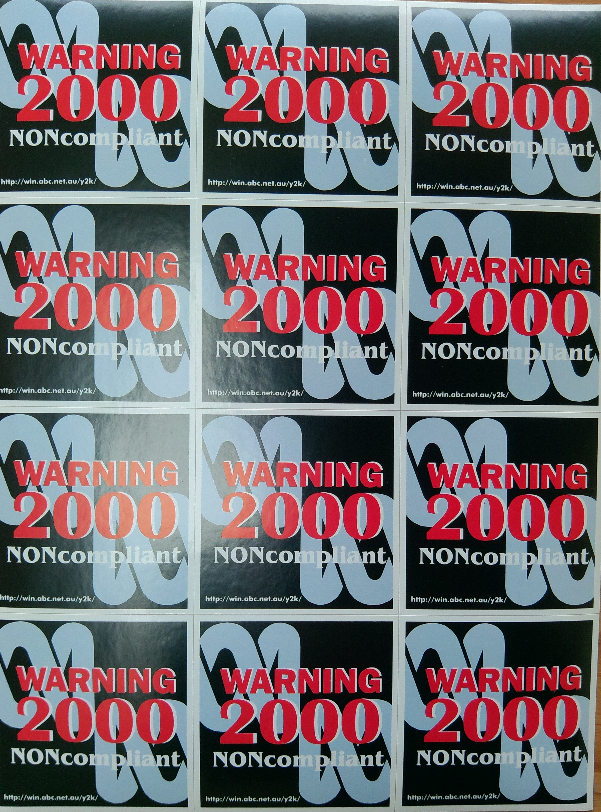
Figure 1: Year-2000 NONcompliant stickers

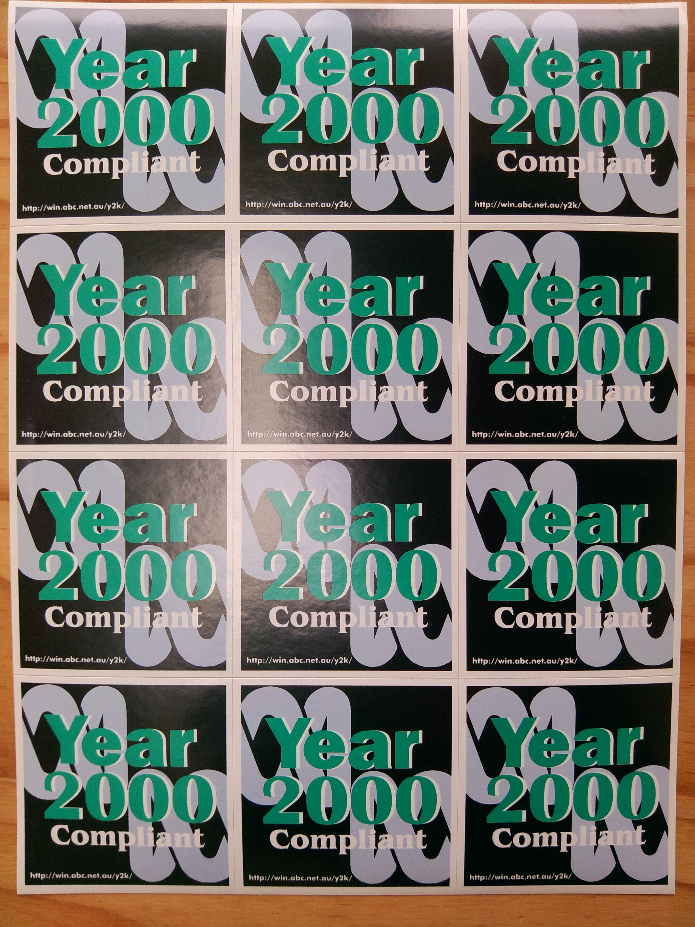
Figure 2: Year-2000 Compliant stickers

