AccessionIndex: TCD-SCSS-V.20160121.003
Accession Date: 21-Jan-2016
Accession By: Peter Canavan
Object name: Microprocessor Interfacing Techniques
Vintage: c.1977
Synopsis: Austin Lesea and Rodnay Zaks, second edition, ISBN 0-89588-003-2, Sybex Inc, 202 Milvia Street, Berkeley, California 94704.

Description:
Rodnay Zaks books (also see Programming the Z80 elsewhere in this catalog) were popular guides for design engineers, students and enthusiasts in the late 1970s.

Microprocessor Interfacing Techniques was co-authored with Austin Lesea and covers early 8-bit CPUs (i8080/i8085, MC6800, Z80), basic and peripheral I/O, analog to digital conversion and vice versa, bus and I/O standards (S100, 6800, IEEE-488, RS-232C, RS-422, RS-423), plus a case study and guide to troubleshooting.

As such it is a good snapshot of the simplicity of mid-to-late 1970s microcomputer technology, just before the rise of complexity begun by the introduction of 16-bit and then 32-bit (and now 64-bit) microprocessors.

Many thanks to Peter Canavan, Network Manager, Broadcast Operations, Australian Broadcasting Commission (ABC), who donated this item from his personal collection.

The homepage for this catalog is at: https://www.scss.tcd.ie/SCSSTreasuresCatalog/
Click 'Accession Index' (1st column listed) for related folder, or 'About' for further guidance. Some of the items below may be more properly part of other categories of this catalog, but are listed here for convenience.

Accession Index | Object with Identification
TCD-SCSS-V.20160121.003 | Austin Lesea and Rodnay Zaks, Microprocessor Interfacing Techniques, second edition, ISBN 0-89588-003-2, Sybex Inc, 202 Milvia Street, Berkeley, California 94704, c.1977.

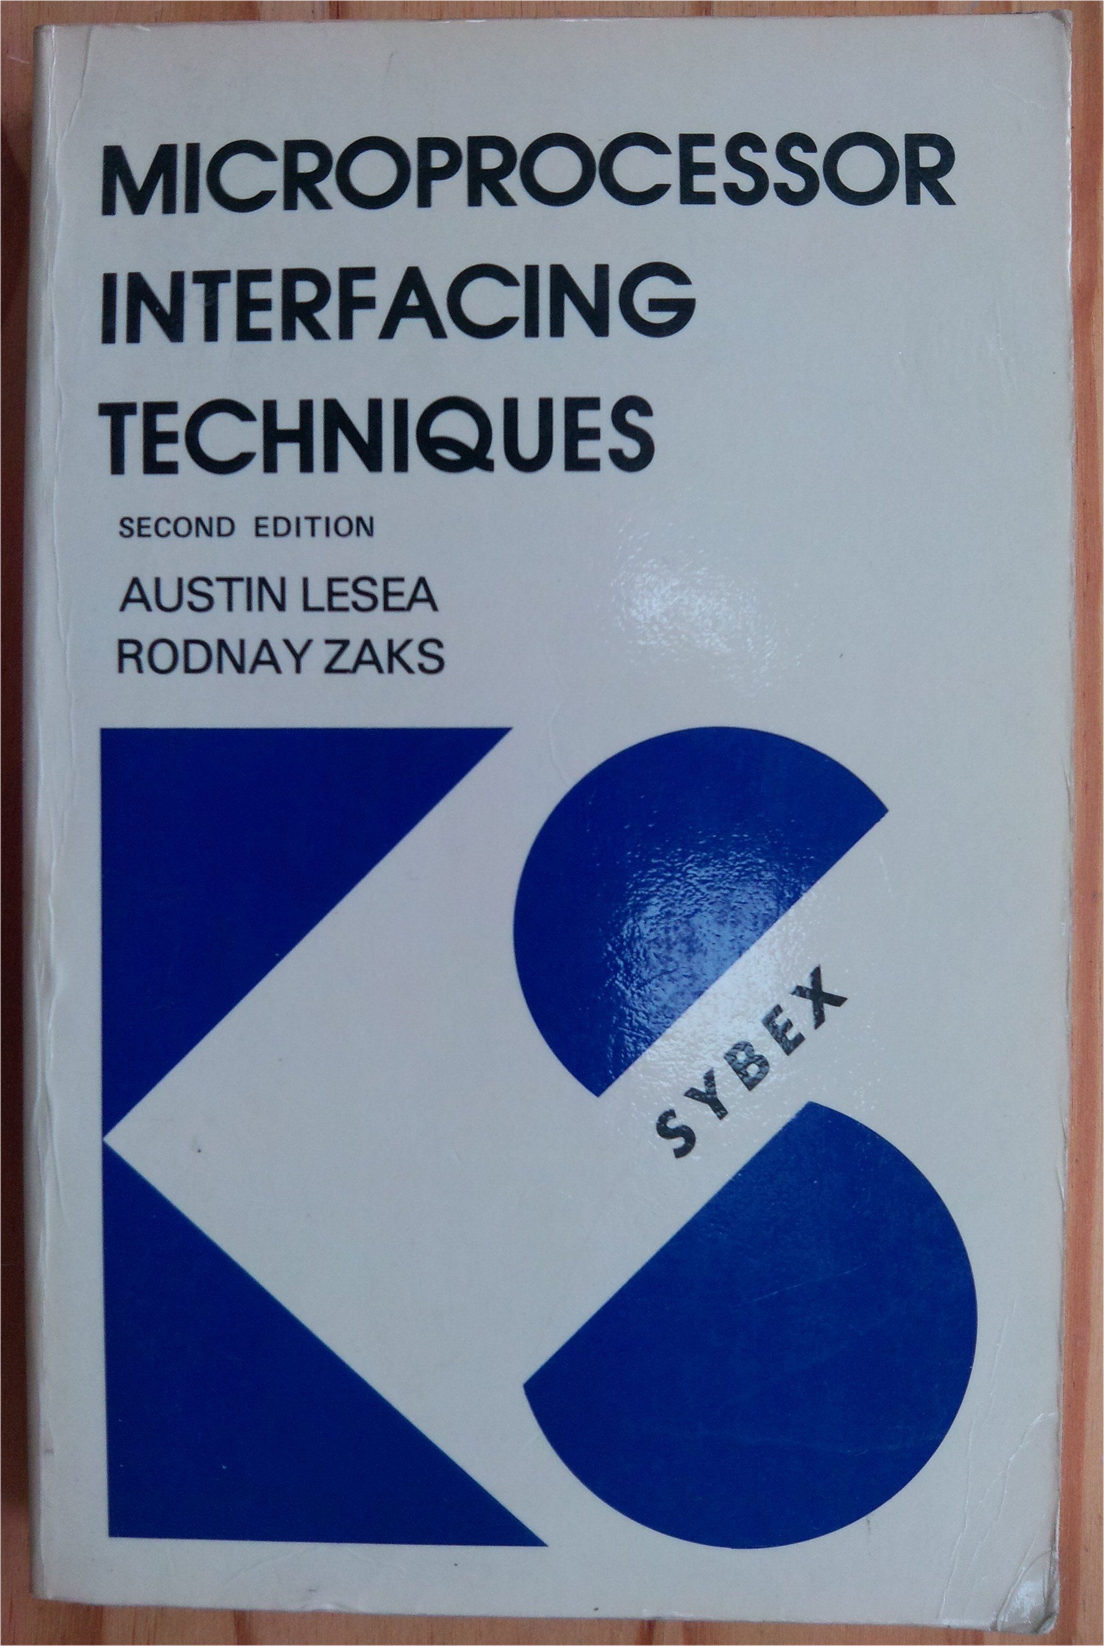
Figure 1: Microprocessor Interfacing Techniques front cover

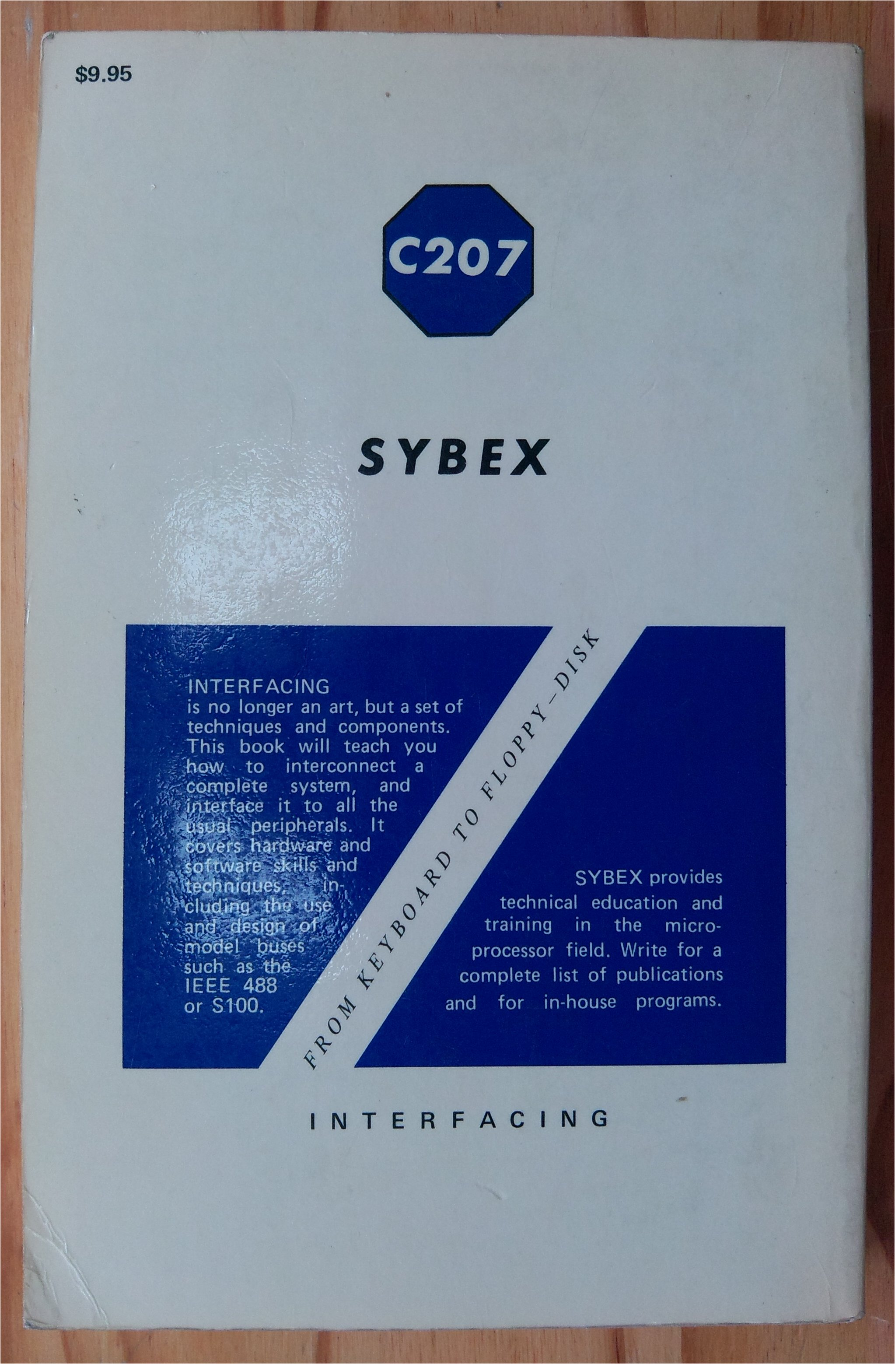
Figure 2: Microprocessor Interfacing Techniques rear cover

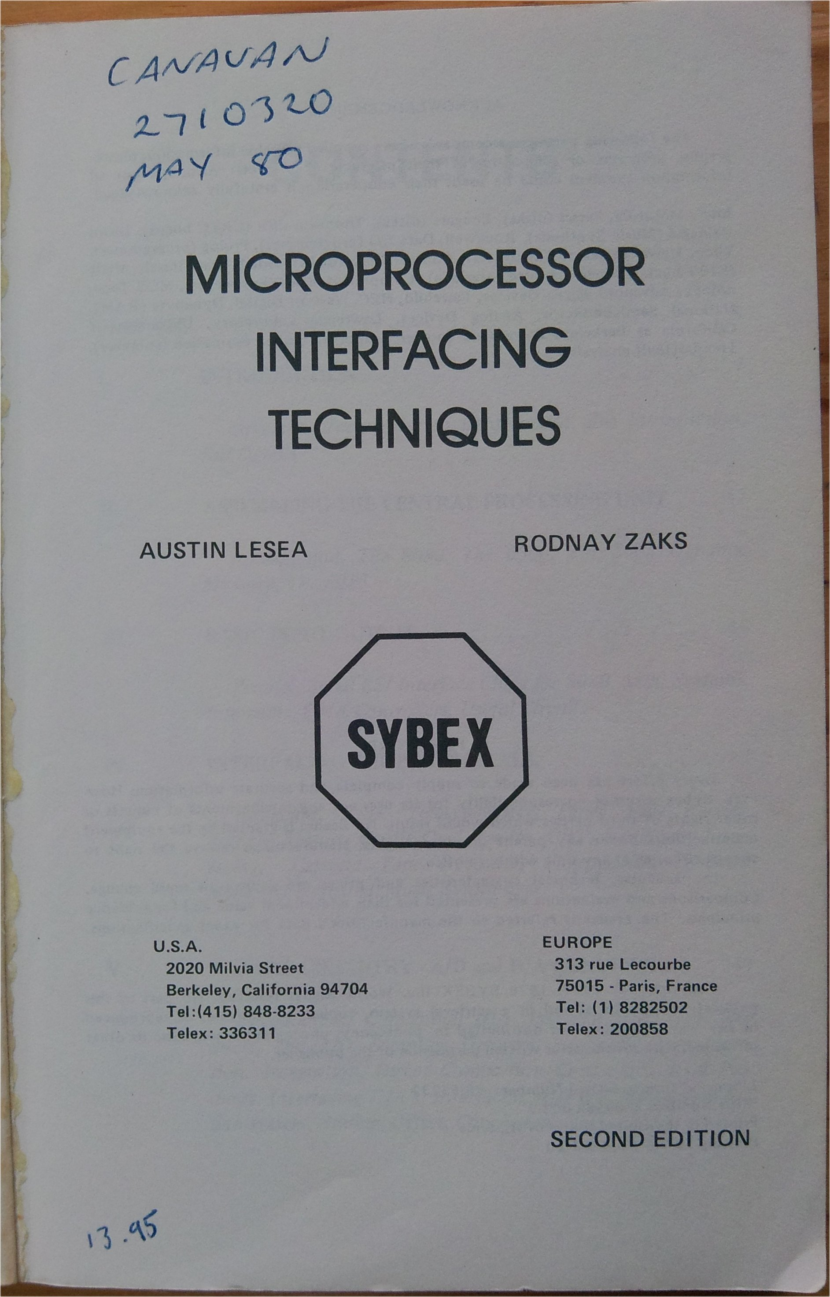
Figure 3: Microprocessor Interfacing Techniques title page

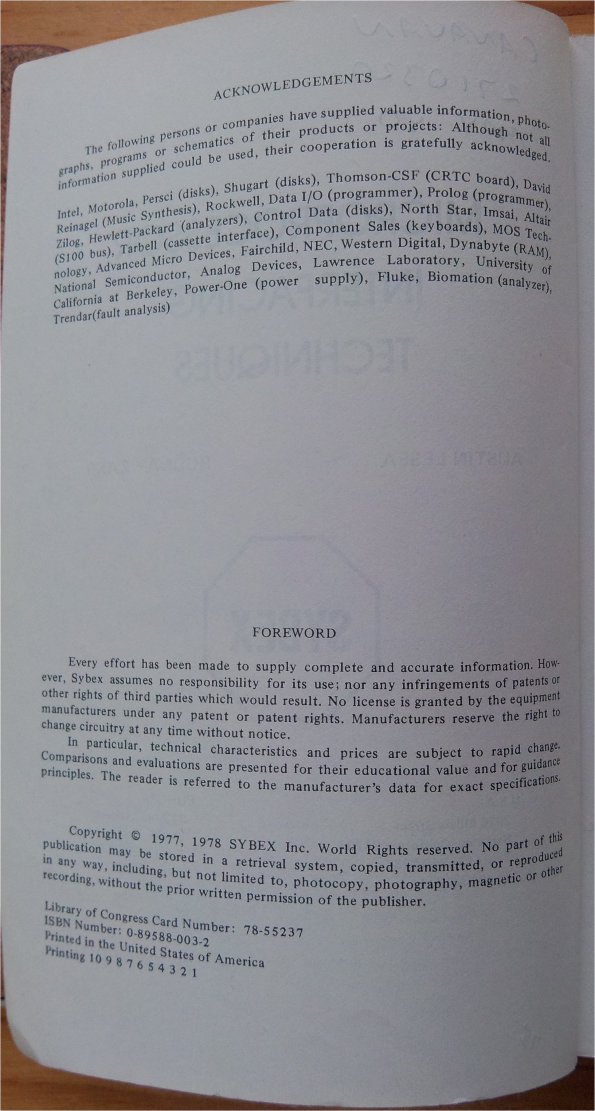
Figure 4: Microprocessor Interfacing Techniques publishers page

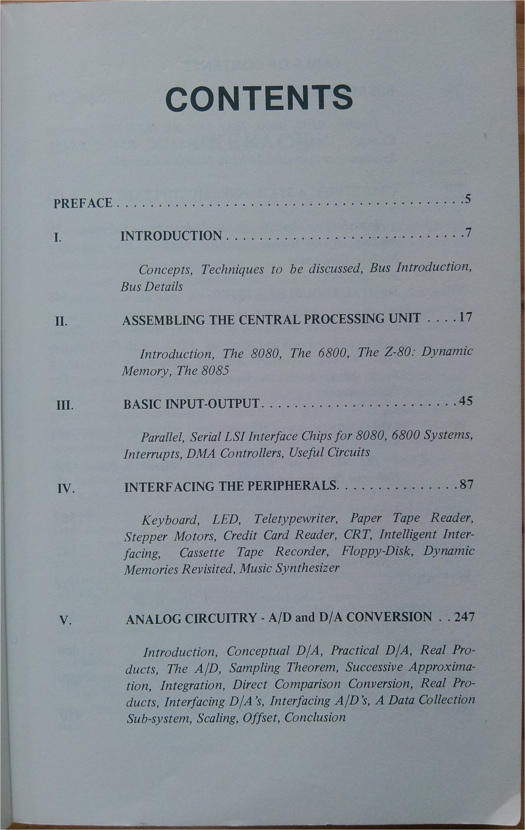
Figure 5: Microprocessor Interfacing Techniques table of contents page 1

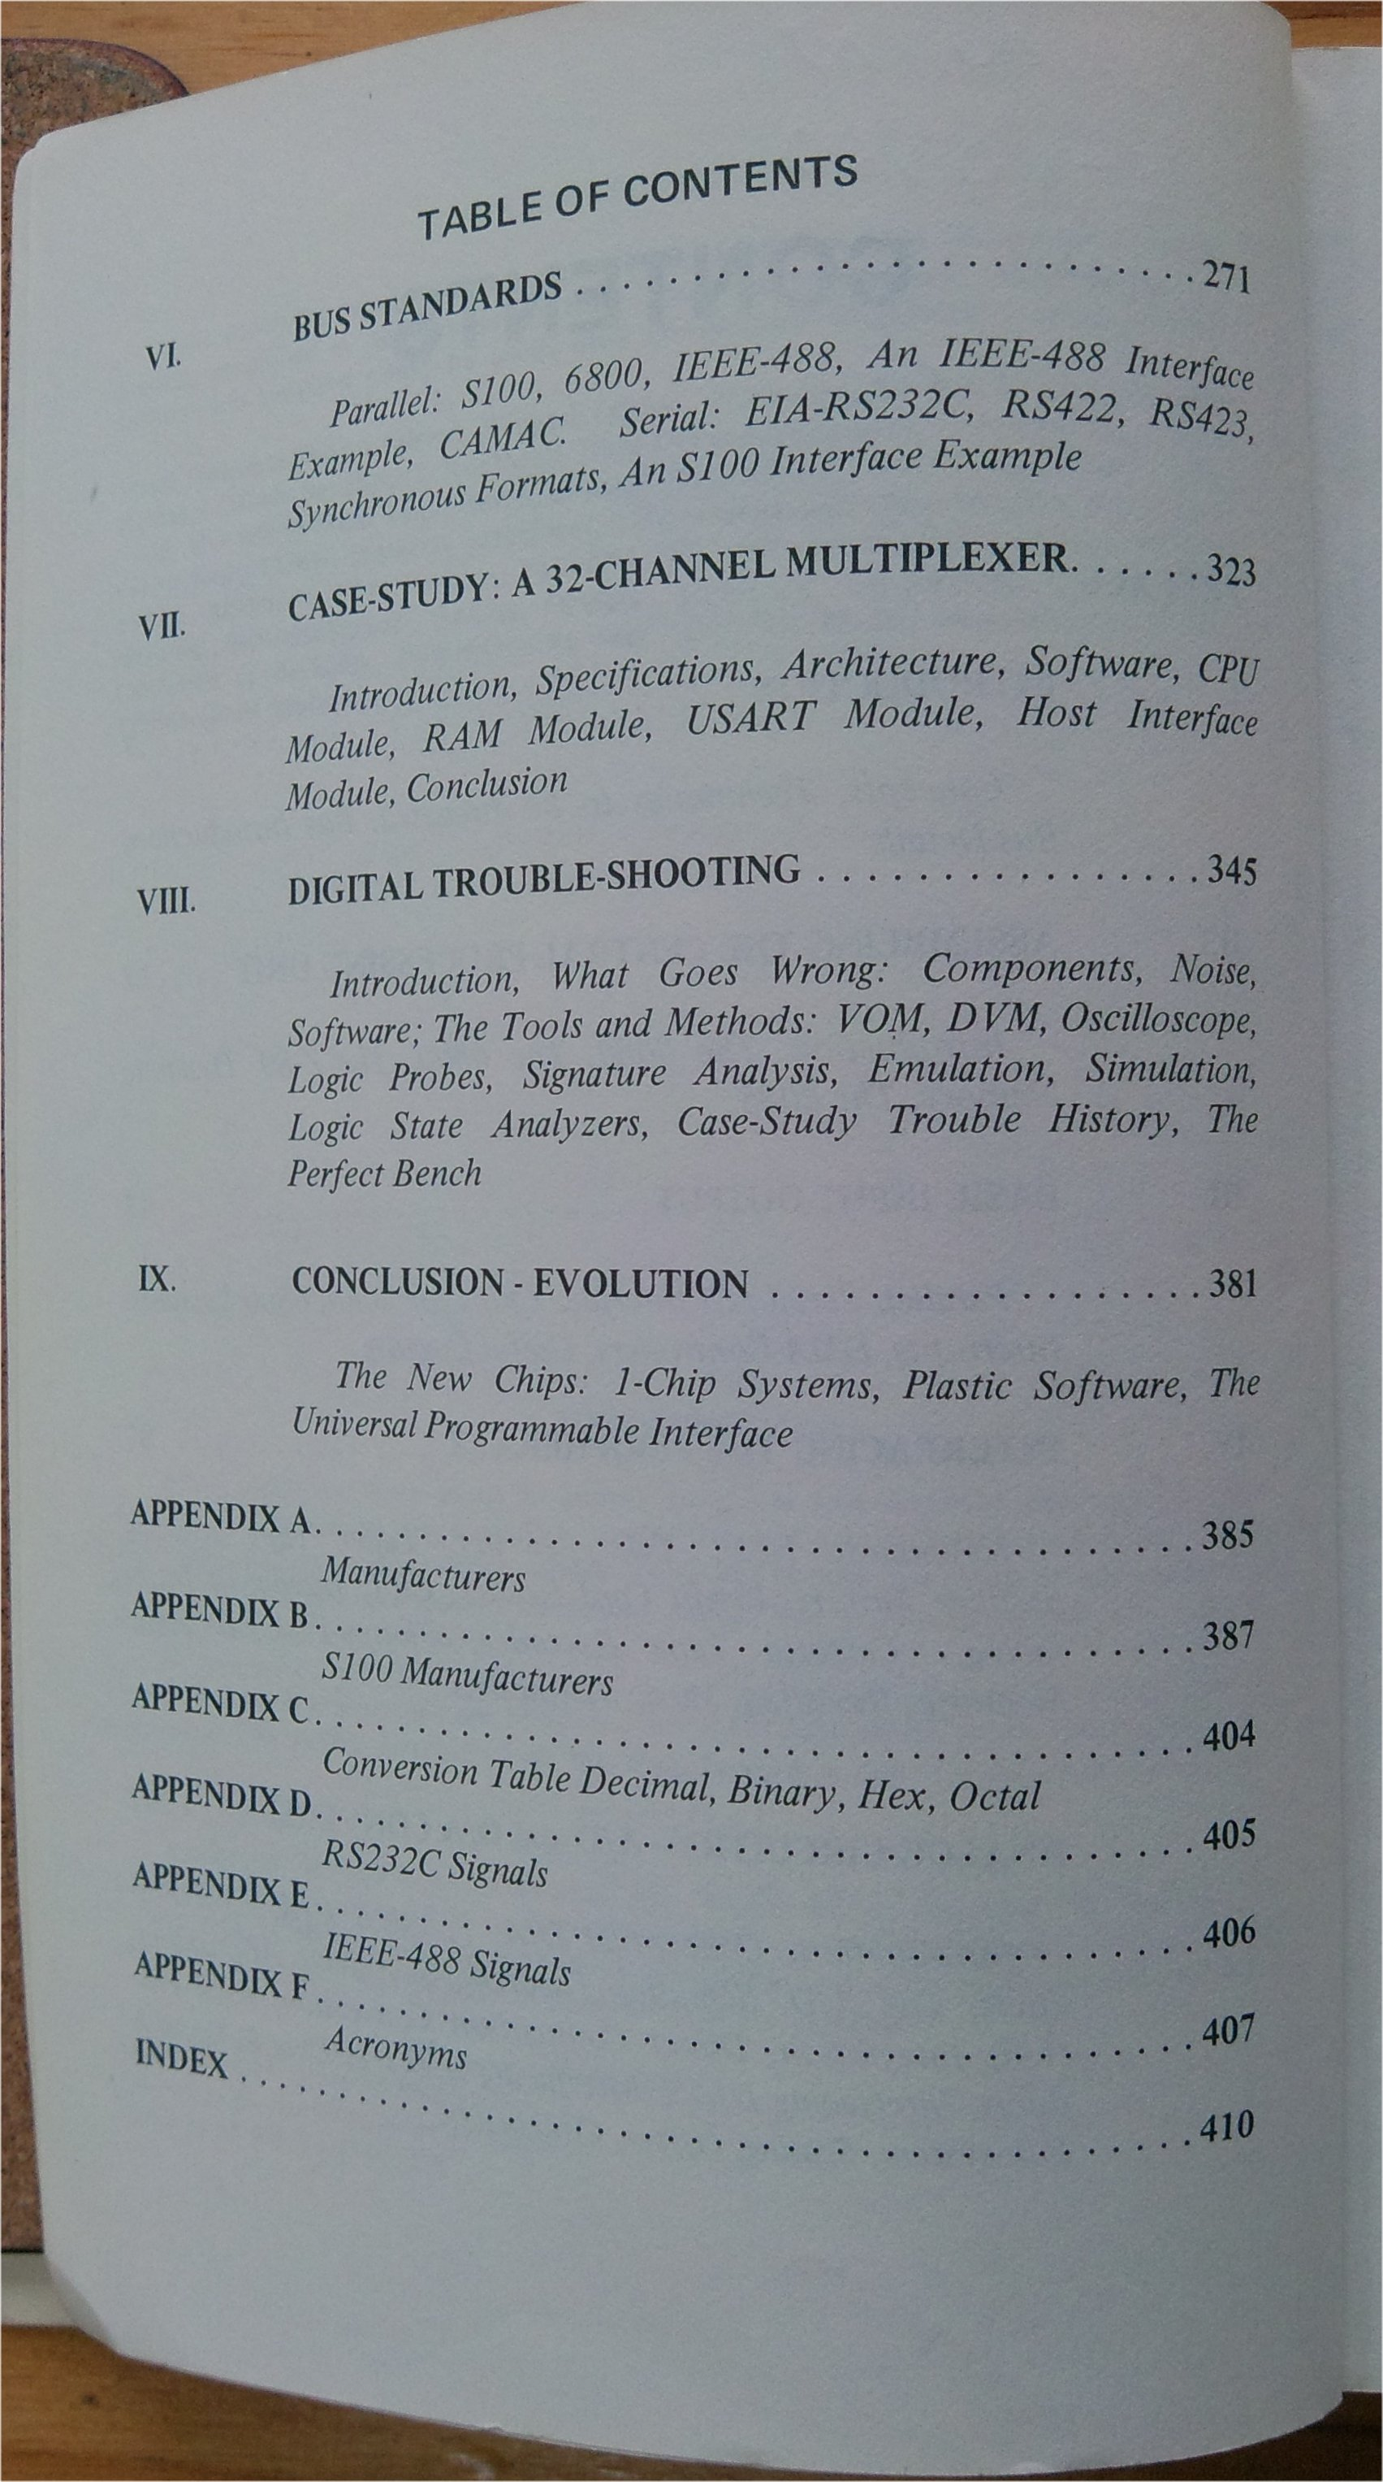
Figure 6: Microprocessor Interfacing Techniques table of contents page 2

