AccessionIndex: TCD-SCSS-V.20160121.001
Accession Date: 21-Jan-2016
Accession By: Peter Canavan
Object name: Z80 Speech Synthesiser assembly code listing
Vintage: c.1980
Synopsis: Peter Canavan, Australian Broadcasting Commission, Sydney, Australia.

Description:
This item represents a classic student project of the early days of microprocessors.

The Z80 Zilog Z80 SDK Development Kit in this catalog was purchased c.1980 by Peter Canavan for an assignment in a master’s degree course unit run by Dr.John Mills at the University of Western Australia. By that time the Z80 was very popular, and in particular was used in the first generation of programmable polyphonic music synthesizers, which presumably prompted this project. The Z80 SDK had a wire-wrap area, onto which Peter wired an AY-3-8910 sound effects controller. This chip “once played melodic gibberish” as directed by the speech synthesiser assembly language software listed in this catalog item.

Like many such early efforts, the original assembly language program was written by Peter in pencil in an exercise book (not on a screen and keyboard), manually entered, then stored to and reloaded from an audio cassette recorder via the SDK’s Kansas City cassette interface. The printed program came later. Again like many such efforts, there was a wish to extend the program to be more musical, but it remained just that.

Many thanks to Peter Canavan, Network Manager, Broadcast Operations, Australian Broadcasting Commission (ABC), who donated this item from his personal collection.

The homepage for this catalog is at: https://www.scss.tcd.ie/SCSSTreasuresCatalog/
Click 'Accession Index' (1st column listed) for related folder, or 'About' for further guidance. Some of the items below may be more properly part of other categories of this catalog, but are listed here for convenience.

Accession Index | Object with Identification
TCD-SCSS-V.20160121.001 | Peter Canavan, Z80 Speech Synthesiser assembly code listing, Australian Broadcasting Commission, Sydney, Australia, c.1980.

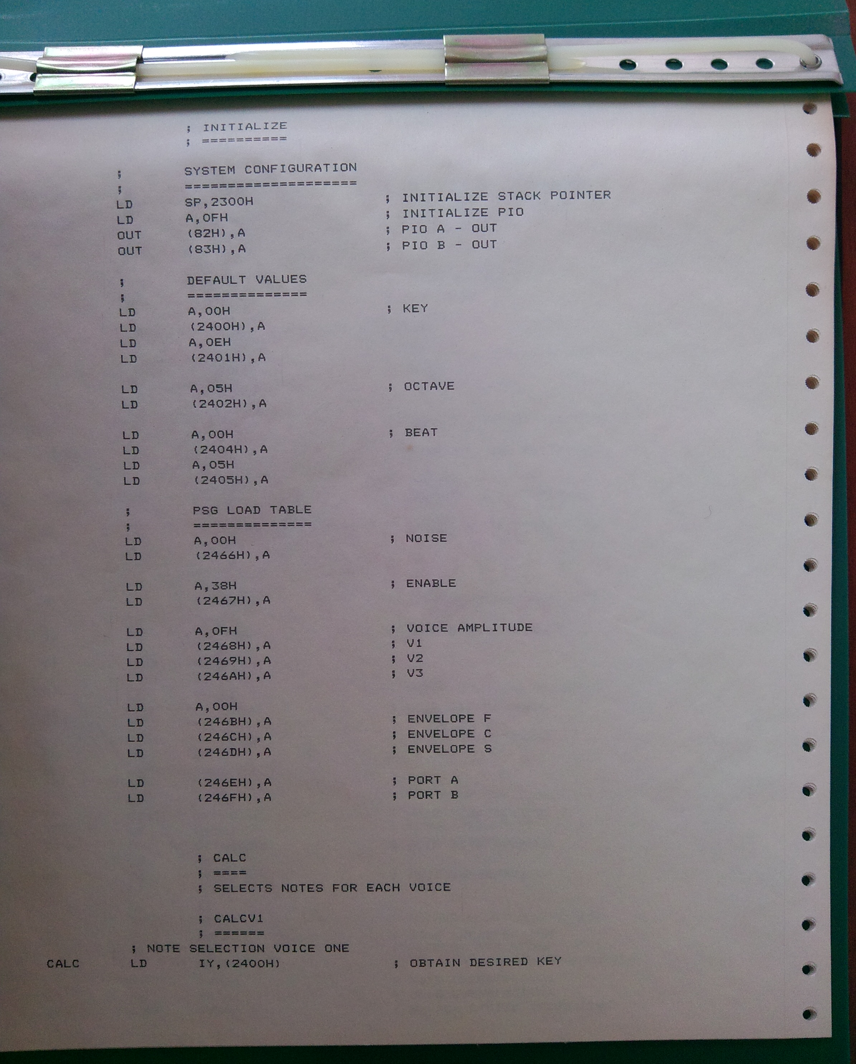
Figure 1: Z80 Speech Synthesiser assembly code listing, page 1

