AccessionIndex: TCD-SCSS-V.20141120.001
Accession Date: 20-Nov-2014
Accession By: Dr.Brian Coghlan
Object name: NS32000 NSU-3203256T-10 Development Board Documentation
Vintage: c.1984
Synopsis: Circuit diagrams, fact sheets, user manual, monitor user manual, reference manual, TDS tiny development system manual, NSX cross-support utilities reference manual, cross-utilities reference manual, ASM32K cross-assembler reference manual, instruction set reference manual.

Description:
The NSU-3203256T-10 Development Board was an evaluation and debug board introduced by National Semiconductor Corporation in 1984 to foster the development of NS32000-based microprocessor systems. Related software and documentation was also provided, as listed here.

The homepage for this catalog is at: https://www.scss.tcd.ie/SCSSTreasuresCatalog/
Click 'Accession Index' (1st column listed) for related folder, or 'About' for further guidance. Some of the items below may be more properly part of other categories of this catalog, but are listed here for convenience.

Accession Index | Object with Identification
TCD-SCSS-V.20141120.001 | NS32000 NSU-3203256T-10 Development Board Documentation, Circuit diagrams, fact sheets, user manual, monitor user manual, reference manual, TDS tiny development system manual, NSX cross-support utilities reference manual, cross-utilities reference manual, ASM32K cross-assembler reference manual, instruction set reference manual, 1984
TCD-SCSS-V.20141120.001.01 | Service Information.  Marked: 423300039-001N p.1-3
TCD-SCSS-V.20141120.001.02 | Circuit Diagrams (1).  Marked: 870010144-001 rev.A sheets 1-14
TCD-SCSS-V.20141120.001.03 | Service Information (2).  Marked: 423300039-001S p.1-3
TCD-SCSS-V.20141120.001.04 | Circuit Diagrams (2).  Marked: 870010144-001 rev.D sheets 1-14.
TCD-SCSS-V.20141120.001.05 | Congratulations & DB32016 Note p.1.
TCD-SCSS-V.20141120.001.06 | NS32332 vs MC68020 Facts p.1-2.
TCD-SCSS-V.20141120.001.07 | User Information, NS32032 CPU Revision F1, p.1-3.
TCD-SCSS-V.20141120.001.08 | User Information, NS32016 CPU Revision N, p.1-11.
TCD-SCSS-V.20141120.001.09 | DB32000 Development Board User’s Manual.
TCD-SCSS-V.20141120.001.10 | DB32000 Development Board Monitor Reference Manual.
TCD-SCSS-V.20141120.001.11 | TDS: Tiny Development Systems User’s Manual.
TCD-SCSS-V.20141120.001.12 | NSX Cross-Support Utilities Reference Manual.
TCD-SCSS-V.20141120.001.13 | Cross-Utilities Reference Manual.
TCD-SCSS-V.20141120.001.14 | ASM32K Cross-Assembler Reference Manual.
TCD-SCSS-V.20141120.001.15 | Instruction Set Reference Manual.

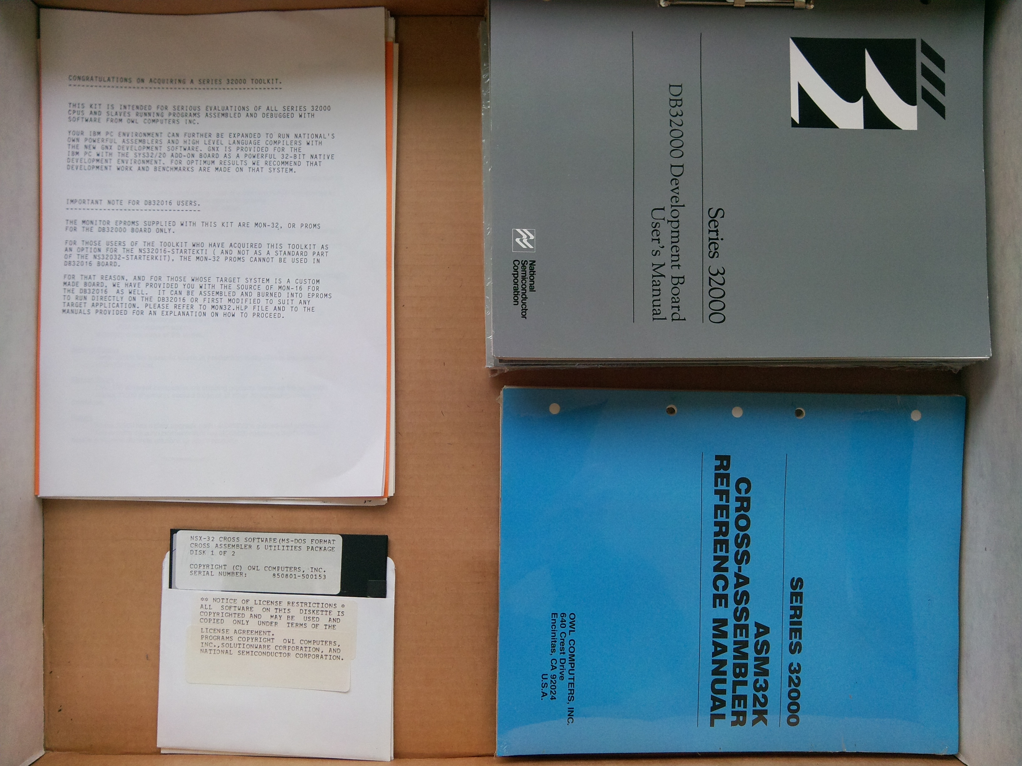
Figure 1: NS32000 Development Board 3 documentation

