AccessionIndex: TCD-SCSS-V.20121208.869
Accession Date: 8-Dec-2012
Accession By: Prof.J.G.Byrne
Object name: Richardson’s Fantastic Forecast Factory
Vintage: c.1986
Synopsis: Painting of imaginary prediction factory, based on Ch.11 of Richardson’s 'Weather Prediction by Numerical Process', ink and water colour, commissioned and owned by Prof.J.G.Byrne, painted by and Copyright of Stephen Conlin, 1986, see also Hardware category of this catalog.

Description:
In 1922 Lewis Fry Richardson published a remarkable book, Weather Prediction by Numerical Process, describing his attempt to forecast changes in the weather by numerical means. This painting, see Figure 1, in ink and water colours, was made by the Irish artist Stephen Conlin in 1986, on the commission of Prof. John Byrne, then Head of the Department of Computer Science in Trinity College, Dublin, who provided both Richardson’s text and suggestions regarding the inclusion of important figures from the history of mathematics and computation.

As Richardson’s Fantastic Forecast Factory represents a very early conception of an ensemble computing architecture, and because many of those interested in hardware find this painting fascinating, it is described in more detail in the Hardware category of this catalog, but the painting is properly part of this Literature category.

The homepage for this catalog is at: https://www.scss.tcd.ie/SCSSTreasuresCatalog/
Click 'Accession Index' (1st column listed) for related folder, or 'About' for further guidance. Some of the items below may be more properly part of other categories of this catalog, but are listed here for convenience.

Accession Index | Object and Identification
TCD-SCSS-V.20121208.048 | Weather Prediction by Numerical Process, Richardson, L.F., Dover, N.Y., 1965.
TCD-SCSS-V.20121208.832 | An approximately full scale preliminary draft in ink on semi-transparent paper of Conlin's Richardson painting, Conlin, S., inscribed 'Stephen Conlin, 53 York Road, Dun Laoghaire, Tel. 802 882', c19xx.
TCD-SCSS-V.20121208.869 | Richardson’s Fantastic Forecast Factory, Painting of imaginary prediction factory, based on Ch.11 of Richardson’s 'Weather Prediction by Numerical Process', ink and water colour, commissioned and owned by Prof.J.G.Byrne, painted by and Copyright of Stephen Conlin, 1986, see also Hardware category of this catalog, 1922.

References:

- Richardson, Lewis Fry, Numerical Prediction by Numerical Process, Cambridge Univ.Press, Second Edition (corrected version of the 1922 original with a new Foreward by Peter Lynch), Cambridge University Press, ISBN: 978-0-521-68044-8, 2007.

- Conlin, Stephen, Artist: For a range of work by the artist, see:
http://www.pictu.co.uk/
Last viewed 26-Nov-2015.

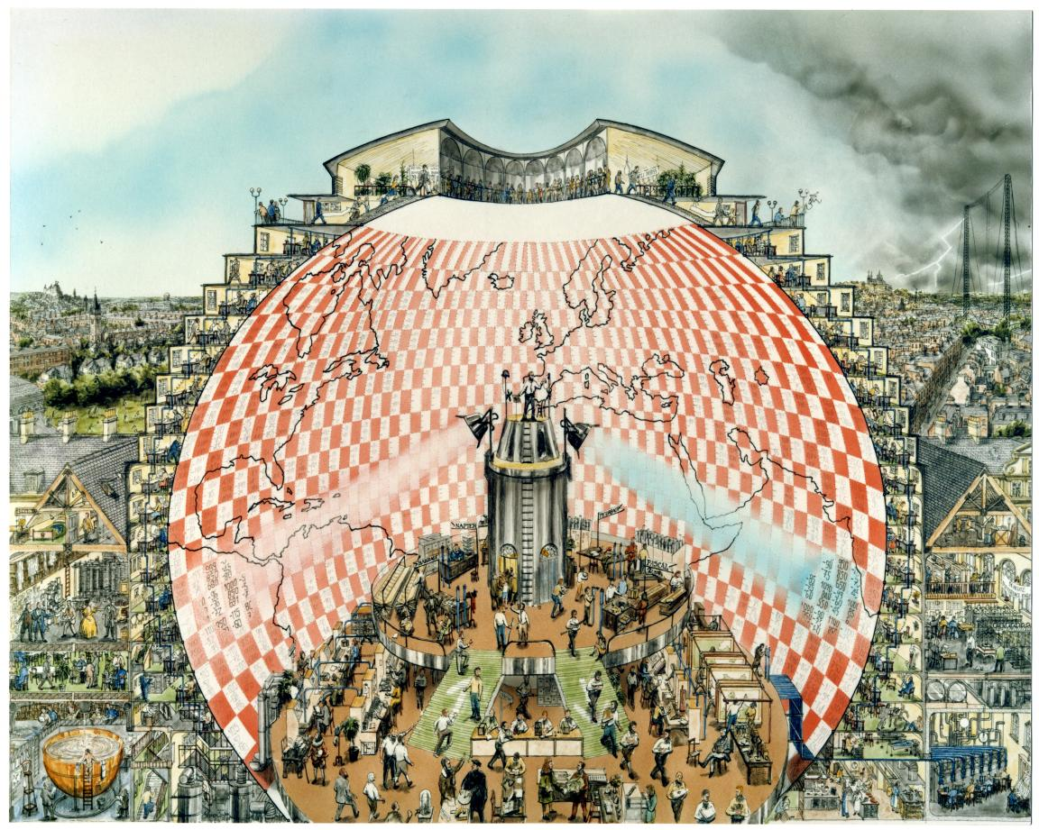
Figure 1: Richardson’s Fantastic Forecast Factory

