AccessionIndex: TCD-SCSS-V.20121208.865
Accession Date: 8-Dec-2012
Accession By: Prof.J.G.Byrne
Object name: Set of stamps issued in honour of Charles Babbage
Vintage: c.1991
Synopsis: British Post Office, framed set of 5x5 twenty-two pence UK stamps.

Description:
These stamps were issued by the British Post Office on 5-Mar-1991, the bicentenary of Charles Babbage’s birth. The stamps are from Prof.J.G.Byrne's 1992 TCD Quatercentenary exhibits.

The homepage for this catalog is at: https://www.scss.tcd.ie/SCSSTreasuresCatalog/
Click 'Accession Index' (1st column listed) for related folder, or 'About' for further guidance. Some of the items below may be more properly part of other categories of this catalog, but are listed here for convenience.

Accession Index | Object with Identification
TCD-SCSS-V.20121208.865 | Set of stamps issued in honour of Charles Babbage, British Post Office, framed set of 5x5 twenty-two pence UK stamps, c.1991. [Prof.J.G.Byrne's 1992 TCD Quatercentenary exhibits]

References:

- refs

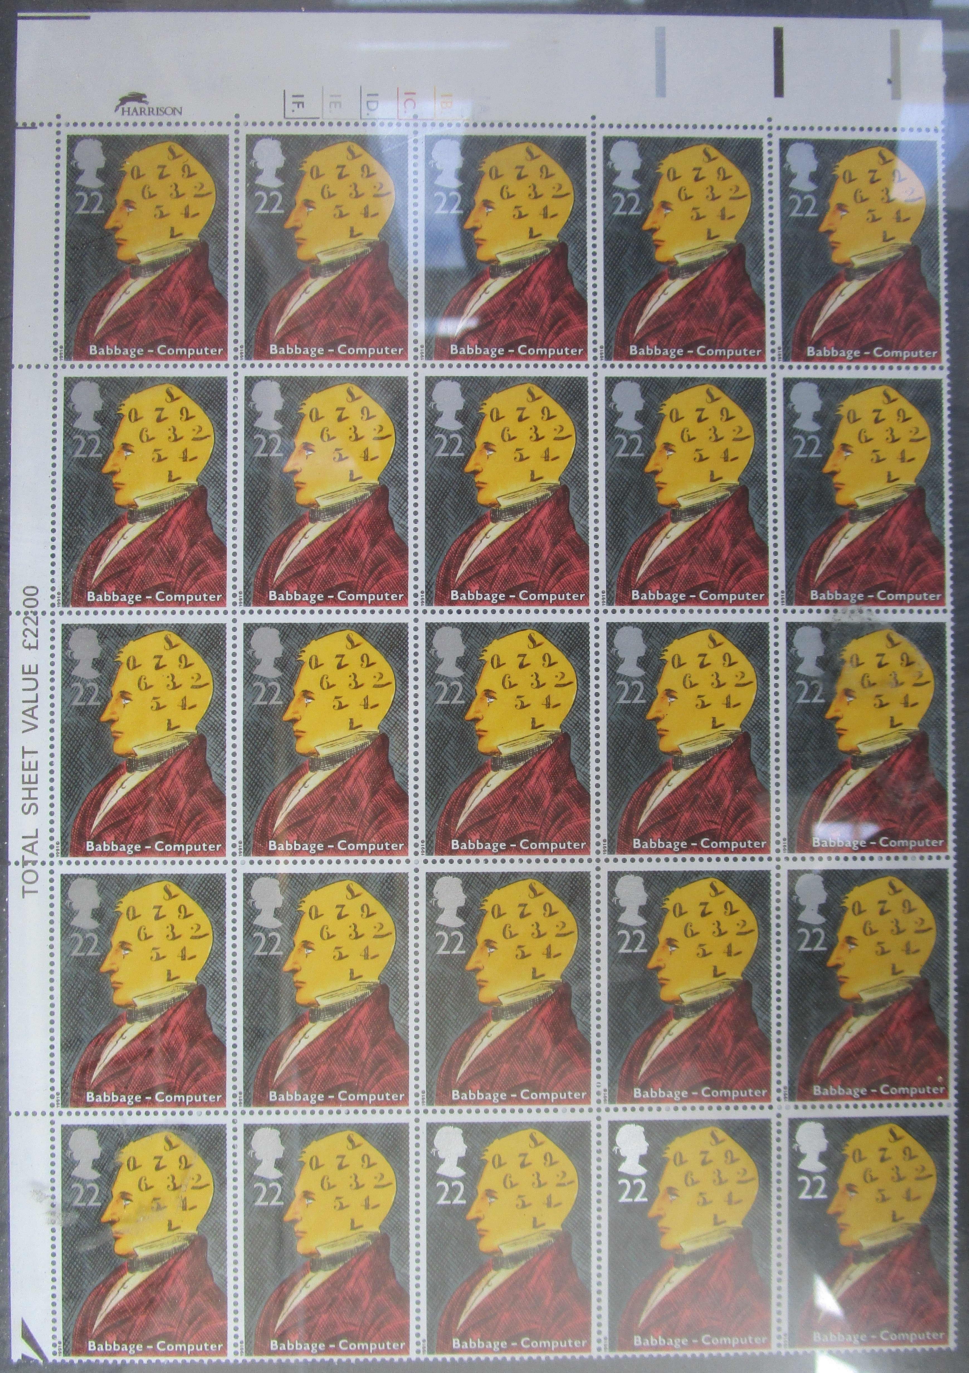
Figure 1: Stamp issue by British Post Office 5-Mar-1991 on bicentenary of Charles Babbage’s birth

