AccessionIndex: TCD-SCSS-V.20121208.856
Accession Date: 8-Dec-2012
Accession By: Prof.J.G.Byrne
Object name: Poster advertising 'The Little Thoughts of Thinking Machines'
Vintage: c.1992
Synopsis: Trinity College Dublin, mounted on wood, advertising lecture by Professor John McCarthy.

Description:
This wooden mounted poster, about 16”x22”, advertised The Little Thoughts of Thinking Machines, a lecture by Professor John McCarthy held on 14th May, 1992. The poster is from Prof.J.G.Byrne's 1992 TCD Quatercentenary exhibits.

The homepage for this catalog is at: https://www.scss.tcd.ie/SCSSTreasuresCatalog/
Click 'Accession Index' (1st column listed) for related folder, or 'About' for further guidance. Some of the items below may be more properly part of other categories of this catalog, but are listed here for convenience.

Accession Index | Object with Identification
TCD-SCSS-V.20121208.856 | Poster advertising lecture on 'The Little Thoughts of Thinking Machines', Trinity College Dublin, mounted on wood, advertising lecture by Professor John McCarthy, c.1992.  [Prof.J.G.Byrne's 1992 TCD Quatercentenary exhibits]

References:

- refs

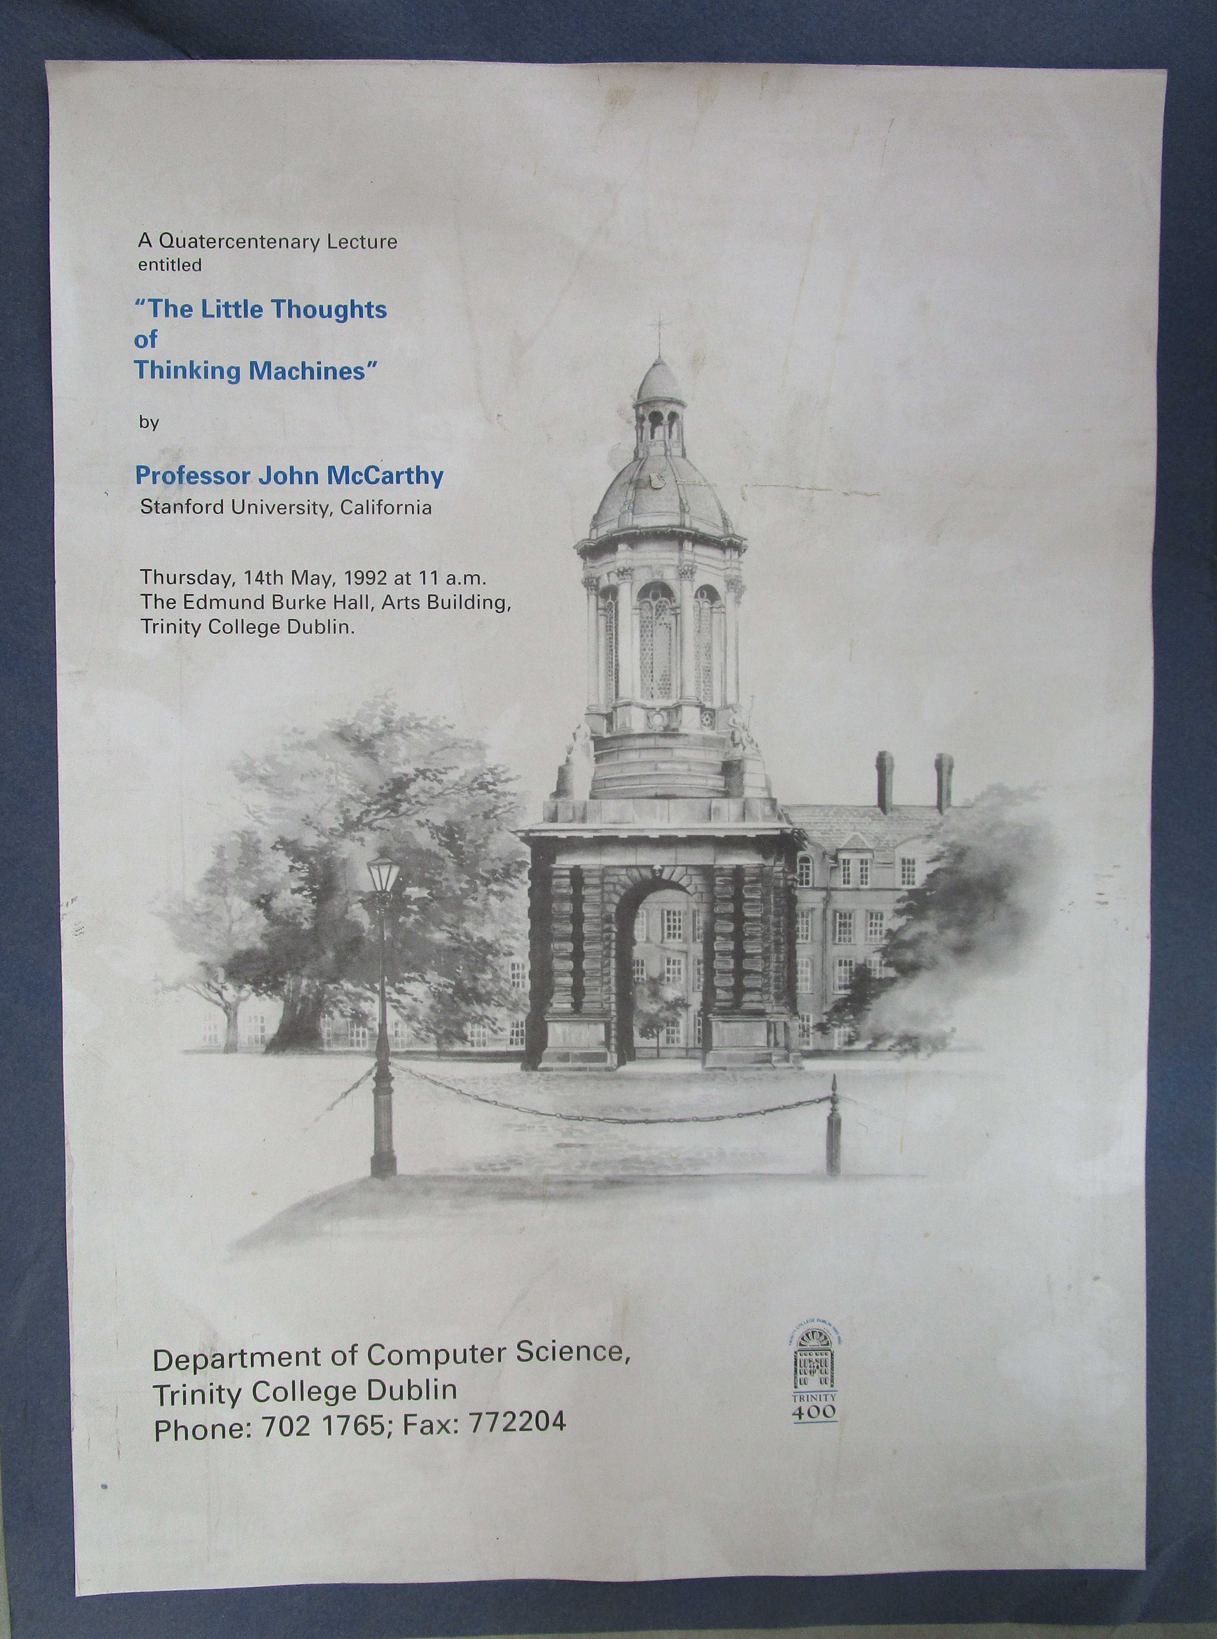
Figure 1: Poster for TCD Quatercentenary lecture by Prof.J.McCarthy

