AccessionIndex: TCD-SCSS-V.20121208.847
Accession Date: 8-Dec-2012
Accession By: Prof.J.G.Byrne
Object name: Posters advertising 'Engineering - Past, Present and Future'
Vintage: c.1992
Synopsis: Trinity College Dublin, mounted, multiple copies, advertising a TCD Quatercentenary exhibition.

Description:
Multiple mounted copies of the poster for the Engineering - Past, Present and Future exhibition held in Trinity College Dublin from 10-May-1992 until 23-May-1992. The poster is from Prof.J.G.Byrne's 1992 TCD Quatercentenary exhibits.

The homepage for this catalog is at: https://www.scss.tcd.ie/SCSSTreasuresCatalog/
Click 'Accession Index' (1st column listed) for related folder, or 'About' for further guidance. Some of the items below may be more properly part of other categories of this catalog, but are listed here for convenience.

Accession Index | Object with Identification
TCD-SCSS-V.20121208.847 | Posters advertising 'Engineering - Past, Present and Future', Trinity College Dublin, mounted, advertising a TCD Quatercentenary exhibition, c.1992.  [Prof.J.G.Byrne's 1992 TCD Quatercentenary exhibits]

References:

- refs

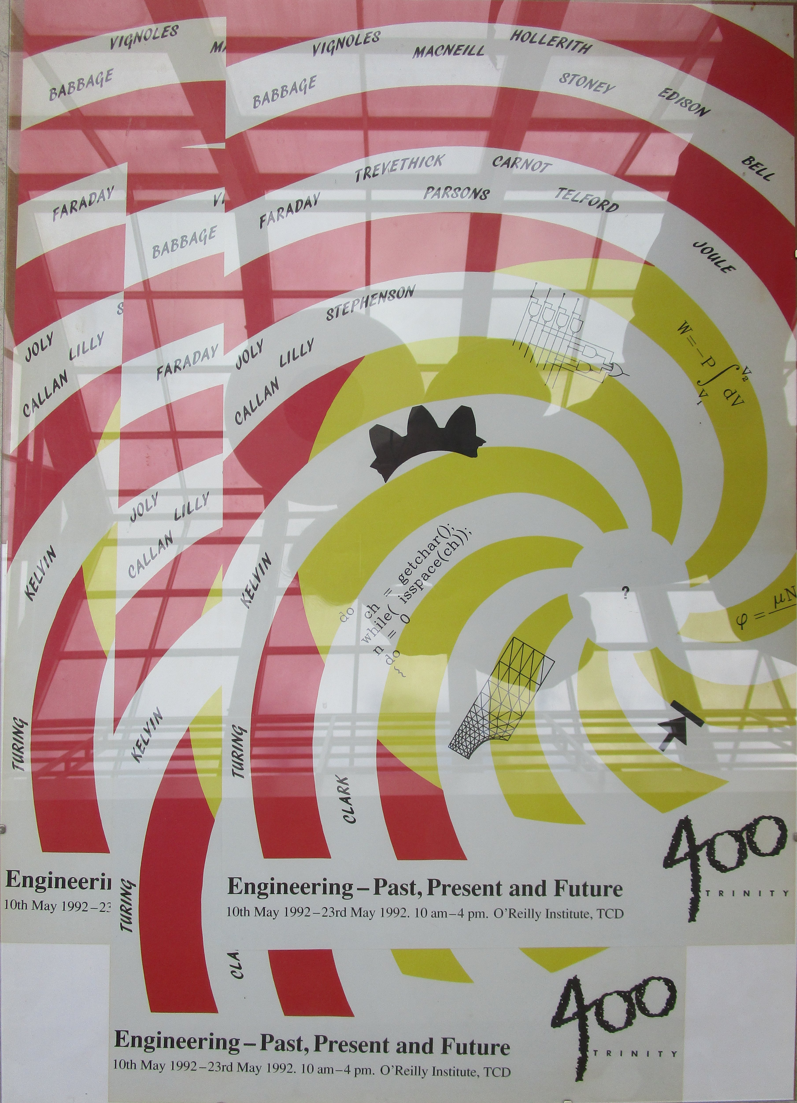
Figure 1: Poster for “Engineering - Past, Present and Future” exhibition

