AccessionIndex: TCD-SCSS-V.20121208.846
Accession Date: 8-Dec-2012
Accession By: Prof.J.G.Byrne
Object name: A large un-mounted poster of Queen Elizabeth I
Vintage: c.1986
Synopsis: Marcus Gheeraerts the Younger, in the British National Portrait Gallery.

Description:
This poster is from a composite exhibition created by Prof.J.G.Byrne that was entitled Computing through the Ages and held in the Long Room of the Old Library in Trinity College Dublin from September, 1986, which amongst other exhibits also included an exhibition on Computation in the era of Queen Elizabeth I (1533-1603), and another on Charles Babbage’s Computing Engines, see elsewhere in this catalog. This large exhibition was timed to coincide with a conference of the International Federation of Information Processing (IFIP) held in Trinity College Dublin in September, 1986.

These exhibition materials were re-used as part of the Treasures of the Mind exhibition held in the Colonnades Gallery of the Old Library for the TCD Quatercentenary in 1992.

The homepage for this catalog is at: https://www.scss.tcd.ie/SCSSTreasuresCatalog/
Click 'Accession Index' (1st column listed) for related folder, or 'About' for further guidance. Some of the items below may be more properly part of other categories of this catalog, but are listed here for convenience.

Accession Index | Object with Identification
TCD-SCSS-V.20121208.846 | A large un-mounted poster of Queen Elizabeth I, Marcus Gheeraerts the Younger, in the British National Portrait Gallery, c.1986.  [Prof.J.G.Byrne's IFIP-1986 and 1992 TCD Quatercentenary exhibits]

References:

- refs

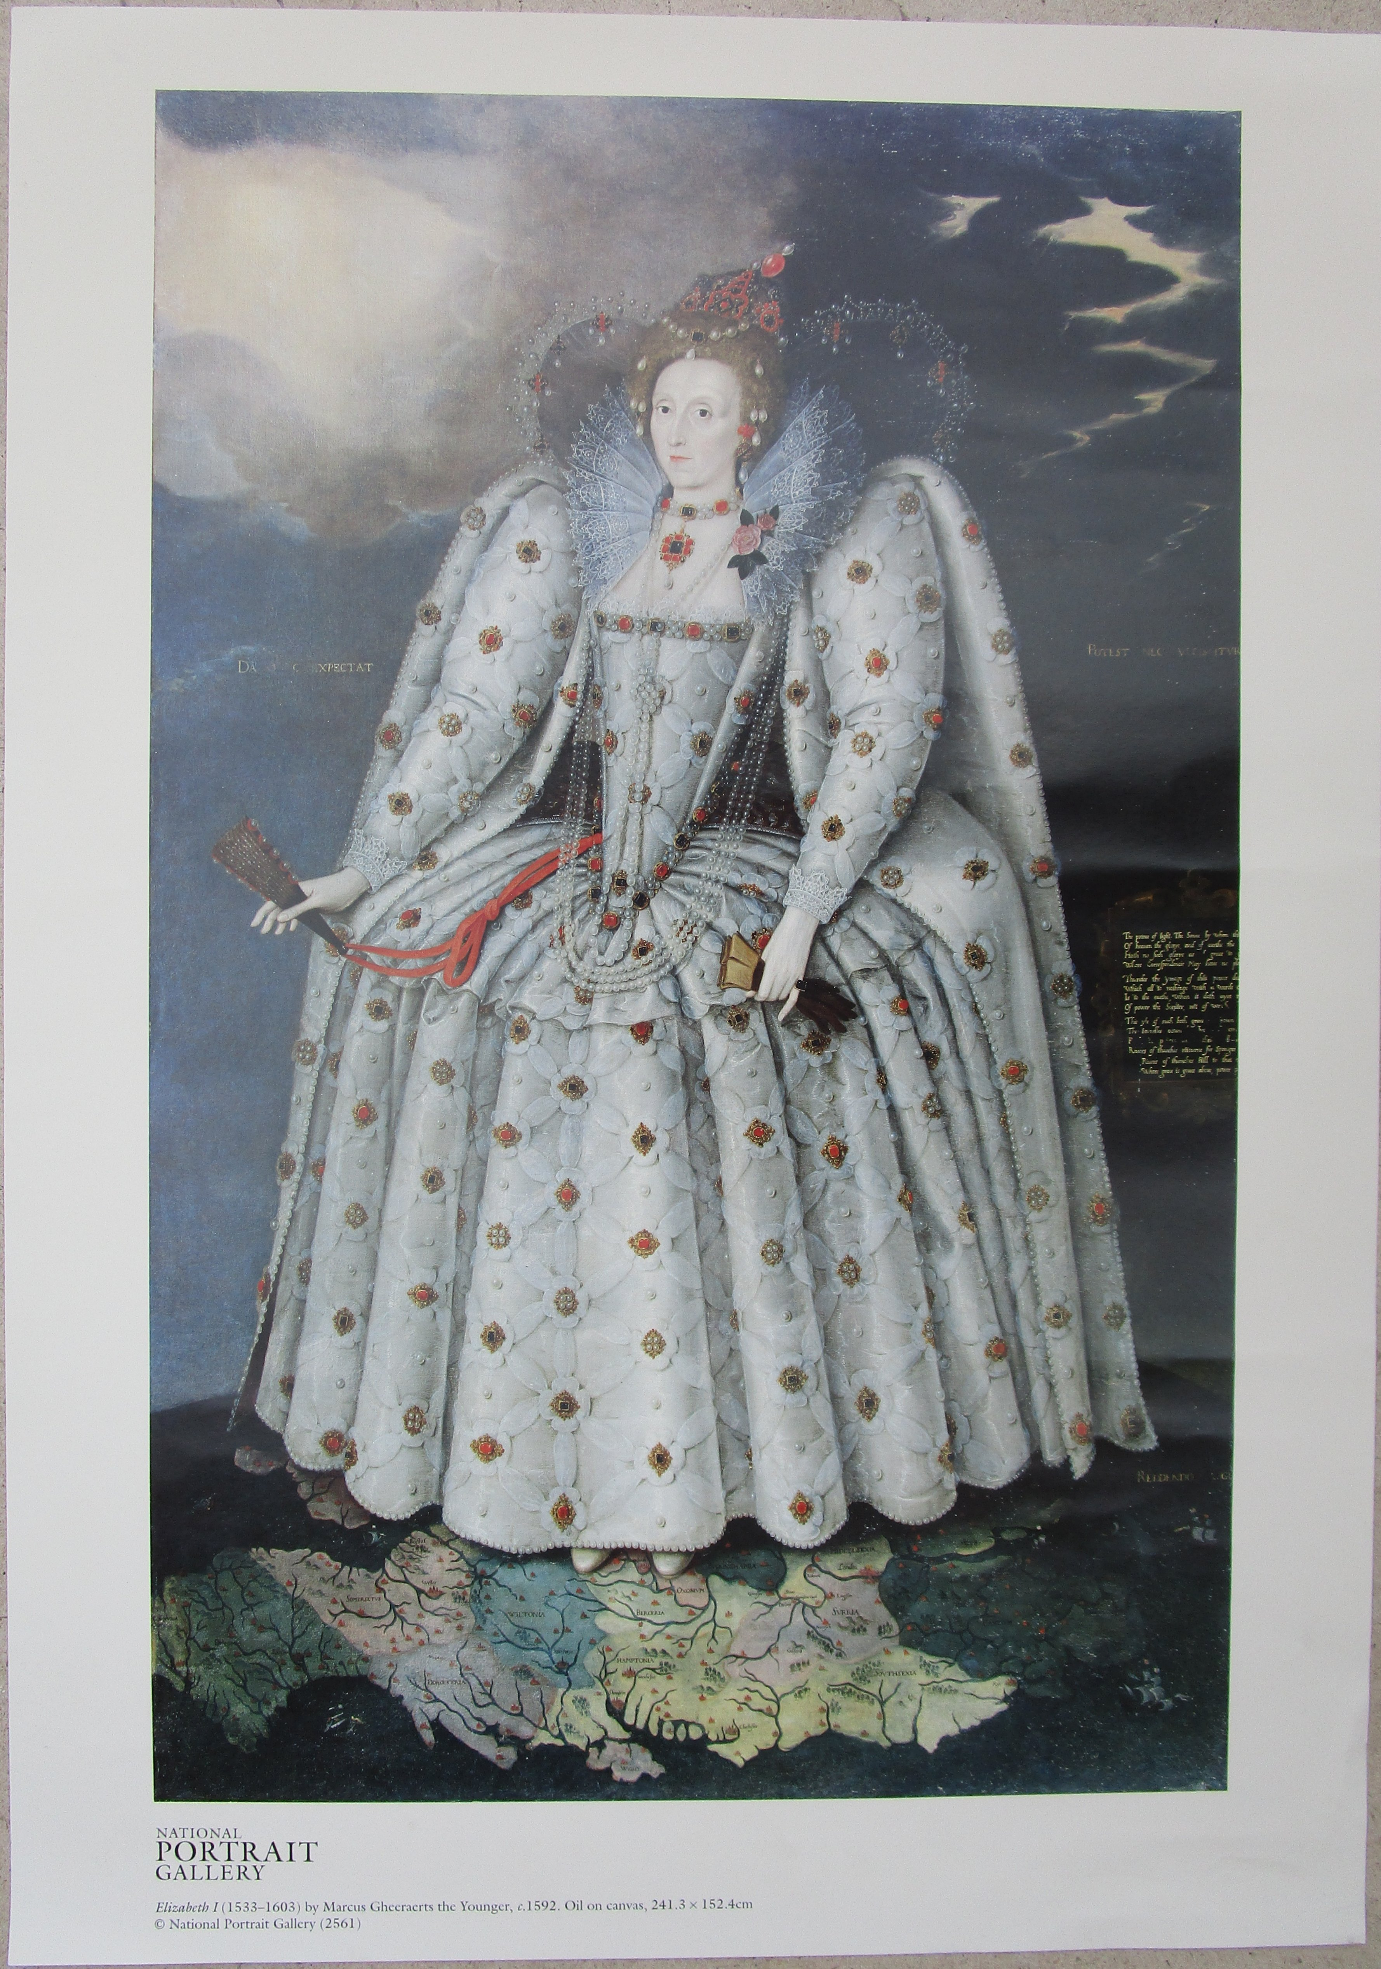
Figure 1: Queen Elizabeth I, 1533-1603
(from the National Portrait Gallery, by Marcus Gheeraerts the Younger, c.1592)

