AccessionIndex: TCD-SCSS-V.20121208.673
Accession Date: 8-Dec-2012
Accession By: Prof.J.G.Byrne
Object name: Irish National Inventory of Historic Scientific Instruments
Vintage: 1995
Synopsis: Mollan, C., Blackrock, ISBN: 1-898-706-05-0.

Description:
This extensive inventory lists, and in many cases describes, the surprisingly large number of scientific instruments which have been preserved in the various public and private institutions, as well as privately, both within and outside of Ireland, but does not include instruments held in this Collection. It covers some archaeological items, but primarily instruments used for professional, teaching, scientific and some domestic purposes, mostly from the 19th and 20th centuries. It provides indexes both of instruments and instrument makers, plus a bibliography.

The inventory was first published by the Royal Dublin Society (RDS), EOLAS (the Irish Science and Technology Agency) and the National Heritage Council in 1989, then updated and republished in 1990 and 1995. This item is the printed version of the inventory published by Samton, Blackrock. For the electronic version of this inventory, see elsewhere in this catalog.

The homepage for this catalog is at: https://www.scss.tcd.ie/SCSSTreasuresCatalog/
Click 'Accession Index' (1st column listed) for related folder, or 'About' for further guidance. Some of the items below may be more properly part of other categories of this catalog, but are listed here for convenience.

Accession Index | Object with Identification
TCD-SCSS-V.20121208.673 | Charles Mollan, Irish National Inventory of Historic Scientific Instruments, Mollan, C., Samton: Blackrock, 1995.
TCD-SCSS-V.20201214.001 | Charles Mollan, Irish National Inventory of Historic Scientific Instruments, electronic version of the last and much the best version of the inventory published by Samton, Blackrock, ISBN: 1-898-706-05-0, 1995.
TCD-SCSS-V.20201230.001 | Charles Mollan & John Upton, The Scientific Apparatus of Nicholas Callan and other Historic Instruments, St Patrick's College Maynooth & Samton Limited, 1994.
TCD-SCSS-V.20201230.002 | Charles Mollan, It's Part of What We Are - Richard Boyle (1566-1643) to John Tyndall (1820-1893), volume 1, Royal Dublin Society, inscribed by the author, 2007.
TCD-SCSS-V.20201230.003 | Charles Mollan, It's Part of What We Are - Samuel Haughton (1821-1897) to John Stewart Bell (1928-1990), volume 2, Royal Dublin Society, inscribed by the author, 2007.

References:

- Charles Mollan, Irish National Inventory of Historic Scientific Instruments, Samton: Blackrock, ISBN: 1-898-706-05-0, 1995.

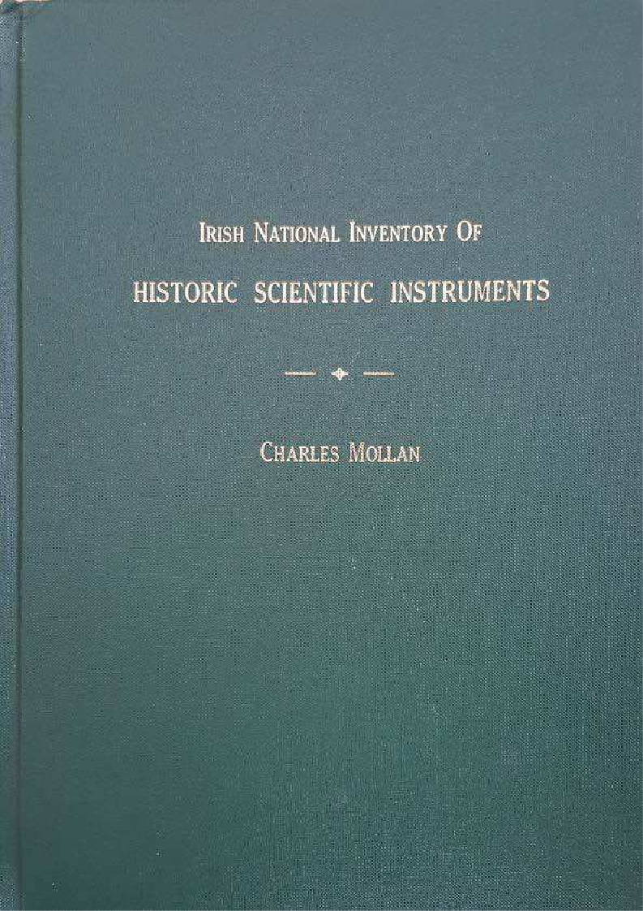
Figure 1. Irish National Inventory of Historic Scientific Instruments, front cover.

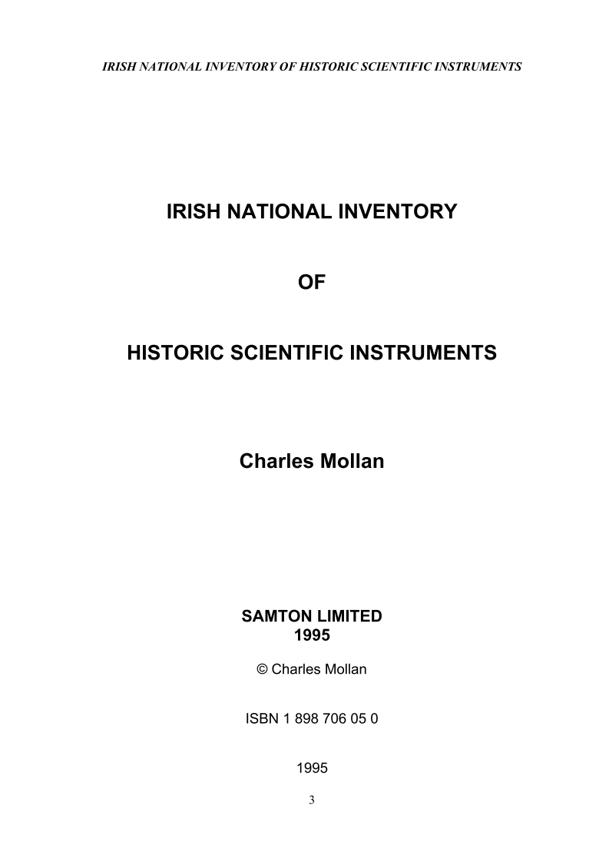
Figure 2. Irish National Inventory of Historic Scientific Instruments, title page, page 3.

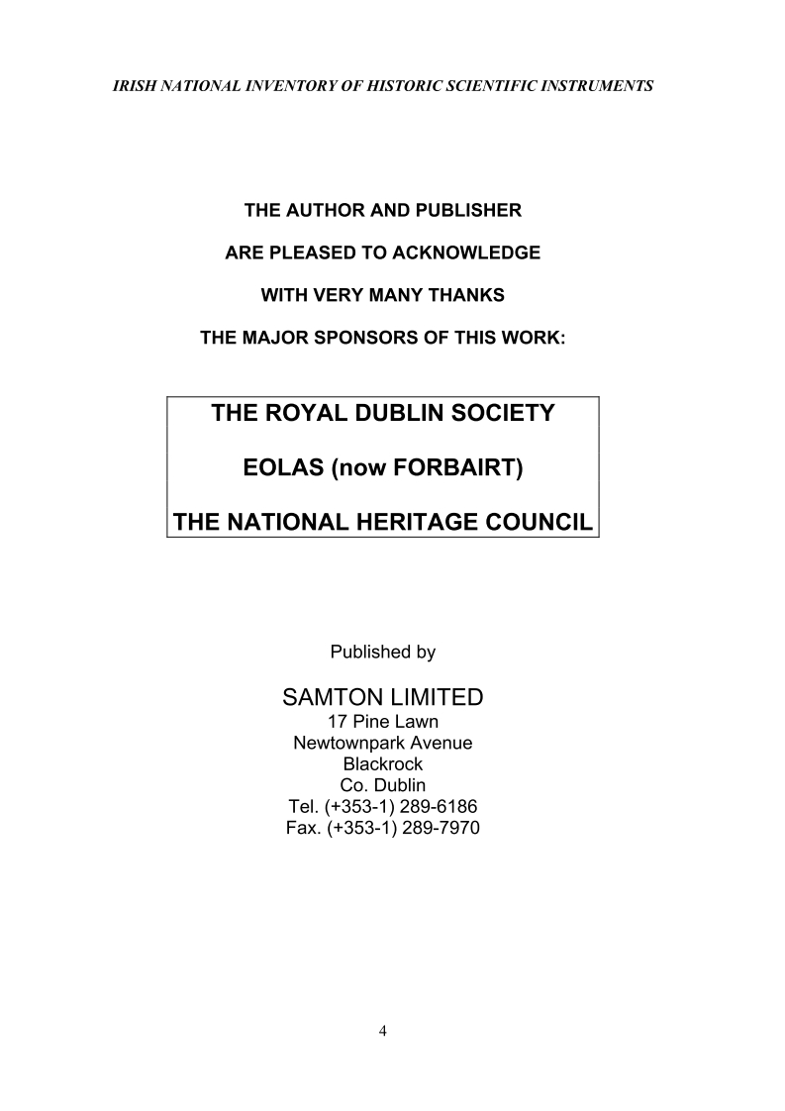
Figure 3. Irish National Inventory of Historic Scientific Instruments, publication details, page 4.

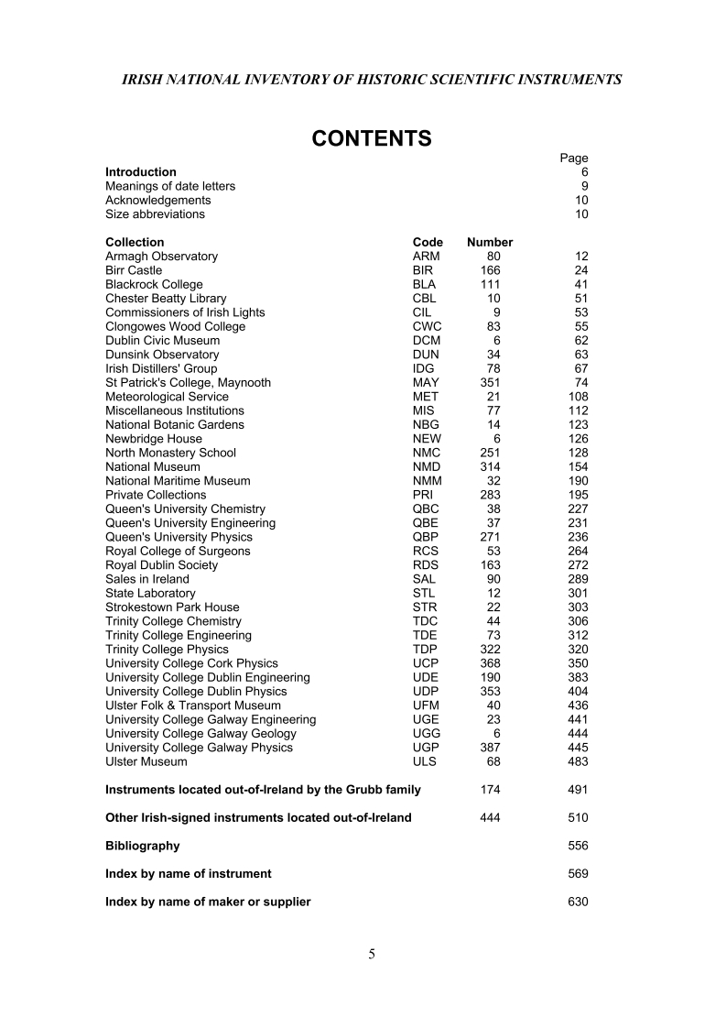
Figure 4. Irish National Inventory of Historic Scientific Instruments, contents, page 5.

Instruments out of Ireland are confined to those with an Irish signature - designated ‘Ex’ (for Instruments located out of Ireland), and covered in two separate listings (pp. 375-389 for those by Grubb; and 391-424 for the rest).

