AccessionIndex: TCD-SCSS-T.20121208.009
Accession Date: 8-Dec-2012
Accession By: Prof.J.G.Byrne
Object name: Facit NEA Calculator
Vintage: c.1943
Synopsis: Electrical motor-driven 13-digit decimal mechanical calculator.

Description:
In 1918 ‘Facit’ calculators were introduced by Axel Wibel, Stockholm. In 1924, the business was incorporated as Facit (Facit AB), a subsidiary of Åtvidaberg Industries, a corporation founded in Åtvidaberg, Sweden, in 1922.

Facit initially made hand-cranked Odhner-type decimal calculators with levers for number entry. In 1932 they introduced the 2-row 10-key Model T decimal calculator, again hand-cranked, and electrically-cranked Model E calculators of the same type in 1934, with a 400rpm electrical motor at the rear replacing the crank handle. The Model TK, see elsewhere in this catalog, and Model EK, both introduced in 1936, were modest updates of the Model T and Model E designs. Only with the Model EA, introduced in 1939, was the potential of the electrical motor exploited to provide automatic division and semi-automatic multiplication. The Model NEA, introduced in 1943, was a modest update of the Model EA, principally a better motor.

Odhner-type pinwheel mechanisms had a pinwheel rotor fixed in the body of the machine, with the registers in a moving carriage at the front. By contrast, the Facit Model T inverted-pinwheel mechanism had registers fixed at the top of the machine, with the pinwheel rotor moving on an internal carriage. The pinwheels were enclosed within the body of the machine, and were operated through a key setting mechanism. A pinned carry rotor at the rear of the machine provided identical carry mechanisms across the full width of both registers.

Like the T, E, TK and EK models, the EA and NEA models had tens transmission (i.e. carry/borrow), a movable accumulator and tabulator (for justifying numbers), and sliding quotient coupling (to automatically extend dividends with zeroes). They had a basic ten-key mechanism, a 9-digit entry register, an 8-digit counter register and a 13-digit accumulator register that showed the result of adds, subtracts and multiplies, and the remainder from divisions. The counter was multi-purpose: for add/subtract it showed the number of these executed; for multiply it showed the multiplier; and for divide it showed the quotient (result).

The electrically-cranked Model E had extra ADD and ÷ keys for add/multiply and subtract/divide, and a control lever at lower left with two positions for add/subtract and multiply/divide (enabling repeated add/subtract). Likewise, the semi-automatic EA and NEA models had extra ADD and ÷ keys (the latter also was used to subtract), but also an extra × key, and the control lever now had three positions: left for multiply in most-to-least significant order, middle for multiply in least-to-most significant order, and right for divide. It also has a related lever with two positions: up for stop and down for ??? [what exactly did each position do ?] There was a red right-shift → key at lower left, and at upper right three red keys [what for?]. Register clearing was still done manually by two levers at the upper left that cleared the accumulator (product register) and the entry register (setting register). [how was the counter register cleared?]

The EA and NEA models provided automatic division and automatic shifting to semi-automate multiplication. The major advance was the automatic division. To perform division, the dividend was entered, left justified, and added to the accumulator, then the divisor was entered, left justified, and finally the divide key was pressed to repeatedly subtract the divisor from the dividend until the machine underflowed, whereupon a stop-division mechanism halted the calculator once the accumulator registered zeroes or nines, then this underflow was automatically corrected.

By modern standards they were barely ‘portable’, in essence large desktop calculators 265 (w) x 250 (d) x 165 (h) mm in size, deeper and wider than Model TK, weighing 10.2kg. From 1966 Facit sold large desktop electronic calculators made by Sharp in Japan. The arrival of portable hand-held electronic calculators in 1971 made Facit’s business obsolete, and the company was sold on, eventually closing in 1998.

Early Facit calculators were black with a script ‘Facit’ logo, then green with a pressed-metal logo in capital letters from the early-1940s, finally grey from the mid-1950s (but often painted the latest colour when serviced), so going by the logo the Facit NEA calculator in this collection was made no earlier than the early-1940s. It was purchased by the Engineering School, Trinity College Dublin, circa 1957.

Also see the Facit TK calculator elsewhere in this catalog.

Accession Index | Object with Identification
TCD-SCSS-T.20121208.009 | Facit NEA Calculator.  S/N:

References:

- Wikipedia, Facit, see: https://en.wikipedia.org/wiki/Facit
Last viewed 3-Apr-2016.

- Christofer Nöring, History of the Facit Calculators, see: http://www.xnumber.com/xnumber/facit_history.htm
Last viewed 4-Apr-2016.

- Christofer Nöring, Family tree of the Facit calculators, see: http://w1.131.telia.com/~u13101111/facitsv.html
Last viewed 4-Apr-2016.
[also see attached folder in this catalog]

- John Wolff, "Facit" Calculators, see: http://www.johnwolff.id.au/calculators/Facit/Facit.htm
Last viewed 4-Apr-2016.

- John Wolff, The Original-Odhner Pinwheel Calculator - Technical Description, see: http://www.johnwolff.id.au/calculators/Tech/OdhnerPinwheel/OdhnerPinwheel.htm
Last viewed 4-Apr-2016.
[also see attached folder in this catalog]

- John Wolff, The Facit C1-13 Pinwheel Calculator - Technical Description, see: http://www.johnwolff.id.au/calculators/Tech/FacitC1-13/C113.htm
Last viewed 4-Apr-2016.
[also see attached folder in this catalog]
[useful pictorial guide to internal mechanism]

- Facit AB, How to become an expert on the FACIT NTK, see: https://mechanicalcalculators.files.wordpress.com/2015/02/facit-ntk-manual-compressed1.pdf
Last viewed 4-Apr-2016.
[also see attached folder in this catalog]
[useful guide to operating a later model Facit inverted-pinwheel calculator]

- Harald Schmid, FACIT Rechenmaschinen, Vom Modell T zur 1051, 2007, see: http://www.rechenautomat.de/Facit/Facit.html
Last viewed 4-Apr-2016.
[also see translation from Swedish to English in attached folder in this catalog]
[detailed technical history of Facit inverted-pinwheel calculators]

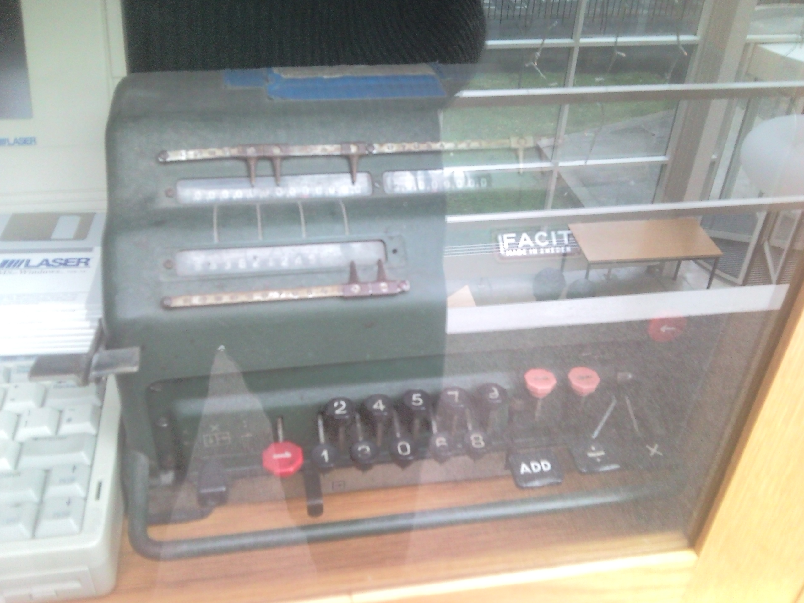
Figure 1: Facit NEA Calculator front top view

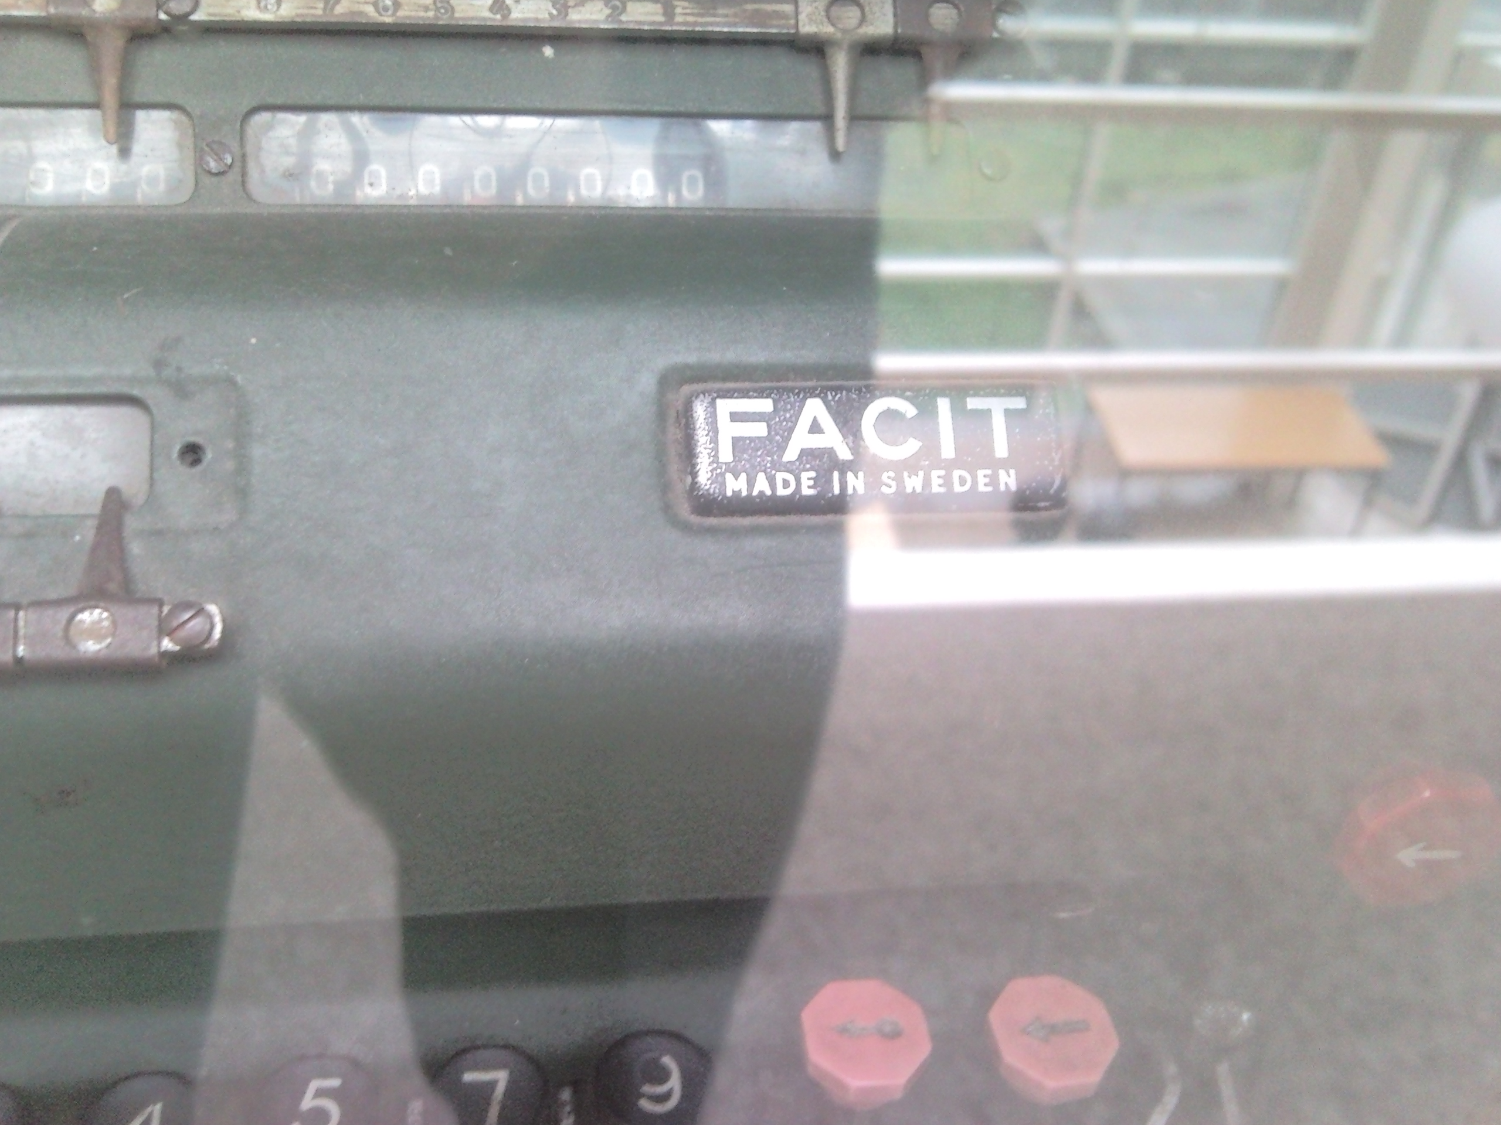
Figure 2: Facit NEA Calculator front closeup

