AccessionIndex: TCD-SCSS-T. 20250701.002
Accession Date: 1-Jul-2025
Accession By: Dr.Mads Haahr
Object name: T-mobile G1 smartphone
Vintage: 2008
Synopsis: First smartphone based on Android software. Touch-screen quad-band 3G GSM mobile phone. S/N: xxxxxxx.

Description:
The T-mobile G1 was the first smartphone based on the Android software, itself layered above Linux. Android Inc. (led by Andy Rubin) had been purchased in July 2005 and its Android operating system and prototype hardware developed by Google and the Open Handset Alliance to create a competitor to other major smartphone platforms of the time, such as the Symbian, BlackBerry OS, iPhone OS and Windows Smartphone mobile phone operating systems. Steve Jobs’ lifting of the secrecy surrounding the iPhone in early-2007 led to a quick redesign of Android and a new prototype device codenamed Dream with a touch-screen and a sliding keyboard. The new Android offered a customizable graphical user interface, deep integration with Google services such as its search engine and Gmail, and a notification system that showed a list of recent messages pushed from apps, an MP3 player, Maps, Search, Talk, YouTube, Contacts and Calendar apps, etc, alongside the Android Market for downloading additional and third-party apps. Its initial operating system version was Android 1.0 (no codename for 1.0 and 1.1), but this was upgradeable online (the last version supported was Android 1.6 Donut). It was officially announced in November 2007. In contrast to its competitors, Google’s policy was notable for being agnostic to the physical platform, openly promoting its use in third-party mobile phones. By 2008 several devices were being developed, but HTC in Taiwan, at the time one of the largest manufacturers of mobile phones, was on 23rd September 2008 the first to announce its product, the HTC Dream, known as the T-mobile G1 in America and the U.K., selling for about 290 euro. Google released a special developer edition of the T-mobile G1 known as the Android Dev Phone 1 for ^{US}$399, which was SIM-unlocked, hardware-unlocked and pre-configured for superuser access to the internal files of the phone, allowing users to completely replace the bootloader and operating system.

Similar to the iPhone, the T-mobile G1 had a 3.2" 320x480 180ppi Corning Gorilla Glass capacitive touch-screen, but sliding sideways to the right to reveal a QWERTY keyboard. An angled uplift at the bottom had a central trackball and five surrounding buttons: left Call and Home, right Back and End Call, above Menu. Alongside 192MB RAM expandable to 16GB via SDcard, it had a Qualcomm MSM7201A SoC with an ARM11 CPU (ARMv6 instruction set, 32-bit single-core, 8-stage pipeline, out-of-order execution, dynamic branch prediction/folding) running at 528MHz, an Adreno 130 GPU, and integrated QDSP400 and QDSP500 digital signal processors, MDDI display interface, Bluetooth 1.2 and 802.11b/g Wi-Fi, and ARM9 modem supporting quad-band GSM/GPRS/EDGE, dual-band UMTS, and HSDPA/HSUPA. Also it had a 3Mpixel auto-focussing camera, an accelerometer and compass, standalone GPS, a mini-SIM, a proprietary mini-USB-compatible socket, 1150mAh Li-Ion battery, but to much disappointment not a 3.5mm headphone socket. It was compact (117 x 55.7 x 17.1 mm) and light (158g). The general response was positive, that the T-mobile G1 was far from perfect but very promising. By April 2009 over a million had been sold. Many thanks to Mads Haahr for donating this very interesting item.
The homepage for this catalog is at: https://www.scss.tcd.ie/SCSSTreasuresCatalog/
Click 'Accession Index' (1st column listed) for related folder, or 'About' for further guidance.
Some of the items below may be more properly part of other categories of this catalog, but are listed here for convenience.

Accession Index | Object with Identification
TCD-SCSS-T.20250701.002 | T-mobile G1 smartphone. First smartphone based on Android software. Touch-screen quad-band 3G GSM mobile phone. S/N: xxxxxxx, 2008.
TCD-SCSS-T.20250620.001 | Nokia 101 analog mobile phone. Analog (1G) mobile phone, S/N: 11/37/00/03675, 1992.
TCD-SCSS-V.20250620.001 | Nokia 1011 User Manual. Nokia, manual for 1011 single-band 2G GSM mobile phone, 1992.
TCD-SCSS-T.20150608.002 | Nokia 8210 Mobile Phone. Red ladies dual-band 2G GSM mobile phone that began Nokia's rise to dominance of the early post millenium mobile market, 1999.
TCD-SCSS-V.20220825.007 | Nokia 8210 User's Guide. Nokia, manual for 8210 dual-band 2G GSM mobile phone. c.2000
TCD-SCSS-T.20150608.001 | Motorola V3690 Mobile Phone. Clamshell dual-band 2G GSM mobile phone, one of very few early mobiles allowing firmware updates, c.2000.
TCD-SCSS-V.20220825.006 | Motorola V3690 User Manual. Motorola, manual for V3690 clamshell dual-band 2G GSM mobile phone. c.2000.
TCD-SCSS-T.20150810.002 | Motorola V66i Mobile Phone. Motorola clamshell tri-band 2G GSM mobile phone. c.2002.
TCD-SCSS-T.20250701.003 | Orange SPV Classic mobile phone. First mobile phone to be based on Windows Smartphone 2002 software. Tri-band 2G GSM mobile phone. S/N: HT246CK09339, 2002.
TCD-SCSS-T.20220825.008 | Samsung SGH-ZV10 mobile phone. Late model clamshell tri-band 3G GSM mobile phone. S/N: R9TYA47381E. 2005.
TCD-SCSS-T.20250701.001 | Apple first-generation iPhone smartphone. Touch-screen quad-band 2G GSM mobile phone based on iPhone OS software, considered by some to be the world's first smartphone. S/N: 7R7351QPWH8, 2007.
TCD-SCSS-T.20220825.007 | Samsung H1 GT-i8320 smartphone. Early touch-screen quad-band 3G GSM mobile smartphone based on Linux LiMo software. S/N: R3XSB53869M. 2009.
TCD-SCSS-T.20220825.006 | Samsung Galaxy S4 Zoom smartphone/camera. Superb combination of 10X optical SLR camera and Android multi-band 4G GSM mobile smartphone, model SM-C101. S/N: CN1D701B1PW. 2013.

References:

- Wikipedia, HTC Dream, see:
https://en.wikipedia.org/wiki/HTC_Dream
Last browsed to on 1-Jul-2025.

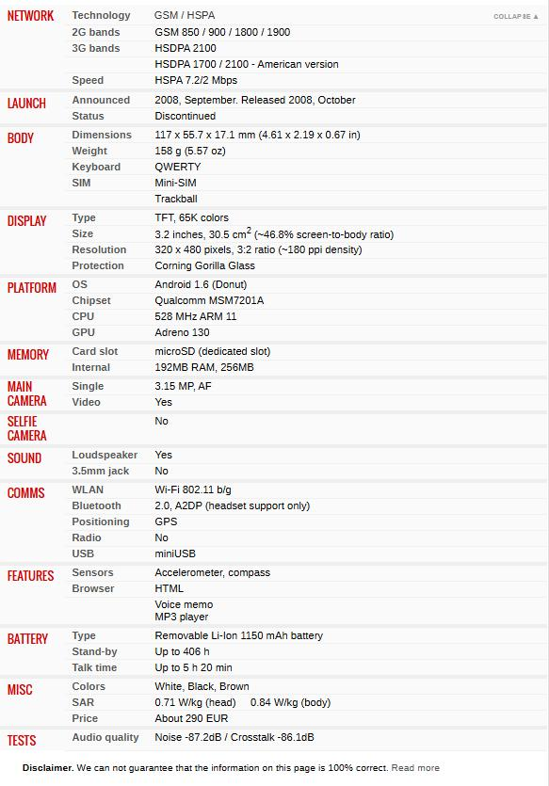
Figure 1: T-mobile G1 specifications

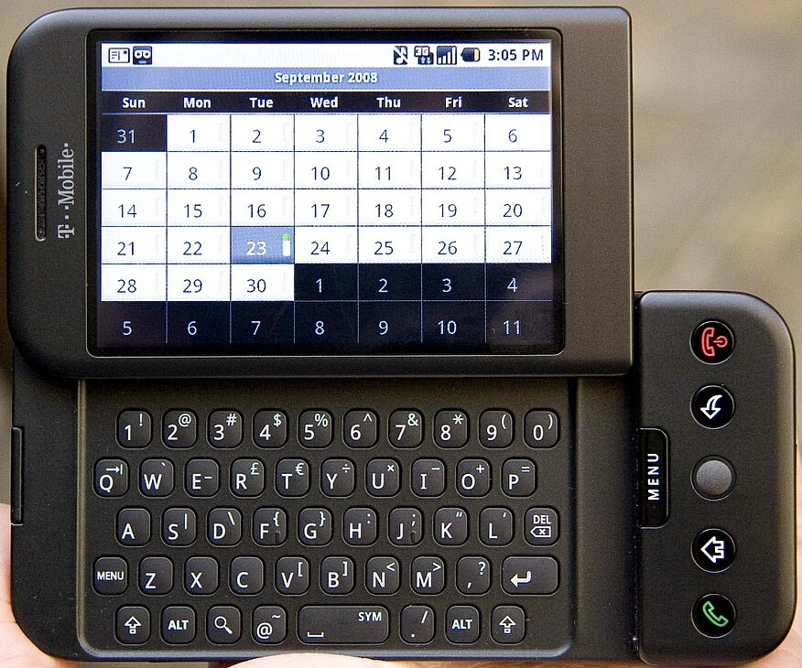
Figure 2: T-mobile G1 front view

Figure 3: T-mobile G1

