AccessionIndex: TCD-SCSS-T.20160121.003
Accession Date: 21-Jan-2016
Accession By: Peter Canavan
Object name: HP-45 Scientific Calculator
Vintage: c.1973
Synopsis: Hewlett Packard's successor to the HP-35 (their first hand-held calculator). S/N: 1350A 26828.

Description:
In 1973 Hewlett-Packard introduced the HP-45, code-named Wizard, as the successor to their HP-35 (their first hand-held calculator). In addition to the HP-35 functionality it included a shift key that expanded the number of key functions. It also added a key for Last X, and trigonometric functions in radians or grads (hundredths of a right-angle), polar to rectangular conversions, conversions of decimal degrees to/from degrees-minutes-seconds, various unit conversion factors, factorials, percentages, basic statistics, 10^{x}, x² and y^{x} (rather than x^{y} as on the HP-35), displayed both fixed and scientific number formats with a choice of the number of digits displayed, and had 9 numbered storage registers in addition to the 4-level stack. These added features made it a very popular product.

Early versions included a timer, invoked by pressing RCL and then CHS, 7, 8 simultaneously, but the HP-45 in this collection does not include this function.

The HP-45 used a HP-82001A 3.75V 500mW rechargeable battery pack with three cells. The battery pack is missing from the HP-45 in this collection (it has become increasingly hard to obtain), but the calculator is fully functional as of 29-Jan-2016 when powered by the AC power supply (the owner’s handbook states it is permissible to do this in the absence of batteries).

Many thanks to Peter Canavan, Network Manager, Broadcast Operations, Australian Broadcasting Commission (ABC), who donated these items from his personal collection, and who was one of the last generation of engineers educated with sliderules (although the HP-35 was introduced during his final undergraduate year, students were not permitted to use them in exams, so he waited for the release of the HP-45 the following year); the HP-35 and HP-45 quickly made sliderules redundant in all but a few applications like mandatory last-resort aircraft navigation.

The documentation is properly part of the Literature category of this catalog, but is listed here too for convenience.

Accession Index | Object with Identification
TCD-SCSS-T.20160121.003.001 | HP-45 Scientific Calculator.  S/N: 1350A 26828
TCD-SCSS-T.20160121.003.002 | HP-82011A Calculator AC Power Supply.  S/N:
TCD-SCSS-T.20160121.003.003 | Australian 240VAC Mains Lead for HP-82011A.  S/N:
TCD-SCSS-T.20160121.003.004 | HP-82012A Calculator Holster.  S/N:
TCD-SCSS-T.20160121.003.005 | HP-82014A Calculator Carrying Case.  S/N:
TCD-SCSS-V.20160121.004.001 | HP-45 Owner’s Handbook, P/N: 00045-90300 Rev.8/73, Hewlett-Packard, 1973.
TCD-SCSS-V.20160121.004.002 | HP-45 Quick Reference Guide, P/N: 00045-90303 Rev.8/73, Hewlett-Packard, 1973.

References:

- Wikipedia, HP-45, see (last browsed to 28-Jan-2016):
https://en.wikipedia.org/wiki/HP-45

See the extensive set of documents in the related folder in this catalog
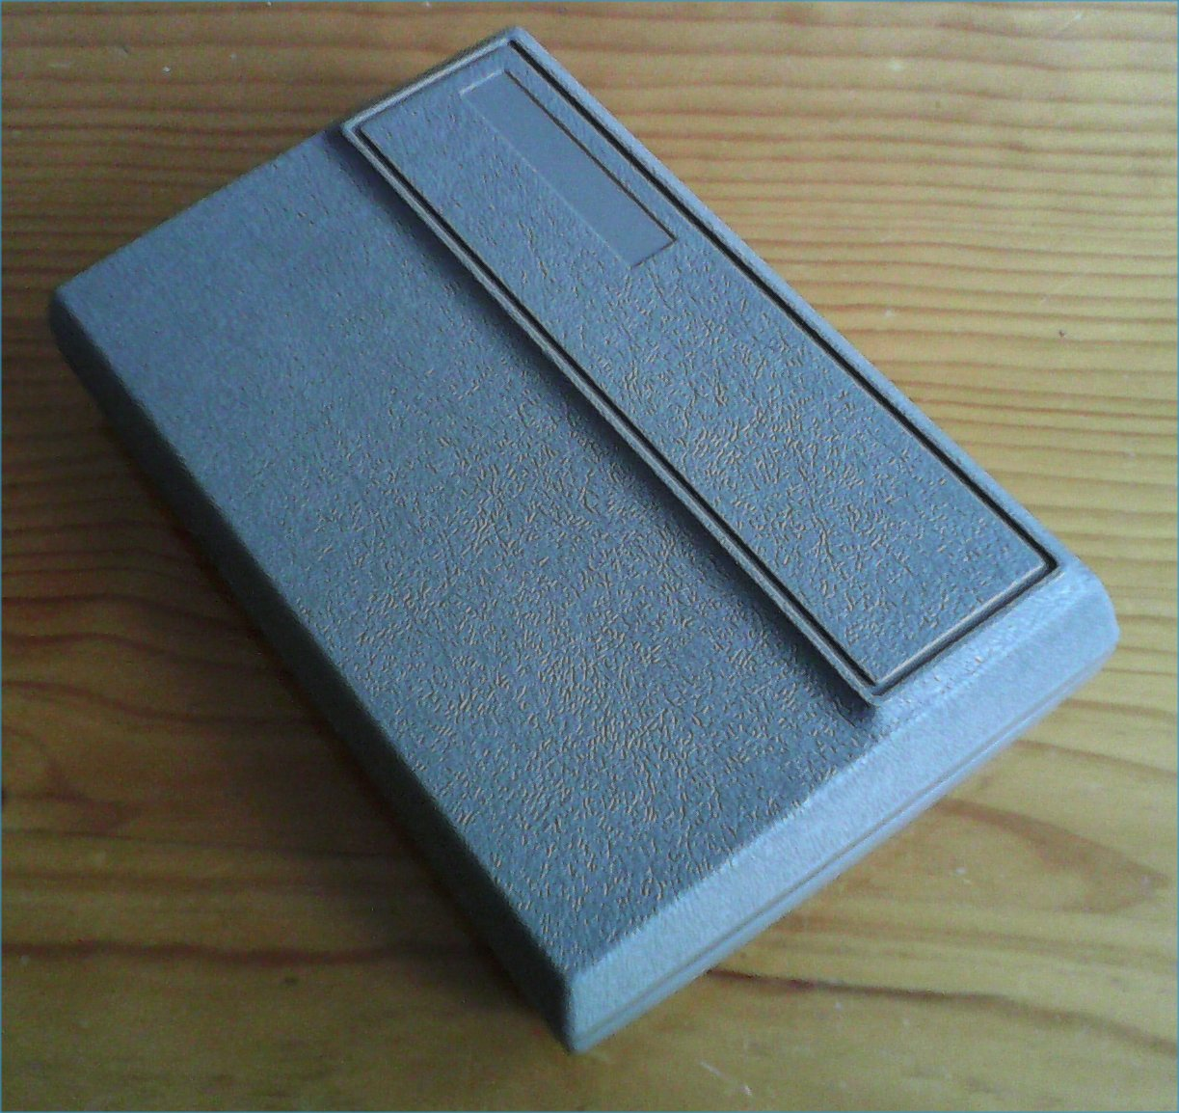
Figure 1: HP-45 front three-quarter view, carrying case cover closed

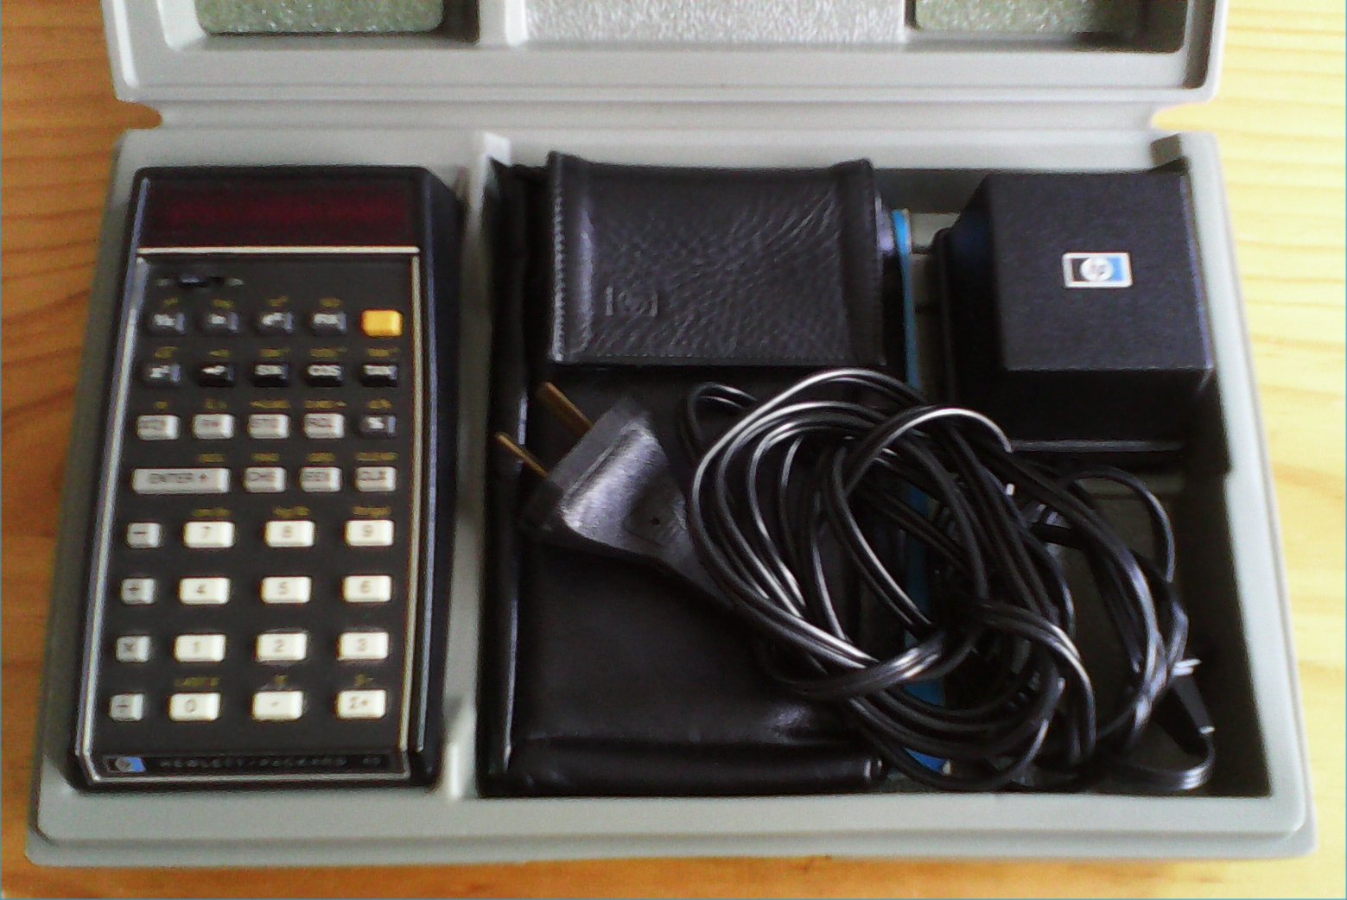
Figure 2: HP-45 front view, carrying case cover open

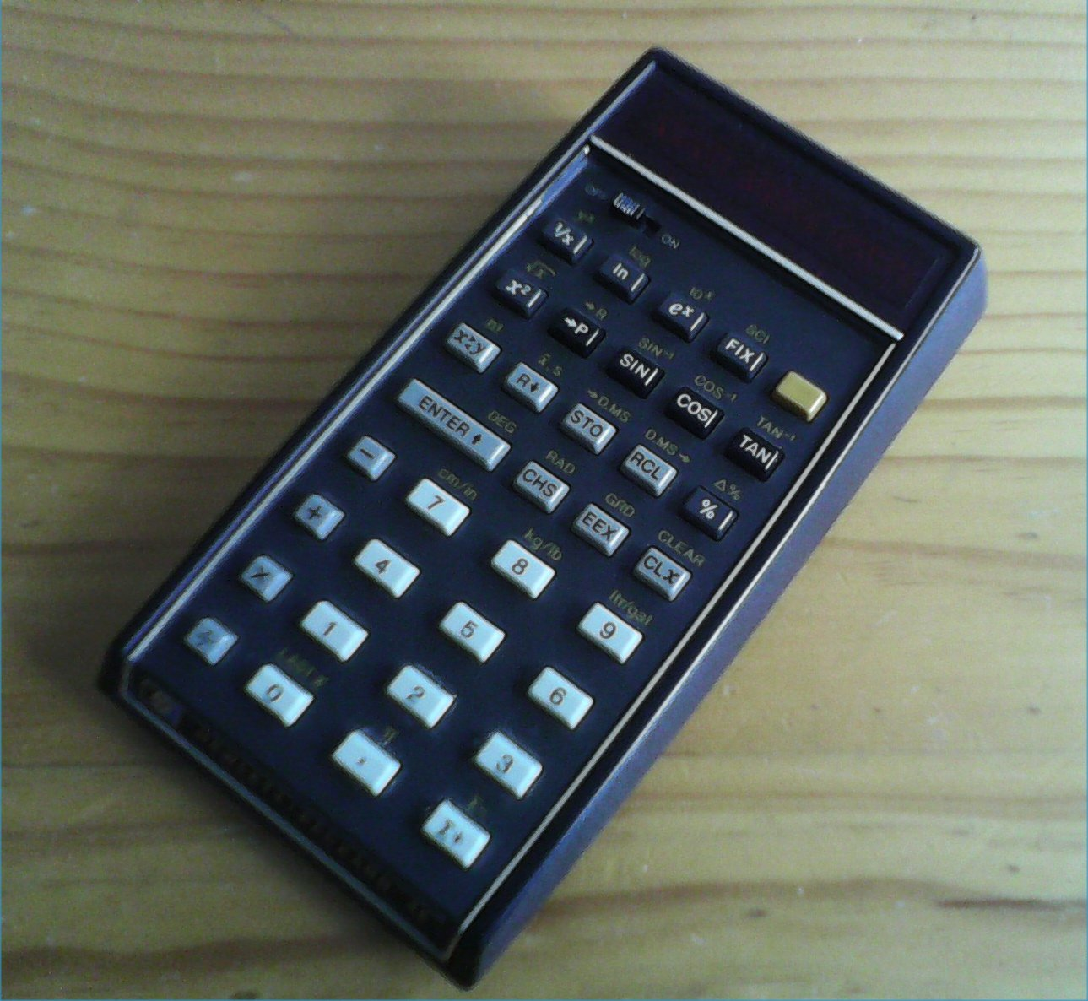
Figure 3: HP-45 front three-quarter view

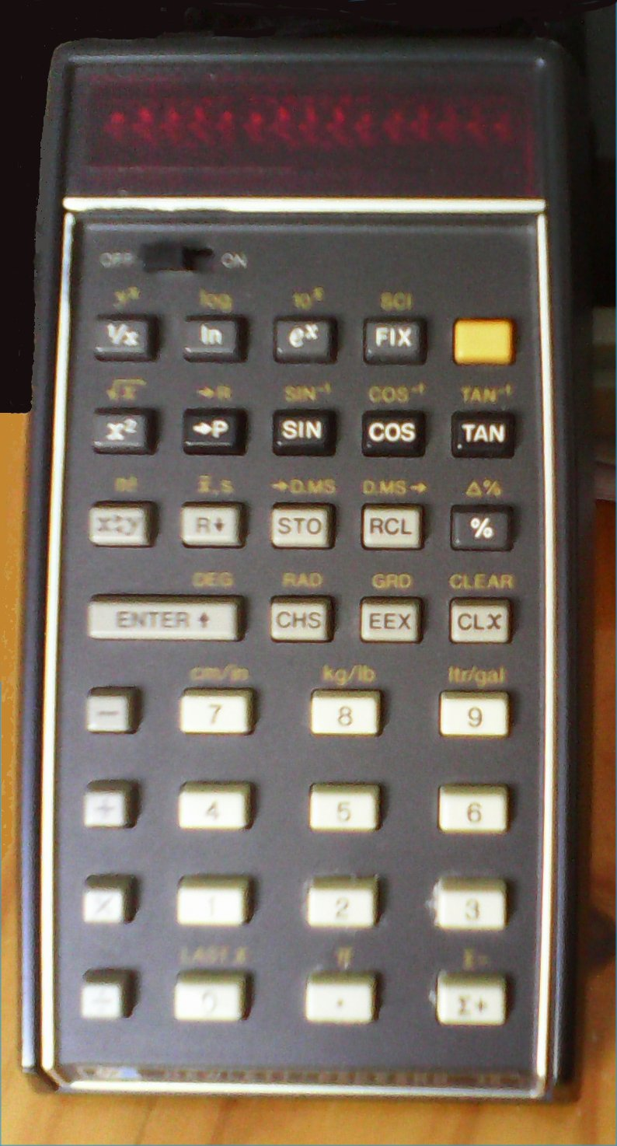
Figure 4: HP-45 front view

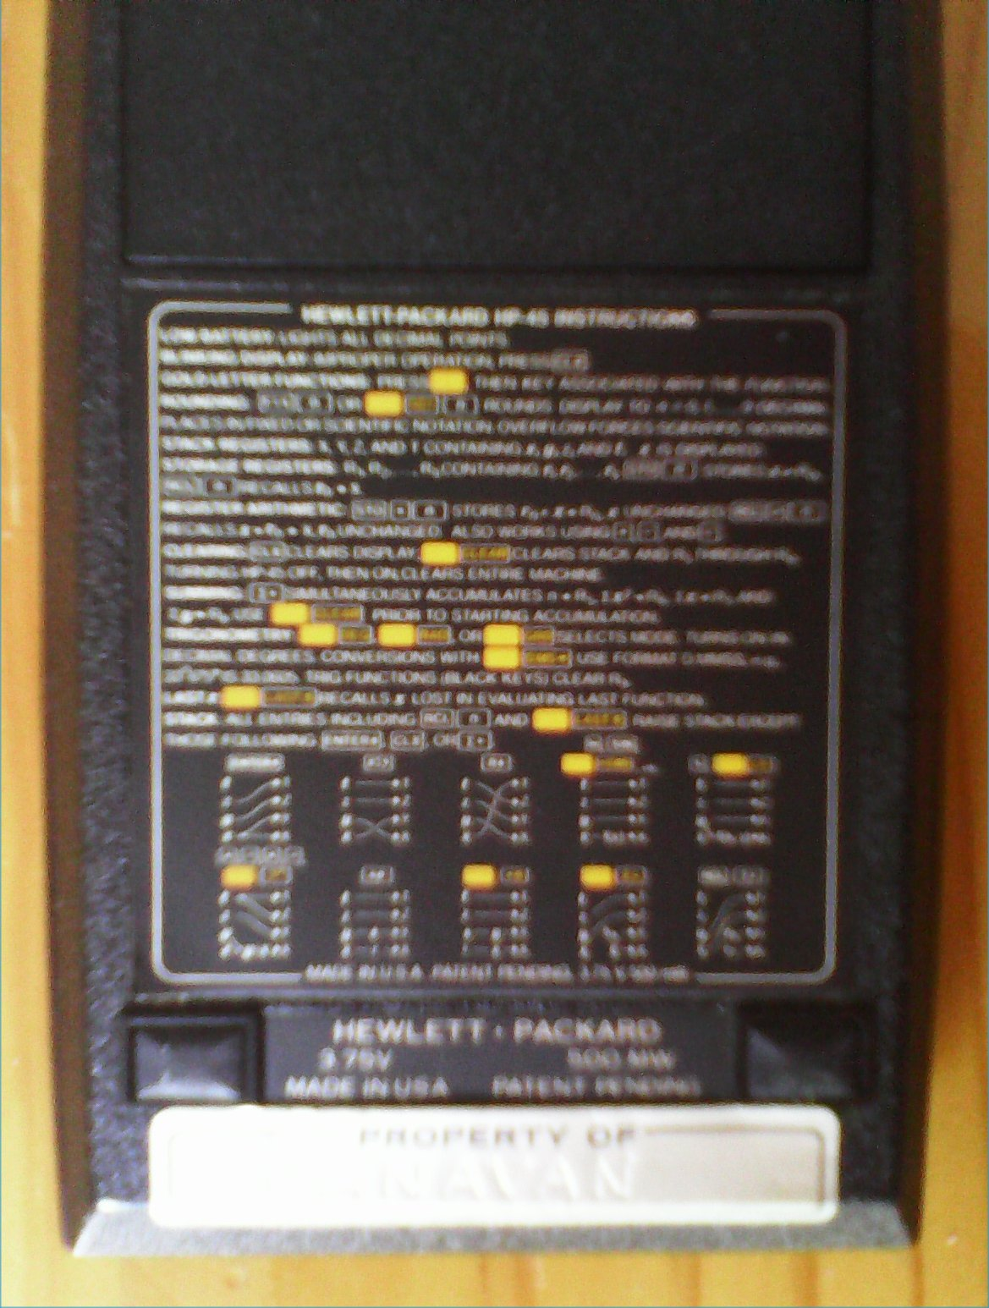
Figure 5: HP-45 rear view

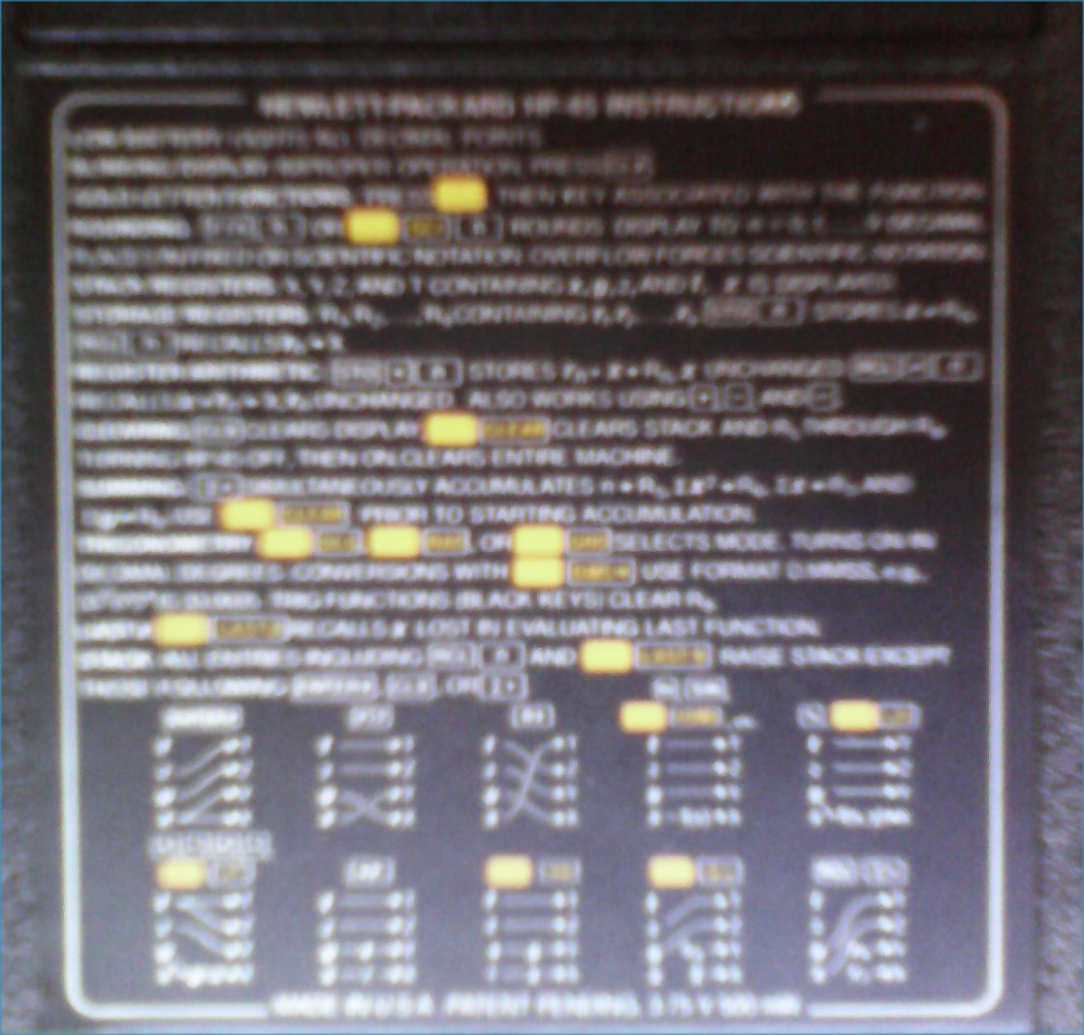
Figure 6: HP-45 rear label quick guide

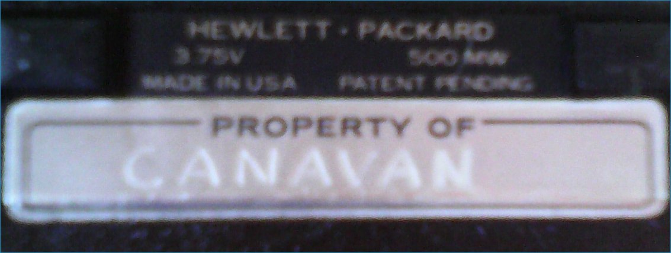
Figure 7: HP-45 manufacturing label

